STUDY OF ANTIOXIDANT AND ANTIEMETIC POTENTIAL OF WILDLY GROWING HERBS (Parthenium hysterophorus & Coronopus didymus)

Thesis
by
Uniba Tariq

Thesis submitted to the Lahore School of Economics
in partial fulfillment of the requirements for the degree of
MPhil Environmental Sciences and Policy
2017- 2019

Supervised by: Prof. Muhammad Nawaz Chaudhry(FPAS)
Co-supervisor: Dr. Naqi Hussain
Table of Contents
List of Tables | 4
List of Figures | 5
List of Abbreviations | 6
Abstract  Chapter 1  Introduction | 8
1.1. Herbs 10
1.2. Antioxidants 11
1.3. Emesis or Vomiting 12
1.3.1 Animal Emesis Model 13
1.4. Profile based plants used in study 13
Rationale | 16
Chapter 2  Literature Review | 17
2.1. Utilization of Medicinal plants | 15
2.2. Antioxidants and their uses: | 18
2.3. Antiemetic Activity | 19
2.4. Herbs used in the study  - Parthenium Hysterophorus  - Coronopus Didymus | 20
Objectives of the study | 23
Chapter 3  Methodology | 24
3.1. Collection and Identification of Plant Material: | 25
3.2. Chemicals and Apparatus | 26
3.3. Preparation of plant extracts  3.3.1. Immersion in Methanol 26 | 26
3.3.2. Filtration and Distillation 26
3.3.3. Percentage of extract yield 26
3.4 Sequential Partitioning 27
3.5. InVitro Antioxidant Assays 28
3.5.1. Radical scavenging of H2O2 28
3.5.2. DPPH Radical Scavenging Assay 29
3.5.3. Total Antioxidant Capacity Assay 31
3.6. Antiemetic Activity 33
3.6.1. Selection of Animals 33
3.6.2. Induction of Emesis by CuSO4 33
3.6.3. Preparation of extract doses fed to the chicks 33
3.6.4. Administration of extracts doses 34
3.6.5. Count and calculation of retches 34
3.6.6. Statistical analysis 35  Chapter 4 36  Results  Chapter 5 46  Discussion  Conclusion 50  References 52 | .
 | .
 | .

List of Tables
Table 4.1: Scavenging activity of H2O2 assay of Parthenium Hysterophorus
Table 4.2. Scavenging activity of H2O2 assay of Coronopus Didymus
Table 4.3: DPPH radical scavenging assay of Parthenium Hysterophorus
Table 4.4. DPPH radical scavenging assay of Coronopus Didymus
Table 4.5 Total antioxidant capacity assay of Parthenium Hysterophorus
Table 4.6 Total antioxidant capacity assay of Coronopus Didymus
Table 4.7: Antiemetic activity of plant extracts (Parthenium hysterophorus & Coronopus didymus)using chick emesis model
List of Figures
Figure 1.1. Parthenium Hysterophorus
Figure 1.2. Coronopus Didymus
Figure 3.1. Methodology flowchart
Figure 3.2. Powder form of P. Hysterophorus
Figure 3.3. Powder form of C. Didymus
Figure 3.4. Crude extract of P. Hysterophorus
Figure 3.5. Crude extract of C. Didymus
Figure 3.6. Scavenging activity of H2O2 assay
Figure 3.7. DPPH radical scavenging assay
Figure 3.8. Total antioxidant capacity assay
Figure 3.9. Preparation of extracts doses fed to the chicks
Figure 4.1. Percentage inhibition of H2O2 of P. Hysterophorus
Figure 4.2. Percentage inhibition of H2O2 of C. Didymus
Figure 4.3. Percentage inhibition of DPPH of P. Hysterophorus
Figure 4.4. Percentage inhibition of DPPH of C. Didymus
Figure 4.5. Absorbance of total antioxidant assay
Figure 4.6. Total antioxidant assay of Parthenium hysterophorus
Figure 4.7. Total antioxidant activity of Coronopus didymus
Figure 4.8. Mean No. of retches in all 4 treatment groups
Figure 4.9. Percentage inhibition of retches in all the experimental groups
List of Abbreviations
- Parthenium Hysterophorus PH
- Coronopus Didymus CD
- Tert-butylhydroquinone TBHQ
- chemoreceptor trigger zone CTZ
- National Health Service NHS
- Dimethyl sulfoxide DMSO
- Hydrogen Peroxide H2O2
- Ultraviolet-visible UV/VIS
- Standard error of mean SEM
- Total Antioxidant Capacity TAC
- 2,2-Diphenyl-1-picrylhydrazyl DPPH
- Butylated Hydroxytoluene BHT
- Remaining Methanolic Extract RME
- Pet Ether PE
- Tetrapleura tetraptera TTE
ABSTRACT
Herbs are the plants which have aromatic and fragrant properties which are either grown as food or to treat various illnesses. Use of herbs and natural resources of medicines leads to a system of treatment and prevention which is much more effective and has lesser side effects. These herbs also have antioxidants in them which have been proven highly beneficial for a lot many purposes. Antioxidants are the compounds that inhibit oxidation reactions. These antioxidants stabilize the unstable free radicals in order to put a stop to the damage and adverse effects that these free radicals or molecules may cause. This study contains two major parts which is evaluation of antioxidant activity and antiemetic activity. Vomiting or emesis is an involuntary, forceful expulsion of the contents of the stomach through the mouth and sometimes the nose. Emesis is mostly induced by the side effects of chemotherapy, sickness of motion, anesthetics, opioid analgesic or any other illnesses and emesis is usually treated by antiemetic agents which efficiently work against emesis. The main objective of this study is to determine the antioxidant and antiemetic activity of two herbs i.e. Parthenium hysterophorus and Coronopus didymus in order to find out their medicinal use. For antioxidant activity three protocols have been used which are Radical scavenging of hydrogen peroxide assay, DPPH radical scavenging assay, and Total antioxidant capacity assay. While for antiemetic activity, the Copper Sulfate induced Chick Emesis model has been used. Both of the activities were followed by the preparation of methanolic extracts of herbs. The Results of antioxidant activity revealed that both the herbs contain antioxidants in them but with every assay both herbs showed different percentages of inhibition. But overall results showed that both the herbs have different kinds of phytochemicals, bioactive flavonoids, and many other phenolic groups that are responsible for good antioxidant activity in both the herbs. On the other hand, antiemetic activity results showed that C. didymus showed more antiemetic activity as compared to P. hysterophorus. The student’s unpaired t-test also applied to the results; *p<0.05 vs control group showed significant difference in values of both the groups. Extract no.2 (P. hysterophorus) has less difference to the control group as compared to extract no.1 (C. didymus) and standard group. This is due to the absence of certain compounds or components like terpenes, flavonoids, alkaloids, steroids and tannins that are considered beneficial in inhibiting retching and combating vomiting or nausea. Thus, C. Didymus has more antiemetic effect out of all experimental groups but its mode of action is not known for which more studies are required which would help in determining its exact mode of action and the obvious active compounds that are responsible for greater antiemetic effect in C. didymus and lesser effect in P. hysterophorus.

CHAPTER 1
INTRODUCTION
Herbs are the plants which have aromatic and fragrant properties which are either grown as food or to treat various illnesses. They are being used in a very little amount in order to import some flavor to food and in this way they are quite different from other plants. There are a large number of herbs that originate from Mediterranean area. Extracts of these herbs contain antimicrobial activity which works against bacteria, viruses, yeast and molds (Martínez-Graciá et al., 2015).
Modern medicine secures a very significant place and phytotherapy which is a part of pharmacotherapy plays its important role in modern medicine as well .Use of herbs and natural resources of medicines leads to a system of treatment and prevention which is much more effective and has lesser side effects (Djordjevic, 2017).
There are different national health care centers which are working for several health challenges and expanding the utilization of phytonutrients and herbal medicines or medicinal plants more rapidly all around the globe. In many developed and developing countries, the past few years have seen much public acceptance and interest in natural herbal remedies as many herbal products are being placed in different food markets, stores and many supermarkets. It has been revealed that more than 80% of the world's population and 4 billion people in developing countries are relying upon herbal products or medicinal plants and consider them as a primary and basic source of healthcare. Use of herbs is now an essential and important part of the many Cultures (Ekor, 2014).
There are several plants that come under both herbs and spices like dill seed and dill weed or coriander seeds and leaves. Herbs that belong to the mint family have their benefits in medicines and culinar (Elansaryn & Mahmoud, 2015).
Oregano, thyme and peppermint are some of the herbs that are stuffed with many antiseptic and antibacterial properties that are much effective in hindering acne problems like minimizing acne marks by making skin glow, radiant and clear. Oregano has been advised to include in the diet for those people who have certain food allergies because this herb contains a large amount of antifungal and antibacterial properties which fights various food borne infections and illnesses (Korać & Khambholja, 2011).
Around 60-85% of the population of developing countries uses herbal products or the native forms of Alternative and Complementary Medicine or CAM for their health problems and this is due to the high cost of antibiotics. Thus, they rely upon herbal medicine which helps them to encounter several health disorders and diseases. Herbal medicines ensure prevention and cure for various illnesses and disorders of both humans and animals that's why they have been considered as a vital source of effective medication in all cultures globally. Medicinal plants hold a very significant place due to the presence of antimicrobial and immunomodulatory activities, health maintenance, valuable therapeutic properties and good healing potentials (Dhama et al., 2014).
1.1. Antioxidants:
Substances which provide protection to cells from various damages due to unstable molecules like free radicals are called Antioxidants. These antioxidants stabilize the unstable free radicals in order to put a stop to the damage and adverse effects that these free radicals or molecules may cause (Hamid et al., 2010).
Oxidation is a chemical reaction that causes a lot of changes in food and food chains which ultimately leads to the degradation of all of its characteristics by lowering and deteriorating its nutritive value. That’s why antioxidants play a vital role in the processing and storage of food as they inhibit oxidation. Raw sources of plants have an immense amount of compounds with antioxidant activity. Antioxidants are present in different parts of plants sometimes in fruits, leaves, seeds, flowers and barks. There are many good and essential sources of antioxidants such as seasonal plants which include, rosemary, oregano, thyme, mustard and sage. In addition to this, oat, rice, barley, soya, wheat, nuts and cocoa shells have antioxidants in them. Different plant extracts have different antioxidant activity which depends upon the presence of phenolic groups and also the derivatives and isomers of catechins, flavonols, isoflavones, flavones, phenolic acids and the best of them all are tocopherols. The plant extracts antioxidant activity is basically the effect of involving two or more compounds thus, plant extracts are not the single compounds just as the food additives (Klimczak et al., 2002).
Several types and parts of plants have been researched and proved to have the potential sources of antioxidants such as oilseeds, leaves, vegetables, barks, fruits, crops, roots, spices and herbs (Kähkönen et al., 1999).
Some antioxidants which are chain breaking in nature and differ in their effectiveness of antioxidant properties depend upon the chemical constituents and physical characteristics within the food. For better effectiveness in antioxidant systems it is important to keep a check on chemical potency of antioxidants, their solubility and accessibility to peroxy radicals mainly in micellar, membrane and emulsion systems (Brewer, 2011).
Synthetic antioxidants which are being used in the food materials like, butylated hydroxyanisole (BHA), tert-butylhydroquinone (TBHQ), and butylated hydroxytoluene (BHT) are present in wide ranges. For the past many years, various spices and herbs like oriental herbs, black pepper, and propolis are considered to give utmost protection to fresh cooked meat and also very essential in lipid oxidation retardation. Antioxidant activity is similar to synthetic phenolic antioxidants that's why the antioxidant characteristics of spices and herbs depend upon their phenolic content. Phenolic groups have the redox properties which allow them to act as reducing agents or free radical quenchers and H atom donors thus, phenolic group antioxidant properties are dependent upon their redox properties (Pan, et al., 2007).
1.2. Emesis or Vomiting:
An involuntary expulsion of stomach contents forcefully either through mouth or nose refers to Vomiting. Wide range of conditions cause vomiting including specific responses to ailments such as gastritis and poisoning and sometimes a range of disorders. For managing treatments related to vomiting and nausea, anti-emetics are the most usual intervention. Neurochemical control of nausea is the ultimate basis for antiemetic therapies (B., J. K., 2016).
Vomiting is considered to be the protective mechanism through which the human body can get rid of all the toxic, unwanted and harmful substances that are taken in or being produced by the body. In Spite of this fact, it is difficult and problematic for patients that are going through radiation therapies, cancerous chemotherapies and in the beginning of pregnancy. Keeping it aside, if vomiting becomes acute it leads to serious troublesome complications such as dehydration, undernutrition, weight loss, abnormality in electrolytes and esophageal tears e.g mallory weiss syndrome and boerhaave syndrome. Many antiemetic drugs are available in the market and most of them are not safe to use in the first trimester of pregnancy because of their overlapping mechanisms of action. These antiemetic drugs not only show the serious effects but also are less effective in relation to the broad spectrum of their antibiotic properties. Many researches have been carried out for various plants which are claimed to have antiemetic properties in them (Medhi, & Gohain, 2019).
Emesis is considered to be the protective measure against vomiting as it serves to remove the toxic components from intestine and stomach and thus provide prevention against further ingestion. Emesis consist of three phases including (1) Pre Ejection phase; gastric relaxation and retro peristalsis (2) Retching phase; respiratory muscles with rhythmic action lead to vomiting and constant contractions in abdomen and (3) The Ejection phase; relaxation of upper esophageal and deep contractions of abdominal muscles that is due to the disturbance in the gastrointestinal system, vestibular system and chemoreceptor trigger zone CTZ which is one of various parts of brain. CTZ is basically controlled by two different parts of the brain; the chemoreceptor trigger zone and vomiting center. Emesis may also be triggered due to renal infection or failure, pregnancy, hepatitis, obstruction, peptic ulcer and drug toxicity (Ahmed et al., 2012).
1.2.1. Animal Emesis Models:
For the assessment of natural and synthetic anti-emetics, various animal emesis models are presently available. There are also non-mammal models consisting of birds and amphibians while mammal models include insectivores, carnivores, artiodactyls and some non-human primates like monkeys. The emetic patterns in these animals are marked as retching, vomiting and ingestion of non-nutritive components. Animals which have the potential to vomit are being observed having retching and vomiting for example house musk shrew, dogs, cats and ferrets. Pica or the ingestion of nonnutritive substances has been observed in those animals that lack the ability to emetic reflux like in mice and rats. Thus, animal models have been in use for the assessment of anti-emetic properties of plant extracts and other natural components. Common emetic stimuli are used for the animal models such as radiations, chemicals and motions (Ahmed et al., 2013).
1.3. Profile based plants used in study:
Different parts of the plants have different medicinal uses derived from plant parts such as barks, leaves, fruits, seeds, roots and flowers. Plant parts have different active ingredients as in one part of a plant has toxic or poisonous ingredients while the other parts have beneficial and useful active ingredients that are not harmful at all.
- Parthenium hysterophorus:
It is an annual herb which has a deep tap root and a straightened stem that becomes woodier with age. This plant originates a lot of branches in the top half when it matures and ultimately grows to a height of 2 meters. Parthenium leaves are pale green in color, and fully covered with hair all around. At the tips of each stem whitish creamy white color flowers grow (Marwat & Khan, 2015).
It is a noxious, wild, fast growing, pantropical and notorious weed which is used extensively in various industries and departments. Cosmetics, pharmaceuticals, pharmacognostic, and agricultural sides believe it to be the fast growing medicinal herb with great degree of diverse relevance. It is also being used by the nanotechnology based industries for considering it to have eco-friendly nanoparticles for the formation of other nanomaterials at larger scale (Singh & Arti, 2014).
Parthenium is enriched with volatile oils, flavonoids, terpenoids, amino acids, sugars and phenolic groups and its derivatives. Different solvent extracts of this herb showed various beneficial properties such as analgesic, antipyretic and ant- inflammatory properties which proved that it can be used for the treatment of fever, headache, migraine, and using the leaf paste approach of this herb showed wound healing properties as well (Kaur, Aggarwal & Dhiman, 2016).
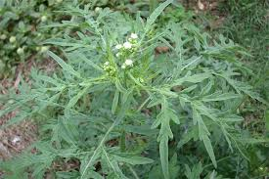
Figure 1.1. Parthenium hysterophorus
- Coronopus didymus:
Coronopus which is considered to be a medicinal plant belongs to the brassica family and is extensively found in wastelands, cultivated areas and along the roadside. Secondary metabolites of Coronopus have been studied and revealed that saponins, sterol glycosides, flavonoids, glucosinolates and anthraquinones are responsible for making the genus Coronopus. Coronopus didymus has been used for treatment of various diseases in which malaria, cancer, and digestive system illnesses are involved. In addition, this herb is also providing benefits to fight against common cold, pain and inflammations. As this herb is extensively used against cancer in different countries of the globe, its traditional use led to explore more about its cytotoxic properties and to analyze the active cytotoxic compounds in this species (Noreen, Farman & McCullagh, 2016).
C. didymus is used traditionally in the southeast region of Brazil in order to combat fever, pain and inflammation. It has been reported that this herb is considered to be an excellent expectorant and helps in purifying blood. Moreover, many researchers found C. didymus to have anticancer and antimalarial properties in it (Noreen, Farman & McCullagh, 2017).
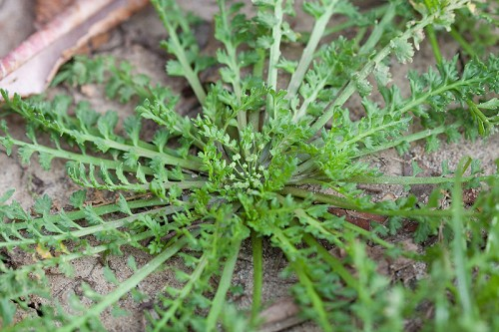
Figure 1.2. Coronopus Didymus
RATIONALE
Herbal medicine use and acceptance is increasing day by day. There are many herbal remedies for emesis or vomiting which have not been scientifically investigated and their side effects have not been assessed. This leads towards the need of getting promising registered antiemetic for the future that too with high efficiency and lesser side effects. As there is less or no scientific evidence for the usage of herbs and other medicinal plants but the benefits people are getting out of these herbs has been observed and encouraged. Thus the trend and tradition of utilizing such medicinal plants and herbs is still in practice even after the emergence of modern medicine. Also, pharmaceuticals and their metabolites enter the environment through excretion, municipal, hospital waste and disposal of unused medicines may result in environmental degradation. The National Health Service NHS Carbon Reduction Strategy for England entitled ‘Saving Carbon, Improving Health’ reveals that due to pharmaceuticals there is an astonishing amount of carbon dioxide of 4 million tons a year in the environment and ecologists suggested that it is equivalent to 3 quarters of a million cars on the road. Hence, there is the dire need to switch ourselves from pharmaceuticals to herbal remedies thus, this study focuses on the herbal cure to emesis.
CHAPTER 2
LITERATURE REVIEW
Herbs have been in use and demand even in ancient eras and are still in use to not only prevent and treat chronic diseases but also to add or improve the flavor of foods that are edible. There is less or no scientific evidence for the usage of herbs and other medicinal plants but the benefits people are getting out of these herbs has been observed and encouraged. Thus the trend and tradition of utilizing such medicinal plants and herbs is still in practice even after the emergence of modern medicine. Many studies have been carried out in order to expand their understanding regarding the nutritional values of herbs by examining the molecular and cellular modes of action of several chemical compounds in herbs more comprehensively. The most advantageous actions of herbs or medicinal plants may involve antioxidant, anti-inflammatory, anti-thrombotic, anti-hypertensive and glucose regulatory effects (Panickar, 2013).
Medicinal plants which are used for the prevention of various diseases give therapeutic modalities with a wide range of antimicrobial activities are being taken by the scientists to derive extracts from various parts of plants which fight against several pathogenic microorganisms and diseases. For the past many years, herbal products and medicinal plants are used for multiple health benefits as their demand and delivery is getting to the peaks. Herbal remedies are still taken as a dietary supplement in countries like the US. There are many herbal therapies which have higher potency in treating several bacterial illnesses. Many of them are proven scientifically to have significant benefits (Dhama et al., 2014).
2.1. Utilization of Medicinal plants:
For the rural population, medicinal plants play an important role in contributing to the healthcare systems of locals as it is considered to be the main and most accessible source of medicine. More than 50,000 flowering plants out of 422,000 are being reported to have a lot of medicinal uses. Around 60% of the total world and 80% population of developing countries depend upon traditional medicines. Moreover, the 4.5 billion population of developing countries is considered too strongly rely upon medicinal plants as their basic component of health care systems. In rural areas, all the allopathic drugs are of highest cost and have multiple side effects thus, a massive population from rural areas uses herbal products and herbal remedies (Mussarat et al., 2014).
The trend of utilizing herbs for self-medication by people is due to multiple reasons like (a) patients or individuals are hesitant in stating or discussing their medical issues or illnesses and being terrifying in handling information regarding their health, (b) fear of getting wrong treatment and misdiagnosed by doctors and (c) having less or no time to visit a doctor which yields to having a no positive experience (Ekor, 2014).
Several herbal medicines finding their ways into official medicines in the past few years such as cannabidiol and dronabinol being extracted from Cannabis Sativa and tiotropium which is being derived from Atropa belladonna which fight against chronic illnesses like bronchitis. Other than this, alkaloid extract from Galanthus nivalis used to combat Alzheimer’s illness and medicinal plant Papaver somniferum extract apomorphine is proven to be a semisynthetic compound and is used to treat Parkinson’s disease (Djordjevic, 2017).
Since many ancient individuals tried their best to find medications against pain and to alleviate different diseases. Every passing century is passed by with the advanced and civilized humankind development and identification of several medicinal plants is noted which is passed on to the next generation in order to combat various illnesses. Therefore, the benefits and advantages of one society passed on to the next with discovering new ones and upgrading the old ones till date. The continued and constant interest of people in medicinal plants is due to the modern and advanced ways of processing and using the medicinal plants (Petrovska, 2012).
2.2. Antioxidants and their uses:
Molecules or Compounds that inhibit the free radical reactions and also inhibit cellular damage are called Antioxidants. However, the defence system of antioxidants varies from species to species but the antioxidant defence is universal. Antioxidants are present in the intracellular and extracellular environment both in the non-enzymatic and enzymatic forms (Nimse & Pal, 2015).
Antioxidants that naturally originated from plants are used in lipids and oils containing foods in order to cure oxidative deterioration. There are two plants that belong to the same Labiatae family which are sage and rosemary seems to be the most effective medicinal plants. Other plants which belong to the same family have also been analyzed, tried and tested but they have proven to have contradictory antioxidant activity when used under different circumstances. Thus, it has been reported that different plants of the same family showed different antioxidant activities and their effectiveness mainly relies upon the substrate, procedure of preparation and the oxidation test (Economou et al., 1991).
In the United States, antioxidants use has expanded especially in adults. The National Health and Nutrition Examination Survey revealed that more than half of the US population consume dietary supplements, third one of them take multivitamins and more than eighth one of them uses vitamin E and C supplements (Seifried et al., 2007).
For health maintenance and combating diseases like cancer and coronary heart illnesses, antioxidants are extensively used in dietary supplements as vital ingredients. However, initially many researches revealed that antioxidant supplements are essential in promoting health. Later, many clinical trials did not find them useful as they considered excess supplementation harmful to health. But still many researchers strongly believe in the uses of natural antioxidants in medicine and its uses are extending to the industrial uses like in cosmetics, in the preservation of food and in securing the rubber and gasoline by preventing them from degradation (Hamid et al., 2010).
2.3. Antiemetic Activity:
Emesis or nausea are considered to be the protective approach to take relief by throwing up all of the toxic and unwanted substances from the body's intestine and stomach and seek prevention from its further ingestion (Ahmed et al., 2012).
Emesis is mostly induced by the side effects of chemotherapy, sickness of motion, anesthetics, opioid analgesic or any other illnesses and emesis is usually treated by antiemetic agents which efficiently work against emesis. However, many synthetic drugs used for the cure of emesis have various side effects when they are being used for a longer period of time. Thus, it's a prior need to produce natural products that are more effective and have lesser or no side effects. Presently, a lot many painkillers are being used by people for various purposes and extensively found in markets but taking these painkillers for a longer period of time are leading towards other problems and illnesses such as liver and kidney dysfunctioning. Consequently, managing or combating pain with no side effects is a need of the time to our healthcare system (Sajib et al., 2015).
Development of effective and safe to use antiemetic drugs is in highest priority as vomiting is troublesome. Although vomiting does not show up in many diseases, still there is a dire need to have effective antiemetic drugs that improves the healthcare outcome in conditions like pregnancy and cancer chemotherapy. Since 40% of the patients have vomiting issues so the contraceptive hormones are being administered with the antiemetic drugs in order to prevent vomiting (Ihekwereme et al., 2016).
There are several herbal remedies for emesis that have not been investigated scientifically and their careful evaluation of their side effects have not been evaluated. It is important to work towards excellent registered antiemetic drugs for the future which are highly efficient and have lesser side effects. For the treatment of vomiting, traditional drugs development may be done which are being utilized through the survey of medicinal plants used worldwide. It is a need of an hour to identify the pharmacological activities of herbal medicines in order to segregate the component that is believed to have the antiemetic effect and thus having suitable and effective formulas against emesis. Advanced technologies used for the separation, structural explanation, screening, and synthesis and processing will help in building up plant extracts as a vital source of new drugs. In order to fill up the spaces in newer drug discoveries the antiemetic effect of separated constituents in different animal models leads to further research on chemistry, clinical therapeutics, pharmacology and pharmacognosy (Ahmed, Hasan & Ahmed, 2014).
2.4. Herbs used in the study:
- Parthenium hysterophorus:
Parthenium is an annual herb which belongs to the family Asteraceae and due to its biological characteristics like constant and abundant flowering, short life cycles i.e. 4 to 6 weeks, higher seed productivity which is up to 15000 to 1 lakh per plant, lightweight seeds, bigger seed bank, seed dormancy in the adverse environment and its ability to strongly regenerate make it highly fertile, productive and fruitful herb or weed. This herb shows an excellent adaptability even under a broad range of environmental conditions hence, it is found to be growing in multiple types of habitats (Saini et al., 2014).
Parthenium has been chemically analyzed and suggested that all parts of the plant have trichrome and pollen which contain toxins in them. Major components of these toxins are parthenon and phenolic acids such as vanillic acid, anisic acid, chlorogenic acid, caffeic acid and p-anisic acid (Tesfu & Emana, 2013). The intrusive nature of this weed is because of its capability to form a large monoculture which stands with no other plant in the locality. It has been reported as a noxious weed as it has the likelihood to reduce the crop productivity, insufficient fodder, biodiversity degradation and many other health issues for humans and livestock animals such as skin diseases, hay fever, and asthma (Marwat & Khan, 2015).
All parts of the Parthenium plant are considered to be used as febrifuge and bitter tonic. Whereas researchers reported that it is beneficial in treating wounds, ulcers, anemia, fever and heart diseases. Many countries including India used the extracts of parthenium as an ethno medicine to combat inflammatory, skin problems, nervous breakdown and female reproductive problems. This plant is also being used for the treatment of diabetes in Gujarat and Maharashtra of India. Also, it is reported to be pharmacologically very active and provides prevention against a number of diseases (Kumar et al., 2014).
Many antioxidant compounds provide protection to the cells from oxidative damage which is mainly caused by free radicals or molecules. Methanolic and ethanolic extract of parthenium through DPPH radical scavenging assay showed that it has very effective antioxidant compounds which are responsible for its higher antioxidant activity. Further research has been done which revealed that acetone extract shows the highest antioxidant activity than that of chloroform and methanol extracts (Vishnu, Radhika & Srinivasa, 2011).
- Coronopus didymus:
Coronopus is a wild annual herb that grows impulsively in winters along the roadsides with an immense branched plant system showing extreme growth biomass. For the past few decades, this herb has been very effective in folk medicines for the treatment of wounds, ulcers, bruises, muscular pain, gastric problems, bronchitis, allergies and other inflammations (Noreen et al., 2017). Allelochemicals and secondary metabolites are being produced by this herb which have detrimental effects on the nearby hazardous plants when being released into the environment (Noreen et al., 2016). Biochemical and physiological processes are disturbed in agroecosystems when the allelochemicals are released as they are responsible in suppressing the growth of unwanted or toxic plants (Javaid & Khan, 2020). It is also known to accumulate lead and cadmium and is considered as an unpalatable plant with lesser swine cress. It has a great and immense biomass which grows rapidly. It has a shortest harvesting period and speedy growth of branched roots and shoot systems (Sidhu et al., 2018).
Coronopus is named as Mentruz in Brazil and grows rapidly in winter farming, pictures and gardens. This herb is indigenous to South America and considered to be a weed with a strong taste of watercress. It is used in salads in fresh forms or sometimes crushed and added to cachaca which is used as a medicine for purifying blood and for curing other illnesses such as cough, bronchitis, gastric and urinary problems, bruises, muscular pains, viral infections, traumatism, wounds, ulcers, rheumatism and arthritis. Anti-inflammatory and wound healing properties of aqueous or ethanol extracts of Coronopus have been reported in various studies. Moreover, it’s antipyretic, antiallergic and hepatoprotective properties of this herb in rats and hypoglycemic characteristics in mice has been assessed (Busnardo et al., 2010).
A 2% leaf of Coronopus dried biomass with soil amendment in the pot trials can effectively fix the rotted onions with zero negative effects on the growth of the plant. Amendment of soil with the dry leaves of Coronopus helps in managing diseases as it contains good phenolic content and peroxidase properties of the plants (Javaid et al., 2017).

OBJECTIVES OF THE STUDY
The aim of this study is to:
- Assess the medicinal use of two herbs (Parthenium hysterophorus and Coronopus didymus).
- Evaluate the antioxidant activity of plant extracts by using three protocols i.e. radical scavenging of hydrogen peroxide assay, DPPH radical scavenging assay, and Total antioxidant capacity assay.
- Evaluate the antiemetic property of plant extracts by using the copper sulfate induced chick emesis model.

CHAPTER 3
METHODOLOGY
A descriptive methodology was adopted for the purpose of completion of this research. Secondary data collection has been collected by gathering all the information and data regarding the selected herbs, antiemetic activity and antioxidant activity. This data was collected through available literature from articles, books, and documents. While for primary data all lab tests for antiemetic (chick emesis model) and antioxidant activity of plant extracts were conducted in the Pakistan Council of Scientific and Industrial Research (PCSIR) lab located in Ferozepur road Lahore. The lab tests were included in vitro-antioxidant activity of ethanolic extracts of two herbs along with antiemetic activity of these plant extracts on chicks in order to analyze the medicinal use of these herbs. Methodology adopted for this study is illustrated in figure 3.1.
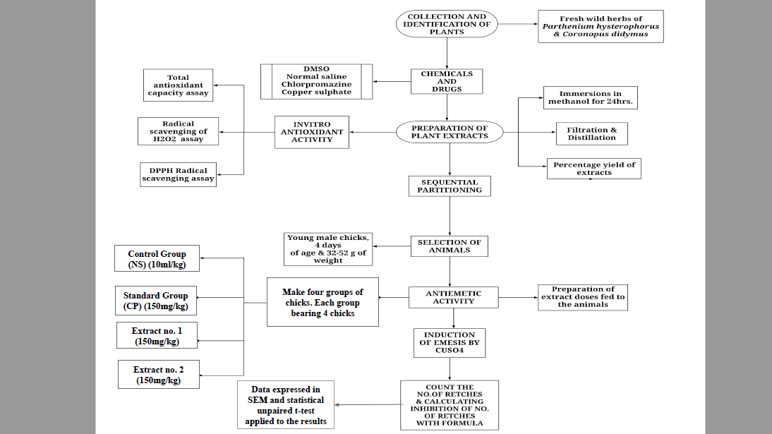
Figure 3.1. Methodology Flowchart

3.1. Collection and Identification of Plant Material:
Fresh wild herbs of Parthenium hysterophorus and Coronopus didymus were collected from the botanical garden of Pakistan Council of Scientific and Industrial Research (PCSIR) Lahore. The herbs were taxonomically identified and authenticated by Prof. Dr. M Zaheer Botanist of Botany Department, Government College University Lahore. The authenticated wild herbs were used for the preparation of extracts.
3.2. Chemicals:
Copper sulfate, chlorpromazine, Dimethyl sulfoxide (DMSO); and methanol were used in the experiment.
3.3. Preparation of Plant Extracts:
The collected samples were cleaned and put under the shaded area. After a few days, these herbs were air dried, crushed and ground into fine powder with the help of mortar and pestle.
3.3.1. Immersion in Methanol:
The sample in the powdered form was passed through sieve no. 40 and kept in an airtight box. The powdered form of these herbs were cleaned and used for the extraction purpose. 500 grams of powdered form of each herb were immersed in an aqueous methanol (1:15 ratio) in different flasks and placed in a shaded area for 48 hours.
3.3.2. Filtration and Distillation:
The solvents were filtered through Whatman filter paper no.1. These extracts were prepared by vacuum distillation using a rotary evaporator at 56 °C to reduce the volume of methanol to dryness. The concentrated extracts were kept in a desiccator for 5h to remove the excessive moisture. The crude extracts were packed in an airtight round bottom flask for further studies.
3.3.3. Percentage yield of extract:
(a) Parthenium hysterophorus:
Percentage yield of the crude extract were determined by following formula:
Amount of herb taken = 500g
Weight of extract after dryness = 6.7g
% extract = (6.7)/(500)*100
= 1.34%
(b) Coronopus didymus:
Percentage yield of the crude extract were determined by following formula:
Amount of herb taken = 500g
Weight of extract after dryness = 6.4g
% extract = (6.4)/(500)*100
=1.28%
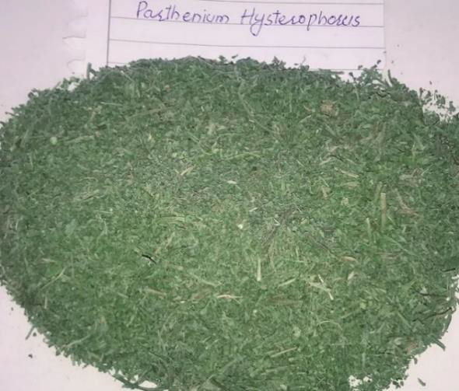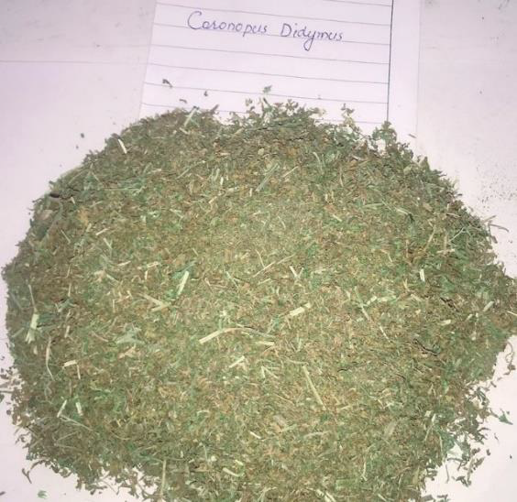
Figure 3.2. Powder form of P. hysterophorus Figure 3.3. Powder form of C. didymus
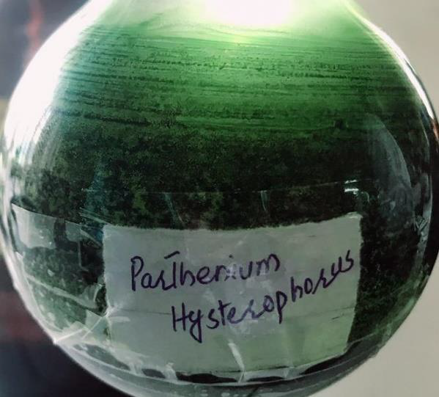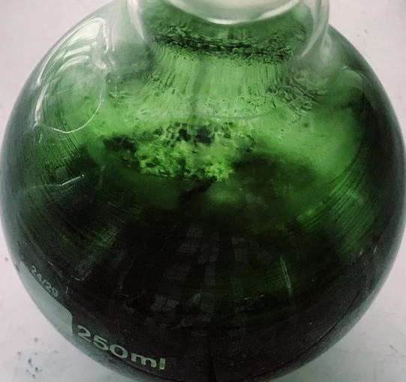Figure 3.4.Crude extract of P. hysterophorusFigure 3.5.Crude extract of C. didymus
3.4. Sequential Partitioning:
The crude extracts were suspended in water in a separating funnel and then extracted with various solvents with increasing polarity such as petroleum ether, chloroform, and ethyl acetate. The mixture was mixed thoroughly and aqueous layers were separated from organic solvents for different species separately. The organic fractions were concentrated to dryness under vacuum with a rotary evaporator at 56 ℃. The dried fractions were packed in airtight round bottom flasks for further studies.
3.5. In-vitro Antioxidant Assays:
The fractions of extracts of Parthenium hysterophorus and Coronopus didymus, were used for the assessment of in-vitro antioxidant assays.
3.5.1. Radical scavenging of hydrogen peroxide assay:
The free radical scavenging activity using hydrogen peroxide (H2O2) of plant extracts was determined by the modified method of Dehpour. The principle is based upon the capacity of the extracts to decompose the hydrogen peroxide to water or the intensity of the color of H₂O₂ solution decreased to light color by the addition of antioxidant or phytocompound.
Reagents:
                - 6% H2O2 diluted with water
                - 0.1 M phosphate buffer maintained the pH- 7.4
                - Ethanol
                - Ascorbic acid
Instrument:
                - Ultraviolet-visible (UV/VIS) spectrophotometer
Reagent preparation:
                - 6% hydrogen peroxide was prepared by dissolving 3 mL of H₂O₂ in 7ml of distilled water.
                - 0.1 M phosphate buffer was prepared by dissolving 4.325 g of di-potassium hydrogen phosphate and 3.425 g of potassium di-hydrogen phosphate in 500 ml of distilled water, pH buffer was maintained at 7.4.
Procedure:
The extract solution of Parthenium hysterophorus, Coronopus didymus, was prepared separately by mixing 15 mg of each crude extract in 10 mL of ethanol and obtaining a stock solution of 1 mg/1 mL ratio. 0.2 mL, 0.4 mL, 0.6 mL, 0.8 mL, 1 mL of stock solution was taken in separate vials and 3.8 mL of 0.1 M phosphate buffers were added separately to each vial. To these vials 0.2 mL of 6% H₂O₂ solution were added separately. The solution which has H₂O₂ alone was used as a blank solution. Vials were closed with Al foil for 10 minutes. After 10 minutes, the absorbance of the reaction mixture was calculated at 230 nm by using the UV-Visible spectrophotometer. Ascorbic acid was used as standard for this activity. The percentage inhibition of H₂O₂ were calculated by using the formula:
Percentage inhibition = 𝐴𝑏𝑠𝑜𝑟𝑝𝑡𝑖𝑜𝑛 𝑜𝑓 𝑏𝑙𝑎𝑛𝑘 -𝐴𝑏𝑠𝑜𝑟𝑡𝑖𝑜𝑛 𝑜𝑓 𝑠𝑎𝑚𝑝𝑙𝑒/𝐴𝑏𝑠𝑜𝑟𝑝𝑡𝑖𝑜𝑛 𝑜𝑓 𝑠𝑎𝑚𝑝𝑙𝑒 ×100
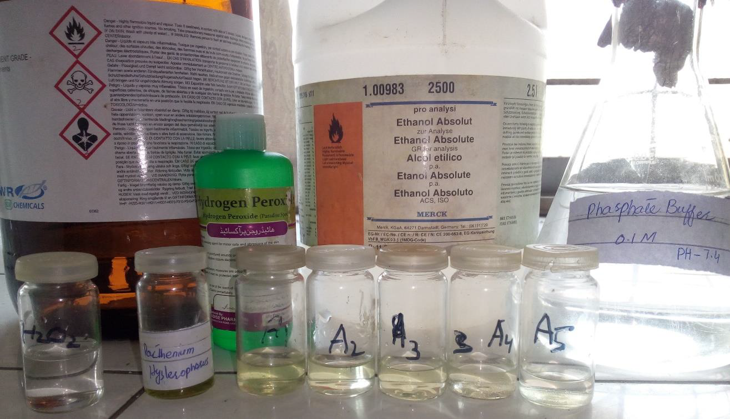
Figure 3.6. Scavenging activity of H2O2 assay
3.5.2. DPPH radical scavenging assay:
This is a very popular method as far as natural products antioxidant potential is to be studied. DPPH· (2, 2-diphenyl-1-picrylhydrazyl) free radical is stable when it is in powdered form in a bottle but when it’s out of the bottle and mixed with methanol solution it produces chain reactions thereby we need to do the assay in which antioxidants donate H⁺ to DPPH to stabilize it so if the extract solution has antioxidant it will donate hydrogen to DPPH free radical. When the DPPH molecule delocalized it showed purple or violet color with maximum absorption band of around 517nm. So, when the hydrogen atom reacts with DPPH it stabilizes it and the reduced form of DPPH is made with the change in its original color which is violet but on stabilizing its color changes into light yellow to transparent depending upon the antioxidant activity. Thus, antioxidant activity can be evaluated by analyzing the decrease or increase of absorbance.
Reagents:
                - Ethanol
                - 0.1 mM DPPH diluted with ethanol
                - Butylated hydroxytoulene (BHT)
Instrument:
                - Ultraviolet-visible (UV/VIS) spectrophotometer
Reagent Preparation:
                - 0.1 mM DPPH solutions were prepared by dissolving 4 mg of DPPH reagent in 100mL of ethanol.
Procedure:
10 mg crude extracts of Parthenium hysterophorus and Coronopus didymus were dissolved in 10 mL ethanol to get a stock solution of 1 mg/1 mL ratio. 125 ppm, 250 ppm, 500 ppm and 1000 ppm of the stock solutions were taken in separate vials. 3 mL of 0.1 mM DPPH solution was added separately in each vial. The reaction mixture without sample was used as blank. The sample solutions and blank solutions were put in a dark area for 30 minutes. After 30 minutes, the absorbance of the reaction mixture was calculated at 517 nm using the UV-Visible spectrophotometer. BHT was used as standard. The percentage inhibition of DPPH radical scavenging assay was calculated by using the formula:
Percentage inhibition = 𝐴𝑏𝑠𝑜𝑟𝑝𝑡𝑖𝑜𝑛 𝑜𝑓 𝑏𝑙𝑎𝑛𝑘 − 𝐴𝑏𝑠𝑜𝑟𝑡𝑖𝑜𝑛 𝑜𝑓 𝑠𝑎𝑚𝑝𝑙𝑒/𝐴𝑏𝑠𝑜𝑟𝑝𝑡𝑖𝑜𝑛 𝑜𝑓 𝑠𝑎𝑚𝑝𝑙𝑒 ×100
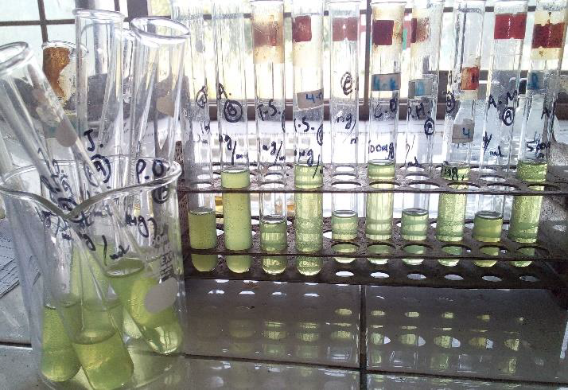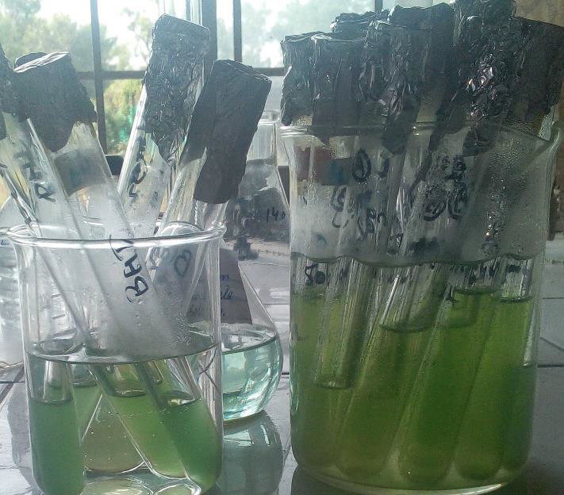
Figure 3.7. DPPH radical scavenging assay

3.5.3. Total antioxidant capacity assay:
This assay is based on the principle of formulation of phosphomolybdenum complexes by using the spectroscopic method of antioxidant capacity quantification. Reduction of Mo (VI) to Mo (V) by using the sample analyte and eventually forming a green phosphate Mo (V) at acidic pH basically helps in evaluating this assay. Total antioxidant capacity can be calculated by the method described by Prieto et al. (1999).
Reagents:
                - Ammonium molybdate
                - Sulphuric acid
                - sodium di-hydrogen phosphate
                - Distilled water
                - Methanol
                - Butylated hydroxytoluene (BHT)
Instrument:
                - Ultraviolet-visible (UV/VIS) spectrophotometer
Preparation of molybdate reagent solution:
                - 1.06g sodium di-hydrogen phosphate, 0.496 g of ammonium molybdate and 3.32 mL of sulphuric acid was dissolved in 20 mL of distilled water and made up to 100 mL by adding distilled water.
Procedure:
The extract solution of Parthenium hysterophorus and Coronopus didymus was prepared separately by dissolving 10 mg of each crude extract in 10 mL of methanol to get a stock solution of 1 mg/1 mL ratio. 500 ppm and 1000 ppm of the stock solution were taken in separate test tubes and maintained the volume to 2 mL of each test tube. 8 mL of molybdate reagent were added in each test tube. These test tubes were capped and incubated in a boiling water bath at 95 ℃ for 90 minutes. A typical blank solution containing 2 mL of methanol and 8 mL of reagent solution were incubated under the same condition as the rest of the sample. These test tubes were normalized to room temperature for 10-15 minutes after incubation process. The reaction mixture absorbance was calculated at 695 nm using the UV-Visible spectrophotometer. BHT was used as standard for this assay.
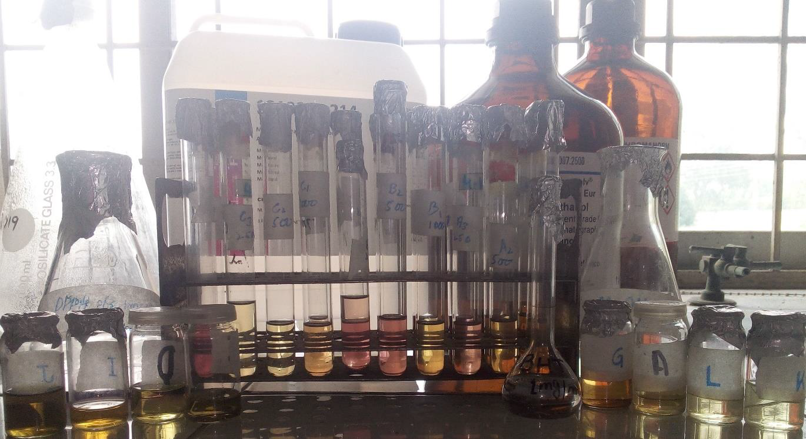
Figure 3.8. Total antioxidant capacity assay
3.6. Antiemetic activity:
The antiemetic activity was determined by following the protocols of Akita et al., 1998.
3.6.1. Selection of Animals:
Young male chicks having age of 4 days and weighing from 25-35 g were purchased from the local market. After 24 hours of fasting, the antiemetic activity was assessed. All the chicks were set aside under laboratory conditions at room temperature with 12 hour light and dark cycles with the free access to water and food.
3.6.2. Induction of Emesis by CuSO4:
40 male chicks of four days old weighing 25 to 35 grams were kept in a large beaker at 25°C for 10 minutes. Every chick was fed with copper sulfate (dissolved in 10ml of saline solution) at 50 mg/kg body weight orally. This induces emesis in chicks and they start retching. No. of retches were counted for 10 mins in every chick.
3.6.3. Preparation of extract doses fed to the chicks:
The extracts of both plants were dissolved in 0.9% saline having 5% DMSO separately and administered at dose 150 mg/kg orally and volume of 10ml/kg to the test animals by keeping their body weights in consideration. 0.9% saline were given to the control group. Chlorpromazine was used as a standard drug receiving the dose of 150 mg per kg body weight, dissolved in 0.9% saline solution.
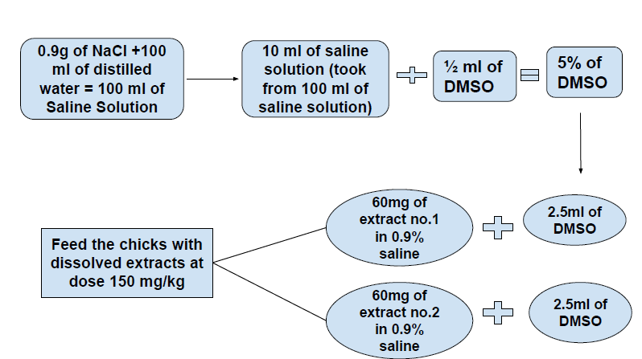
Figure 3.9. Preparation of extracts doses fed to the chicks
3.6.4. Administration of extracts doses:
The chicks were divided into 4 groups with each group bearing 4 chicks (n=4). Group I (control) received 10ml/kg normal saline; Group II (standard) received 150 mg/kg chlorpromazine; Group III received Parthenium extract (D-150mg/kg); Group IV received Coronopus extract (D-150mg/kg). All doses were given intraperitoneally. All 4 treatments on chicks are shown in the table below. The antiemetic effect was evaluated by the decrease in the number of retches in the treated group in comparison to the control group. The antiemetic effect was determined by calculating the mean decrease in number of retching.
3.6.5. Count and calculate no. of retches:
No. of retches were counted right after 10 minutes of Copper sulfate induction and the retches were counted for 10 mins. After the induction of emesis, chicks were grouped in 4 groups and administered with extracts at different doses. The retches in treated groups were counted again for 10 minutes after administration. With the count, calculation of inhibition of retches was done with the inhibition formula. The inhibition (%) was calculated as follows:
Inhibition (%) = ((𝐴−𝐵)/𝐴) ×100
Where A is the frequency of retching in the control group and B is the frequency of retching in the treated group.
3.6.6. Statistical analysis:
All the data were expressed in mean ± S.E.M. The difference between the experimental and control groups were evaluated by the unpaired student’s t-test values which is p<0.05 vs control group.

CHAPTER 4
RESULTS
4.1. In-Vitro Antioxidant Assays:
4.1.1. Radical scavenging of hydrogen peroxide assay:
- Parthenium hysterophorus:
The scavenging effects of our extracts on hydrogen peroxide (H2O2) radical are shown in Table 4.1. The extract of P. hysterophorus was prepared with methanol and their fractions like petroleum ether, chloroform, ethyl acetate and remaining methanolic extract. Maximum scavenging activity was found at concentration of 1 mg/mL while the minimum scavenging activity was found at 0.2 mg/1 mL. The extraction solution and their fractions determined the different %inhibition of H2O2 scavenging effect shown in Table 4.1. and Graph 4.1.
Table 4.1. Scavenging activity of H2O2 assay of P. hysterophorus
Concentration  (mg/ml) | %age inhibition of H₂O₂ activity
Concentration  (mg/ml) | MCE | PE | CF | EA | RME | AA
0.2 | 62.97% | 56.78% | 43.28% | 42.65% | 39.76% | 70%
0.4 | 68.46% | 62.74% | 51.74% | 50.67% | 46.07% | 74%
0.6 | 72.41% | 69.94% | 64.70% | 59.60% | 53.81% | 79%
0.8 | 76.68% | 77.67% | 69.89% | 68.98% | 61.09% | 83%
1 | 83.23% | 84.90% | 78.54% | 77.76% | 69.05% | 90%

*MCE= Methanolic Crude Extract, AA= Ascorbic Acid, PE= Pet Ether, CF= Chloroform,
EA= Ethyl Acetate, RME= Remaining Methanolic Extract

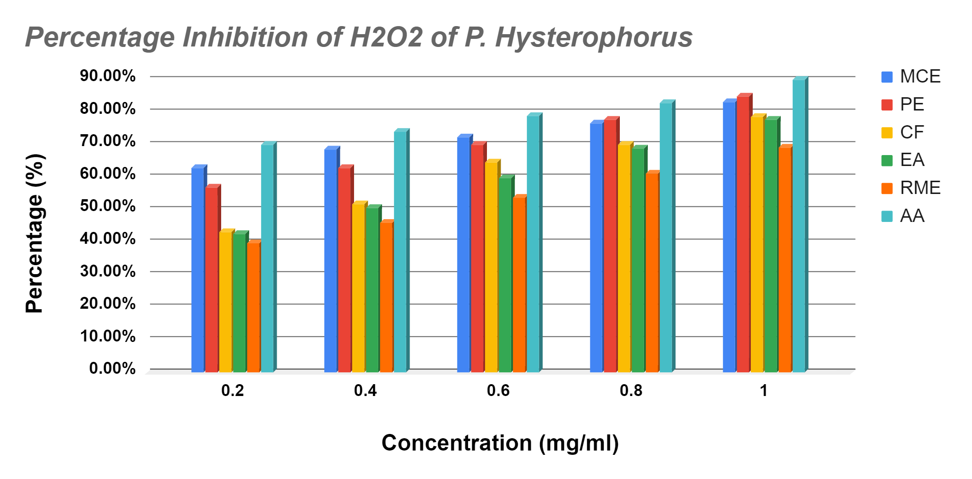
Figure 4.1. Percentage inhibition of H2O2 of P. Hysterophorus
Coronopus Didymus:
The scavenging effects of C. Didymus extracts on hydrogen peroxide (H2O2) radical are shown in Table 4.2. The extract of C. Didymus was prepared with methanol and their fractions like petroleum ether, chloroform, ethyl acetate and remaining methanolic extract. Maximum scavenging activity was found at concentration of 1 mg/mL while the minimum scavenging activity was found at 0.2 mg/ml. The extraction solution and their fractions determined the different %inhibition of H2O2 scavenging effect shown in Table 4.2 and Graph 4.2.
Table 4.2. Scavenging activity of H2O2 assay of C. Didymus
Concentration  (mg/ml) | %age inhibition of H₂O₂ activity
Concentration  (mg/ml) | MCE | PE | CF | EA | RME | AA
0.2 | 48.96% | 51.74% | 44.19% | 49.87% | 53.09% | 70%
0.4 | 55.18% | 63.07% | 52.94% | 56.82% | 59.47% | 74%
0.6 | 65.31% | 70.98% | 64.67% | 63.98% | 68.19% | 79%
0.8 | 74.34% | 76.12% | 72.30% | 71.78% | 73.14% | 83%
1 | 85.38% | 84.15% | 81.09% | 78.74% | 78.56% | 90%

*MCE= Methanolic Crude Extract, AA= Ascorbic Acid, PE= Pet Ether, CF= Chloroform,
EA= Ethyl Acetate, RME= Remaining Methanolic Extract

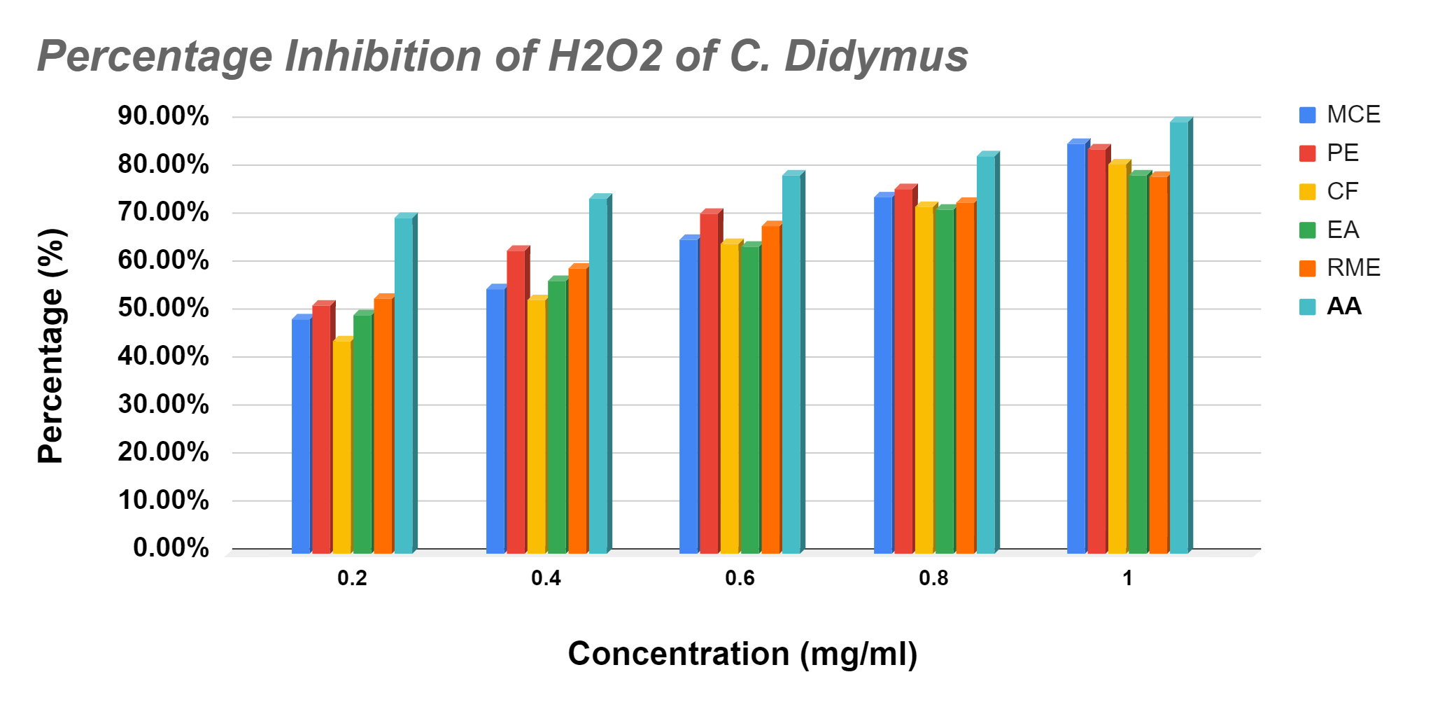

Figure 4.2. Percentage inhibition of H2O2 of C. Didymus
4.1.2. DPPH radical scavenging assay:
The scavenging effects of extracts of Parthenium hysterophorus and Coronopus didymus on DPPH radicals are shown in Table 4.3 and 4.4 respectively. These extracts were prepared with methanol and their fractions like petroleum ether, chloroform, ethyl acetate and remaining methanolic extract. Maximum scavenging activity was found at 1 mg/ml concentration while the minimum scavenging activity was found at 0.125 mg/ml for each extract. The extraction solution and their fractions determined the different %inhibition of DPPH scavenging effect shown below Table (4.3 and 4.4) and Graph (4.3 and 4.4).

- Parthenium Hysterophorus:
Table 4.3: DPPH radical scavenging assay of Parthenium Hysterophorus

Concentration  (mg/ml) | %age inhibition of DPPH activity
Concentration  (mg/ml) | MCE | PE | CF | EA | RME | BHT
0.125 | 59.09% | 52.05% | 48.71% | 54.82% | 47.04% | 72.48%
0.25 | 70.48% | 63.76% | 59.07% | 67.07% | 56.06% | 79.89%
0.5 | 75.80% | 71.06% | 65.92% | 74.03% | 61.19% | 85.48%
1 | 81.08% | 76.21% | 71.38% | 80.15% | 67.09% | 88.35%

*DPPH= 2,2-Diphenyl-1-picrylhydrazyl, BHT= Butylated Hydroxytoluene, MCE= Methanolic Crude Extract, PE= Pet Ether, CF= Chloroform, EA= Ethyl Acetate, RME= Remaining Methanolic Extract

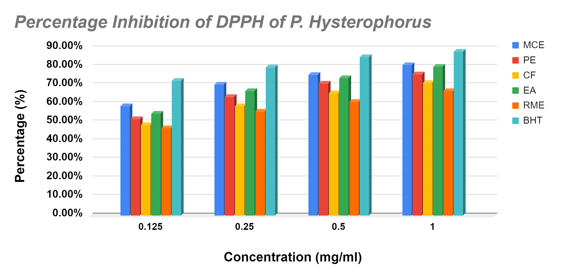
Figure 4.3. Percentage inhibition of DPPH of P. Hysterophorus

- Coronopus Didymus:
Table 4.4. DPPH radical scavenging assay of Coronopus Didymus
Concentration  (mg/ml) | %age inhibition of DPPH activity
Concentration  (mg/ml) | MCE | PE | CF | EA | RME | BHT
0.125 | 38.23% | 42.81% | 45.09% | 41.32% | 39.64% | 72.48%
0.25 | 54.48% | 54.93% | 54.17% | 58.08% | 48.08% | 79.89%
0.5 | 63.35% | 61.79% | 59.10% | 67.04% | 52.87% | 85.48%
1 | 70.09% | 67.91% | 63.10% | 74.56% | 57.03% | 88.35%

*DPPH= 2,2-Diphenyl-1-picrylhydrazyl, BHT= Butylated Hydroxytoluene, MCE= Methanolic Crude Extract, PE= Pet Ether, CF= Chloroform, EA= Ethyl Acetate, RME= Remaining Methanolic Extract
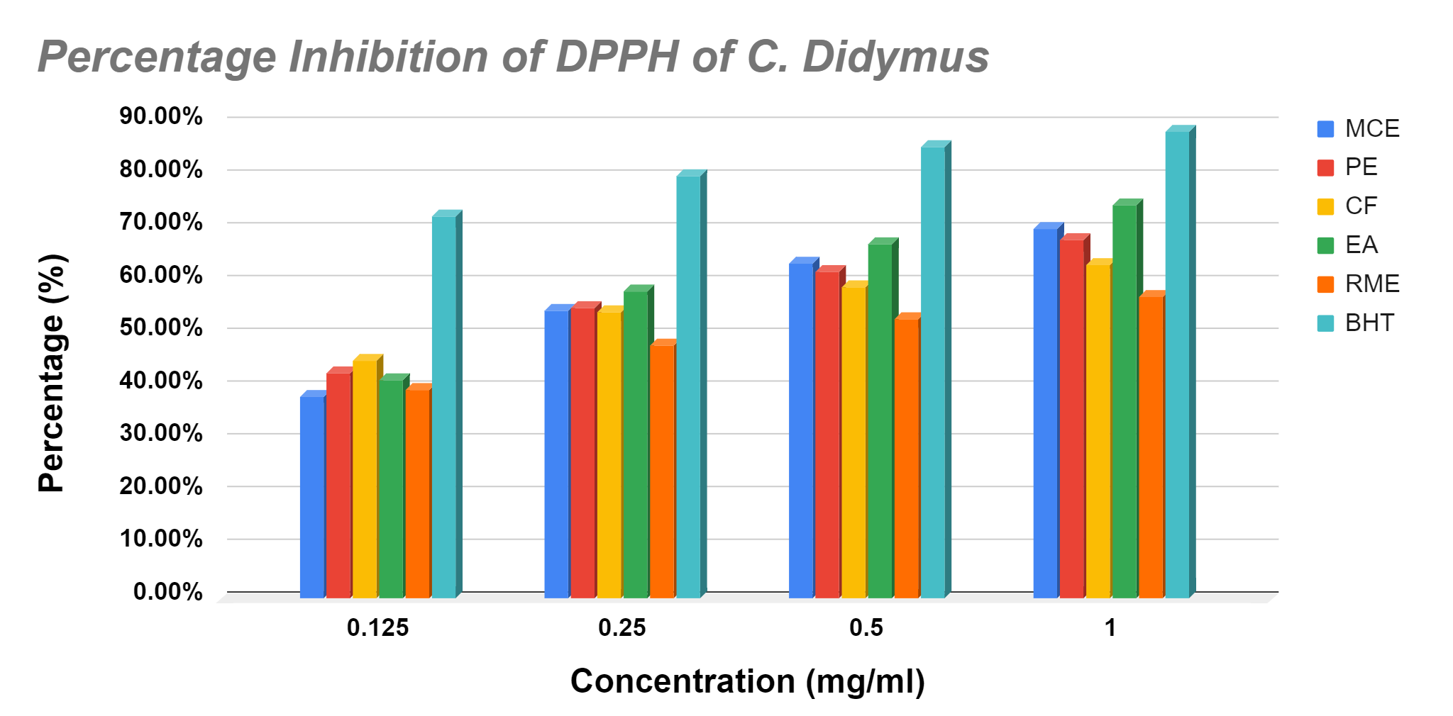

Figure 4.4. Percentage inhibition of DPPH of C. Didymus

4.1.3. Total Antioxidant Capacity Assay:
The reducing capacity of antioxidants was coined in a single measure as “Total Antioxidant Capacity (TAC)”. Butylated hydroxytoluene (BHT) was used as standard and showed a curve in between absorbance and concentration. Maximum absorbance of standard curve was found at concentration of 1000ppm while the minimum absorbance was found at 125ppm for each extract. The curve is shown in figure 4.21 below:
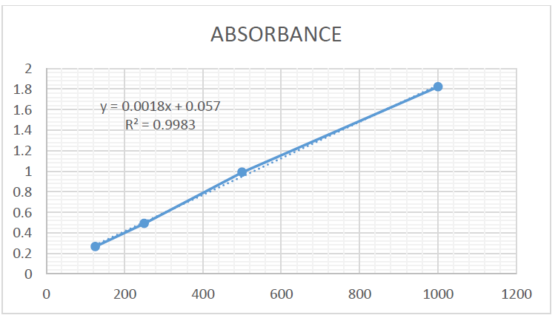
Figure 4.5 Absorbance of total antioxidant assay
According to the above standard curve, an equation can show the scavenging effects of extracts of Parthenium hysterophorus and Coronopus didymus on phosphomolybdenum assay as shown in Table 4.5 and 4.6 respectively. These extracts were prepared with methanol and their fractions like petroleum ether, chloroform, ethyl acetate and remaining methanolic extract. These fractions were determined by mgBHTE/g of each extract compared with the standard curve equation as measured shown in Graph (fig 4.22 and 4.23).

- Parthenium hysterophorus :
Table 4.5 Total antioxidant capacity assay of Parthenium hysterophorus
Fractions of Parthenium hysterophorus | mg BHTE/g of Parthenium hysterophorus
MCE | 411.51±12.01
PE | 185.23±08.13
CF | 257.02±09.03
EA | 488.97±14.73
RME | 265.41±11.27

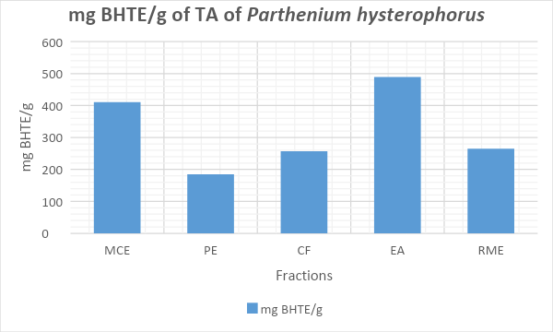
Figure 4.6. Total antioxidant assay of Parthenium hysterophorus

- Coronopus didymus:
Table 4.6 Total antioxidant capacity assay of Coronopus didymus
Fractions of Coronopus didymus | mg BHTE/g of Coronopus didymus
MCE | 363.02±12.01
PE | 176.17±09.13
CF | 265.47±11.03
EA | 498.32±14.63
RME | 278.25±11.27

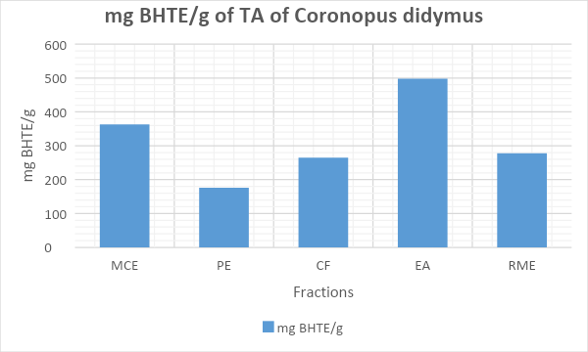
Figure 4.7. Total antioxidant activity of Coronopus didymus
4.2. Antiemetic Activity:
Antiemetic activity of chicks was carried out by making 4 groups. The results of observed retches were computed as Mean number of retches and Standard error of mean. Control group which had normal saline encountered the highest number of retches (60.5 ± 3.24) while extract 2 showed the least no. of retches (8.5 ± 2.26) and highest inhibition of retches. On the other hand extract no 2 showed less inhibition as compared to the standard group as shown in table 4.7.
Table 4.7. Antiemetic activity of plant extracts (Parthenium hysterophorus & Coronopus didymus) using chick emesis model
No. | Treatments | No. of Animals | Doses (mg/kg) | Mean Number of Retches ± S.E.M. | Inhibition of emesis (%)
1. | Control | 4 | 10 | 60.5 ± 3.24 | --
2. | Standard(CP) | 4 | 150 | 19.5 ± 1.39* | 28.26%
3. | Extract 1-PH | 4 | 150 | 24.25 ± 1.92 | 20.4%
4. | Extract 2- CD | 4 | 150 | 8.5 ± 2.26* | 46.45%

S.E.M. = Standard Error of Mean, *p<0.05 vs. control showing significant values using unpaired student’s t-test.
Mean number of retches were counted in each of the four groups and with the count it has been observed that after the control group extract no.1 (P. hysterophorus) showed highest no. of retches (24.25) which were followed by the standard group (19.5) and extract no.1 (C. didymus) showed the lowest mean no. of retches (8.5).
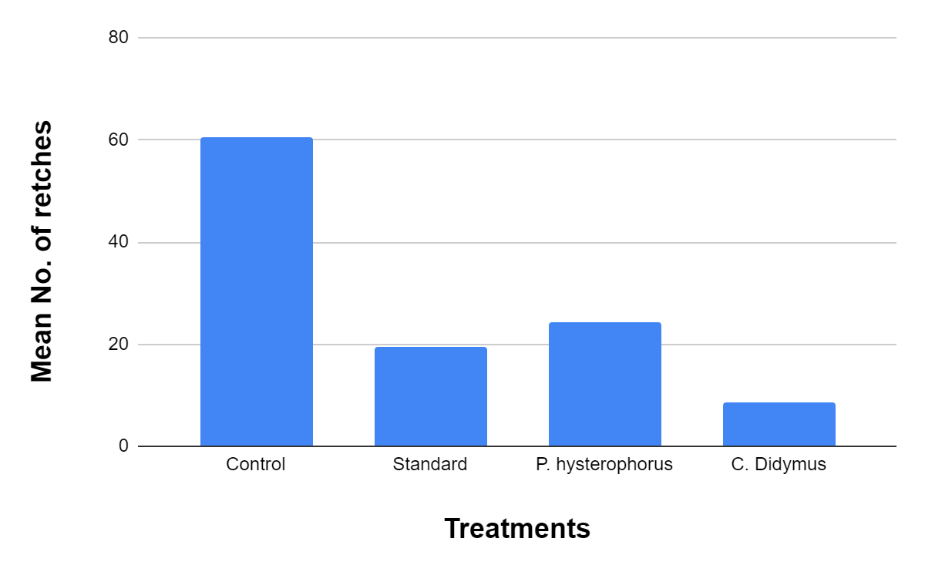Figure 4.8. Mean No. of retches in all 4 treatment groups

Figure 4.25 illustrates the percentage inhibition of retches in all the experimental groups in which C. didymus showed the highest percentage inhibition of them all.
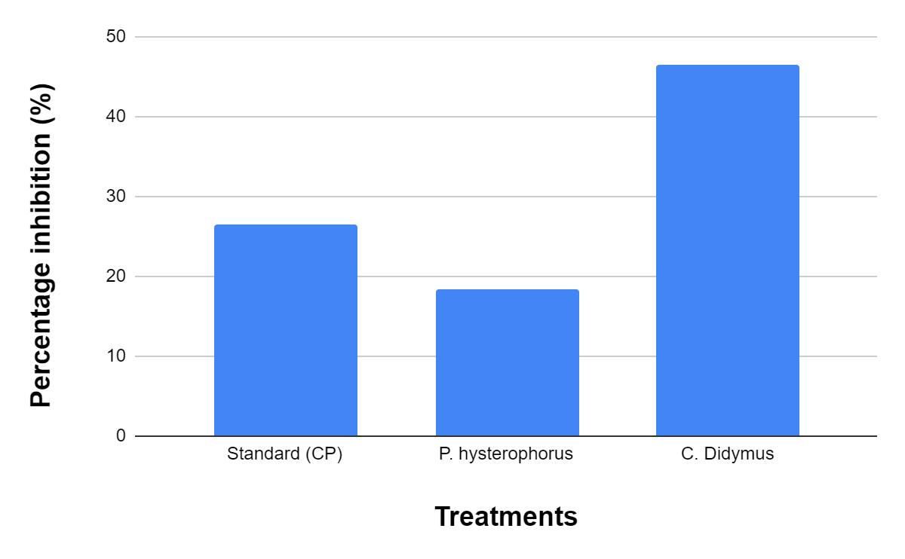Figure 4.9. Percentage inhibition of retches in all the experimental groups
CHAPTER 5
DISCUSSION
Herbal plants are used for treatments against a lot of illnesses worldwide because of the fact that they are providing significant health care services whether people are getting allopathic access or not. Medicinal plants set a benchmark in the healthcare system as they are offering effective access and treatment with lesser side effects unlike the pharmaceuticals. Moreover, pharmaceutical medicines are responsible for environmental degradation on a global scale. Pharmaceutical processing is basically the processing or making of a specific drug which goes through certain unit operations and processes such as blending, filing, granulation, miling, coating, tablet press etc. Pharma products enter the environment at any of the processing stages but more particularly they enter the environment in the production phase. The major concern of pharma production is the production and disposal phase because when the antibiotics are disposed of it will lead to the natural formation of antibiotic resistant pathogens which are even harder to treat. However, it is a global problem which has adverse effects on the environment, triggering air pollution, water pollution, soil pollution, food contamination and several other health problems. Hence, there is a dire need to switch ourselves from pharmaceuticals or antibiotics to herbal products or the medicinal plants which are shown to have various health benefits with lesser or no side effects. Medicinal plants have various anti-inflammatory, antioxidant, anti-allergic, antibacterial, antimicrobial and antifungal etc compounds in them which helps in fighting against many diseases. Many categories of medicinal plants have been researched by scientists which have proven to have such health benefits and are vital in the health care system.
Herbs which have antioxidant compounds in them are very effective as these antioxidants help in inhibiting oxidation which is a chemical reaction that produces free radicals and is potent to human health. In order to evaluate the antioxidant activity of plant extract various antioxidant assays have been established and are being practiced by many renowned researchers for a longer period of time. Antioxidant activity assays may be generally categorized as hydrogen atom transfer based assay or single electron transfer based assays. Majority of HAT assays are kinetics based and include a scheme of competitive reaction wherein antioxidant and substrate compete for free radicals thermally produced through the decomposition of azo compounds. SET assays measure the capacity of an antioxidant in the reduction of an oxidant which on its reduced form or reduction changes color. SET assays are much convenient and easier than HAT assays. SET assays like H2O2, DPPH, and Total antioxidant activity were selected to examine the reduction capacity. These methods are involved in the mechanism of a single electron transfer system.
In the scavenging activity of H2O2 assay, C. Didymus and P. Hysterophorus both showed the highest antioxidant activity at 1 mg/ml concentration with all of the extracted forms but PE and MCE extracted solution showed the highest antioxidant activity among all. This is because Aqueous and hydro alcohol are the best solvents for bioactive compounds extraction or herbal formulation. These solvents mainly produce herbal products without any fear of higher toxicity. While ascorbic acid is being taken as a standard which helps in comparing the overall results. As being an antioxidant, ascorbic acid has the potential to lower the oxidation state of various metals thus affecting the oxidation catalyst and shows maximum antioxidant activity. A study has been conducted in which the antioxidant activity of various extracts of cassia fistula was assessed with different protocols such as DPPH, FRAP and H2O2 radical scavenging protocol. The results showed that the methanolic extract of the plant showed maximum antioxidant activity with ascorbic acid as compared to the other extracts of the plant (Irshad et al., 2012).
Mantena and his coworkers carried out a research on extract of C. Didymus which suggested that this medicinal plant may contain bioactive flavonoids that are highly responsible for antioxidant activity. Moreover, flavonoids, tannins, and saponins which act as antioxidants have various other biological effects such as anti-allergic, anti-inflammatory, antipyretic, anti-hepatotoxic and antidiabetic effects. Thus, it is proved that C. Didymus boost antioxidant activity due to its capability to scavenge superoxide and DPPH radicals (Mantena et al., 2005). DPPH is used as a stable free radical donor to assess free radical scavenging effects. DPPH radical scavenging assay of C. Didymus showed good antioxidant activity which means that they contain flavonoids, tannins and saponins which accelerate the antioxidant effect. On the other side P. Hysterophorus showed even more antioxidant activity than C. Didymus through DPPH radical scavenging assay which can be related with a study that showed that different parts of P. Hysterophorus contain different kinds of phytochemicals which exhibit various biological properties. Its exact fractions of stem, roots, leaf and flower showed that it has significant antioxidant potential (Kumar & Pandey, 2014).
Total antioxidant assay is performed in a microplate and evaluates the total phenolic content which tells the antioxidant activity of specific plant extract (Gillespie et al., 2007). Total antioxidant capacity of these extracts also showed different antioxidant effects. The fractions of methanolic extracts of these plants showed values on the basis of mgBHTE/g. Ethyl acetate showed greater values than other fractions such as petroleum ether, methanolic extract, chloroform and remaining methanolic extract. C. didymus showed greater values of antioxidant effect (498.32±14.63) as compared to P. hysterophorus which showed (488.97±14.73) values of total antioxidant effect. Medicinal plants have phenolic compounds in them which are responsible for their antioxidant potential. This is because phenolic groups have significant redox properties which assist in inhibiting chemical oxidation processes and therefore leads to high antioxidant activity. Hence, antioxidant potentials are directly proportional to the phenolic content being present in a plant species.
Antiemetics play a very significant role against vomiting, nausea and motion sickness. Using medicinal plants or herbal products for the treatment of nausea is under experimentation. Many herbs have been researched in evaluating their antiemetic effect and many have been proved beneficial for antiemetics.
C. Didymus showed highest inhibition of retches with least mean no. of retches as shown in table 4.7. With its efficient antiemetic effect it could be implied that this herb has a great amount of terpenes and flavonoids which are the major and active components against emesis and every plant or herb having these compounds would possibly have the ability to fight against emesis. Abbas and his coworkers carried out a research in which they took fifteen weeds (C. didymus is one of them) and evaluated their phytochemical potential. The results of this experiment showed that these weeds have Alkaloids, saponins, glycosides, terpenoids, anthraquinine, steroids, flavonoids and tannins in them. Out of all alkaloids and tannins were the greatest in amount which proved them to be medically significant and important (Abbas et al., 2012). Thus, the presence of alkaloids in C. Didymus may be the reason for their antiemetic potential. Another study has been conducted related to this research which identified the antiemetic effect of extract of T. diversifolia by using the chick emesis model. The results of this study revealed that this herb has a significant antiemetic effect when compared to the control group which is due to the presence of flavonoids and terpenes in the herb being taken (Ahmed & Onocha, 2013).
While on the other hand P. Hysterophorus showed less antiemetic effect as compared to the standard group which makes it least effective for the treatment of vomiting or nausea. The student’s unpaired t-test also applied to the results; *p<0.05 vs control group showed significant difference in values of both the groups. Extract no.2 (parthenium) has less difference to the control group as compared to extract no.1 and standard group which makes P. Hysterophorus less efficient in antiemetic activity. This is due to the absence of certain compounds or components that are considered beneficial in inhibiting retches and combating vomiting or nausea. Thus, C. Didymus has more antiemetic effect out of all experimental groups but its mode of action is not known for which more studies are required which would help in determining its exact mode of action and the active compounds that are responsible for greater antiemetic effect in C. didymus and lesser effect in P. hysterophorus.
CONCLUSION
Medicinal plants set a benchmark in the healthcare system as they are offering effective access and treatment with lesser side effects unlike the pharmaceuticals. Moreover, pharmaceutical medicines are responsible for environmental degradation on a global scale. However, it is a global problem which has adverse effects on the environment, triggering air pollution, water pollution, soil pollution, food contamination and several other health problems. Hence, there is a dire need to switch ourselves from pharmaceuticals or antibiotics to herbal products or the medicinal plants which are shown to have various health benefits with lesser or no side effects. Medicinal plants have various anti-inflammatory, antioxidant, antiallergic, antibacterial, antimicrobial and antifungal etc compounds in them which helps in fighting against many diseases. This research investigaed the antioxidant and antiemetic activity of two plant extracts i.e. C. Didymus and P. Hysterophorus. The results of both activities showed that these herbs have antioxidants in them which helps in inhibiting oxidation chemical reactions that are dangerous for human health thus, the antioxidant compounds in these herbs made them beneficial in the healthcare system. Antiemetics play a very significant role against vomiting, nausea and motion sickness. Many herbs have been researched in evaluating their antiemetic effect and many have been proved beneficial for antiemetics. C. Didymus showed highest inhibition of retches with least mean no. of retches as compared to P. Hysterophorus. With its efficient antiemetic effect it could be implied that this herb has a great amount of terpenes and flavonoids which are the major and active components against emesis.
The literature survey indicated that many scientists or researchers assessed the antimicrobial, antiviral, antifungal, antineurative, cytotoxicity activities of these herbs along with many other biological activities. As there is no research which has been carried out on the antiemetic and antioxidant effects of these two herbs thus, this study can be a guideline for further evaluation of biological activities. Also, in case of antiemetics, C. Didymus and P. Hysterophorus real mode of action is not known for which more studies are required which would help in determining their exact mode of action and the active compounds that are responsible for greater antiemetic effect in C. didymus and lesser effect in P. hysterophorus.

REFERENCES
Martínez-Graciá, C., González-Bermúdez, C. A., Cabellero-Valcárcel, A. M., Santaella-Pascual, M., & Frontela-Saseta, C. (2015). Use of herbs and spices for food preservation: advantages and limitations. Current opinion in food science, 6, 38-43.
Djordjevic, S. M. (2017). From medicinal plant raw material to herbal remedies. Aromatic and Medicinal Plants: Back to Nature, 269-288.
Ekor, M. (2014). The growing use of herbal medicines: issues relating to adverse reactions and challenges in monitoring safety. Frontiers in pharmacology, 4, 177.
Elansary, H. O., & Mahmoud, E. A. (2015). Egyptian herbal tea infusions' antioxidants and their antiproliferative and cytotoxic activities against cancer cells. Natural product research, 29(5), 474-479.
Dweck, A. C. (2009). The internal and external use of medicinal plants. Clinics in dermatology, 27(2), 148-158.
Korać, R. R., & Khambholja, K. M. (2011). Potential of herbs in skin protection from ultraviolet radiation. Pharmacognosy reviews, 5(10), 164.
Dhama, K., Tiwari, R., Chakraborty, S., Saminathan, M., Kumar, A., Karthik, K., ... & Rahal, A. (2014). Evidence based antibacterial potentials of medicinal plants and herbs countering bacterial pathogens especially in the era of emerging drug resistance: An integrated update. Int J pharmacol, 10(1), 1-43.
Hamid, A. A., Aiyelaagbe, O. O., Usman, L. A., Ameen, O. M., & Lawal, A. (2010). Antioxidants: Its medicinal and pharmacological applications. African Journal of pure and applied chemistry, 4(8), 142-151.
Klimczak, I., Małecka, M., & Pachołek, B. (2002). Antioxidant activity of ethanolic extracts of amaranth seeds. Food/Nahrung, 46(3), 184-186.
Kähkönen, M. P., Hopia, A. I., Vuorela, H. J., Rauha, J. P., Pihlaja, K., Kujala, T. S., & Heinonen, M. (1999). Antioxidant activity of plant extracts containing phenolic compounds. Journal of agricultural and food chemistry, 47(10), 3954-3962.
Brewer, M. S. (2011). Natural antioxidants: sources, compounds, mechanisms of action, and potential applications. Comprehensive reviews in food science and food safety, 10(4), 221-247.
Pan, Y., Zhu, J., Wang, H., Zhang, X., Zhang, Y., He, C., ... & Li, H. (2007). Antioxidant activity of ethanolic extract of Cortex fraxini and use in peanut oil. Food chemistry, 103(3), 913-918.
Amarowicz, R., Wanasundara, U. N., Karamać, M., & Shahidi, F. (1996). Antioxidant activity of ethanolic extract of mustard seed. Food/Nahrung, 40(5), 261-263.
B., J. K., R, S. K., Deepthi, R., & Bakshi, V. (2016). Phytochemical screening and anti-emetic activity of Leonotis nepetifolia leaves extract. International Journal of Pharmaceutical Chemistry, 6(7), 177-180.
Medhi, P. K., & Gohain, K. (2019). Study on the antiemetic property of methanolic stem extract of Swertia chirata using chick emesis model. International Journal of Basic & Clinical Pharmacology, 8(2), 327.
Ahmed, S., Zahid, A., Abidi, S., & Meer, S. (2012). Anti-emetic activity of four species of genus Cassia in chicks. IOSR Journal of Pharmacy, 2(3), 380-384.
Ahmed, S., Hasan, M. M., Ahmed, S. W., Mahmood, Z. A., Azhar, I., & Habtemariam, S. (2013). Anti-emetic effects of bioactive natural products. Phytopharmacology, 4(2), 390-433.
Marwat, S. K., & Khan, I. U. (2015). Ethnobotanical importance and phytochemical constituents of Parthenium weed (Parthenium hysterophorus L.)–A Review. Plant Science Today, 2(2), 77-81.
Singh, R. K., & Arti, G. (2014). Parthenium hysterophorus L.-neither noxious nor an obnoxious weed. Indian Forester, 140(12), 1260-1262.
Kaur, M., Aggarwal, N. K., & Dhiman, R. (2016). Antimicrobial activity of medicinal plant: Parthenium hysterophorus L. Res. J. Med. Plant, 10(1), 106-112.
Saini, A., Aggarwal, N. K., Sharma, A., Kaur, M., & Yadav, A. (2014). Utility potential of Parthenium hysterophorus for its strategic management. Advances in Agriculture, 2014.
Noreen, H., Farman, M., & McCullagh, J. S. (2016). Bioassay-guided isolation of cytotoxic flavonoids from aerial parts of Coronopus didymus. Journal of ethnopharmacology, 194, 971-980.
Noreen, H., Semmar, N., Farman, M., & McCullagh, J. S. (2017). Measurement of total phenolic content and antioxidant activity of aerial parts of medicinal plant Coronopus didymus. Asian Pacific journal of tropical medicine, 10(8), 792-801.
S Panickar, K. (2013). Beneficial effects of herbs, spices and medicinal plants on the metabolic syndrome, brain and cognitive function. Central Nervous System Agents in Medicinal Chemistry (Formerly Current Medicinal Chemistry-Central Nervous System Agents), 13(1), 13-29.
Mussarat, S., AbdEl-Salam, N. M., Tariq, A., Wazir, S. M., Ullah, R., & Adnan, M. (2014). Use of ethnomedicinal plants by the people living around Indus River. Evidence-Based Complementary and Alternative Medicine, 2014.
Petrovska, B. B. (2012). Historical review of medicinal plants’ usage. Pharmacognosy reviews, 6(11), 1.
Nimse, S. B., & Pal, D. (2015). Free radicals, natural antioxidants, and their reaction mechanisms. Rsc Advances, 5(35), 27986-28006.
Economou, K. D., Oreopoulou, V., & Thomopoulos, C. D. (1991). Antioxidant activity of some plant extracts of the family Labiatae. Journal of the American Oil Chemists Society, 68(2), 109-113.
Seifried, H. E., Anderson, D. E., Fisher, E. I., & Milner, J. A. (2007). A review of the interaction among dietary antioxidants and reactive oxygen species. The Journal of nutritional biochemistry, 18(9), 567-579.
Hamid, A. A., Aiyelaagbe, O. O., Usman, L. A., Ameen, O. M., & Lawal, A. (2010). Antioxidants: Its medicinal and pharmacological applications. African Journal of pure and applied chemistry, 4(8), 142-151.
Sajib, A. I., Dewan, S. M. R., Das, A., Sarwar, M. S., Sarkar, R. C., Ahmed, M. U., & Islam, M. S. (2015). In vitro antimicrobial activity study and in vivo antiemetic, antinociceptive activity evaluation of leaves extract of Erioglossum rubiginosum using experimental animal model. Oriental Pharmacy and Experimental Medicine, 15(2), 135-140.
Ihekwereme, C. P., Chukwuson, M. A., Erhirhie, E. O., & Uche, G. O. (2016). Preliminary evaluation of the anti-emetic activity of crude methanol extract and fraction of Ocimum gratissimum. J Dev Drugs, 5(1), 2329-6631.
Hussain, M., Raza, M. S., Khan, R. M., & Nawaz, S. (2015). In vivo assessment of antiemetic potential of crude extract of Vetiveria zizanioides (Linn); chick emesis model. International Journal of Pharma Sciences, 5(3), 1068-71.
Ahmed, S., Hasan, M. M., & Ahmed, S. W. (2014). Natural antiemetics: An overview. Pakistan journal of pharmaceutical sciences, 27.
Tesfu, F., & Emana, G. (2013). Evaluation of Parthenium hysterophorus L. powder against Callosobruchus chinensis L.(Coleoptera: Bruchidae) on chickpea under laboratory conditions. African Journal of Agricultural Research, 8(44), 5405-5410.
Kumar, S., Pandey, S., & Pandey, A. K. (2014). In vitro antibacterial, antioxidant, and cytotoxic activities of Parthenium hysterophorus and characterization of extracts by LC-MS analysis. BioMed Research International, 2014.
Vishnu, P., Radhika, K., & Srinivasa, A. (2011). Evaluation of in-vitro free radical scarvenging activity of different organic extracts of Parthenium hysterophorus leaves. Int. J. Pharm. Pharm Sci, 3(3), 135-138.
Kumar, S., Chashoo, G., Saxena, A. K., & Pandey, A. K. (2013). Parthenium hysterophorus: a probable source of anticancer, antioxidant and anti-HIV agents. BioMed Research International, 2013.
Ahmad, M. N., Shekh, M. R., & Saiyad, M. A. (2018). A Brief Review of the Noxious Weed: Parthenium hysterophorus Linn. Research & Reviews: A Journal of Health Professions, 8(2), 1-7.
Bagachi, A., Raha, A. N. U. S. R. E. E., & Mukherjee, P. R. O. S. E. N. J. I. T. (2016). A Complete Review on Parthenium Hysterophorus Linn. International Journal of Recent Advance Pharmaceutical Research, 6(1), 42-49.
Javaid, A., & Khan, I. H. (2020). POTENTIAL USE OF Coronopus didymus (L.) SM. IN PARTHENIUM MANAGEMENT. Pakistan Journal of Weed Science Research, 26(1), 37.
Sidhu, G. P. S., Bali, A. S., Singh, H. P., Batish, D. R., & Kohli, R. K. (2018). Ethylenediamine disuccinic acid enhanced phytoextraction of nickel from contaminated soils using Coronopus didymus (L.) Sm. Chemosphere, 205, 234-243.
Busnardo, T. C. P. M., Padoani, C., Mora, T. C., Biavatti, M. W., Fröde, T. S., Bürger, C., ... & de Souza, M. M. (2010). Anti-inflammatory evaluation of Coronopus didymus in the pleurisy and paw oedema models in mice. Journal of Ethnopharmacology, 128(2), 519-525.
Javaid, A., Niaz, L., & Shoaib, A. (2017). Effect of Incorporation of Leaf Biomass of Coronopus didymus on Management of Basal Rot Disease of Onion and its Physiology. International Journal of Agriculture & Biology, 19(3).
Irshad, M., Zafaryab, M., Singh, M., & Rizvi, M. (2012). Comparative analysis of the antioxidant activity of Cassia fistula extracts. International journal of medicinal chemistry, 2012.
Mantena, S. K., Mutalik, S., Srinivasa, H., Subramanian, G. S., Prabhakar, K. R., Reddy, K. R., ... & Unnikrishnan, M. K. (2005). Antiallergic, Antipyretic, Hypoglycemic and Hepatoprotective Effects of Aqueous Extract of Coronopus didymus L INN. Biological and Pharmaceutical Bulletin, 28(3), 468-472.
Kumar, S., Pandey, S., & Pandey, A. K. (2014). In vitro antibacterial, antioxidant, and cytotoxic activities of Parthenium hysterophorus and characterization of extracts by LC-MS analysis. BioMed Research International, 2014.
Gillespie, K. M., Chae, J. M., & Ainsworth, E. A. (2007). Rapid measurement of total antioxidant capacity in plants. Nature Protocols, 2(4), 867-870.
Abbas, M. N., Rana, S. A., Shahid, M., Rana, N., Mahmood-ul-Hassan, M., & Hussain, M. (2012). Chemical evaluation of weed seeds mixed with wheat grains at harvest. The Journal of Animal & Plant Sciences, 22(2), 283-288.
Ahmed, S., & Onocha, A. P. (2013). Antiemetic Activity of Tithonia diversifolia (HemsL) A Gray leaves in copper sulphate induced chick emesis model. Am J Phytomed Clin Therapeut, 1, 734-9.

