THE ADVENT OF HYBRID WARFARE: AN ISSUE OF NATIONAL SECURITY
A Cross Country Empirical Analysis

By
Khalida Khalid

Thesis submitted to the Lahore School of Economics
in partial fulfilment of the requirement for the degree of
MPhil in Development Studies
Class of 2021

Supervised by: Dr. Ahmad Nawaz

Table of Contents

CHAPTER I 4
INTRODUCTION 4
1.1 Evolving Dimensions of National Security in the 21st Century and Overview 5
1.2 Hybrid Warfare: Evolution, Characteristics, and Historical Context 7
1.3 Cybercrime and ICT s as Core Instruments of Hybrid Warfare 10
1.4 The Relevance of Global Cybersecurity Index in Hybrid Warfare 13
1.5 Relevance of the 2025 India-Pakistan Conflict to Hybrid Warfare and National Security 14
1.6 Problem Statement 17
1.7 Research Objective 18
1.8 Research Question 19
CHAPTER II 20
LITERATURE REVIEW 20
2.1 Literature Gap 29
CHAPTER III 30
RESEARCH METHODOLOGY 30
3.1 Research Design 31
3.2 Data and Sources 31
3.3 Nature of Data Set 34
3.4 Theoretical Framework 34
3.5 Research Hypothesis 35
3.6 Methodology 36
CHAPTER IV 38
RESULTS AND DISCUSSION 38
4.1 Descriptive Analysis 39
4.1.1 Income-Level Comparisons of Key Variables 40
4.1.2 Regional Comparisons of Key Variables 43
4.1.3 Summary Statistics 47
4.1.4 Correlation Among Variables 49
4.2 Empirical Analysis 51
CHAPTER V 70
CONCLUSIONS AND RECOMMENDATIONS 70
5.1 Policy Recommendations and Way Forward 73
5.2 Limitations of the Study 75
BIBLIOGRAPHY 76
ANNEXURES 83
Annexure A: Definition of Variables 83
Annexure B: List of Countries 85
Annexure C: Global Cybersecurity Index (GCI) Questionnaire 90

CHAPTER I

INTRODUCTION

This chapter starts by giving the background, explaining the relevance, listing its main goals and giving an overview that will guide the entire study.

1.1 Evolving Dimensions of National Security in the 21st Century and Overview
In the past, national security meant only to protect the country's borders via military defense. Now it means a lot more. Today, it includes a wide range of interconnected areas, including social, economic, political, and environmental ones, all of which are important for a country's stability and strength. Modern threats don't just come from outside forces; they also come from weaknesses within and pressures from the global system (Miryukova & Sokolova, 2023; Toimbek, 2022; Khan, 2022). This change shows that more people are realizing that protecting a country's security needs flexible and integrated frameworks that can handle both traditional and non-traditional threats (Kondratenko & Dobryanskyy, 2023; Stukalo et al., 2018; Rotaru, 2009).
Economic security has become a core part of national security. When a country’s economy is strong, the government has the resources to take care of its people, drive innovation and invest in defense as well as environmental protection (Kondratenko & Dobryanskyy, 2023; Hapieieva et al., 2023; Zub, 2024). On the other hand when the economy is unstable, it can weaken trust in institutions, spark social unrest and leave the nation vulnerable on the global stage. The link between economic health and other areas of security is clear—financial crises often ripple out, causing political instability, rising social tensions and reducing a government’s ability to deal with external threats (Miryukova & Sokolova, 2023; Kondratenko & Dobryanskyy, 2023; Kadala et al., 2023). That’s why building strong economic security measures is crucial for safeguarding national interests and ensuring long-term development and stability.

Social security is closely connected to economic well-being. Challenges like poverty, inequality and limited access to healthcare and education can weaken social bonds and make communities more vulnerable to problems both inside and outside the country (Miryukova & Sokolova, 2023; Stukalo et al., 2018; Bondaruk & Bondaruk, 2018). Because of this, addressing the social side of economic security means creating strong welfare programs, investing in public health and promoting inclusive growth. These efforts are vital for keeping people's trust in their government and ensuring long-term peace and stability. Political security is equally important as it guarantees the rule of law, supports democratic practices and keeps institutions steady. All these pieces are key for carrying out national security plans effectively and protecting human rights (Slawotsky, 2024; Khan, 2022; Toimbek, 2022).

Environmental security is becoming an increasingly important part of national security discussions. Issues like climate change, loss of biodiversity and shortages of natural resources pose serious threats, not just to the ecosystems but also to the economy, people’s health and the stability of countries (Samusevych et al., 2021; Zub, 2024; Czarny, 2020). When the environment suffers, it can lead to conflicts over scarce resources, force people to leave their homes and lower food production. To tackle these challenges, policymakers are turning to new approaches like ecological taxes and smart planning models that help balance protecting nature with strengthening national security (Samusevych et al., 2021; Zub, 2024; Czarny, 2020). Understanding that keeping our environment healthy is vital for both people and nations highlights why caring for the planet isn’t just a choice, it’s a critical part of staying safe and secure. In essence, the modern understanding of national security is no longer linear or static; it is holistic, fluid and multidimensional. Responding to today’s diverse and interconnected threats demands interdisciplinary, cross-sectoral strategies that coordinate efforts across social protection, economic planning, governance reform and environmental management

1.2 Hybrid Warfare: Evolution, Characteristics, and Historical Context

The nature of warfare has changed significantly in a time of swift technological development, increased global interconnectedness and shifting geopolitical dynamics. Modern conflict has evolved into a multifaceted arena where traditional armed force is used in conjunction with cyberattacks, disinformation, economic coercion and proxy violence. It is no longer limited to traditional battlefields or defined exclusively by military engagements. This is demonstrated by the conflicts between Russia and Ukraine and more recently India and Pakistan. One of the biggest threats to modern national security is this new phenomenon which is commonly known as hybrid warfare. In contrast to traditional threats hybrid strategies take advantage of a country's internal weaknesses to target political unity, vital infrastructure and public opinion, often without going over the line into open combat. As a result, the emergence of hybrid warfare represents a fundamental change in the way that security needs to be perceived and safeguarded in the twenty first century, making it more than just a military issue.
In the pre-Soviet era, the world witnessed a drastic proclivity among nations to engage in kinetic war tactics. Before the Soviet Union, these kinds of tactics were used by many countries all over the world. In the wake of the collapse of the Soviet Union and the rise of the United States as the world's sole superpower, the possibility of an all-out, large-scale war has been reduced significantly, if not diminished entirely. Globalization and the associated economic and geostrategic interdependence support the claim that conventional, face-to-face battles are now becoming a thing of the past.
World War II led to the establishment of the United Nations as an international organization to minimize the frequency and severity of conventional wars. So, a new era of warfare began, which, unlike the ones before it, was dominated by tactics that could eventually bring a country down from within. Analysts are conjuring up new warfare terminology, such as 5th generation/hybrid warfare, to define a new era in warfare. The 5th generation war, also called hybrid warfare, is a multi-sided, invisible war in which the enemy does not know who the enemy is, and deception and manipulation are used to fool and control them (Puyvelde, 2015). The goal of 5th generation warfare is not to gain territory, but to weaken a country's political, cultural, and economic foundations in order to cause an internal collapse and maybe even a civil war, which leaves the country open to attack from other countries.
In contrast to the traditional goals of war, such as territorial conquest and government takeover, modern decentralized hybrid wars attempt to destroy a nation and all the intangible characteristics that unify its people by fomenting rogue elements, typically driven by religious or ethnic hatred (Otaiku, 2018). Therefore, in order to accomplish the new goals, one had to adopt new strategies. Fifth-generation war is both complicated and innovative, with features such as guerrilla warfare, economic terrorism, psychological operations, propaganda delivered by cyber methods, low-intensity combat, and the merging of politicians, the media, and the general population, so it is essential first to understand how they fit into history.
The 21st century has been witnessed to the start of a new era of social, political, economic, and technical development. There has been a shift in the character of warfare in the modern era. The internet and other forms of information technology have altered the nature of warfare in the modern era. The importance of the internet is expanding in the field of military operations. The internet is the primary instrument utilized in the most recent age of warfare. The newest kind of war is a battle over how people see and understand things. It happens when a country cannot use direct military attacks to destroy a rival country. To that end, propaganda campaigns, misinformation, the employment of non-state actors, and the exploitation of the media are launched to sow the seeds of disorder, turmoil, and anger. Campaigns in the media tend to get out of hand and are difficult for governments to rein down. As social media has become more popular, it has led to new trends in warfare. The social media platforms Facebook, WhatsApp, Instagram, and Twitter, among others, have evolved into fifth-generation warfare instruments. These modern media tools spread fake news, false reports, and propaganda (Azad, 2020).
Over 178 years ago, in his book On War, Carl von Clausewitz stated that wars in every age have distinct forms and independent conditions, and, consequently, every period must have its own independent theory of war. The future of warfare, according to the Capstone Concept for Joint Operations, will have elements of both conventional and irregular fighting. Thus, hybrid warfare is the dominant form of warfare in the twenty-first century due to the prevalence of hybrid threats that currently exist worldwide. A type of war that grew out of the 4th generation of war and used a variety of strategies and tactics to destroy, dismantle, and weaken an enemy. It uses political warfare, conventional and unconventional warfare, information and cyber warfare to support local unrest, mass propaganda, diplomacy, and constant interference in foreign elections.
For the past sixty years, nuclear weapons have kept nuclear-armed states from going to war with one another. Because of this, non-conventional warfare has become the most popular way to fight.
This kind of war is meant to weaken a country on a political, social, and economic level. The hybrid nature of today's conflicts is one of the defining features of the twenty-first century's security environment. The term "Hybrid Warfare" is used to describe a military tactic that combines elements of traditional conflict, "irregular warfare," and cyberattacks with other means of influence, including propaganda, diplomacy, and direct political intervention (Weissmann, Nilsson, & Thunholm, 2021). Hoffman gave the first definition of hybrid warfare: "Hybrid wars incorporate a range of different modes of warfare, including conventional capabilities, irregular tactics and formations, terrorist acts including indiscriminate violence and coercion, and criminal disorder" (Hoffman, 2007). Hybrid warfare is an instrument used to destabilize a state and is of particular concern to nuclear-armed nations like Pakistan.
In addition, the rapid growth of social media has made it simpler to disseminate propaganda, bogus reports, and fabricated news at a rate greater than at any other time in history. By ignoring media ethics and the primary rules of journalism, social media has become a potent weapon in the hands of those with malicious intentions. Social media has become the medium where unethical journalism is spread and fake news is spread without checking to see if it is true. This changes the way people think, which threatens the national unity of a country (Singer & Brooking, 2018). The global security environment has been completely reshaped with the advent of hybrid warfare

1.3 Cybercrime and ICT s as Core Instruments of Hybrid Warfare
The advancement of technology is a primary driving factor in most emerging nations, and it has frequently been utilized to augment military techniques. These technologies strengthen the cyber- security of nations and can vary from advanced information data systems and centers to top-secret technological instruments. Because of these technologies, these countries can achieve a more favorable position throughout the war (Bukhari, 2020). However, even nations with technologically superior defenses are sometimes susceptible to cyberattacks. In addition to politically motivated hacking, corporate espionage, data collecting from Internet Service Providers (ISPs), viruses, malware, the dark web, spam emails used to steal passwords or other personal data, and other types of cyberattacks are considered examples of cyberwarfare.
Most nations' modern armed forces rely primarily on increasingly sophisticated computer technology. Information warfare, also known as IW and consisting of network assault, exploitation, and defense, is not a new threat to national security; however, its importance has grown since September 11, 2001. It has the potential to easily transmit malicious software, causing networks to fail and disseminating false information.
About 90% of what is on the internet is junk, and only 10% is sound security systems. When hackers find easy-to-break-into systems, they hack into them. Criminals and terrorists alike increasingly turn to digital tools for the planning and execution of their crimes. Globalization and the widespread adoption of information technology have contributed to an uptick in criminal activity and terrorist threats. Due to advancements in communication technology, it is no longer necessary for criminals to be in the same nation to arrange their activities. Therefore, terrorists and criminals can uncover security flaws in the system and operate from unknown locations rather than from their home nation. These crimes have been financed partly through the use of the internet for fraudulent bank transactions, money transfers, etc. Hence, enhanced encryption technologies aid in these illegal activities. (Bresinsky, 2016)
Cybercrime has evolved into a core strategic tool within hybrid warfare, posing direct threats to a country’s economic security and defense posture. At the national level, cyberattacks have targeted state banks, power grids, and tax systems, destabilizing financial governance and reducing investor confidence (Danyk & Briggs, 2023)
Russia has stood out as a key example of how modern states employ hybrid warfare. By combining cyberattacks, disinformation efforts, and indirect military strategies, it has pursued its geopolitical objectives while avoiding direct attribution. The annexation of Crimea in 2014 and continued involvement in undermining democratic institutions across the globe illustrate how Moscow blends cybercrime, proxy engagements, and psychological tactics to exert influence. Russia's cyberattack on Ukraine’s Prykarpattyaoblenergo power station in 2015 caused systemic disruption and demonstrated how hostile actors use cyber tools to weaken critical infrastructure. At the international level, financial markets have been manipulated through disinformation campaigns and coordinated ransomware attacks, affecting global trade routes and monetary systems. Cybercrime's yearly global economic impact surpassed $6 trillion in 2021. National economies were severely strained as a result, and large investments in cybersecurity were made. After the US and China, cybercrime would have the third-largest economy in the world if it were a nation.
These threats directly pressure defense spending. Hybrid campaigns force governments to reallocate defense budgets toward non-kinetic domains, including cyber command units, digital surveillance infrastructure, and resilience frameworks. Russia, for example, developed advanced capabilities through its ‘Kremlin troll army’ and cyber espionage units after failing to win information dominance in Georgia (Giles, 2015). Western countries responded by increasing military expenditure on cyber defense and information warfare, shifting priorities from traditional arms to cognitive and digital readiness (NATO, 2021; Giles, 2015). Pakistan, like other nuclear states, faces a rising need to balance conventional defense with cyber deterrence, as digital incursions become a cost-effective alternative to traditional warfare. Hence, cybercrime is no longer a peripheral risk but a direct driver of national defense and economic planning.

1.4 The Relevance of Global Cybersecurity Index in Hybrid Warfare
In lieu of the discussions in the previous section on the conceptual underpinnings of hybrid warfare, this study identifies the Global Cybersecurity Index (GCI) as the most appropriate proxy for the concept of hybrid warfare. It aims to create synergies among existing and forthcoming initiatives and centers on five key pillars that form the fundamental components of a national cybersecurity culture.
The legal measures are based on the presence of regulatory structures addressing cybersecurity and cyber offenses. Legal provisions (encompassing laws, regulations, and spam control statutes) empower a government to establish fundamental response mechanisms via the investigation and prosecution of offenses and the enforcement of penalties for violations or infractions of the law. The technical measures are based on the presence of technical organizations and structures that address cybersecurity. Effective ICT advancement and application can thrive solely in a setting of trust and safety.
The organizational measures are based on the presence of coordination bodies, policies, and strategies for advancing cybersecurity at the national scale. Organizational actions encompass identifying cybersecurity goals and strategic plans, along with the official definition of institutional roles, responsibilities, and accountabilities to guarantee their execution.
The measures for capacity building are based on the presence of research and development, educational and training initiatives, certified experts, and public sector organizations promoting capacity enhancement. Capacity building encompasses public awareness initiatives, a system for the certification and accreditation of cybersecurity experts, professional training programs in cybersecurity, educational initiatives, or academic course offerings, etc.
And last but not the least, the collaborative measures rely on the presence of partnerships, cooperative structures, and networks for information exchange. Owing to the unprecedented degree of interconnectivity among nations, cybersecurity represents a collective obligation and a global issue. Enhanced collaboration can lead to the creation of significantly stronger cybersecurity abilities, assisting in reducing cyber threats and facilitating improved investigation, capture, and prosecution of harmful operators.
Therefore, the global cybersecurity index best commensurate with the overarching concept of hybrid warfare. Today, smartphones have transformed everyday living, and social media has integrated into a broader segment of society. At present, 3.5 billion individuals are connected online, and the digital universe is projected to be 44 zettabytes, eliminating the risk of insufficient storage due to cloud computing. Moreover, the expansion of ICT has influenced the wider national framework, generating new organizational opportunities like e-government services and new economic and productive models, including Industry 4.0 and the wider digital economy. Every nation experiences the digital divide to varying degrees, and given that it is a crucial facilitator of the economy, society, and governance that depend on digital infrastructure, cybersecurity must be prioritized in the context of hybrid warfare.

1.5 Relevance of the 2025 India-Pakistan Conflict to Hybrid Warfare and National Security

The India–Pakistan crisis of May 2025 stands as an example of hybrid warfare in practice, particularly in the South Asian context. Far from being a conventional conflict limited to armed forces engaging across borders, the confrontation was marked by a seamless blend of state military action, proxy terrorism, psychological manipulation, and nuclear signaling. The Resistance Front, a group connected to Pakistani intelligence, carried out the attack in Pahalgam, it showcases a deliberate strategy of utilizing non-state actors to achieve national objectives while escaping scrutiny. (Das, G., 2025)
These groups benefited from financial support of illicit networks, logistical assistance and ideological support from state-affiliated groups. India responded by initiating Operation Sindoor, which marked a change from merely defending itself to actively thwarting threats. Along with diplomatic initiatives, strategic messaging on the international scene and the introduction of a new Anti-Terror Doctrine, this operation included targeted strikes in Pakistan-administered Kashmir and Punjab. This multifaceted strategy exemplifies contemporary hybrid warfare, combining information campaigns, policy reforms and military action to simultaneously address threats on multiple fronts. With Operation Bunyan Marsoos, Pakistan retaliated by using missile strikes to target Indian military installations. One notable aspect of this 2025 conflict was how rapidly cyberwarfare emerged as a pivotal front. Large portions of the power grid were brought down, sensitive military data was made public, and Pakistani cyber units launched coordinated attacks on Indian banks.
In response, India increased drone strikes and launched a coordinated psychological campaign in international media to sway public opinion and manage the narrative. A long-standing agreement between the two nations, the Indus Water Treaty, was also suspended by India in an unprecedented move, demonstrating how economic measures can be used as effective weapons in hybrid warfare.
Meanwhile, conflicting narratives found a battlefield on news sites and social media. Diplomacy became even more difficult as polarised stories and disinformation exacerbated divisions and stoked public ire. Traditional military conflicts did occur, but a large portion of the conflict was fought in a digital, information-rich environment.
Cyberspace emerged as a crucial arena for influence, disruption, and manipulation in addition to the actual conflicts (Naveed et al., 2025). Credible reports disclosed widespread disinformation campaigns on social media, attacks on communication systems, and attempted hacking of military networks, despite the fact that many cyber operations remained covert. This short, fierce battle demonstrated how hybrid warfare now takes place on multiple fronts at once. The use of cyber tactics, which are frequently supported or made possible by states, demonstrates how important digital operations have become to national security plans.
Both India and Pakistan used drones, surveillance technology, and cyber tools to get an edge in both tactics and strategy. In today's hybrid warfare, these cyber skills are no longer side projects. They make damage worse by breaking up enemy unity, changing how the public sees things, and stopping important services. The crisis of 2025 shows how important it is to make cybersecurity a key part of national defence. Hybrid tactics brought about asymmetric warfare, cyber invasions, psychological operations, and attempts to build alliances in the region. Pakistan's strategy of using non-state actors, spreading false information, and making nuclear threats put India in a difficult position outside of the battlefield, affecting diplomacy, media, and public opinion. Pakistan's ties to China and Turkey also made the crisis more international (Malik, N. A., 2025). India's response included precise retaliation, diplomatic outreach to global partners, and a major revision of its security doctrines. This showed that the country was moving towards a national security approach that includes military strength, cyberspace, public influence, and global standing.
After the crisis, India released a new Anti-Terror Doctrine that clearly showed what they had learnt about the nature of hybrid threats. This doctrine understands that terrorism, cyberattacks, false information, and geopolitical moves all happen at the same time now. India's lack of international support showed another harsh truth: global alliances can be unpredictable, especially in hybrid conflicts where it's hard to assign blame and interests differ. Because of this, India's defence and foreign policies are becoming more self-reliant. They are now more focused on being strong and ready to deal with threats on many fronts.
This conflict showed how hybrid warfare makes it hard to tell the difference between war and peace. It calls for flexible responses that include everything from improving cybersecurity to dealing with false information and diplomatic problems. In this new world, military power alone can't keep a nation safe. To protect the country, there is need to use smart intelligence, cutting-edge technology, and skilled diplomacy.

1.6 Problem Statement
Hybrid warfare is an emerging but ill-defined notion in conflict studies. Hybrid warfare has been the bandwagon term to describe modern warfare in academic, policy, and journalistic accounts. It describes a wide array of warfare techniques that do not correspond with earlier notions of warfare.
While the concept is relatively new, its effects and outcomes are often in the headlines today. Russia’s approach to Ukraine is an example of this form of warfare. Hybrid warfare includes various activities and uses different instruments to destabilize society by influencing its decision making. Frequent instruments include interference in electoral processes, disinformation, false news, cyber-attacks, drone attacks, financial influence, etc.
As mentioned, Russia is the most frequently cited source of hybrid attacks, particularly disinformation, interference in elections, and cyber-attacks. It and other states often act via third-party non-state entities such as nationalist, criminal, or terrorist groups. This leaves the attacking stateroom for deniability, confuses the attacked country, and can prevent a timely and adequate response, all of which threaten national security. This highlights the significance of hybrid warfare which is rapidly increasing globally. Hence, a country must be aware of such threats as it can play a significant role in a country’s national security. In order to formulate an effective policy regarding national security it is fundamental to first understand and uncover the significance and relevance of hybrid warfare.
More recently, the 2025 confrontation between India and Pakistan marks a turning point in how conflicts are fought, highlighting the increasing relevance of hybrid warfare in shaping national security dynamics. In just a few days, the war moved from the battlefield to cyberspace and information networks, showing how threats to sovereignty now often emerge from unseen vectors. Pakistan’s cyber retaliation under Operation Bunyan Marsoos, after India’s conventional strikes targeted Indian banking systems, airports, and military networks. Sensitive information was leaked via social platforms, and widespread digital outages triggered panic among civilians. Pakistan even claimed to have breached nearly 70% of India’s power infrastructure. This merging of cybercrime with military objectives reaffirms that hybrid warfare can inflict damage without a single shot being fired on the ground. For countries armed with nuclear capabilities, such tactics dramatically raise the stakes by increasing the likelihood of miscalculations that could have catastrophic consequences.

1.7 Research Objective
In light of the above discussion, the following research questions have been formulated to guide the study
General Objective
- To examine whether, in the wake of hybrid warfare, a country’s global cybersecurity affects its overall national security, controlling for the country’s socio-economic, institutional, technological, and geographical factors.
- To examine whether, in the wake of hybrid warfare, a country’s global cybersecurity affects the individual components of national security; law and order, economic, social, and environmental security, controlling for the country’s socio-economic, institutional, technological, and geographical factors.
- Based on the findings, to suggest viable policy responses and way forward.

1.8 Research Question
Based on the above objective following research questions are derived:
In the wake of hybrid warfare:
- Does a country’s global cybersecurity affect its national security, controlling for country’s specific socio-economic, institutional, geographical and technological factors?
- Does a country’s global cybersecurity affect the individual components of its national security i.e., law and order, social, economic, and environmental security, controlling for the country’s specific socio-economic, institutional, geographical, and technological factors?
The thesis is structured into successive chapters, beginning with the literature review. This is followed by the research methodology, detailing the data sources and analytical techniques employed. The subsequent chapters present the results and discussion, and the thesis concludes with a summary of key findings, conclusions, and policy recommendations.

CHAPTER II

LITERATURE REVIEW

This chapter reviews existing literature relevant to the study, outlines the theoretical framework guiding the analysis, and identifies research gaps that inform the development of the research questions.
National security, once viewed almost exclusively through the lens of military defense, has expanded into a multifaceted concept that reflects the diverse and evolving challenges facing modern states. Contemporary literature emphasizes that national security includes not only the protection of territorial integrity but also the safeguarding of a nation’s critical systems and interests across economic, social, environmental, informational and cyber domains (Alguliyev et al., 2020). This integrated approach is essential in a globalized world, where risks are increasingly complex, interconnected and often transnational.
Economic disruptions caused by global financial crises, pandemics, or geopolitical conflicts severely compromise a state's national security, underscoring the need for sound legal frameworks and proactive policy responses (Hapieieva et al., 2023). The digitization of economic systems has also heightened the connection between economic and cyber security, exposing national economies to an expanding array of cyber threats (Ptashchenko, 2023). Economic security is fundamental for ensuring a state’s autonomy, financial stability and capacity for sustainable development. Issues such as climate change, resource depletion, pollution and natural disasters pose significant risks to national well-being and have a direct impact on economic development and social health. Safeguarding ecosystems and ensuring sustainable access to vital natural resources are not only environmental imperatives but also strategic necessities (Kubetska et al., 2020). The interconnectedness of environmental security with social and economic dimensions reinforces the idea that environmental degradation can no longer be viewed in isolation from broader national security concerns. In the context of digital transformation, social security also includes promoting digital literacy and responsible technology use. Building public awareness of cyber hygiene and data protection is now a vital component of a nation’s resilience against cyber threats (Ptashchenko, 2023). Strong collaboration between the state, private sector and civil society is essential to creating robust, people-centered strategies to enhance social stability within the digital landscape. Social security is equally critical, focusing on societal well-being, public safety and the equitable distribution of resources and opportunities. It encompasses access to healthcare, education, social services and employment factors that significantly influence a society’s stability and cohesion. Information and cyber security have moved to the forefront of national security agendas, particularly in the era of digital infrastructure and interconnected systems. As information and communication technologies evolve, so too do the threats posed by cybercrime, cyberterrorism and digital espionage. Protecting sensitive information systems, communication networks and critical infrastructure from malicious cyber activities is now a fundamental requirement for national sovereignty (Alguliyev et al., 2020). The cross-cutting nature of information security means it impacts not only military and economic operations but also societal trust, media integrity and democratic processes. Accordingly, governments are increasingly prioritizing national cybersecurity strategies as essential components of broader security frameworks (Ptashchenko, 2023).
Critical infrastructure protection has emerged as another key area within national security discourse. Energy grids, transportation systems, healthcare services, and telecommunications networks form the backbone of modern societies. Any significant disruption whether through physical attacks, cyber intrusions, or natural disasters can lead to cascading failures across economic, defense, and public service sectors. As a result, securing these critical systems requires coordinated, multisectoral efforts that reflect the growing convergence of infrastructure resilience and national security (Kubetska et al., 2020).
Hybrid warfare involves the use of all instruments of state power to impose one state's will on another, by exploiting the target's weakest points across military, economic, cyber, and informational domains. In addition, the strategies of "hybrid warfare" have been put to use throughout history, including in ancient times, the Middle Ages, and by the intelligence agencies of the Soviet Union. (Otaiku, 2018). Authors such as William Nemeth, John McCuen, Frank Hoffmann, and Russell Glenn have explained what hybrid warfare entails. Some attribute the phrase "hybrid means" to W.Nemeth's writings on the Chechen war, in which he describes how the parties' activities grew to include a mix of regular and irregular techniques and their flexible combinations in an extended nonlinear sense, all aimed at obtaining an edge over the adversary through the use of information tools (Nemeth, 2002).
In J.McCuen's view, hybrid conflicts encompass the complete spectrum of battles across their physical and conceptual dimensions, from fighting an armed adversary to fighting a more significant battle with the support of the local populace and even the worldwide community (McCuen, 2008).
F.Hoffman, on the other hand, thinks that hybrid risks encompass a wide range of instruments, from conventional capabilities to irregular tactics and formations to terrorist activities to indiscriminate violence and coercion and criminal disturbance, and that these instruments are typically operationally and tactically controlled and coordinated to produce a more significant impact in the physical and psychological aspects of warfare (Hoffman, 2007).
An examination of the evolution of war's goals over time reveals that beginning with the first generation, advancements in combat technology have steadily boosted firepower and the scope of damage until the force of firepower becomes lethal for both the user and on whom it is aimed. (Tabansky, 2012). This prompted the growth of cybernetic, informational, economic, political, and similar "warfare tools." Using these instruments combined with special operations troops and public protests has shown to be an effective means of accomplishing strategic aims.
The present age is too quick to use the time factor to enhance performance. The usage of the internet is the sole factor that makes this a possibility. The internet is the global system of interconnected computer networks that enables the sharing of information and ideas amongst billions of people worldwide. The internet is connected to millions upon millions of computers worldwide. Though its utility is universally acknowledged, no one can deny the existence of its dark side, i.e., cybercrime that has drawn the attention of law enforcement agencies. Cybercrime is any action or inaction that goes against a law that forbids or orders it and for which a punishment is given if the person is found guilty. In other words, cybercrime is the illegal use of computers, such as breaking into someone else's computer system or database without permission, changing or stealing stored or online data, or sabotaging equipment and data. Cyberspace, or the Internet space, is overgrowing, and so are cybercrimes.
Unauthorized access to digital systems, interception of data during its transmission, and interference with stored information, such as deletion, modification, or corruption are all considered forms of cybercrime. Additionally, disrupting the functionality of a computer system by transmitting harmful commands or data constitutes system interference. Broader cyber offenses also include activities like hacking, online fraud, and identity theft, all of which exploit the underlying information technology infrastructure.
In today’s digital era, the majority of critical information is hosted online, making it increasingly vulnerable to a wide range of cyber threats. These threats are not only unpredictable in nature but also difficult to detect in their early stages, complicating efforts to prevent or mitigate their impact. While some cyber incidents may occur unintentionally, deliberate attacks fall under the scope of cybercrime and can result in serious consequences ranging from economic disruption and psychological stress to risks against national security. As emphasized by Saini et al. (2012), the ability to effectively counter cybercrime depends on a thorough understanding of its underlying mechanisms and its wide-ranging effects on different sectors of society.
Organized crime gangs conduct major fraud and theft operations through the internet. Internet- based crime is growing more common as criminals shift away from more conventional ways of operation. Law enforcement agencies at all levels have seen an uptick in reports of this type of crime during the past several years. The rise of the computer, the expansion of internet commerce, and the sophistication of the geek criminal all contribute to this nationwide trend.
Typically, cybercriminals use social media as a launchpad for their malicious activities. The use of social media as a fundamental component of marketing strategies has become increasingly widespread among companies. Companies will struggle to combine the urge to be involved in online social groups with regulatory and legal concerns. Likewise, corporations are having difficulty managing their users' behavior within online social networking environments.
In terms of national security, no definitive conclusion has been reached in the academic literature, as the concept of is continually evolving. Security as a notion has also changed significantly since the cold war's end. The shift in emphasis was from military to non-military security, covering concerns as diverse as economic and environmental safety within the country.
The theoretical underpinnings of Pakistan’s National Security Policy (2022–2026) provide a strong foundation for understanding the evolving dynamics of national security. The policy adopts the concept of comprehensive national security, which explicitly recognises the interconnectedness of traditional and non-traditional security dimensions. Traditional security, based on defense, deterrence, territorial integrity, and diplomacy is no longer sufficient on its own. It must be supplemented by non-traditional security domains such as economic resilience, cyber capacity, social welfare, and environmental sustainability. By moving beyond the simple "guns versus butter" debate, the NSP promotes a comprehensive security paradigm where safeguarding sovereignty and territorial integrity is intrinsically tied to ensuring citizen welfare, economic stability, and technological advancement.
Crucially, the NSP emphasizes the symbiotic relationship between traditional and non-traditional security. It highlights how economic security, positioned as the core element of Pakistan’s national security, underpins the resources, capabilities, and resilience required to sustain traditional security imperatives. In this framework, a strong economy improves internal stability, the well-being of citizens, and resilience against new threats like terrorism, pandemics, and cyberwarfare in addition to bolstering military readiness and diplomatic clout. Moreover, ensuring territorial integrity, internal security, and political stability fosters the conditions required for long-term economic growth and social development. This symbiotic approach provides a theoretical lens for analyzing hybrid warfare, where adversaries exploit both conventional and unconventional domains. It reinforces the notion that a state’s ability to counter hybrid threats depends on the integration of traditional and non-traditional strategies.

The findings of Anwar et al. (2018) reveal that certain areas of national security, such as food insecurity, borders, biopolitics, homeland security, and secrecy, have gotten more attention from researchers, indicating the dominance of non-traditional ideas of national security in both theoretical and methodological approaches. In addition, most of the research on national security has taken on the perspective of the broadening agenda of securitization, i.e., emphasizing the human element of national security rather than its militarization as the primary area of concentration. Therefore, the concept of national security needs to go beyond the traditional military approach and include political, economic, environmental, and societal considerations. Information security, cyber security, and network security are identified as neglected yet crucial fields of national security research.
Two key points direct the relationship between cybercrime and national security. (Tabansky, 2012). As a first point, the nation-state is ultimately accountable for its residents' individual and social well-being. Cybercrime has many adverse effects on both individuals and businesses. The extent of such harm is unknown. However, the state must still respond to the possibilities and difficulties of the reality as it emerges, even if there is no consensus on the magnitude and harm experienced by persons, organizations, and governments. As the internet becomes increasingly integrated into daily life, it stands to reason that citizens would place greater expectations on their government to protect them online. One of the most contentious issues that have arisen due to the gradual but steady expansion of the state's role in cyberspace is the tension between the two competing goals of protecting citizens' privacy and ensuring national security. Developing a government policy on cybercrime in a democracy requires public discussion, political struggle, and maybe years of legal repercussions.
Second, the commercialization of technological and operational skills is making it easier for non-state actors to participate in cyber warfare, broadening the scope of the reference threats beyond states and significant terrorist groups and imposing an enormous load on national security authorities. Cybercriminal groups advertise their available tools, networks, and even customer service at reasonable rates. This market can be used not only to commit crimes for money but also to attack national security directly. Protecting critical infrastructures from cyberspace threats is a big part of cyber security. It is even more important given how many potential risk factors can buy cyberspace weapons and hire "fighters" on the cybercriminal black market.
Studies on hybrid warfare now generally recognize the connection between cybercrime and national security. According to academics, the economic consequences of cybercrime include industrial sabotage, disruptions in financial flows, and a decline in public confidence in digital infrastructure. These effects affect international trade systems and investment behaviour, particularly in emerging economies, in addition to domestic markets. (Danyk & Briggs, 2023) The strategic use of cyber tools by state actors to weaken economic foundations, as seen in Russia’s digital interference in Ukraine and Georgia, has led to a shift in how states conceptualize economic security (Giles, 2015).
In response, nations have begun restructuring their military expenditures. Defense budgets now include allocations for cybersecurity units, network protection, and counter-disinformation operations (NATO, 2021). According to NATO Review, modern hybrid threats compel states to spend more on information resilience and technological preparedness than ever before. For countries like Pakistan, this includes diverting resources toward cyber readiness and digital intelligence capabilities, reshaping both their economic and defense priorities. This evolving trend indicates that cybercrime has become not only a criminal issue but a key driver in the transformation of national security strategy.

2.1 Literature Gap
There is a paucity of literature on this problem, but the growing significance of hybrid warfare is attracting researchers and analysts to contemplate over. In lieu of the above literature, the evidence so far has largely focused on qualitative analysis, and the majority of those studies have been conducted in high-income countries. Furthermore, there is a lack of holistic national security analysis encompassing law and order, economic, social, and environmental security aspects. The cross-country analysis fills the void by empirically investigating the impact of hybrid warfare on national security holistically and on multiple facets of national security.

CHAPTER III

RESEARCH METHODOLOGY

This chapter outlines the research approach, detailing the data collection and analysis processes, as well as the rationale behind selecting specific methods to effectively address the research questions.

3.1 Research Design
This thesis undertakes a quantitative approach to examine the impact of hybrid warfare on national security, using real-world data to test and validate existing theories. The analysis draws on a panel dataset covering 185 countries (see Annexure B) from 2014 to 2021, compiled from secondary sources. Because of the panel nature of the data (cross-sectional and over-time), random or fixed effect model are best suited for empirical analysis. The choice between selecting the fixed or random effect is determined by conducting the Hausman Test.

3.2 Data and Sources
Following table 3.1 depicts the variables used in the study along with their corresponding data sources. For a detailed definition of the Global Cybersecurity Index, refer to the Annexure A.
Table 3.1 Variable and Descriptions
Variable Name | Definition | Source
Dependent Variables
Military Expenditure as % of GDP | Military Expenditure, as defined by SIPRI, includes all current and capital spending on armed forces, defense ministries, paramilitary units trained for military operations, and military-related activities such as personnel costs, operations, procurement, R&D, and military aid. It excludes civil defense and spending on past military activities like veterans’ benefits and demobilization. | World Bank Development Indicators (WDI)
Social Expenditure as % of GDP | Social Expenditure comprises two key components: Current Health Expenditure, measured as a percentage of GDP, which reflects spending on healthcare goods and services consumed within a year (excluding capital investments); and Government Expenditure on Education, also expressed as a percentage of GDP, which includes all public spending on education. Together, these indicators capture the government's investment in health and education as core aspects of social development. | World Bank Development Indicators (WDI)
Terms of Trade (TOT) | It refers to the ratio between the prices a country receives for its exports and the prices it pays for its imports. This index is expressed as a percentage and compares export and import price levels relative to a base year—2015 in this case. A higher index indicates that a country is getting more value for its exports compared to what it spends on imports. | World Bank Development Indicators (WDI)
Carbon dioxide (CO2) Emissions per Capita | It represents the total amount of CO₂ released each year by key sectors such as agriculture, energy, waste management, and industry—excluding emissions from land use and forestry (LULUCF). These emissions are converted into carbon dioxide equivalent units and then averaged across the population of a country, providing a per-person measure of environmental impact. | World Bank Development Indicators (WDI)
Independent Variable
Global Cybersecurity Index (GCI) | This index measures how committed countries are to improving their cybersecurity. It looks at 25 key factors and breaks them down into five areas: laws, technical protections, how organizations are set up, how well the country develops cybersecurity skills, and how countries work together internationally. These areas help give a clear picture of how ready and proactive each country is when it comes to handling cybersecurity issues.  See Annexure A for the complete definition of the Global Cybersecurity Index and Annexure C for the full questionnaire that ranks countries. | International Telecommunication Union (ITU) - United Nations
Controlled Variables
GDP per capita | It shows a country’s overall economic activity, in the form of gross domestic product (GDP), apportioned to the population at midyear in number of people. It yields a mean economic worth of each person and is rendered in modern U.S. dollars. | World Bank Development Indicators (WDI)
Human Development Index (HDI) | It is a composite measure that captures a country's average achievements in three fundamental aspects of human well-being: life expectancy, education, and income. It is calculated using the geometric mean of standardized scores for each of these dimensions, providing a broad view of overall human development. | United Nations Development Programme (UNDP)
ICT | The ICT Index includes three main components: Fixed Broadband Subscriptions, Fixed Telephone Subscriptions and Mobile Cellular Subscriptions. These indicators collectively measure a country's access to and usage of core information and communication technologies. | World Bank Development Indicators (WDI)
Total Natural Resources Rent (TNRR) as % of GDP | It refers to the combined economic value generated from a country’s natural resources, including oil, natural gas, coal, minerals, and forests, expressed as a percentage of its gross domestic product. This indicator reflects the extent to which a nation's economy relies on income from its natural resource base. | World Bank Development Indicators (WDI)
Globalization Index (GI) | It is a comprehensive measure that captures how globally connected a country is by assessing its level of integration in three main areas: the economy, society, and politics. The index helps compare the degree of globalization across countries by evaluating factors such as trade, communication, international cooperation. | Swiss Economic Institute
World Bank Governance Index  (WGI) | Itis a composite framework that evaluates a country's institutional strength and quality of governance across six key areas: control of corruption, government effectiveness, political stability and absence of violence or terrorism, regulatory quality, rule of law, and voice and accountability. These dimensions together offer a broad picture of how public authority is exercised, whether it is effective, transparent, and aligned with democratic and legal principles. | World Bank Development Indicators (WDI)

3.3 Nature of Data Set
Panel data analysis involves longitudinal or cross-sectional time series data as it is derived from a number of observations over time on a number of cross-sectional units (Moffatt, 2018). Panel datasets typically have two types of information: cross-sectional and time series. It allows researchers to study the impact of independent variables across different observations as well as over time.
There are two types of panel data: balanced and unbalanced. A balanced panel dataset contains the same number of observations or when all elements are observed in all timeframes, thus creating an equitable review (Hauser, 2018). Whereas, in an unbalanced panel dataset, data category is not observed for certain years because of missing values (Hauser, 2018). The data used for this study is balanced.

3.4 Theoretical Framework
Based on the literature review and the objective of the study, the model has been proposed in figure 3.1.
Controlling Factors
-GDP Per Capita
-HDI
-Total Natural Resources Rent
-World Bank Governance Indicator
-Globalization Index
-ICT
NATIONAL SECURITY

Law and Order Security
-Defense Expenditure as % of GDP
Economic Security
-Terms of Trade

Social Security
-Social Expenditure as % of GDP
Environment Security
-Carbon Emissions as % of GDP
HYBRID WARFARE

Cyber Security
-Global Cybersecurity Index (GCI)

Figure 3.1: Theoretical Model

3.5 Research Hypothesis
In order to undertake the above theoretical framework, following alternative hypothesis will be empirically examined:
H₁: In the wake of hybrid warfare, a country’s global cybersecurity does significantly affect its national security, controlling for country’s specific socio-economic, institutional, geographical and technological factors?
H_{2:} In the wake of hybrid warfare, a country’s global cybersecurity does significantly affect its law-and-order security, controlling for the country’s specific socio-economic, institutional, geographical and technological factors?
H₃: In the wake of hybrid warfare, a country’s global cybersecurity does significantly affect its economic security, controlling for the country’s specific socio-economic, institutional, geographical and technological factors?
H₄: In the wake of hybrid warfare, a country’s global cybersecurity does significantly affect its social security, controlling for the country’s specific socio-economic, institutional, geographical and technological factors?
H₅: In the wake of hybrid warfare, a country’s global cybersecurity does significantly affect its environment security, controlling for the country’s specific socio-economic, institutional, geographical and technological factors?

3.6 Methodology
As the data set is panel in nature and balanced across countries, this study employs three types of regression techniques; Ordinary Least Square (OLS) regression analysis, Fixed/Random effects model, and Generalized Method of Moments (GMM) is used to empirically investigate the relationship between hybrid warfare and national security after controlling for macro-economic variables. The quantitative nature of the study allows for systematic examination of the impact of hybrid warfare on national security indicators using econometric models suited to panel data.
Fixed-effects model is used when the variables differ across the units but are constant over the time. It allows the researcher to use the variations in the variables over time to measure the impact of independent variables on the dependent variable. If it is the case that some omitted variables may be constant over time but vary between cases, and others may be fixed between cases but vary over time, then both type of effects can be estimated by using random-effects model.
The Hausman test is generally used to choose between fixed-effects and random-effects. Statistically, the fixed-effects model always gives consistent results and that is why it is always preferred. However, it may not be the most efficient model. On the other hand, the random-effects model provides better t-values having efficient estimator and therefore should be used if warrants statistically.
The Hausman test checks the null hypothesis that the coefficients estimated by the efficient random-effects estimator are the same as the ones estimated by the consistent fixed-effects estimator. If it comes out as insignificant, t-value with Prob > chi2 more than 0.05, then it is proposed to use random-effects. On the other hand, in case of significant t-value with Prob > chi2 < than 0.05, fixed-effects model is proposed.
The Generalized Method of Moments, first developed by Hansen in 1982, offers a practical approach to analyse panel data, especially when standard estimation methods fall short due to challenges like endogeneity, heteroskedasticity, or autocorrelation. In this study, GMM helps produce reliable and unbiased estimates, even when there are concerns about variables influencing each other or important factors not being directly observed, both of which are common in examining how hybrid warfare interacts with national security.
This research estimates the model in which the impact of hybrid warfare (independent variable) is measured on national security (dependent variable). The hybrid warfare is measured through the Global Cybersecurity Index (GCI). The dependent variables are measured by creating a national security index that includes four dimensions of national security. These dimensions are law and order security, economic security, social security and environmental security.
The following panel data models were empirically estimated to examine the relationship between dependent and independent variables.
NSI_{it}​=α_{i}​+β₁​(GCI)_{it​}+γ₁ (GDP)_{it}​+γ₂(​HDI) _{it​}+γ₃​ (TNRR)_{it}​+γ₄​(GI)_{it}​+γ₅​(WBGI)_{it}​+γ₆​(ICT)_{it}​+ϵ_{it}
ME_{it}​= α_{i}​+β₁​(GCI)_{it​}+γ₁ (GDP)_{it}​+γ₂(​HDI) _{it​}+γ₃​ (TNRR)_{it}​+γ₄​(GI)_{it}​+γ₅​(WBGI)_{it}​+γ₆​(ICT)_{it}​+ϵ_{it}
SE_{it}​= α_{i}​+β₁​(GCI)_{it​}+γ₁ (GDP)_{it}​+γ₂(​HDI) _{it​}+γ₃​ (TNRR)_{it}​+γ₄​(GI)_{it}​+γ₅​(WBGI)_{it}​+γ₆​(ICT)_{it}​+ϵ_{it}
TOT_{it}​= α_{i}​+β₁​(GCI)_{it​}+γ₁ (GDP)_{it}​+γ₂(​HDI) _{it​}+γ₃​ (TNRR)_{it}​+γ₄​(GI)_{it}​+γ₅​(WBGI)_{it}​+γ₆​(ICT)_{it}​+ϵ_{it}
CE_{it}​= α_{i}​+β₁​(GCI)_{it​}+γ₁ (GDP)_{it}​+γ₂(​HDI) _{it​}+γ₃​ (TNRR)_{it}​+γ₄​(GI)_{it}​+γ₅​(WBGI)_{it}​+γ₆​(ICT)_{it}​+ϵ_{it}
$$Where,$$
G$CI = Global Cyber Security Index,$
$$NSI = National Security Index,$$
$$ME=Military Expenditure (as \% of GDP),$$
$$SE=Social Expenditure (as \% of GDP)$$
$$TOT=Terms of trade,$$
$$CE=Carbon Emissions (as \% of GDP)$$

"Controlled Variables"
GDP= GDP per Capita, HDI = Human Development Index, TNRR= Total Natural Resources Rents, GI = Globalization Index WBGI = World Bank Globalization Index, ICT = Information Technology Index

CHAPTER IV

RESULTS AND DISCUSSION

This chapter presents the analysis of the collected data, interprets the findings, and discusses their relevance in relation to the research questions and overall objectives of the study.

4.1 Descriptive Analysis
The analysis begins with visual representations of the data. Pie charts display the distribution of countries by income classification (low, middle, and high income) and regional classification, providing an overview of global economic and geographic patterns. Followed by bar charts illustrating income and regional comparisons. It then presents summary statistics to highlight key patterns, and concludes with a correlation matrix to explore the relationships among variables.

Figure 4.1.1 Income Classification Figure 4.1.2 Regional Classification
Figure 4.1.1 categorizes countries by income level. High-income countries make up the largest proportion at 30.93%, closely followed by lower-middle-income (28.11%) and upper-middle-income countries (27.27%). Low-income countries represent 13.69% of the total. Figure 4.1.2 illustrates the distribution of countries according to geographic regions. The majority of countries are classified under Europe and Central Asia at 28.11%, followed by Sub-Saharan Africa at 24.32% and Latin America & the Caribbean at 17.3%. East Asia & Pacific accounts for 15.68%. The Middle East & North Africa and South Asia represent 9.19% and 4.32% of countries, respectively, while North America constitutes the smallest share at 1.08%.

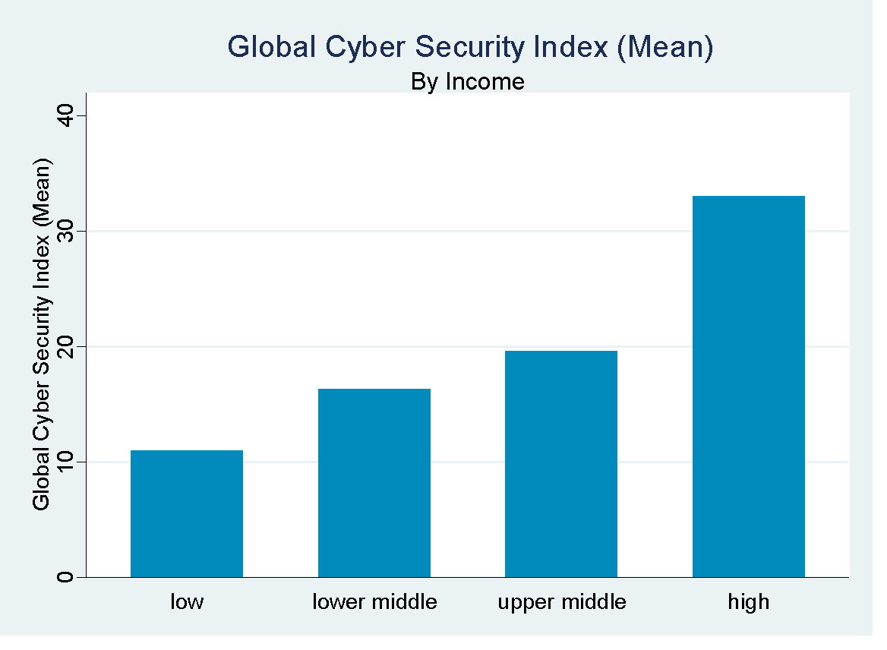
4.1.1 Income-Level Comparisons of Key Variables

Figure 4.1.1(a) Global Cybersecurity Index Figure 4.1.1(b) Military Expenditure
Figure 4.1.1(a) illustrates the mean Global Cybersecurity Index scores across different income groups. The data reveals a clear upward trend, where higher-income countries demonstrate significantly stronger cybersecurity capabilities. Figure 4.1.1(b) effectively communicates a trend suggesting that as income levels increases the mean military expenditure also tends to increase, with the high-income countries showing the highest expenditure.

Figure 4.1.1(c) Health Expenditure Figure 4.1.1(d) Education Expenditure
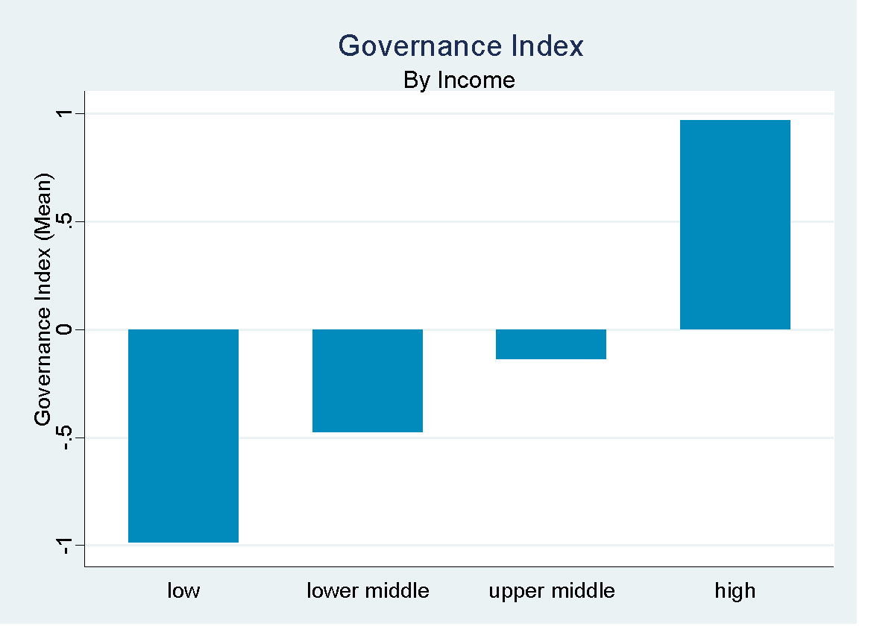
Figure 4.1.1(c) depicts that among different income levels, health expenditure is highest in high income countries, followed by low, upper middle and lower middle-income countries respectively. Figure 4.1.1(d) graph illustrates a general upward trend in average education spending as income levels increase, with a slight deviation observed in the highest income bracket.

Figure 4.1.1(e) ICT Figure 4.1.1(f) Governance Index
Figure 4.1.1(e) indicates that as income levels rise from low to high, the average ICT index also increases. In other words, as we move from low-income to high-income countries, access to and use of information and communication technologies also increases. Figure 4.1.1(f) illustrates a positive correlation between a country's income level and its mean governance index, with the high-income group exhibiting the highest index value.
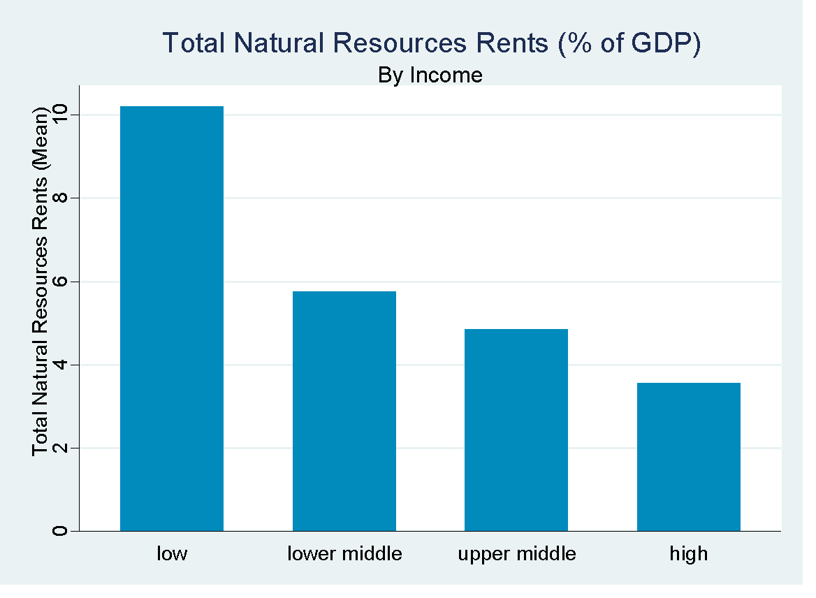
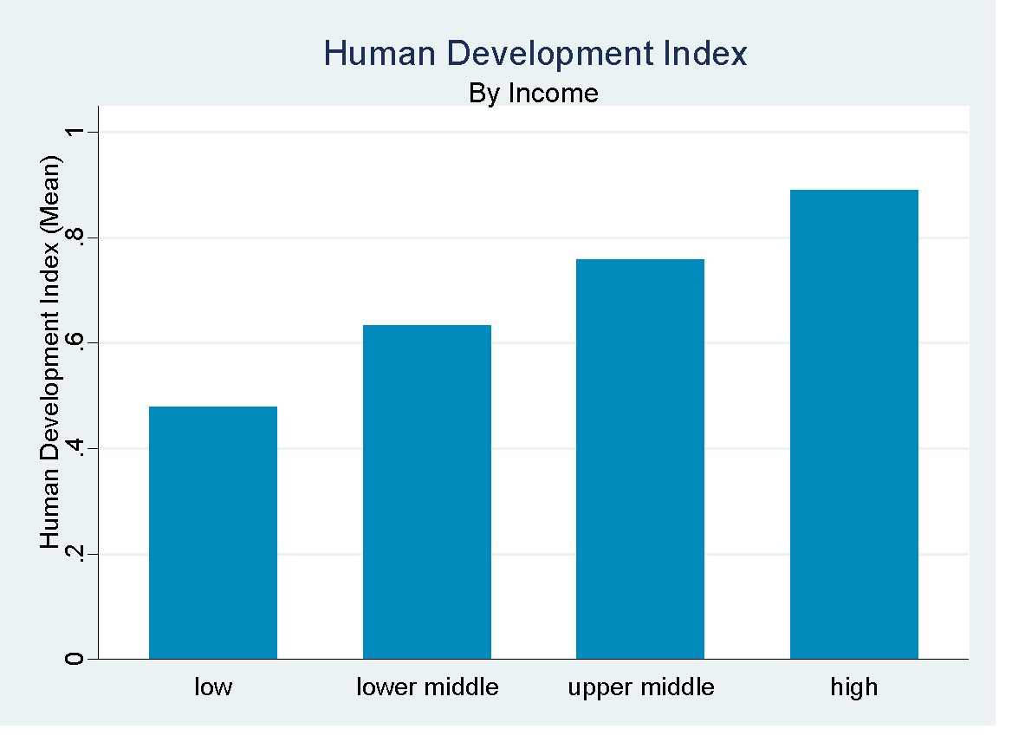

Figure 4.1.1(g) Human Development Index Figure 4.1.1(h) Total Natural Resource Rents

Figure 4.1.1(g) indicates as income levels progress from low to high, there is a corresponding increase in the mean HDI, highlighting the interconnectedness of economic status and overall human development. Figure 4.1.1(h) shows the trend of decreasing reliance on natural resource rents as a percentage of GDP with increasing income levels. Low-income countries, on average, derive a larger proportion of their GDP from natural resource rents compared to high-income countries. This suggests a potential shift in economic structure as nations develop.
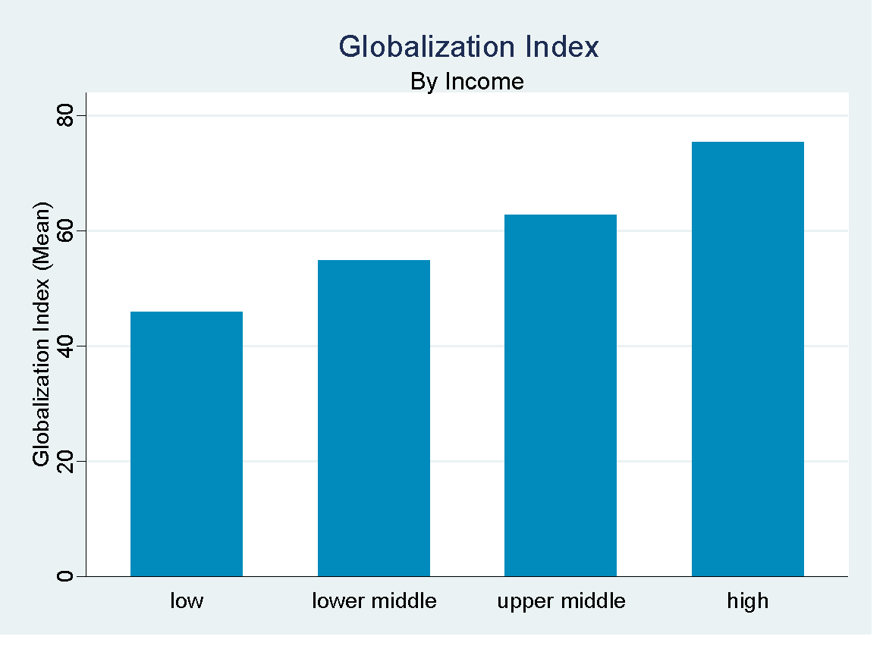

Figure 4.1.1(i) Globalization Index Figure 4.1.1(j) Terms of Trade
Figure 4.1.1(i) shows that as income levels rise from low to high, the mean globalization index also tends to increase, suggesting that more affluent economies are, on average, more globalized. Figure 4.1.1(j) depicts that Low and upper middle income groups have slightly higher mean terms of trade compared to lower middle and high income groups, but the differences are not substantial.

Figure 4.1.1(k) Carbon Dioxide Emissions
Figure 4.1.1(k) illustrates a clear positive relationship between income level and CO₂ emissions. Higher income levels are strongly associated with increased carbon dioxide emissions. This reflects higher industrialization, greater energy consumption, and more widespread use of fossil fuels in wealthier nations.

4.1.2 Regional Comparisons of Key Variables
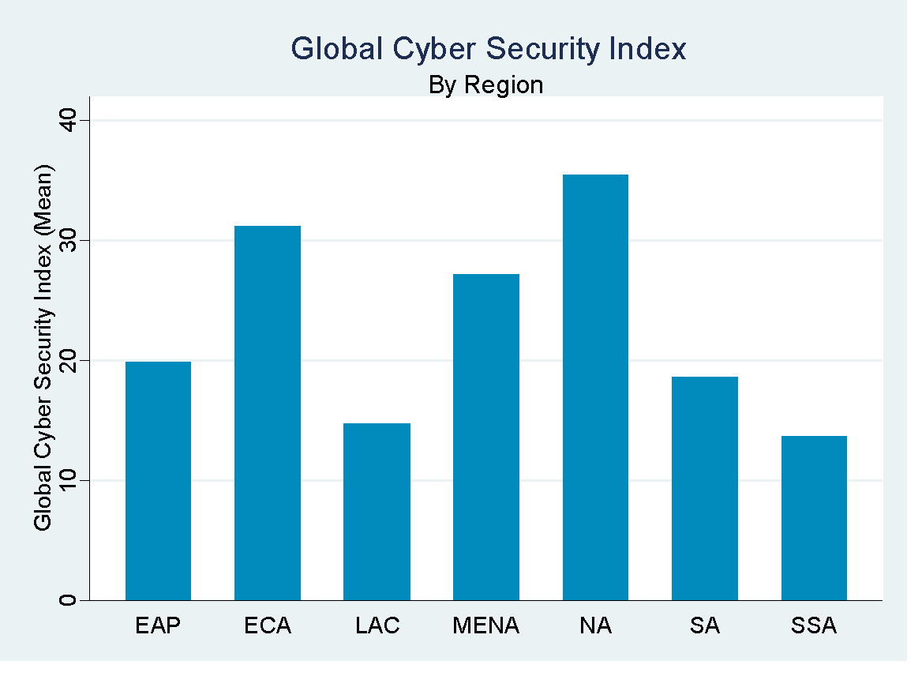

Figure 4.1.2(a) Global Cybersecurity Index Figure 4.1.2(b) Military Expenditure
Figure 4.1.2(a) North America (NA) exhibits the highest average GCI index, while Sub-Saharan Africa (SSA) shows the lowest. This suggests significant regional variations in cybersecurity preparedness and capabilities globally. In Figure 4.1.2(b) the Middle East and North Africa (MENA) region demonstrates the highest mean military expenditure. In contrast, Latin America and the Caribbean (LAC) shows the lowest average expenditure among the regions depicted. This highlights the diverse geopolitical priorities and security contexts shaping military spending across the world.

Figure 4.1.2(c) Health Expenditure Figure 4.1.2(d) Education Expenditure
The Figure 4.1.2(c) North America exhibits the highest average health expenditure. Conversely, the Middle East and North Africa region shows one of the lower mean expenditures among those presented. This visualization underscores the disparities in healthcare investment across various parts of the world. Figure 4.1.2.4 compares the average education expenditure across different global regions. North America shows the highest mean expenditure on education. South Asia exhibits the lowest average expenditure among the regions presented. This represents the varying levels of investment in education across different parts of the world.
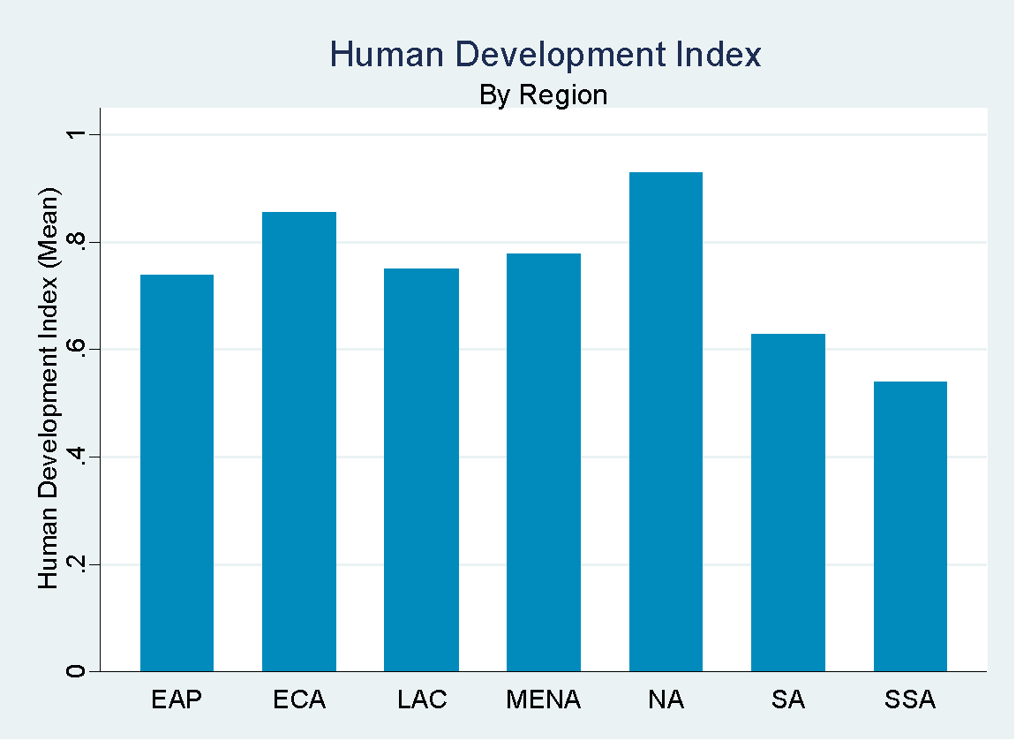

Figure 4.1.2(e) Terms of Trade Figure 4.1.2(f) Human Development Index
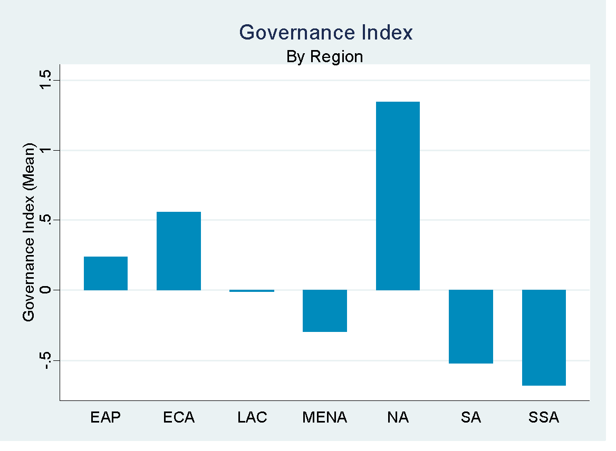
Figure 4.1.2(e) shows the mean terms of trade are relatively consistent across all regions, with only minor variations and no extreme outliers. In Figure 4.1.2(f) North America registers the highest mean HDI, whereas Sub-Saharan Africa indicates the lowest. These differences underscore the uneven progress in health, education, and living standards worldwide.

Figure 4.1.2(g) ICT Figure 4.1.2(h) Governance Index
Figure 4.1.2(g) With the highest mean ICT index, Europe and Central Asia stands out, while Sub-Saharan Africa records the lowest. The varying heights of the bars visually represent the disparities in ICT development and adoption levels worldwide. Figure 4.1.2(h) reveals the average governance index scores across different global regions. North America registers the highest mean governance index. Conversely, South Asia and Sub-Saharan Africa (SSA exhibit notably lower average governance index scores. These variations suggest differing levels of institutional quality and effectiveness across the world.

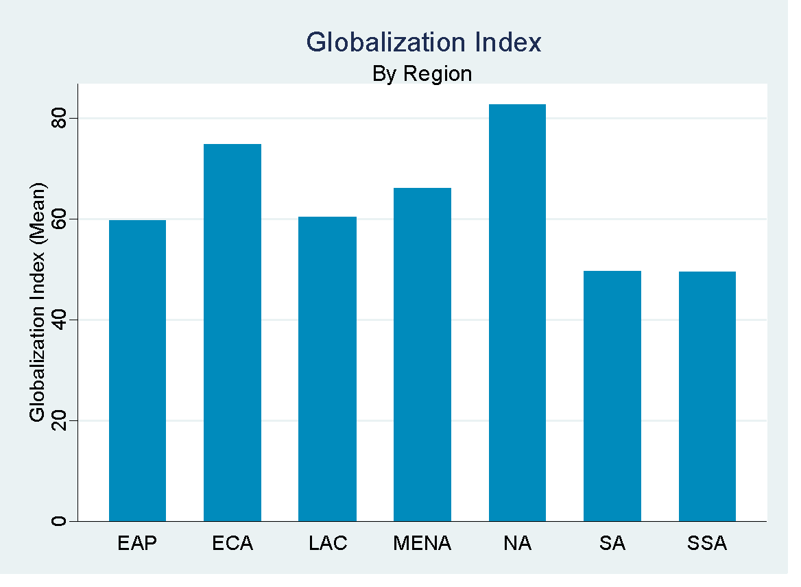

Figure 4.1.2(i) Globalization Index Figure 4.1.2(j) Total Natural Resources Rents

Figure 4.1.2(i) graph reveals that North America registers the highest average. Conversely, South Asia and Sub-Saharan Africa exhibit relatively lower mean scores. The visual disparity in bar heights effectively communicates the spectrum of global interconnectedness and integration among these areas. Figure 4.1.2(j) The Middle East and North Africa region exhibits the highest mean in this metric. Conversely, North America and South Asia show some of the lowest average total natural resource rents. These variations underscore the diverse economic dependencies on natural resources across the world.

Figure 4.1.2(k) Carbon Dioxide Emissions
Figure 4.1.2(k) exhibits stark regional disparities in carbon dioxide emissions. North America and MENA are the highest emitters, which reflect high energy consumption, heavy reliance on fossil fuels, and advanced industrial sectors. In contrast, regions such as Sub-Saharan Africa and South Asia have much lower emissions, likely due to lower levels of industrialization and energy use.

4.1.3 Summary Statistics

Table 4.2.1 presents the descriptive statistics for all variables. The Global Cybersecurity Index has an average score of 21.37 with a relatively high standard deviation of 31.69, indicating substantial variation in cybersecurity readiness among countries in the sample. The minimum value is 0, and the maximum approaches 100, suggesting that while some countries have made significant progress in cybersecurity, others lag considerably behind.

Table 4.2.1 Summary Statistics
Variable |  | Unit | Obs | Mean | Std. Dev. | Min | Max
GCI |  | Index | 1575 | 21.37 | 31.689 | 0 | 99.76
ME |  | % of GDP | 1334 | 1.897 | 1.743 | .04 | 33.55
HE |  | % of GDP | 1628 | 6.843 | 3.093 | 1.75 | 27.23
EE |  | % of GDP | 1557 | 4.452 | 1.861 | .35 | 15.38
TOT |  | Ratio | 1546 | 103.256 | 14.005 | 49.712 | 185.825
CE |  | % of GDP | 1602 | 4.828 | 7.714 | 0 | 78.726
WBGI |  | Index | 1665 | -.008 | .883 | -2.193 | 1.852
ICT |  | Index | 1638 | 46.386 | 19.068 | 4.223 | 136.453
TNRR |  | % of GDP | 1467 | 5.442 | 8.44 | 0 | 79.43
HDI |  | Index | 1630 | .725 | .152 | .35 | .97
GDP (per capita) |  |  | 1665 | 16585.304 | 26849.679 | 216.83 | 240862.2
GI |  |  | 1456 | 62.121 | 14.456 | 28.29 | 90.93
Military expenditure averages at 1.90% of GDP, with a wide range from 0.04% to 33.55%, reflecting diverse national priorities and security concerns. Health expenditure averages 6.84% of GDP, with moderate variability, indicating differing levels of investment in healthcare infrastructure. Education expenditure averages 4.45%, with a minimum of 0.35% and a maximum of 15.38%, showing a broad spectrum of commitment to education across countries.

The Terms of Trade centers around 100 for most countries, though there are cases at both extremes. This highlights differences in international trade positions, with some countries facing more favorable trading conditions than others. CO₂ emissions per capita also vary widely, from almost zero to nearly 80 metric tons. This points to significant differences in industrialization and energy use, as well as environmental policy choices. For the ICT index and the Globalization Index, the data indicate considerable differences in digital development and integration into the global economy. Some countries are highly advanced, while others remain less connected or developed in these domains.
The Human Development Index averages around 0.73, placing most countries in the medium to high human development category, though a few falls below this range. GDP per capita shows a mean of approximately $16,585 but with a very large standard deviation, reflecting significant income disparities.
The Governance Index has a mean value close to zero (-0.008) with a standard deviation of 0.883, indicating that governance quality varies widely across the countries. The index ranges from a minimum of -2.193 to a maximum of 1.852, reflecting a spectrum that includes countries with weak governance structures as well as those with strong, effective governance. Total Natural Resource Rent averages 5.44% of GDP but varies widely (0 to 79.43%), indicating some countries heavily rely on natural resources, while others do not.

4.1.4 Correlation Among Variables
Table 4.3.1 displays the pairwise correlation coefficients among the key variables of the study. Global Cybersecurity Index is positively and significantly correlated with many variables, including Governance Index (0.226), ICT (0.261), Human Development Index (0.280), GDP per Capita (0.192), and Globalization Index (0.310). These results suggest that higher levels of cybersecurity are generally associated with better governance, greater digital development, higher human development, increased economic prosperity, and greater global integration.

Table 4.3.1 Pairwise Correlations
Variables | GCI | ME | HE | EE | TOT | CE | WBGI | ICT | TNRR | HDI | GDP | GI
GCI | 1
ME | 0.049 | 1
HE | 0.096* | 0.002 | 1
EE | 0.007 | 0.098* | 0.390* | 1
TOT | 0.084* | 0.079* | -0.075* | -0.041 | 1
CE | 0.088* | 0.350* | 0.119* | -0.011 | 0.018 | 1
WBGI | 0.226* | -0.089* | 0.338* | 0.294* | -0.147* | 0.333* | 1
ICT | 0.261* | 0.076* | 0.210* | 0.053* | -0.091* | 0.485* | 0.686* | 1
TNRR | -0.083* | 0.344* | -0.273* | -0.087* | 0.391* | 0.127* | -0.418* | -0.252* | 1
HDI | 0.280* | 0.092* | 0.281* | 0.196* | -0.082* | 0.454* | 0.788* | 0.830* | -0.285* | 1
GDP | 0.192* | 0.029 | 0.201* | 0.036 | -0.064* | 0.443* | 0.667* | 0.562* | -0.163* | 0.657* | 1
GI | 0.310* | 0.012 | 0.369* | 0.154* | -0.098* | 0.310* | 0.698* | 0.691* | -0.324* | 0.809* | 0.434* | 1
*** p<0.01, ** p<0.05, * p<0.1
Health Expenditure, Education Expenditure, and Governance Index are strongly interrelated. For example, health and education expenditures are both moderately correlated with the Governance Index (0.338 and 0.294, respectively), and also with the Human Development Index (0.281 and 0.196, respectively). This pattern is consistent with the idea that investments in human capital and strong governance go hand-in-hand.
ICT and Globalization Index both exhibit strong positive correlations with the Governance Index, Human Development Index, and GDP per Capita, highlighting how digital advancement and global engagement are intertwined with economic and social development.
CO₂ Emissions is positively correlated with GDP per Capita (0.443), Human Development Index (0.454), and ICT Index (0.485), suggesting that more developed and technologically advanced countries tend to have higher emissions.
Human Development Index, GDP per Capita, and Globalization Index are strongly correlated with each other (e.g., HDI and GI: 0.809), reflecting their shared underlying factors such as economic growth, institutional quality, and global connectivity.
Military expenditure correlates moderately with environmental impact (CO2) and natural resource rents (TNRR), suggesting countries with higher military spending might also exploit natural resources more. The negative correlation with governance implies that higher military spending is associated with weaker governance structures.

TNRR and Terms of Trade exhibits significant negative correlations with the core development nexus (Governance, ICT, HDI, GDP/capita, Globalization). Economies heavily reliant on natural resource rents tend to lag in institutional quality, technological infrastructure, human development, wealth creation, and global integration. This aligns strongly with the "resource curse" hypothesis, suggesting resource wealth can hinder the development of other critical economic, institutional, and human capital foundations.

4.2 Empirical Analysis

Empirical analysis forms the core of this study, aiming to investigate how cyber security, as measured through the Global Cybersecurity Index (GCI), influences national security across a panel of countries. The analysis further disaggregates national security into four critical components: military expenditure, social expenditure, terms of trade, and carbon emissions, to capture a holistic understanding of the relationship.

Table 4.2.1 Impact of Cybersecurity on National Security Index
Variables | Dependent Variable (National Security Index)
 | Linear Reg | Fixed Effects | GMM
 | (1) | (2) | (3)
GCI | 0.005 | 0.002 | 0.008*
 | (-0.003) | (-0.003) | (-0.004)
WBGI | -0.299 | -0.982 | 0.353
 | (-0.268) | (-0.982) | (-1.775)
ICT | 0.037*** | 0.038* | 0.043
 | (-0.012) | (-0.021) | (-0.032)
TNRR | 0.270*** | 0.522*** | 0.557***
 | (-0.022) | (-0.03) | (-0.08)
HDI | 1.917 | 4.3 | -30.935**
 | (-2.437) | (-8.459) | (-14.804)
GDP | 0.000** | 0.000*** | 0.000*
 | (0. 000) | (0.000) | (0. 000)
GI | -0.007 | -0.129 | -0.099
 | (-0.019) | (-0.079) | (-0.122)
EAP Region | 0.351
 | (-0.415)
ECA Region | 0.411
 | (-0.476)
LAC Region | 0.666*
 | (-0.381)
MENA Region | 0.471
 | (-0.553)
NA Region | 3.593***
 | (-0.634)
SA Region | 0.830*
 | (-0.448)
Lower Middle Income | -0.288 | 1.408**
 | (-0.405) | (-0.679)
Upper Middle Income | 0.865 | 3.593***
 | (-0.577) | (-0.884)
High Income | 0.565 | 3.659***
 | (-0.699) | (-1.095)
L.NS |  |  | -0.356***
 |  |  | -(0.096)
Constant | 23.503*** | 25.448***
 | (-1.278) | (-6.795)
Observations | 1,031 | 1,031 | 772
Prob. > chi2 |  | 0.000
R-squared | 0.384 | 0.321
Prob > F | 0.000 | 0.000
Number of CNT |  | 131 | 129
Robust standard errors in parentheses *** p<0.01, ** p<0.05, * p<0.1
Reference Categories: For Region: SSA, For Income Low Income

The regression results eq (3) demonstrate that cybersecurity, as measured by the Global Cybersecurity Index (GCI), has a significant positive impact on national security when accounting for dynamic effect, suggesting that stronger cyber defenses contribute to overall security. Additionally, ICT development (0.037**) in Linear Regression eq (1) and natural resource rents (0.270***) eq (1) to (0.557***) eq (3) consistently enhance national security, likely by enabling better infrastructure and funding for defense. In this study, after applying the Hausman Test, the fixed-effect model is applied for regression analyses. Economic factors such as GDP per capita (0.000**) and high-income status (3.659*) in fixed effects regression eq (2) further reinforce security, while the unexpected negative coefficient for HDI in GMM eq (3) (-30.935) indicate complex development-security trade-offs in advanced economies. Regional disparities exist, with North America (3.593) and South Asia (0.830) in linear regression eq (2) showing heightened security effects, possibly due to military spending or geopolitical risks. These findings underscore the importance of integrating cybersecurity, technological advancement, and economic stability into national security strategies, with GMM emerging as the preferred model due to its handling of endogeneity through lagged effects. Additionally, Sub-Saharan Africa serves as the reference category. The results indicate that North America exhibits a substantially higher value on the dependent variable compared to SSA, with a coefficient of 3.593 eq (1) is statistically significant at the 1% level. This suggests a pronounced difference between North America and SSA in terms of the measured outcome. Similarly, Latin America & the Caribbean and South Asia have positive and statistically significant coefficients of 0.666 and 0.830, respectively in linear regression eq (1), indicating these regions outperform SSA to a moderate but meaningful extent.
The fixed effects regression eq (2) results reveal a significant and positive relationship between a country’s income level and its national security score, using low-income countries as the reference category. Specifically, compared to low-income countries, lower middle-income countries exhibit an average increase of 1.41 units eq (2) in national security, which is statistically significant at the 5% level. This positive trend intensifies for upper middle-income and high-income countries, with national security scores increasing by approximately 3.59 and 3.66 units, respectively in eq (2), both highly significant at the 1% level. These findings suggest that higher income levels are strongly associated with improved national security, indicating that economic development plays a critical role in a country’s ability to enhance and maintain security.
Strengthening cyber capabilities has been shown to significantly enhance an overall security posture, which not only mitigates digital threats but also positively influences economic performance and institutional resilience (Hasan et al., 2021). These improvements contribute meaningfully to a country's broader national security agenda, underscoring the strategic value of robust cybersecurity infrastructure. Moreover, the study's findings align with evidence that the expansion of information and communication technologies including increased internet accessibility and digital literacy can promote inclusive economic development and reduce socio-economic disparities. As digital transformation accelerates, countries with greater ICT integration often experience more stable political environments and stronger social cohesion, both of which are essential for national security (Cioacă et al., 2020; Wang & Ullah, 2023).
Regional disparities further highlight the uneven distribution of cyber capacity and security resilience across the globe. Regions such as North America and South Asia demonstrate stronger security performance compared to Sub-Saharan Africa, reflecting underlying differences in economic development levels, digital infrastructure, and institutional maturity (Cioacă et al., 2020; Cao et al., 2023). These variations emphasize the importance of context-specific strategies that account for regional and developmental realities.

Table 4.2.2 Impact of Cyber Security on Military Expenditure (As Percentage of GDP)
Variables | Dependent Variable (Military Expenditure)
 | LinearReg | Fixed Effects |  | GMM
 | (1) | (2) |  | (3)
GCI | 0.001 | 0.002*** |  | 0.000
 | (-0.001) | (0.000) |  | (-0.001)
WBGI | -0.249** | -0.101 |  | -0.286
 | (-0.125) | (-0.151) |  | (-0.258)
ICT | 0.007 | 0.000 |  | 0.005
 | (-0.004) | (-0.003) |  | (-0.005)
TNRR | 0.026*** | -0.015*** |  | -0.016**
 | (-0.007) | (-0.004) |  | (-0.006)
HDI | 0.379 | -0.693 |  | -4.757
 | (-0.839) | (-1.268) |  | (-3.322)
GDP | -0.000*** | -0.000** |  | 0.000
 | (0.000) | (0.000) |  | (0.000)
GI | -0.020*** | -0.044*** |  | 0.060***
 | (-0.007) | (-0.012) |  | (-0.022)
EAP Region | 0.137
 | (-0.133)
ECA Region | 0.196
 | (-0.161)
LAC Region | -0.242**
 | (-0.121)
MENA Region | 2.783***
 | (-0.248)
NA Region | 0.023
 | (-0.173)
SA Region | 0.637***
 | (-0.162)
Lower Middle Income | 0.205* | 0.118
 | (-0.11) | (-0.097)
Upper Middle Income | 0.691*** | 0.289**
 | (-0.202) | (-0.129)
High Income | 1.444*** | 0.325**
 | (-0.263) | (-0.162)
L.ME |  |  | 0.203*
 |  |  | (-0.105)
Constant | 1.496** | 5.129***
 | (-0.581) | (-1.008)
Observations | 1,126 | 1,126 | 843
Prob. > chi2 |  | 0.000
R-squared | 0.476 | 0.058
Prob > F | 0.000 | 0.000
Number of CNT |  | 144 | 141
Robust standard errors in parentheses *** p<0.01, ** p<0.05, * p<0.1
Reference Categories: For Region: SSA, For Income Low Income

In this study, after applying the Hausman Test, the fixed-effect model is applied for regression analyses. The Global Cybersecurity Index showing a significant positive impact in the Fixed Effects model eq (2) (0.002*), suggesting that countries investing in cyber capabilities may also increase military spending, possibly due to integrated defense strategies. Globalization consistently reduces military spending (-0.020*) eq (2) to (-0.060*) eq (3), supporting the "peace dividend" hypothesis (Graham & Mueller, 2019; Farzanegan, 2023). While natural resource rents exhibit conflicting effects positive in cross-sectional analysis (0.026*) eq (1) but negative in fixed effects model eq (2); (-0.015*), possibly reflecting divergent strategies between resource-dependent and diversified economies.
The linear regression analysis eq (1) reveals significant regional variations in military expenditure compared to Sub-Saharan Africa. The Middle East & North Africa and South Asia regions exhibit substantially higher military spending, with coefficients of 2.783 (p < 0.01) and 0.637 (p < 0.01), respectively, indicating stronger defense investments likely due to geopolitical tensions or conflict risks. In contrast, Latin America & the Caribbean spends significantly less (-0.242) eq (1), possibly reflecting lower security threats (Clements et al., 2019).
In the fixed effects model eq (2), the coefficients for income levels reflect differences in military expenditure relative to low-income countries (the reference group). The upper-middle-income and high-income countries exhibit significantly higher military expenditure than low-income countries (Biswas, 2019; Clements et al., 2019), with coefficients of 0.289 and 0.325 in eq (2), respectively, both statistically significant at the 5% level.
Cybersecurity is now an essential component of national power and military capability. Modern armed forces rely largely on secure networks and digital systems, therefore advances in a country's Global Cybersecurity frequently indicate improved foundations for military readiness. Valeriano et al. (2018) claim that cyber and military power are inextricably linked because cyber defenses protect important infrastructure and enable forces to operate successfully in battle. This means that cybersecurity investments frequently coincide with increased military spending rather than replacing it (Buchanan, 2016).
This connection is even more evident in the realm of hybrid warfare, where nations employ cyber assaults in conjunction with propaganda, economic coercion, and various gray-zone strategies (Hoffman, 2007). Nations react by enhancing their cyber protections and modernizing traditional military forces, frequently via organizations such as national Cyber Commands or agreements like NATO's acknowledgment of cyberspace as an operational domain in 2016.
As nations face evolving security challenges, particularly in the cyber domain, defense strategies are no longer limited to conventional force projection but increasingly encompass cyber preparedness, resilience, and digital defense capabilities. This paradigm shift has driven a noticeable increase in military budgets globally, as countries integrate cyber capabilities into their national defense apparatus (Farzanegan, 2023). The inclusion of cyber units, digital intelligence infrastructure, and offensive/defensive cyber operations represents a critical evolution in how modern militaries allocate resources.
Table 4.2.3 Impact of Cyber Security on Social Expenditure (As Percentage of GDP)
Variables | Dependent Variable (Social Expenditure)
 | Linear Reg | Fixed Effects | GMM
 | (1) | (2) | (3)
GCI | 0.002 | 0.006*** | 0.007***
 | (-0.001) | (-0.001) | (-0.001)
WBGI | 1.280*** | 0.081 | 0.036
 | (-0.157) | (-0.195) | (-0.275)
ICT | -0.021*** | -0.007* | -0.011*
 | (-0.006) | (-0.004) | (-0.006)
TNRR | -0.017* | -0.007 | -0.017***
 | (-0.009) | (-0.006) | (-0.006)
HDI | 3.335*** | -3.406** | -7.804**
 | (-1.168) | (-1.645) | (-3.099)
GDP | -0.000** | -0.000*** | -0.000***
 | (0.000) | (0.000) | (0.000)
GI | -0.004 | 0.025* | 0.028
 | (-0.007) | (-0.014) | (-0.023)
EAP Region | -0.001
 | (-0.232)
ECA Region | 1.038***
 | (-0.222)
LAC Region | 0.994***
 | (-0.182)
MENA Region | 0.525**
 | (-0.228)
NA Region | 1.418***
 | (-0.28)
SA Region | -0.348
 | (-0.333)
Lower Middle Income | -1.444*** | -0.312**
 | (-0.216) | (-0.148)
Upper Middle Income | -1.691*** | -0.233
 | (-0.288) | (-0.192)
High Income | -2.091*** | -0.431*
 | (-0.325) | (-0.234)
L.SE |  |  | 0.420***
 |  |  | (-0.12)
Constant | 5.565*** | 7.284***
 | (-1.00) | (-1.00)
Observations | 1,244 | 1,244 | 931
Prob. > chi2 |  | 0.000
R-squared | 0.295 | 0.115
Prob > F | 0.000 | 0.000
Number of CNT |  | 158 | 156
Robust standard errors in parentheses *** p<0.01, ** p<0.05, * p<0.1
Reference Categories: For Region: SSA, For Income Low Income

In this study, after applying the Hausman Test, the fixed-effect model is applied for regression analyses. The findings from Table 5.3 demonstrate a significant positive relationship between cybersecurity development (GCI) and social expenditure, with coefficients of 0.006*** in fixed effects model eq (2) and 0.007*** in GMM model eq (3) indicating that enhanced cybersecurity capabilities are associated with greater social spending, likely reflecting broader public sector investments or the recognition of digital infrastructure as a social good. However, countervailing forces emerge, as ICT development shows consistent negative coefficients (-0.007*) in eq (2) and (-0.021*) in eq (1), suggesting potential trade-offs between technological advancement and social welfare budgets. These results collectively suggest that the cybersecurity-social expenditure relationship is mediated by complex institutional, economic and regional factors, with important implications for policymakers seeking to balance digital transformation with social welfare objectives in different national contexts.
The linear regression analysis eq (1) reveals significant regional disparities in social expenditure compared to Sub-Saharan Africa (SSA). Europe & Central Asia (ECA), Latin America & the Caribbean (LAC), and North America (NA) exhibit substantially higher social spending, with coefficients of 1.038, 0.994, and 1.418, respectively (all significant at p < 0.01), reflecting stronger welfare systems or redistributive policies. The Middle East & North Africa (MENA) also shows moderately higher spending (0.525, p < 0.05), likely supported by resource-driven social programs. Regional disparities illuminate the structural and institutional factors shaping social spending. Countries in Europe & Central Asia, Latin America & the Caribbean, and North America consistently allocate a higher proportion of resources to social welfare compared to nations in Sub-Saharan Africa. These differences reflect not only divergent economic capacities but also the maturity of welfare institutions, redistributive frameworks, and historical commitments to social protection (Alataş & Sarı, 2021; Sidek, 2021). In the fixed effects model eq (2), relative to low-income countries (the reference category), both lower middle-income and high-income countries exhibit significantly lower social expenditure. Specifically, lower middle-income countries spend on average 0.312 units less on social expenditure, while high-income countries spend 0.431 units less, with these differences being statistically significant.
The observed positive relationship between cybersecurity development and social expenditure aligns with emerging research that underscores the transformative role of digital infrastructure in advancing public investment and social welfare. Enhancements in digital finance and secure ICT systems have enabled governments to deliver social services more efficiently, expand coverage, and improve the impact of welfare programs. For instance, initiatives in digital financial inclusion have been linked to reductions in poverty and greater equity between urban and rural populations, reinforcing the argument that cybersecurity and digital systems now serve as foundational enablers of modern social policy (Xu, 2023; Yu & Li, 2021). Governments are beginning to see digital infrastructure as a public benefit that is essential to social wellbeing. According to studies, investing in cybersecurity not only safeguards digital systems but also supports more general social policy objectives by guaranteeing the continuation of vital services including public administration, healthcare, and education (Vergara Cobos et al., 2024). Moreover, digitalization-driven social investment supports inclusivity, as secure platforms enhance access to online education, e-government, and digital healthcare, especially in regions striving to bridge socio-economic gaps (Afonasova et al., 2019) The integration of cybersecurity within social expenditure thus reflects a dual objective: safeguarding critical digital services while reinforcing equitable access to welfare benefits, thereby strengthening social resilience and national development simultaneously.
However, the analysis also reveals a nuanced dynamic: the negative correlation between ICT development and social expenditure suggests that as digital technologies advance, some governments may reallocate resources away from traditional welfare programs. This could result from the efficiencies gained through digital governance, which reduce the need for extensive public spending, or from strategic trade-offs where technology investments take precedence over direct social transfers (Hussain et al., 2024). This tension highlights the importance of deliberate policy design to ensure that technological progress does not inadvertently undercut essential social safety nets.
Table 4.2.4 Impact of Cyber Security on Terms of Trade
Variables | Dependent Variable (Terms of Trade)
 | Linear Reg | Fixed Effects | GMM
 | (1) | (2) | (3)
GCI | 0.037*** | 0.021* | 0.036**
 | (-0.012) | (-0.011) | (-0.015)
WBGI | 1.37 | 3.839 | 6.747
 | (-0.943) | (-3.668) | (-6.494)
ICT | 0.008 | 0.045 | 0.061
 | (-0.039) | (-0.076) | (-0.123)
TNRR | 0.836*** | 1.810*** | 1.947***
 | (-0.084) | (-0.102) | (-0.355)
HDI | -14.740* | -2.197 | -109.853*
 | (-8.475) | (-31.295) | (-57.186)
GDP | 0.000 | 0.000*** | 0.001**
 | (0.000) | (0.000) | (0.000)
GI | 0.150*** | -0.227 | -0.088
 | (-0.051) | (-0.269) | (-0.347)
EAP Region | 3.033**
 | (-1.491)
ECA Region | 3.176*
 | (-1.682)
LAC Region | 4.294***
 | (-1.443)
MENA Region | -2.824
 | (-1.935)
NA Region | 6.020**
 | (-2.585)
SA Region | 6.046***
 | (-1.72)
Lower Middle Income | -0.51 | 5.437**
 | (-1.552) | (-2.685)
Upper Middle Income | 1.765 | 15.024***
 | (-2.184) | (-3.468)
High Income | -1.928 | 16.594***
 | (-2.813) | (-4.266)
L.TermofTrade |  |  | -0.243***
 |  |  | (0.000)
Constant | 96.959*** | 88.919***
 | (-3.92 | (-24.071)
Observations | 1,279 | 1,279 | 956
Prob. > chi2 |  | 0.000
R-squared | 0.214 | 0.289
Prob > F | 0.000 | 0.000
Number of CNT |  | 163 | 160
Robust standard errors in parentheses *** p<0.01, ** p<0.05, * p<0.1
Reference Categories: For Region: SSA, For Income Low Income

The analysis reveals that cybersecurity (GCI) has a statistically significant positive impact on terms of trade across both models, with coefficients of 0.037*** in the linear regression eq (1) and 0.021* in the fixed effects eq (2) specification, suggesting that enhanced cybersecurity capabilities contribute to improved trade competitiveness, potentially by reducing digital trade barriers and increasing foreign buyer confidence. In this study, after applying the Hausman Test, the fixed-effect model is applied for regression analyses. The effect remains robust though slightly attenuated in the fixed effects model eq (2), indicating that while the relationship persists within countries over time, some cross-sectional variation may be driving the stronger OLS result. Natural resource rents demonstrate an even more pronounced positive association (0.836***) eq (1) to (1.810) eq (2) , highlighting how commodity wealth fundamentally shapes trade performance. These findings underscore cybersecurity's role as an emerging determinant of trade performance, while emphasizing how resource endowments, regional context, and development level jointly shape countries' trade positions.
The linear regression analysis eq (2) reveals significant regional disparities in terms of trade compared to Sub-Saharan Africa (SSA). Latin America & the Caribbean (LAC), North America (NA), and South Asia (SA) demonstrate the strongest terms of trade advantages, with coefficients of 4.294 (p < 0.01), 6.020 (p < 0.05), and 6.046 (p < 0.01) respectively, reflecting their competitive export structures in commodities, advanced goods, and services. East Asia & Pacific (EAP) and Europe & Central Asia (ECA) also show moderately better terms of trade (3.033, p < 0.05 and 3.176, p < 0.10) in eq (2), likely due to diversified export bases. The positive impact of cybersecurity (GCI) across all models suggests that enhanced digital resilience may contribute to trade competitiveness, particularly in regions with strong export sectors.
In the fixed effects model eq (2), income levels show a significant positive impact on terms of trade relative to low-income countries, which serve as the reference category. Specifically, lower middle-income countries have terms of trade that are on average 5.437 units higher than those of low-income countries. This positive effect becomes even more pronounced for upper middle-income and high-income countries, with increases of 15.024 and 16.594 units respectively, both statistically significant at conventional levels. These results indicate that as countries' income levels rise, they tend to experience substantially better terms of trade, suggesting that wealthier countries may benefit from more favorable trade conditions due to factors such as greater market access, stronger negotiating power, or more diversified economies.
The positive association identified between enhanced cybersecurity and improved terms of trade is strongly supported by contemporary research, which increasingly positions digital security as a critical enabler of international commerce. In today’s global economy, particularly within digital and tech-driven sectors, robust cybersecurity infrastructure contributes significantly to trade competitiveness by fostering trust, mitigating cross-border risks, and lowering transaction barriers (Gummadi, 2024; Kamisetty, 2024). Secure digital environments are now essential for facilitating global e-commerce, safeguarding digital supply chains, and enabling businesses of all sizes to access international markets more confidently and efficiently (Kamisetty, 2024; Narsina, 2022).
Countries with advanced cybersecurity policies and infrastructure are better equipped to attract foreign investment, maintain supply chain integrity, and minimize operational disruptions—all of which contribute to more favorable trade terms and sustained export growth (Gummadi, 2024; Zaiats & Kytsyuk, 2024). These benefits are particularly pronounced in economies with higher income levels and substantial resource endowments, where greater fiscal capacity allows for targeted investment in digital infrastructure, regulatory compliance, and institutional development, further strengthening trade outcomes (Zaiats & Kytsyuk, 2024).
Studies also highlight how bolstering cybersecurity skills promotes sustainable growth and innovation by boosting trust in digital economies and protecting digital assets. Strong cyber governance frameworks, for example, have been found to be directly associated with increased investor confidence and institutional efficacy, both of which promote economic resilience and development (Mehmood, 2025).
Nevertheless, the literature also draws attention to structural challenges that may hinder the equitable realization of these gains. Issues such as regulatory fragmentation, uneven cybersecurity capacity, and the widening digital divide pose significant risks especially for low- and middle-income countries that lack the institutional or technological readiness to fully capitalize on digital trade opportunities (Gummadi, 2024; Kamisetty, 2024). Moreover, the absence of harmonized international cybersecurity standards can create friction in cross-border data flows and limit cooperation between trading partners.
Table 4.2.5 Impact of Cyber Security on Carbon Emissions (As Percentage of GDP)
Variable | Dependent Variable (Carbon Emissions)
 | Linear Reg | Fixed Effects | GMM
 | (1) | (2) | (3)
GCI | -0.009* | -0.007*** | -0.005***
 | (-0.005) | (-0.001) | (-0.001)
WBGI | -1.462*** | 0.687*** | 0.817
 | (-0.253) | (-0.211) | (-0.528)
ICT | 0.061*** | 0.011** | 0.012*
 | (-0.014) | (-0.004) | (-0.007)
TNRR | 0.117*** | 0.013** | 0.011
 | (-0.031) | (-0.005) | (-0.01)
HDI | 10.722*** | -0.949 | 0.32
 | (-2.183) | (-1.786) | (-3.673)
GDP | 0.000*** | 0.000*** | 0.000*
 | (0.000) | (0.000) | (0.000)
GI | -0.077** | 0.021 | -0.023
 | (-0.039) | (-0.016) | (-0.029)
EAP Region | 1.425**
 | (-0.597)
ECA Region | -1.364***
 | (-0.462)
LAC Region | -1.710***
 | (-0.4)
MENA Region | 3.632***
 | (-0.743)
NA Region | 6.559***
 | (-0.639)
SA Region | 0.256
 | (-0.381)
Lower Middle Income | -0.084 | 0.094
 | (-0.268) | -(0.151)
Upper Middle Income | 2.492*** | 0.288
 | (-0.51) | (-0.197)
High Income | 6.104*** | 0.422*
 | (-1.003) | (-0.244)
L.CE |  |  | 0.421***
 |  |  | (0.000)
Constant | -5.182** | 2.972**
 | (-2.015) | (-1.379)
Observations | 1,286 | 1,286 | 962
Prob. > chi2 |  | 0.000
R-squared | 0.541 | 0.135
Prob > F | 0.000 | 0.000
Number of CNT |  | 164 | 161
Robust standard errors in parentheses *** p<0.01, ** p<0.05, * p<0.1
Reference Categories: For Region: SSA, For Income Low Income

The regression analysis reveals a significant negative relationship between cybersecurity (GCI) and carbon emissions across all models, with coefficients of -0.009* in linear regression model eq (1) and -0.007*** in fixed effects model eq (2), suggesting that enhanced cybersecurity capabilities contribute to reduced emissions, potentially through enabling more efficient digital infrastructure and smart technologies that lower energy consumption. In this study, the fixed-effect model is applied for regression analyses, after applying the Hausman Test. The fixed effects model eq (2), which controls for country-specific characteristics, shows an even stronger statistical significance, indicating that this relationship holds within countries over time. Notably, while ICT development (0.061*** in eq (1), 0.011** in eq (2)) and natural resource rents (0.117*** in eq (1), 0.013** in eq (2)) are associated with higher emissions, likely due to increased energy use from digital expansion and resource extraction, their impact diminishes considerably in the Fixed Effects specification, suggesting that much of their effect operates through between-country differences rather than within-country changes.
The linear regression analysis eq (1) examining the impact of cybersecurity on carbon emissions reveals significant regional variations when compared to Sub-Saharan Africa (SSA) as the reference category. The results show that East Asia & Pacific (EAP) and North America (NA) have significantly higher carbon emissions, with coefficients of 1.425 (p<0.05) and 6.559 (p<0.01) respectively, reflecting their more industrialized economies. Conversely, Europe & Central Asia (ECA) and Latin America & Caribbean (LAC) demonstrate significantly lower emissions (-1.364 and -1.710, both p<0.01). These findings highlight distinct regional emission patterns, with developed regions (NA, EAP) and oil-dependent economies (MENA) showing the highest carbon footprints compared to SSA, while demonstrating the potential environmental benefits of enhanced cybersecurity measures.
High-income countries show a positive coefficient of 0.422 in eq (2), which is statistically significant at the 10% level, indicating that these countries tend to have higher carbon emissions compared to low-income countries when accounting for fixed effects and other control variables. This pattern suggests that carbon emissions generally increase with income level, but the relationship is statistically robust only for the highest income group after controlling for unobserved, time-invariant country characteristics. The result aligns broadly with existing studies showing that higher income is often associated with greater emissions, possibly due to higher consumption levels and industrial activity, although nuances such as the non-linear impact of income distribution on emissions are documented in the literature.
The significant negative relation identified between enhanced cybersecurity and carbon emissions is well supported by emerging empirical evidence. As digital transformation accelerates, cybersecurity is increasingly recognized not only for its protective function but also for its role in promoting environmental sustainability. Modern cybersecurity systems are becoming more energy-conscious, contributing to reduced carbon footprints through the adoption of efficient digital infrastructure and intelligent resource optimization.
Advanced solutions such as Next Generation DataGuard exemplify this shift, demonstrating up to 88% greater energy efficiency compared to conventional systems, thereby cutting both emissions and operational costs (Akana et al., 2023). These technologies enable organizations to secure their digital environments while simultaneously minimizing their environmental impact.
In sectors such as transportation, cybersecurity-enhanced smart technologies play a pivotal role in optimizing logistics, managing energy use, and facilitating the deployment of low-emission vehicles. Green cybersecurity practices help ensure that digital control systems in smart transport remain secure and efficient, reducing unnecessary emissions and improving overall sustainability (Al-Dosari et al., 2023).
Within global supply chains, the integration of secure digital frameworks like blockchain improves the transparency, traceability, and integrity of environmental data. This enhanced visibility is critical for monitoring emissions across complex production and distribution networks, making it easier to identify inefficiencies and implement carbon reduction strategies (Nechetnyy et al., 2024).
Additionally, adaptive cybersecurity in Internet of Things and cloud computing environments supports emission reductions by minimizing the energy overhead typically associated with security protocols. These dynamic systems adjust in real time to optimize energy consumption, contributing to broader efforts toward energy conservation and climate mitigation (Halabi et al., 2022).
Overall, these findings emphasize that cybersecurity, when aligned with sustainability principles, extends beyond risk mitigation to become a facilitator of green transformation. By securing the digital backbone of energy-efficient systems and technologies, cybersecurity contributes directly to environmental policy goals, reinforcing its role as a key pillar in sustainable development

CHAPTER V

CONCLUSIONS AND RECOMMENDATIONS

This chapter presents the key conclusions drawn from the study, evaluates their implications in light of the research questions and objectives, and offers practical recommendations for policy and future research

This study examined how cybersecurity affects various aspects of national security by analyzing data from 185 countries between 2014 and 2021. Through panel data modeling techniques, the analysis assessed how cybersecurity impacts defense spending, social expenditure, environmental security and trade competitiveness, each representing a vital component of contemporary national security.
The results showed that cybersecurity plays an increasingly important role in shaping national security. For example, stronger cybersecurity is linked to better trade outcomes, improving export performance and helping countries compete in global markets. This highlights the critical role secure digital infrastructure plays in maintaining economic competitiveness. The study also found a connection between stronger cybersecurity and higher military spending, indicating that countries are increasingly seeing digital threats as vital to national defense. There was also a link between cybersecurity and increased social spending, likely because secure digital platforms enhance the effectiveness of social programs. Interestingly, the analysis found that stronger cybersecurity is associated with lower carbon emissions, suggesting that secure and energy-efficient digital systems contribute to environmental sustainability.
Overall, countries with better cybersecurity tend to enjoy stronger national security, emphasizing the growing importance of digital defense in today’s interconnected world. Investments in ICT and natural resource revenues also play a crucial role in enhancing security by improving infrastructure and funding defense needs.
Economic strength is another key factor, as wealthier nations with higher GDP per capita generally perform better in terms of national security. However, the relationship isn't always clear-cut. For example, in some models, the Human Development Index (HDI) showed a surprising negative effect, suggesting that advanced economies might face conflicts between development goals and security priorities. The study also found that regional differences impact security levels. North America and South Asia have significantly higher security levels than Sub-Saharan Africa, likely due to differences in military spending and geopolitical factors. Latin America and the Caribbean perform better than Sub-Saharan Africa but show more modest advantages.
The study also explored how cybersecurity affects specific national security areas. For example, countries investing in cyber capabilities tend to allocate more money to defense, reflecting a holistic approach to security. However, globalization seems to reduce the need for military spending, supporting the idea that economic interdependence lowers the necessity for large defense budgets. The impact of natural resource wealth on military spending is mixed, sometimes boosting spending, other times reducing it, depending on a country’s economic structure. Regarding social spending, stronger cybersecurity correlates with increased public welfare spending, likely because digital infrastructure is seen as a public asset. However, investments in ICT development can sometimes shift funds away from social programs, creating a potential conflict between advancing technology and funding welfare.
Lastly, cybersecurity also affects economic performance, especially in trade. Countries with strong digital defenses tend to have better trade terms, likely because reduced cyber risks make them more attractive trading partners. The effect is even stronger when these countries have significant natural resource wealth.
Natural resource wealth further amplifies this effect, reinforcing the importance of commodities in global trade. On the environmental front, stronger cybersecurity is associated with lower carbon emissions, possibly due to more efficient digital infrastructure and smart technologies that reduce energy consumption. However, the expansion of ICT and resource extraction still contributes to higher emissions, emphasizing the need for sustainable technological policies.

5.1 Policy Recommendations and Way Forward

The results carry notable policy implications for stakeholders across multiple domains. For the academic community, this research contributes to the expanding discourse on the transformation of national security in the digital era. It opens space for further inquiry into how cybersecurity intersects with emerging forms of warfare, including hybrid and cognitive threats. Future studies could enhance this framework by developing more precise proxies for different national security dimensions, particularly with growing access to disaggregated data and more sophisticated cybersecurity indices. Future research could further refine the analysis by categorizing countries based on their levels of cybersecurity readiness using the National Cyber Security Index by classifying countries into distinct tiers, such as high, medium, or low security. Researchers can better examine variations in national security outcomes across different cybersecurity maturity levels. This stratified approach would offer more nuanced insights into how cybersecurity influences various dimensions of national security and help tailor policy recommendations accordingly.

From a policymaking perspective, the study offers guidance on how to allocate resources strategically across sectors most affected by cybersecurity. The findings highlight the need for tailored investments that enhance not only traditional defense systems but also digital readiness in economic, environmental, and social infrastructures. Moving forward, policymakers should balance the benefits of digital advancement with social and environmental considerations to build resilient, secure, and sustainable societies in the digital age along with integrating cybersecurity into national planning. Furthermore, the study draws attention to regional and developmental inequalities in how cybersecurity influences national security, pointing to the urgency of international cooperation and capacity-building, particularly in low- and middle-income countries that may be more vulnerable to hybrid threats.
This study affirms that cybersecurity is a crucial element which affects multifaceted national security of a country. Strengthened cyber defenses not only enhance overall security but also interact intricately with military spending, social welfare policies, trade competitiveness, and environmental outcomes. Economic development and regional context significantly shape these dynamics, highlighting that cybersecurity strategies must be integrated with broader technological, economic, and policy frameworks.
In conclusion, this study demonstrates that cybersecurity is a fundamental component of national security, with far-reaching implications for military strategy, social welfare, economic competitiveness, and environmental sustainability. The findings suggest that governments should prioritize cybersecurity investments as part of a holistic national security strategy. While economic and technological advancements strengthen security, policymakers must carefully balance these with social and environmental considerations. Regional disparities further highlight the need for tailored approaches, as wealthier nations may benefit more from cybersecurity investments than developing regions, which may require additional support to build digital resilience.

5.2 Limitations of the Study
Although this study provides valuable insights into the relationship between cybersecurity and national security, several limitations should be acknowledged.
- The use of the Global Cybersecurity Index (GCI) as a proxy for hybrid warfare may not fully capture the complexity of evolving hybrid threats, which extend beyond cybersecurity into domains such as information warfare, disinformation campaigns, and psychological operations.
- The study operationalized national security through four dimensions: defense spending, social expenditure, environmental security, and trade competitiveness. Although these are significant, they do not encompass the full spectrum of national security concerns.
- Given the rapidly changing nature of cyber threats, newer dynamics particularly those arising from artificial intelligence, big data exploitation, and post-2021 hybrid conflicts are not captured in this analysis.
- The panel data modeling approach controls for several socio-economic, institutional, technological, and geographical factors, the study may still be affected by omitted variable bias.

BIBLIOGRAPHY
Aleksandrova, O., Kosych, M., & Kurman, T. (2021). Public and legal regulation of economic security as a component of national security. Financial and Credit Activity: Problems of Theory and Practice, 10/12/2021.
Anwar, A. M., Rongting, Z., Dong, W., & Asmi, F. (2018). Mapping the knowledge of national security in 21st century: a bibliometric study. Cogent Social Sciences, 4:1. https://doi.org/10.1080/23311886.2018.1542944
Azad, T. M. (2020, October). Understanding the International Propaganda Patterns Against Pakistan. ResearchGate.
Afonasova, M. A., Panfilova, E. E., Galichkina, M. A., & Ślusarczyk, B. (2019). Digitalization in economy and innovation: The effect on social and economic processes. Polish Journal of Management Studies, 19(2), 22–32
Bondaruk, T. H., & Bondaruk, I. S. (2018). Social aspects of economic security of the state. Economies' Horizons, 7/3/2018.
Bresinsky, M. (2016). Understanding Hybrid Warfare as Asymmetric Conflict: Systemic Analysis by Safety, Security and Certainty. Online Journal Modelling the New Europe, (21), 29-51.
Buchanan, B. (2016). The cybersecurity dilemma: Hacking, trust, and fear between nations. Oxford University Press.
Bukhari, S. (2020, January 24). Hybrid Warfare and the Role of Social Media. South Asian Strategic Stability Institute.
Cao, L., Gu, M., Jin, D., & Wang, C. (2023). Geopolitical risk and economic security: Exploring natural resources extraction from BRICS region. Resources Policy, 86, 104312. https://doi.org/10.1016/j.resourpol.2023.104312
Cioacă, S.-I., Cristache, S., Vuță, M., Marin, E., & Vuță, M. (2020). Assessing the Impact of ICT Sector on Sustainable Development in the European Union: An Empirical Analysis Using Panel Data. Sustainability, 12(2), 591. https://doi.org/10.3390/su12020591
Clausewitz, C. V., Howard, M., Paret, P., & Brodie, B. (1976). On war. Princeton, N.J: Princeton University Press.
Czarny, R. M. (2020). Energy security: Contemporary challenges. The Nordic Dimension of Energy Security, 1/1/2020.
Das, G. (2025). India-Pakistan rivalry in May 2025: Conflict, proxy warfare, and geopolitical alignments [Unpublished manuscript]. Department of Political Science, University of Delhi.
Danyk, Y., & Briggs, C. M. (2023). Modern cognitive operations and hybrid warfare. Journal of Strategic Security, 16(1), 35–50. https://doi.org/10.5038/1944-0472.16.1.2032
Department of Defense (2009). Capstone Concept for Joint Operations, Washington DC, (3), 1-18.
Diachkov, O. O. (2021). Economic security of the national economy: Essence, features, structure. Economies' Horizons, 3/30/2021.
Do, T. (2021). Resource curse or rentier peace? The impact of natural resource rents on military expenditure. Resources Policy, 72, 102066. https://doi.org/10.1016/j.resourpol.2021.102066
Dudley, L. M., & Montmarquette, C. (1981). The demand for military expenditures: An international comparison. Public Choice, 36(2), 231–245. https://doi.org/10.1007/BF00123954
Floștoiu, S. (2024). Military Spending in the Context of National and Global Security. Scientific Bulletin (to be published December 2024).
Florișteanu, E. (2023). Military and Defence Expenditures in the Current Security Context. Concepts and Influencing Factors. Scientific Bulletin (published December 2023).
Giles, K. (2015, February). Russia’s hybrid warfare: A success in propaganda. Conflict Studies Research Centre.
Gummadi, J. C. S. (2024). Cybersecurity in international trade agreements: A new paradigm for economic diplomacy. American Journal of Trade and Policy, 11(2), 45–59.
Hapieieva, O., Vitiutin, Y., & Pochtamtsev, O. (2023). Economic security as a component of national security. Market Infrastructure, (67), 1–8. https://doi.org/10.32843/infrastruct67-1
Halabi, T., Bellaïche, M., & Fung, B. (2022). Towards Adaptive Cybersecurity for Green IoT. In 2022 IEEE International Conference on Internet of Things and Intelligence Systems (IoTaIS) (pp. 1–6). IEEE. https://doi.org/10.1109/IoTaIS56456.2022.10038413
Hasan, S., Ali, M., Kurnia, S., & Thurasamy, R. (2021). Evaluating the cyber security readiness of organizations and its influence on performance. Journal of Information Security and Applications, 58, 102804. https://doi.org/10.1016/j.jisa.2021.102804
Hoffman, F. (2007). Conflict in the 21st Century: The Rise of Hybrid Wars. Arlington, VA: Potomac Institute for Policy Studies.
Hoffman, F. (2009). Hybrid Warfare and Challenges. JFQ, 1(52).
International Telecommunication Union. (2020). Global Cybersecurity Index 2020. ITU Publications.
Kadala, V., Guzenko, O., & Bondarenko, O. (2023). Economic security as a tool for the protection of national interests. Baltic Journal of Economic Studies, 11/17/2023.
Kamisetty, A. (2024). The role of cybersecurity in safeguarding cross-border e-commerce and economic growth. Asian Business Review, 14(3), 112–125.
Khan, E. (2022). Comprehensive national security: Contemporary discourse. Margalla Papers, 6/30/2022.
Kondratenko, N., & Dobryanskyy, O. (2023). The formation of an integrated system of economic security at the national level. The Problems of Economy, 1/1/2023.
Loishyn, A., Tkach, I., Havrylko, Y., Oleksiy, G., & Tkach, M. (2021). Analysis of the features of hybrid warfare. Political Science and Security Studies Journal, 2(1), 14-25.
Malik, N. A. (2025). Flames across the line: A strategic and tactical analysis of the May 2025 India-Pakistan conflict. Annals of Human and Social Sciences, 6(3), 1-16.
McCuen, J.J. (2008). Hybrid wars. Military Review, 107–113.
MCDC (2017). Countering Hybrid Warfare Project: Understanding Hybrid Warfare.
Mehmood, M. (2025). The role of cyber security in promoting digital inclusion: A case study of Pakistan. Annals of Human and Social Sciences, 6(1), 35–44
Miryukova, M. A., & Sokolova, V. F. (2023). Formation of socio-economic security as a system-forming element of national security. Bulletin of the Siberian State Industrial University, 9/30/2023.
NATO Review. (2021, March 19). Enlarging NATO’s toolbox to counter hybrid threats. NATO Review.
Naveed, R., Saeed, U. E. H., & Imtiaz, A. (2025). Warfare of 2025 between India and Pakistan: Causes and consequences. Policy Journal of Social Science Review, 3(6), 146-151.
Nechetnyy, N., Balassem, Z. A., Subbarayudu, Y., Goyal, W., Singh, M. P., Mittal, V., Sobti, S., Sharma, G., & Nagaraju, K. C. (2024). Analysis of Carbon Footprint Reduction in Supply chains using Blockchains. E3S Web of Conferences, 438, 01001. https://doi.org/10.1051/e3sconf/202443801001
Neocleous, M. (2006). From social to national security: On the fabrication of economic order. Security Dialogue, 9/1/2006.
Nemeth, W. J. (2002). Future War and Chechnya: A Case for Hybrid War. Monterey Naval Postgraduate School thesis, 74.
Narsina, D. (2022). Impact of cybersecurity threats on emerging markets' integration into global trade networks. American Journal of Trade and Policy, 9(1), 33–47.
Ongo Nkoa, B. E., Song, J., & Minkoue Bikoula, B. (2024). Natural resource rents in developing countries: Is the positive influence on the fragilities real? Resources Policy, 89, 104468. https://doi.org/10.1016/j.resourpol.2023.104468
Olson, B., Soldz, S., & Davis, M. (2008). The ethics of interrogation and the American Psychological Association: A critique of policy and process. Philosophy, Ethics, and Humanities in Medicine, 3(1), 1–13. https://doi.org/10.1186/1747-5341-3-2
Otaiku, A. A. (2018). A framework for hybrid warfare: Threats, challenges and solutions. J Def Manag, 8(178), 374-2167.
Puyvelde, D. D. (2015). Hybrid War - does it even exist? NATO Review Magazine.
Rotaru, M.-P. (2009). Economic security - Organic dimension of national security. Research Papers in Economics, 7/2/2009.
Sadykova, A., Sokolov, A. P., Rutskoi, R. A., Patlan, E. S., Atamanchuk, M. O., & Idrisov, I. M. (2023). Economic security as a tool for ensuring national economic development. SHS Web of Conferences, 1/1/2023.
Samusevych, Y., Maroušek, J., Kuzmenko, O., Streimikis, J., & Vysochyna, A. (2021). Environmental taxes in ensuring national security: A structural optimization model. Journal of International Studies, 6/1/2021.
Saini, H., Rao, Y. S., & Panda, T. C. (2012). Cyber-crimes and their impacts: A review. International Journal of Engineering Research and Applications, 2(2), 202-209.
Slawotsky, J. (2021). The fusion of ideology, technology and economic power: Implications of the emerging new United States national security conceptualization. Chinese Journal of International Law, 5/13/2021.
Slawotsky, J. (2024). Conceptualizing national security in an era of great power rivalry: Implications for international economic law. East Asia, 10/11/2024.
Stukalo, N., Steblianko, I., Simakhova, A., & Doroshkevych, V. (2018). Trends in economic and social security at national and European level: Interrelationships, threats and opportunities. Journal of Security and Sustainability Issues, 12/29/2018.
Tabansky, L. (2012). Cybercrime: A national security issue. Military and Strategic Affairs, 4(3), 117-136.
Toimbek, D. (2022). Formation and evolution of the non-traditional security discourse. Bulletin of the L.N. Gumilyov Eurasian National University. Political Science. Regional Studies. Oriental Studies. Turkology Series, 1/1/2022.
Vakulyk, O., Petrenko, P. D., Kuzmenko, I., Pochtovyi, M., & Orlovskyi, R. (2020). Cybersecurity as a component of the national security of the state. Journal of Security and Sustainability Issues, 9(3), 843–852. https://doi.org/10.9770/jssi.2020.9.3(19)
Valeriano, B., Maness, R. C., & Jensen, B. (2018). Cyber strategy: The evolving character of power and coercion. Oxford University Press.
Vergara Cobos, E., Cakir, S., Mei-Zahav, H., & Barakcin, B. B. (2024). The role of cybersecurity in economic performance. Washington, DC: World Bank.
Wang, Y., & Ullah, S. (2023). Effects of digitalization on energy security risk: do financial development and environmental trade matter? Environmental Science and Pollution Research, 31, 1–19. https://doi.org/10.1007/s11356-023-31213-2
Weissmann, M., Nilsson, N., & Thunholm, P. (2021). Security and Asymmetric Conflict in International Relations. Bloomsbury Publishing.
Xu, K. (2024). Digital finance, social security expenditures, and rural-urban household income poverty: Evidence based on an area and household level analysis. Finance Research Letters, 60, 104845. https://doi.org/10.1016/j.frl.2023.104845
Zaiats, D., & Kytsyuk, I. (2024). The role of cybersecurity in international economic relations. Herald UNU. International Economic Relations And World Economy, 6(1), 22–38.
Zub, V. (2024). An essential characteristic of the economic security of the state. Analytical and Comparative Jurisprudence, 5/11/2024

ANNEXURES

Annexure A: Definition of Variables

Dependent Variables
Military Expenditure as % of GDP | Military expenditures data from SIPRI are derived from the NATO definition, which includes all current and capital expenditures on the armed forces, including peacekeeping forces; defense ministries and other government agencies engaged in defense projects; paramilitary forces, if these are judged to be trained and equipped for military operations; and military space activities. Such expenditures include military and civil personnel, including retirement pensions of military personnel and social services for personnel; operation and maintenance; procurement; military research and development; and military aid (in the military expenditures of the donor country). Excluded are civil defense and current expenditures for previous military activities, such as for veterans' benefits, demobilization, conversion, and destruction of weapons. This definition cannot be applied for all countries, however, since that would require much more detailed information than is available about what is included in military budgets and off-budget military expenditure items. (For example, military budgets might or might not cover civil defense, reserves and auxiliary forces, police and paramilitary forces, dual-purpose forces such as military and civilian police, military grants in kind, pensions for military personnel, and social security contributions paid by one part of government to another.)
Social Expenditure as % of GDP | Social Expenditure comprises two key components: Current Health Expenditure and Education Expenditure.  Level of current health expenditure expressed as a percentage of GDP. Estimates of current health expenditures include healthcare goods and services consumed during each year. This indicator does not include capital health expenditures such as buildings, machinery, IT and stocks of vaccines for emergency or outbreaks.  General government expenditure on education (current, capital, and transfers) is expressed as a percentage of GDP. It includes expenditure funded by transfers from international sources to government. General government usually refers to local, regional and central governments.
Terms of Trade | Net barter terms of trade index is calculated as the percentage ratio of the export unit value indexes to the import unit value indexes, measured relative to the base year 2015.
Carbon dioxide (CO2) Emissions per Capita | Total annual emissions of carbon dioxide (CO2), one of the six Kyoto greenhouse gases (GHG), from the agriculture, energy, waste, and industrial sectors, excluding LULUCF, standardized to carbon dioxide equivalent values divided by the economy's population. This measure excludes GHG fluxes caused by Land Use Change Land Use and Forestry (LULUCF), as these fluxes have larger uncertainties.
Independent Variable
Global Cybersecurity Index (GCI) | The Global Cybersecurity Index (GCI) is a trusted reference that measures the commitment of countries to cybersecurity at a global level – to raise awareness of the importance and different dimensions of the issue. As cybersecurity has a broad field of application, cutting across many industries and various sectors, each country’s level of development or engagement is assessed along five pillars – (i) Legal Measures, (ii) Technical Measures, (iii) Organizational Measures, (iv) Capacity Development, and (v) Cooperation – and then aggregated into an overall score.​  The ITU framework for international multi-stakeholder cooperation in cybersecurity aims to build synergies between current and future initiatives, and focuses on the following five pillars:  1. Legal: Measures based on the existence of legal institutions and frameworks dealing with cybersecurity and cybercrime.  2. Technical: Measures based on the existence of technical institutions and framework dealing with cybersecurity.  3. Organizational: Measures based on the existence of policy coordination institutions and strategies for cybersecurity development at the national level.  4. Capacity building: Measures based on the existence of research and development, education and training programmes, certified professionals and public sector agencies fostering capacity building.  5. Cooperation: Measures based on the existence of partnerships, cooperative frameworks and information sharing networks.  These five designated areas form the basis of the indicators for GCI because they shape the inherent building blocks of a national cybersecurity culture.
Controlled Variables
GDP per capita | GDP per capita is gross domestic product divided by midyear population. GDP is the sum of gross value added by all resident producers in the economy plus any product taxes and minus any subsidies not included in the value of the products. It is calculated without making deductions for depreciation of fabricated assets or for depletion and degradation of natural resources. Data are in current U.S. dollars.
Human Development Index | The HDI is a summary composite measure of a country's average achievements in three basic aspects of human development: health, knowledge and standard of living. It is a measure of a country's average achievements in three dimensions of human development:  a long and healthy life, as measured by life expectancy at birth;  knowledge, as measured by mean years of schooling and expected years of schooling; and  a decent standard of living, as measured by GNI per capita in PPP terms in US$
ICT | The ICT Index includes three main components: Fixed Broadband Subscriptions, Fixed Telephone Subscriptions and Mobile Cellular Subscriptions.  Fixed broadband subscriptions refers to fixed subscriptions to high-speed access to the public Internet (a TCP/IP connection), at downstream speeds equal to, or greater than, 256 kbit/s. This includes cable modem, DSL, fiber-to-the-home/building, other fixed (wired)-broadband subscriptions, satellite broadband and terrestrial fixed wireless broadband. This total is measured irrespective of the method of payment. It excludes subscriptions that have access to data communications (including the Internet) via mobile-cellular networks. It should include fixed WiMAX and any other fixed wireless technologies. It includes both residential subscriptions and subscriptions for organizations.  Fixed telephone subscriptions refers to the sum of active number of analogue fixed telephone lines, voice-over-IP (VoIP) subscriptions, fixed wireless local loop (WLL) subscriptions, ISDN voice-channel equivalents and fixed public payphones.  Mobile cellular telephone subscriptions are subscriptions to a public mobile telephone service that provide access to the PSTN using cellular technology. The indicator includes (and is split into) the number of postpaid subscriptions, and the number of active prepaid accounts (i.e. that have been used during the last three months). The indicator applies to all mobile cellular subscriptions that offer voice communications. It excludes subscriptions via data cards or USB modems, subscriptions to public mobile data services, private trunked mobile radio, telepoint, radio paging and telemetry services.
Total Natural Resources Rent as % of GDP | Total natural resources rents are the sum of oil rents, natural gas rents, coal rents (hard and soft), mineral rents, and forest rents.
Globalization Index | The KOF Globalization Index measures the economic, social and political dimensions of globalization. It is used in order to monitor changes in the level of globalization of different countries over extended periods of time. The Index measures globalization on a scale of 1 to 100, where higher values indicate a higher degree of globalization.
World Bank Governance Index  (WGI) | It is a composite framework that evaluates a country's institutional strength and quality of governance across six key areas: control of corruption, government effectiveness, political stability and absence of violence or terrorism, regulatory quality, rule of law, and voice and accountability. These dimensions together offer a broad picture of how public authority is exercised, whether it is effective, transparent, and aligned with democratic and legal principles.  Control of Corruption captures perceptions of the extent to which public power is exercised for private gain, including both petty and grand forms of corruption, as well as "capture" of the state by elites and private interests. Estimate gives the country's score on the aggregate indicator, in units of a standard normal distribution, i.e. ranging from approximately -2.5 to 2.5.  Government Effectiveness captures perceptions of the quality of public services, the quality of the civil service and the degree of its independence from political pressures, the quality of policy formulation and implementation, and the credibility of the government's commitment to such policies. Estimate gives the country's score on the aggregate indicator, in units of a standard normal distribution, i.e. ranging from approximately -2.5 to 2.5.  Political Stability and Absence of Violence/Terrorism measures perceptions of the likelihood of political instability and/or politically-motivated violence, including terrorism. Estimate gives the country's score on the aggregate indicator, in units of a standard normal distribution, i.e. ranging from approximately -2.5 to 2.5.  Regulatory Quality captures perceptions of the ability of the government to formulate and implement sound policies and regulations that permit and promote private sector development. Estimate gives the country's score on the aggregate indicator, in units of a standard normal distribution, i.e. ranging from approximately -2.5 to 2.5.  Rule of Law captures perceptions of the extent to which agents have confidence in and abide by the rules of society, and in particular the quality of contract enforcement, property rights, the police, and the courts, as well as the likelihood of crime and violence. Estimate gives the country's score on the aggregate indicator, in units of a standard normal distribution, i.e. ranging from approximately -2.5 to 2.5.

Annexure B: List of Countries
Countries | Regional Classification | Income Classification
Afghanistan | SA | Low
Albania | ECA | Upper Middle
Algeria | MENA | Upper Middle
Andorra | ECA | High
Angola | SSA | Upper Middle
Antigua and Barbuda | LAC | High
Argentina | LAC | Upper Middle
Armenia | ECA | Lower Middle
Australia | EAP | High
Austria | ECA | High
Azerbaijan | ECA | Upper Middle
Bahamas, The | LAC | High
Bahrain | MENA | High
Bangladesh | SA | Low
Barbados | LAC | High
Belarus | ECA | Upper Middle
Belgium | ECA | High
Belize | LAC | Upper Middle
Benin | SSA | Lower Middle
Bhutan | SA | Lower Middle
Bolivia | LAC | Lower Middle
Bosnia and Herzegovina | ECA | Upper Middle
Botswana | SSA | Upper Middle
Brazil | LAC | Upper Middle
Brunei Darussalam | EAP | High
Bulgaria | ECA | Upper Middle
Burkina Faso | SSA | Low
Burundi | SSA | Low
Cabo Verde | SSA | Lower Middle
Cambodia | EAP | Low
Cameroon | SSA | Lower Middle
Canada | NA | High
Central African Republic | SSA | Low
Chad | SSA | Low
Chile | LAC | High
China | EAP | Upper Middle
Colombia | LAC | Upper Middle
Comoros | SSA | Lower Middle
Congo, Dem. Rep. | SSA | Low
Costa Rica | LAC | Upper Middle
Cote d'Ivoire | SSA | Lower Middle
Croatia | ECA | Upper Middle
Cuba | LAC | Upper Middle
Cyprus | ECA | High
Czechia | ECA | High
Denmark | ECA | High
Djibouti | MENA | Lower Middle
Dominica | LAC | Upper Middle
Dominican Republic | LAC | Upper Middle
Ecuador | LAC | Upper Middle
Egypt, Arab Rep. | MENA | Lower Middle
El Salvador | LAC | Lower Middle
Equatorial Guinea | SSA | High
Estonia | ECA | High
Eswatini | SSA | Lower Middle
Ethiopia | SSA | Low
Fiji | EAP | Upper Middle
Finland | ECA | High
France | ECA | High
Gabon | SSA | Upper Middle
Georgia | ECA | Upper Middle
Germany | ECA | High
Ghana | SSA | Lower Middle
Greece | ECA | High
Grenada | LAC | Upper Middle
Guatemala | LAC | Lower Middle
Guinea | SSA | Low
Guinea-Bissau | SSA | Low
Guyana | LAC | Upper Middle
Haiti | LAC | Lower Middle
Honduras | LAC | Lower Middle
Hong Kong SAR, China | EAP | High
Hungary | ECA | High
Iceland | ECA | High
India | SA | Lower Middle
Indonesia | EAP | Lower Middle
Iraq | MENA | Upper Middle
Ireland | ECA | High
Israel | MENA | High
Italy | ECA | High
Jamaica | LAC | Upper Middle
Japan | EAP | High
Jordan | MENA | Lower Middle
Kazakhstan | ECA | Upper Middle
Kenya | SSA | Lower Middle
Kiribati | EAP | Lower Middle
Korea, Rep. | EAP | High
Kuwait | MENA | High
Kyrgyz Republic | ECA | Lower Middle
Lao PDR | EAP | Lower Middle
Latvia | ECA | High
Lebanon | MENA | Upper Middle
Lesotho | SSA | Lower Middle
Liberia | SSA | Low
Libya | MENA | Upper Middle
Liechtenstein | ECA | High
Lithuania | ECA | High
Luxembourg | ECA | High
Madagascar | SSA | Low
Malawi | SSA | Low
Malaysia | EAP | Upper Middle
Maldives | SA | Upper Middle
Mali | SSA | Low
Malta | MENA | High
Marshall Islands | EAP | Lower Middle
Mauritania | SSA | Lower Middle
Mauritius | SSA | Upper Middle
Mexico | LAC | Upper Middle
Moldova | ECA | Lower Middle
Monaco | ECA | High
Mongolia | EAP | Lower Middle
Montenegro | ECA | Upper Middle
Morocco | MENA | Lower Middle
Mozambique | SSA | Low
Myanmar | EAP | Lower Middle
Namibia | SSA | Upper Middle
Nauru | EAP | Upper Middle
Nepal | SA | Low
Netherlands | ECA | High
New Zealand | EAP | High
Nicaragua | LAC | Lower Middle
Niger | SSA | Low
Nigeria | SSA | Lower Middle
North Macedonia | ECA | Upper Middle
Norway | ECA | High
Oman | MENA | High
Pakistan | SA | Lower Middle
Palau | EAP | Upper Middle
Panama | LAC | Upper Middle
Papua New Guinea | EAP | Lower Middle
Paraguay | LAC | Upper Middle
Peru | LAC | Upper Middle
Philippines | EAP | Lower Middle
Poland | ECA | High
Portugal | ECA | High
Qatar | MENA | High
Romania | ECA | Upper Middle
Russian Federation | ECA | High
Rwanda | SSA | Low
Samoa | EAP | Lower Middle
San Marino | ECA | High
Sao Tome and Principe | SSA | Lower Middle
Saudi Arabia | MENA | High
Senegal | SSA | Lower Middle
Serbia | ECA | Upper Middle
Seychelles | SSA | High
Sierra Leone | SSA | Low
Singapore | EAP | High
Slovak Republic | ECA | High
Slovenia | ECA | High
Solomon Islands | EAP | Lower Middle
Somalia | SSA | Low
South Africa | SSA | Upper Middle
South Sudan | SSA | Lower Middle
Spain | ECA | High
Sri Lanka | SA | Lower Middle
St. Kitts and Nevis | LAC | High
St. Lucia | LAC | Upper Middle
St. Vincent and the Grenadines | LAC | Upper Middle
Sudan | SSA | Lower Middle
Suriname | LAC | Upper Middle
Sweden | ECA | High
Switzerland | ECA | High
Tajikistan | ECA | Low
Tanzania | SSA | Low
Thailand | EAP | Upper Middle
Timor-Leste | EAP | Lower Middle
Togo | SSA | Low
Tonga | EAP | Lower Middle
Trinidad and Tobago | LAC | High
Tunisia | MENA | Lower Middle
Turkiye | ECA | Upper Middle
Turkmenistan | ECA | Upper Middle
Tuvalu | EAP | Lower Middle
Uganda | SSA | Low
Ukraine | ECA | Lower Middle
United Arab Emirates | MENA | High
United Kingdom | ECA | High
United States | NA | High
Uruguay | LAC | High
Uzbekistan | ECA | Lower Middle
Vanuatu | EAP | Lower Middle
Viet Nam | EAP | Lower Middle
Zambia | SSA | Lower Middle
Zimbabwe | SSA | Lower Middle

Annexure C: Global Cybersecurity Index (GCI) Questionnaire

The questionnaire is composed of five sections, where questions in all sections expect yes/no responses are accompanied by tick-boxes. It also enables respondents to upload relevant documents (and URLs) for each question as supporting information.

Table 1: GCI Questionnaire: Legal measures
1. Cybercrime substantive law
EXP: Substantive law refers to all categories of public and private law, including the law of contracts, real property, torts, wills, and criminal law that essentially creates, defines, and regulates rights.
1.1 Do you have substantive law on illegal online behaviour?
□ YES
□ No
Provide links/URL
Provide document
1.1.1 Do you have substantive laws on illegal access on devices, computer systems and data?
EXP: Access - the ability and means to communicate with or otherwise interact with a system, to use system resources to handle information, to gain knowledge of the information the system contains, or to control system components, and functions (NICCS);
Computer system or system - any device or a group of interconnected or related devices, one or more of which, pursuant to a program, performs automatic processing of data (COE - Convention on Cybercrime);
Computer data - any representation of facts, information or concepts in a form suitable for processing in a computer system, including a program suitable to cause a computer system to perform a function (COE - Convention on Cybercrime);
□ YES
□ No
Provide links/URL
Provide document
1.1.2 Do you have substantive law on illegal interferences (through data input, alteration, and suppression) on devices, data and computer system?
EXP: Computer system interference - both intentional and unauthorized serious hindering of the functioning of a computer system. It may include inputting, transmitting, damaging, deleting, deteriorating, altering or suppressing computer data.
Data interference - either intentional and unauthorized damaging, deletion, deterioration, alteration, or suppression of computer data.
□ YES
□ No
Provide links/URL
Provide document
1.1.3 Do you have substantive laws on illegal interception on devices, computer systems and data?
EXP: Illegal interception - both intentional and unauthorized, non-public transmission of computer data to, from or within a computer or another electronic system, made by technical means.
□ YES
□ No
Provide links/URL
Provide document
1.1.4 Do you have substantive laws on online identity and data theft?
EXP: Online identity theft- stealing personal information such as names, addresses, date of birth, contact information or bank account. Can occur as a result of phishing, hacking online accounts, retrieving information from social media or illegal access to databases.
□ YES
□ No
Provide links/URL
Provide document
1.2 Do you have dispositions on computer-related forgery (piracy / copyright infringements)?
EXP: Unauthorized input, alteration, or deletion of computer data resulting to inauthentic data with the intent that it be considered or acted upon for legal purposes as if it were authentic, to perpetuate a fraudulent or dishonest design.
□ YES
□ No
Provide links/URL
Provide document
1.3 Do you have substantive laws on online safety?
EXP: Online Safety - refers to maximizing Internet safety-related to various security risks on private and personal or property associated information, as well as enhancing users’ self-protection from cybercrimes.
1.3.1 Do you have dispositions/legal measures on offences related to racist and xenophobic online materials?
EXP: Measures to prevent different forms of online hate speech and other forms of intolerances because of race, colour, religion, descent or national or ethnic origin, sexual orientation or gender identity, disability, social status or other characteristics.
□ YES
□ No
Provide links/URL
Provide document
1.3.2 Do you have dispositions/legal measures on online harassment and abuse against personal dignity/integrity?
EXP : Cyber harassment or bullying - messages sent by email, direct messaging, or derogatory websites aimed to bully or otherwise harass an individual or a group of individuals via personalized attacks.
□ YES
□ No
Provide links/URL
Provide document
1.3.3 Do you have dispositions/legal measures related to Child Online Protection?
EXP: Laws which makes it clear that any and every crime that can be committed against a child in the real world can also be committed on the Internet or any other electronic network. It is necessary to develop new laws or adopt existing ones to outlaw certain types of behaviour which can only take place on the Internet, for example the remote enticement of children to perform or watch sexual acts or grooming children to meet in the real world for a sexual purpose (ITU Guidelines for policy makes on Child Online Protection).
□ YES
□ No
Provide links/URL
Provide document
2. Is there any cybersecurity regulation related to…
EXP: Regulation is rule based and meant to carry out a specific piece of legislation. Regulations are enforced usually by a regulatory agency formed or mandated to carry out the purpose or provisions of a legislation.
Cybersecurity regulation designates the principles, to be abided by various stakeholders, emanating from and being part of the implementation of laws dealing with data protection, breach notification, cybersecurity certification/standardization requirements, implementation of cybersecurity measures, cybersecurity audit requirements, privacy protection, child online protection, digital signatures and e-transactions, and the liability of Internet service providers.
2.1 Personal data/privacy protection?
EXP: Regulations about protection personal data from unauthorized access, alteration, destruction, or use. Internet privacy is the privacy and security level of personal data published via the Internet. It is a broad term that refers to a variety of factors, techniques and technologies used to protect sensitive and private data, communications, and preferences; An example of such legislation may be in the Data Protection Act.
□ YES
□ No
Provide links/URL
Provide document
2.2 Data breach/incident notification?
EXP: Breach notification laws or regulations are ones that require an entity that has been subject to a breach to notify the authorities, their customers and other parties about the breach, and take other steps to remediate injuries caused by the breach. These laws are enacted in response to an escalating number of breaches of consumer databases containing personally identifiable information;
□ YES
□ No
Provide links/URL
Provide document
2.3 Cybersecurity audit requirements?
EXP: A security audit means a systematic and periodic evaluation of the information system’s security. Typical audit may include assessment of the security of the system's physical configuration and environment, software, information handling processes, and user practices.
□ YES
□ No
Provide links/URL
Provide document
2.4 Implementation of standards?
EXP: Existence of a government-approved (or endorsed) framework (or frameworks) for the implementation of internationally recognized cybersecurity standards within the public sector (government agencies) and within the critical infrastructure (even if operated by the private sector). These standards include, but are not limited to those developed by the following agencies: ISO, ITU, IETF, IEEE, ATIS, OASIS, 3GPP, 3GPP2, IAB, ISOC, ISG, ISI, ETSI, ISF, RFC, ISA, IEC, NERC, NIST, FIPS, PCI DSS, etc.;
□ YES
□ No
Provide links/URL
Provide document
2.5 Identifying and protecting the national critical information infrastructures?
EXP: Critical infrastructure constitutes basic systems crucial for safety, security, economic security, and public health of a nation. Those systems may include, but are not limited to defense systems, banking and finance, telecommunications, energy, and other. Attach any links or documents that define critical infrastructures or documents/news that confirms definitions of those.
□ YES
□ No
Provide links/URL
Provide document
Table 2: GCI Questionnaire: Technical measures
1. National/Government CIRT/CSIRT/CERT.
EXP: CIRT-CSIRT-CERT: computer incident response teams, staffed concrete organizational entities that are assigned the responsibility for coordinating and supporting the response to computer security events or incidents on national or government level.
NOTE: Sometimes distinctions are made between Government and National CIRTs as separate/different entities – Government CIRT serves Governmental constituents, and National CIRT serves the national constituents, including the private sector and citizens. Sometimes they referred to them as the same entity.
1.1 Is there a National/Government CIRT/CSIRT/CERT?
EXP: Supported by a government’s decision or is part of governmental or national structures.
□ YES
□ No
Provide links/URL
Provide document
1.2 Does your National or Government CIRT/CSIRT/CERT…
1.2.1 Develop and execute cybersecurity awareness activities?
EXP: Efforts to promote widespread publicity campaigns to reach the nation about safe cyber-behaviour online.
□ YES
□ No
Provide links/URL
Provide document
1.2.2 Conduct regular cyber security exercises such as CyberDrills?
EXP: A planned event during which an organization simulates a cyber disruption to develop or test capabilities such as preventing, detecting, mitigating, responding to, or recovering from the disruption. Are the exercises organized periodically or repeatedly?
□ YES
□ No
Provide links/URL
Provide document
1.2.3 Provide publicly available Advisories?
EXP: CIRT Advisories: the sharing of information with the general public on emerging cyberthreats and the recommended actions to take.
□ YES
□ No
Provide links/URL
Provide document
1.2.4 Contribute to the issues of Child Online Protection?
EXP: The CIRT/CSIRT/CERT provides support such as awareness creation campaigns, reporting of incidents related to children, providing educational materials on Child Online Protection and others.
□ YES
□ No
Provide links/URL
Provide document
1.3 Are the above mentioned CIRTs (CSIRT or CERT) affiliated with FIRST?
EXP: A Full Member or Liaison Member of the Forum of Incident Response and Security Teams. www.first.org
□ YES
□ No
Provide links/URL
Provide document
1.4 Are the above CIRT/s (CSIRT or CERT) affiliated with a regional CERT?
EXP: A formal or informal relation with any other CERT within, or outside the country, as a part of any regional CERT group. Examples of regional CERTS include APCERT, AFRICACERT, EGC, OIC, and OAS.
□ YES
□ No
Provide links/URL
Provide document
1.5 Was the maturity level of above CIRT, CSIRT or CERT services certified by the TI certification scheme under TF-CSIRT –SIM3?
Exp: SIM3 is a basis for CIRT certification.
□ YES
□ No
Provide links/URL
Provide document
2. Sectoral CIRT/CSIRT/CERT
EXP: A sectoral CIRT/CSIRT/CERT is an entity that responds to computer security or cybersecurity incidents which affect a specific sector. Sectoral CERTs are usually established for critical sectors such as healthcare, public utilities, academia, emergency services and the financial sector. The sectoral CERT provides its services to constituents from a single sector only.
2.1 Are there sectoral CIRTs/CSIRTs/CERTs in your country?
□ YES
□ No
Provide links/URL
Provide document
2.2. Does your sectoral CIRT/s, CSIRT/s, CERT/s:
2.2.1 Develop and execute cybersecurity awareness activities for a sector?
□ YES
□ No
Provide links/URL
Provide document
2.2.2 Actively participate in national CyberDrills?
□ YES
□ No
Provide links/URL
Provide document
2.2.3 Share sectoral related incidents within its constituency?
EXP: sharing of information on emerging cyberthreats and the recommended actions to take.
□ YES
□ No
Provide links/URL
Provide document
3. National framework for implementation of cybersecurity standards
EXP: Adopted a national framework (or frameworks) for the implementation of internationally recognized cybersecurity standards within the public sector (government agencies) and within the critical infrastructure (even if operated by the private sector). These standards include, but are not limited to, those developed by the following agencies: ISO, ITU, IETF, IEEE, ATIS, OASIS, 3GPP, 3GPP2, IAB, ISOC, ISG, ISI, ETSI, ISF, RFC, ISA, IEC, NERC, NIST, FIPS, PCI DSS, etc.
3.1 Is there a framework for implementation/adoption of cybersecurity standards?
□ YES
□ No
Provide links/URL
Provide document
3.2 Does the framework include international or other related standards?
EXP: ITU-T, ISO/IEC, NIST, ANSI/ISA and others.
□ YES
□ No
Provide links/URL
Provide document
4. Child Online Protection
EXP: This indicator measures the existence of a national agency dedicated to Child Online Protection, the availability of a national telephone number to report issues associated with children online, any technical mechanisms and capabilities deployed to help protect children online, and any activity by government or non-government institutions to provide knowledge and support to stakeholders on how to protect children online telephone number, email address, web forms and other, where the interested parties can report incidents or concerns related to Child Online Protection (COP).
4.1 Are there any reporting mechanisms and capabilities deployed to help protect children online?
EXP: Such as hotlines, helplines etc.
□ YES
□ No
Provide links/URL
Provide document
Please provide some of the best practices/ achievements/on-going development your country has been/is being involved in pertaining to the technical areas as part of cybersecurity activities.
Use the comment box for a detailed practice/s and include links for proof
Or provide document/s including links for proof

Table 3: GCI Questionnaire: Organizational measures
1. National Cybersecurity Strategy
EXP: The development of policy to promote cybersecurity as one of national top priorities. A national cybersecurity strategy should define the maintaining of resilient and reliable national critical information infrastructures including the security and the safety of citizens; protect the material and intellectual assets of citizens, organizations and the nation; respond, prevent cyber-attacks against critical infrastructures; and minimize damage and recovery time from cyber-attacks.
1.1 Does your country have a national cybersecurity strategy/policy?
□ YES
□ No
Provide links/URL
Provide document
Does it address the protection of national critical information infrastructures, including in the telecommunication sector?
EXP: Any physical or virtual information system that controls, processes, transmits, receives or stores electronic information in any from including data, voice, or video that is vital to the functioning of a critical infrastructure; so vital that the incapacity or destruction of such systems would have a debilitating impact on national security, national economic security, or national public health and safety.
□ YES
□ No
Provide links/U RL
Provide document
Does it include reference to the national cybersecurity resilience?
EXP: A national cybersecurity resiliency plan ensures that the country has the ability to resist, absorb, accommodate to and recover from the effects of any hazard (including natural or human-made) in a timely and efficient manner, including through the preservation and restoration of its essential services and functions with reliance on external service.
□ YES
□ No
Provide links/URL
Provide document
Is the national cybersecurity strategy revised and updated on a continuous basis?
EXP: The life cycle management of the strategy is defined, the strategy is updated according to national, technological, social, economic and political developments that may affect national cybersecurity situation.
□ YES
□ No
Provide links/URL
Provide document
Is the cybersecurity strategy open to any form of consultation with national experts in cybersecurity?
EXP: The strategy is open for consultation by all relevant stakeholders, including operators of critical infrastructures, ISPs, academia and others.
□ YES
□ No
Provide links/URL
Provide document
1.2 Is there a defined action plan/roadmap for the implementation of cybersecurity governance?
EXP: A strategic plan that defines the national cybersecurity outcomes including steps and milestones needed to implement it.
□ YES
□ No
Provide links/URL
Provide document
1.3 Is there a national strategy for Child Online Protection?
□ YES
□ No
Provide links/URL
Provide document
2. Responsible Agency
EXP: A responsible agency for implementing the national cybersecurity strategy/policy can include permanent committees, official working groups, advisory councils, or cross-disciplinary centres. Such a body may also be directly responsible for the national CIRT. The responsible agency may exist within the government and may have the authority to compel other agencies and national bodies to implement policies and adopt standards.
2.1 Is there an agency responsible for cybersecurity coordination at a national level?
□ YES
□ No
Provide links/URL
Provide document
2.1.1 Does this agency oversee National Critical Information Infrastructure Protection?
□ YES
□ No
Provide links/URL
Provide document
2.2 Is there a national agency overseeing national cybersecurity capacity development?
□ YES
□ No
Provide links/URL
Provide document
2.3 Is there any agency overseeing the child online protection initiatives at the national level?

EXP: Existence of a national agency dedicated to oversee and promote Child Online Protection.
□ YES
□ No
Provide links/URL
Provide do cument
3. Cybersecurity metrics
EXP: Existence of any officially recognized national or sector-specific benchmarking exercises or referential used to measure cybersecurity development, risk-assessment strategies, cybersecurity audits, and other tools and activities for a rating or evaluating resulting performance for future improvements. For example, based on ISO/IEC 27004, which is concerned with measurements relating to information security management.
3.1 Are there any cybersecurity audits performed at a national level?
EXP: A security audit is a systematic evaluation of the security of an information system by measuring how well it conforms to a set of established criteria. A thorough audit typically assesses the security of the system's physical configuration and environment, software, information handling processes, and user practices. Privately managed critical infrastructures may be requested by the regulatory bodies to perform security posture assessments periodically and report on findings.
□ YES
□ No
Provide links/URL
Provide document
3.2 Are there metrics for assessing cyberspace associated risks at a national level?
EXP: It is a process comprising risk identification, risk analysis and risk evaluation.
□ YES
□ No
Provide links/URL
Provide document
3.3 Are there measures for assessing the level of cybersecurity development at a national level?
EXP: It is an approach to measure the development level of cybersecurity in a nation state.
□ YES
□ No
Provide links/URL
Provide document

Table 4: GCI Questionnaire: Capacity development measures
1. Public cybersecurity awareness campaigns
EXP: Public awareness includes efforts to promote campaigns to reach as many citizens as possible as well as making use of NGOs, institutions, organizations, ISPs, libraries, local trade organizations, community centres, community colleges and adult education programmes, schools and parent-teacher organizations to get the message across about safe cyber-behaviour online. This includes actions such as setting up portals and websites to promote awareness, disseminating support materials and other relevant activities.
1.1 Are there public awareness campaigns targeting specific sector such as SMEs, private sector companies, and government agencies?
□ YES
□ No
Provide links/URL
Provide document
1.2 Are there public awareness campaigns targeting civil society?
EXP: NGOs, community-based organisations.
□ YES
□ No
Provide links/UR L
Provide document
1.3 Are there public awareness campaigns targeting citizens?
□ YES
□ No
Provide links/URL
Provide document
1.4 Are there public awareness campaigns targeting the elderly?
□ YES
□ No
Provide links/URL
Provide document
1.5 Are there public awareness campaigns targeting persons with special needs?
□ YES
□ No
Provide links/URL
Provide document
1.6 Are there public awareness campaigns involving parents, educators and children (COP related)?
□ YES
□ No
Provide links/URL
Provide document
2. Training for Cybersecurity professionals
EXP: The existence of sector-specific professional training programs for raising awareness for the general public (i.e., national cybersecurity awareness day, week, or month), promoting cybersecurity education for the workforce of different profiles (technical, social sciences, etc.) and promoting certification of professionals in either the public or the private sector.
It also includes cybersecurity training for law enforcement officers, judicial and other legal actors designate professional and technical training that can be recurring for police officers, enforcement agents, judges, solicitors, barristers, attorneys, lawyers, paralegals and other persons of the legal and law enforcement profession. This indicator also includes the existence of a government-approved (or endorsed) framework (or frameworks) for the certification and accreditation of professionals by internationally recognized cybersecurity standards. These certifications, accreditations, and standards include, but are not limited to, the following: Cloud Security knowledge (Cloud Security Alliance), CISSP, SSCP, CSSLP CBK, Cybersecurity Forensic Analyst (ISC²), and other.
2.1 Does your government develop/support professional training courses in cybersecurity?
EXP: Promoting cybersecurity courses in the workforce (technical, social sciences, etc. and promoting certifications for professionals in either the public or the private sector.
□ YES
□ No
Provide links/URL
Provide document
2.2 Is there an accreditation program for cybersecurity professionals in your country?
EXP: Institutes accrediting cybersecurity professionals, or any other related mechanisms.
□ YES
□ No
Provide links/URL
Provide document
2.3 Are there a national sector-specific educational programmes/trainings/courses for professionals in cybersecurity?
□ YES
□ No
Provide links/URL
Provide document
2.3.1 Are there a national sector-specific educational programmes/trainings/courses for law enforcement?
EXP: Cybersecurity formal process for educating legal actors (police officers and enforcement agents) about computer security
□ YES
□ No
Provide links/URL
Provide document
2.3.2 Are there a national sector-specific educational programmes /trainings/courses for judicial and other legal actors?
EXP: Cybersecurity training or technical training that can be recurring for police officers, enforcement agents, judges, solicitors, barristers, attorneys, lawyers, paralegals and other persons of the legal and law enforcement profession.
□ YES
□ No
Provide links/URL
Provide document
2.3.3 Are there a national sector-specific educational programmes/trainings/courses for SMEs/private companies?
EXP: Good practices trainings / capacity development on cybersecurity to guard their businesses, etc. by proper use of online services.
□ YES
□ No
Provide links/URL
Provide document
2.3.4 Are there a national sector-specific educational programmes/trainings/courses for other public sector/government officials?
□ YES
□ No
Provide links/URL
Provide document
3. Does your government/organization develop or support any educational programmes or academic curricula in cybersecurity…
EXP: Existence and the promotion of national education courses and programmes to train the younger generation in cybersecurity-related skills and professions in schools, colleges, universities and other learning institutes. Cybersecurity-related professions include, but are not limited to, cryptanalysts, digital forensics experts, incident responders, security architects and penetration testers.
3.1 In primary education?
□ YES
□ No
Provide links/URL
Provide document
3.2 In secondary education?
□ YES
□ No
Provide links/URL
Provide document
3.3 In higher education?
□ YES
□ No
Provide links/URL
Provide document
4. Cybersecurity research and development programmes
EXP: This indicator measures the investment into national cybersecurity research and development programs at institutions that could be private, public, academic, non-governmental, or international. It also considers the presence of a nationally recognized institutional body overseeing the program. Cybersecurity research programs include but are not limited to, malware analysis, cryptography research, and research into system vulnerabilities and security models and concepts. Cybersecurity development programs refer to the development of hardware or software solutions that include but are not limited to firewalls, intrusion prevention systems, honey pots, and hardware security modules. The presence of an overarching national body to increase coordination among the various institutions and the sharing of resources is required.
4.1 Are there cybersecurity R&D activities at the national level?
□ YES
□ No
Provide links/URL
Provide document
4.1.1 Are there private sector cybersecurity R&D programmes?
□ YES
□ No
Provide links/URL
Provide document
4.1.2 Are there public sector cybersecurity R&D programmes?
□ YES
□ No
Provide links/URL
Provide document
4.1.3 Are higher education institutions such as academia and universities engaged in R&D activities?
□ YES
□ No
Provide links/URL
Provide document
5. National cybersecurity industry
EXP: A favourable economic, political, and social environment supporting cybersecurity development incentivizes the growth of a private sector around cybersecurity. The existence of public awareness campaigns, workforce development, capacity building, and government incentives drive a market for cybersecurity products and services. The existence of a home-grown cybersecurity industry is a testament to such a favourable environment and drives the growth of cybersecurity start-ups and associated cyber-insurance markets.
5.1 Is there a national cybersecurity industry?
□ YES
□ No
Provide links/URL
Provide document
6. Are there any government incentive mechanisms in place...
EXP: This indicator looks at any incentive efforts by the government to encourage capacity building in the field of cybersecurity, whether through tax breaks, grants, funding, loans, disposal of facilities, and other economic and financial motivators, including dedicated and nationally recognized institutional body overseeing cybersecurity capacity-building activities. Incentives increase the demand for cybersecurity-related services and products, which improves defences against cyber threats.
6.1 To encourage capacity development in the field of cybersecurity?
□ YES
□ No
Provide links/URL
Provide document
6.2 For the development of a cybersecurity industry?
EXP: support to start-ups cybersecurity services in academia and other
□ YES
□ No
Provide links/URL
Provide document

Table 5: GCI Questionnaire: Cooperative measures
1. Bilateral agreements on cybersecurity cooperation with other countries
EXP: Bilateral agreements (one-to-one agreements) refer to any officially recognized national or sector-specific partnerships for sharing cybersecurity information or assets across borders by the government with one other foreign government and regional entity (i.e., the cooperation or exchange of information, expertise, technology and other resources). The indicator also measures whether information sharing of threat intelligence. Capacity building refers to the sharing of professional tools, advanced envelopment of experts, and others.
1.1 Do you have bilateral agreements on cybersecurity cooperation with other countries?
□ YES
□ No
Provide links/URL
Provide document
Is information sharing part of the agreement(s)?
EXP: Information-sharing refers to the practices around sharing on non-sensitive information.
□ YES
□ No
Provide links/URL
Provide document
Is capacity building part of the agreement(s)?
EXP: The ability to encourage trainings to strengthen the skills, competencies and abilities of National cybersecurity professionals through cooperation to ensure collective efforts against cyber threats.
□ YES
□ No
Provide links/URL
Provide document
Is mutual legal assistance part of the agreement(s)?
EXP: Mutual assistance between two or more countries for the purpose of gathering and exchanging information in an effort to enforce public or criminal laws.
□ YES
□ No
Provide links/URL
Provide document
2. Government participation in international mechanisms related to cybersecurity activities
EXP: It may also include ratification of international agreements regarding cybersecurity, such as African Union Convention on Cyber Security and Personal Data Protection, Budapest Convention on Cybercrime and others.
2.1 Does your government/organization participate in international mechanisms related to cybersecurity activities?
□ YES
□ No
Provide links/URL
Provide document
3. Cybersecurity multilateral agreements
EXP: Multilateral agreements (one to multiparty agreements) refers to any officially recognized national or sector-specific programmes for sharing cybersecurity information or assets across borders by the government with multiple foreign governments or international organizations (i.e. the cooperation or exchange of information, expertise, technology and other resources).
3.1 Does your government have multilateral agreements on cybersecurity cooperation?
□ YES
□ No
Provide links/URL
Provide document
3.1.1 Is information sharing part of the agreement(s)?
EXP: Information-sharing refers to the practices around sharing on non-sensitive information.
□ YES
□ No
Provide links/URL
Provide document
3.1.2 Is capacity building part of the agreement(s)?
EXP: The ability to encourage trainings to strengthen the skills, competencies and abilities of National cybersecurity professionals through cooperation to ensure collective efforts against cyber threats.
□ YES
□ No
Provide links/URL
Provide document
4. Partnerships with the private sector (PPPs)
EXP: Public-private partnerships (PPP) refer to ventures between the public and private sector. This performance indicator measures the number of officially recognized national or sector-specific PPPs for sharing cybersecurity information and assets (people, processes, tools) between the public and private sector (i.e. official partnerships for the cooperation or exchange of information, expertise, technology and/or resources), whether nationally or internationally.
4.1 Does your government engage in PPPs with locally established companies?
□ YES
□ No
Provide links/URL
Provide document
4.2 Does your government engage in PPPs with foreign owned companies in your country?
□ YES
□ No
Provide links/URL
Provide document
5. Inter-agency partnerships
EXP: This performance indicator refers to any official partnerships between the various government agencies within the nation state (does not refer to international partnerships). This can designate partnerships for information- or asset-sharing between ministries, departments, programmes and other public sector institutions.
5.1 Are there inter-agency partnerships/agreements among different governmental bodies in relation to cybersecurity?
EXP: Cooperation between ministries or specialized agencies
□ YES
□ No
Provide links/URL
Provide document

https://www.weforum.org/stories/2019/04/how-much-data-is-generated-each-day-cf4bddf29f/
https://www.itu.int/en/ITU-D/Cybersecurity/pages/global-cybersecurity-index.aspx

