QUANTIFICATION OF HEAVY METALS, STEROIDS, AND THEIR HEALTH RISK ASSESSMENT IN LOCALLY MARKETED FACE WASH OF PAKISTAN

By
Dua Fatima

Thesis submitted to Lahore School of Economics in fulfilment of the requirements for the degree of MPhil in Environmental Science and Policy

2022- 2025

Supervisor: Prof. Dr. Muhammad Nawaz Chaudhry (FPAS)
Co-supervisor: Dr Naqi Hussain (Scientific Officer at PCSIR)

Copyright © 2023 Lahore School of Economics. All rights reserved

¹The Lahore School of Economics hereby grants to the student permission to reproduce and to publish paper and electronic copies of this thesis document in whole or in part in any medium now known or hereafter created. The reproduction/publication will, however, carry the Lahore School of Economics copyright.

Abstract
The widespread use of face wash products in Pakistan requires a detailed investigation into their chemical composition and potential health effects, especially regarding undeclared hazardous substances. This research addresses a significant public health and environmental issue by measuring heavy metals, including Cadmium (Cd), Chromium (Cr), Copper (Cu), Nickel (Ni), and Lead (Pb), as well as steroids, in locally marketed face wash products. It also evaluates the associated risks to human health and the environment. The purpose of the study is to establish the level of contamination, health risks, evaluate environmental effects, and recommend improvements in the regulation. This was done with a survey of consumer awareness, physicochemical study, and proper quantification of heavy metals through atomic absorption spectrophotometry as well as steroid (Betamethasone and Hydrocortisone) by High-Performance Liquid Chromatography (HPLC). Health risk assessment was carried out in the form of calculation of the Chronic Daily Intake (CDI) and Hazard Quotient (HQ).
The results indicated high prevalence of heavy metals and some of the samples to be above international regulatory limits. Remarkably, the proportion of samples containing Cd (up to 1.06 ppm) and Pb (up to 1.26 ppm), which is far beyond the standard limit of the EU and WHO. Worryingly the researchers also found the presence of the undeclared corticosteroids: 20% of the samples had Betamethasone (0.6-0.9%) and 40% had Hydrocortisone (0.2-2.4%) which is strictly forbidden in cosmetics because of severe dermatological and systemic side effects. Although HQ values of heavy metals for non-carcinogenic effects were very low (10⁻⁴ to 10⁻¹), the presence of multiple heavy metals and potent steroids together raises serious concerns about cumulative and potential toxic effects. The environmental impact assessment showed that these chemicals are discharged into wastewater, potentially contaminating aquatic environments and entering the food chain. Based on these critical findings, the thesis recommends actions such as setting and enforcing comprehensive permissible limits, conducting regular market surveillance, launching public awareness campaigns, and strengthening legislation and testing capacities to protect public health and reduce environmental contamination from the cosmetic industry in Pakistan.

Dedication
I dedicate this thesis to my parents, professors and friends who put so much effort into making me stand here and confident enough to carry out this work.

Acknowledgement
All praise and thanks to Allah Almighty, who gave me courage and strength to complete this thesis. I want to thank each person in our department who facilitated our work in conducting this research. A special thanks is due in this regard to my Supervisor, Prof. Dr. Muhammad Nawaz Chaudhry (FPAS), and Co-Supervisor, Dr. Naqi Hussain (Scientific Officer at PCSIR), as this research could not have been completed without their unmatched support and assistance. I appreciate the encouragement, support, and inspiration I received from all of my teachers, coworkers, and fellow students. I want to express my gratitude to the Lahore School of Economics for providing me with the opportunity to earn an MPhil degree in Scholarship from this esteemed institution. I also acknowledge the CREB Committee, as their comments enabled me to refine my research. I thank each respondent who took part in this study. Lastly, I would like to express my gratitude to my loved ones for their unwavering prayers and support.

Table of Contents

Abstract i
Dedication ii
Acknowledgement iii
Table of Contents iv
List of Tables vii
List of Figures viii
Abbreviations x
1 Introduction 1
1.1 Heavy metals in cosmetics 1
1.2 Sources of Heavy Metals in Cosmetics 2
1.3 Effects of Heavy Metals 2
1.4 Toxicity of Lead 2
1.5 Toxicity of Cadmium 2
1.6 Toxicity of Chromium 3
1.7 Toxicity of Copper 3
1.8 Toxicity of Nickel 3
1.9 Steroids in Cosmetics 3
1.9.1 Effects of Betamethasone 4
1.9.2 Effects of Hydrocortisone 5
1.10 Health Risk Assessment 5
1.11 Research Questions 6
2 Literature Review 7
3 Methodology 15
3.1 Desk Study: 15
3.1.1 Review of Previous Research Work: 15
3.1.2 Questionnaire Formation and Analysis: 16
3.2 Sample Collection: 16
3.3 Determination of Heavy Metal Concentration: 18
3.3.1 Preparation of Samples: 18
3.3.2 Digestion and Dilution of Samples: 18
3.3.3 Standards Preparation: 20
3.3.4 Analysis of Samples: 20
3.4 Determination of Steroids (Cortisone & Betamethasone): 20
3.4.1 HPLC Conditions: 20
3.4.2 Preparation of Standard and its Stock Solution: 21
3.4.3 Mobile Phase Preparation: 21
3.4.4 Preparation of Face Wash Sample: 21
3.4.5 High Performance Liquid Chromatography Procedure: 21
3.5 Health Risk Assessment: 23
3.6 Analysis 25
4 Results 26
4.1 Consumer Awareness and Perceptions (Survey Results): 26
4.1.1 Demographic Information: 26
4.1.2 Usage Patterns: 28
4.1.3 Awareness of Harmful Substances and Ingredients: 30
4.1.4 Perceived Effects and Health Risks: 32
4.1.5 Main Reasons for Using Face Wash: 34
4.2 Physicochemical Parameters of Face Wash Samples: 35
4.2.1 pH Levels: 36
4.2.2 Temperature Levels: 36
4.3 Concentrations of Heavy Metals in Face Wash Samples: 37
4.3.1 Cadmium (Cd) Concentration: 37
4.3.2 Chromium (Cr) Concentration 38
4.3.3 Nickel (Ni) Concentration 39
4.3.4 Lead Concentration 40
4.3.5 Copper (Cu) Concentration 41
4.3.6 Comparison of Different Heavy Metal Concentrations 42
4.4 Human Health Risk Assessment: 44
4.4.1 Chronic Daily Intake (CDI): 44
4.4.2 Hazard Quotient (HQ) 44
4.5 Steroids 47
4.6 Regulatory measures of cosmetics in Pakistan 52
4.6.1 Regulatory bodies in Pakistan 52
5 Discussion and Recommendation 54
5.1 Discussion and Recommendations 54
6 Conclusion 57
APPENDIX 62

List of Tables
Table 3.1 Question used in the questionnaire for the Survey 17
Table 3.2 Input Parameters for Chronic Daily Intake 24
Table 3.3 Reference dose for dermal exposure associated with Heavy metals 25
Table 4.1 Have You Ever Experienced Any of The Following Side Effects from Using Face Wash? 33
Table 4.2 Questionnaire Results 34
Table 4.3 Results of Temperature and pH 36
Table 4.4 Heavy metal concentration results 43
Table 4.5 Chronic Daily Intake (CDI) and Health Quotient (HQ) 46
Table 4.6 Concentration of Steroids in Facewash Samples 50

List of Figures
Figure 3.1 Face Wash Samples 17
Figure 3.2 Samples during digestion and dilution (a) 18
Figure 3.3 Samples during digestion and dilution (b) 18
Figure 3.4 Blank solution run to calibrate the instrument 19
Figure 3.5 Samples detection on HPLC (a) 22
Figure 3.6 Samples detection on HPLC (b) 23
Figure 4.1 Gender Percentage 27
Figure 4.2 Age Groups of People Surveyed 27
Figure 4.3 Education Level of Surveyed People 28
Figure 4.4 List of Face Wash Brands Used by People 29
Figure 4.5 How Often Do You Use Face Wash? 29
Figure 4.6 How Frequently Do You Use Face Wash? 30
Figure 4.7 Have You Heard of The Following Harmful Substances (Heavy Metals, Steroids) in Face Wash? 31
Figure 4.8 Do You Believe Heavy Metals and Steroids are Used in Face Wash Due to a Lack of Regulation in Pakistan? 31
Figure 4.9 Are You Aware of The Ingredients Used in Face Wash? 32
Figure 4.10 Are You Aware of Any Long-term Health Risks Linked to the Use of Face Wash (e.g., skin thinning, skin infection)? 33
Figure 4.11 What are the Main reasons for Using Face Wash? 34
Figure 4.12 Cadmium Concentration in Different Samples of Face Wash 38
Figure 4.13 Chromium Concentration in Different Samples of Face Wash 39
Figure 4.14 Nickel Concentration in Different Samples of Face Wash 40
Figure 4.15 Lead Concentration in Different Samples of Face Wash 41
Figure 4.16 Copper Concentration in Different Samples of Face Wash 42
Figure 4.17 CDI and HQ 47
Figure 4.18 Hydrocortisone Standard Chromatograph 47
Figure 4.19 Hydrocortisone detected Chromatograph 48
Figure 4.20 Hydrocortisone non-detected Chromatograph 48
Figure 4.21 Betamethasone standard Chromatograph 49
Figure 4.22 Betamethasone detected Chromatograph 50
Figure 4.23 Betamethasone Non-detected Chromatograph 50

Abbreviations
HM | Heavy Metal
FW | Face Wash
Cd | Cadmium
Cr | Chromium
Pd | Lead
Ni | Nickel
Cu | Copper
CS | Metal Concentration of Sample
ABS | Dermal Absorption Fraction
CF | Unit Conversion Factor
BW | Body Weight
SA | Exposure Skin Area
EF | Exposure Frequency
AT | Average Time for Non-carcinogens
CDI | Chronic Daily Intake
RfDderm  WHO  USFDA  EU | Absorbed Reference Dose for Dermal Exposure  World Health organization  United State Food and Drug Administration  European Union

Chapter 1

Introduction
Cosmetics are widely recognized products used globally to improve human appearance and beauty (Morshed, 2017). Although face wash has been used for thousands of years, recent years have seen an increasing concern among consumers regarding the potential presence of harmful toxic substances in these formulations (Yebpella et al., 2014). Modern cosmetics are typically a blend of plant-based and synthetic ingredients, formulated to meet diverse public demands. Face wash, an essential component of daily hygiene, is designed to cleanse the face by removing natural oils, dust, and environmental impurities, thereby maintaining skin softness and smoothness. Cosmetics and other related products can be exposed in different ways especially in the form of heavy metals impurities. Oral exposure may be through the use of products that are applied in and around the mouth, as well as through the use of hand-mouth decontamination by touching the contaminated products. Nevertheless, the most serious way of exposure is known to be dermal exposure as most of the cosmetic products are applied to the skin (Massadeh et al., 2017). Most cosmetics have also been found to contain a moisturizing compound which may augment the permeability of the skin thereby enabling the toxic acceptance of the metals into the blood (Ababneh & Al-Momani et al., 2018).

Heavy metals in cosmetics
Heavy metals can be existing in cosmetic products either intentionally, as active elements or preservatives, or as residual contaminants from raw materials. Substances like mercuric chloride and lead carbonate were deliberately incorporated into mixtures for skin peeling and whitening (Burger et al., 2016). Today, many cosmetic products are found to comprise heavy metals such as lead, cadmium, chromium, arsenic, mercury, cobalt, and nickel, whether as deliberate elements or unintended contaminants. Numerous recent studies have linked the occurrence of these metals to various skin problems. Consequently, the use of lead, arsenic, and mercury in skincare products is prohibited by law in most countries (Alam et al., 2019).

Sources of Heavy Metals in Cosmetics
The presence of metals in cosmetics can be attributed to multiple sources. A significant pathway for contamination is the use of metal-contaminated plants in cosmetic production, leading to the pollution of herbal-based products. Research indicates that herbs commonly used in the cosmetics industry, especially those cultivated in industrialized regions, frequently exhibit excessive metal contamination (Borowska & Brzóska et al., 2015).

Effects of Heavy Metals
While certain heavy metals, such as chromium VI, zinc, and iron, are essential for various body functions, most, including lead, cadmium, chromium III, and mercury, pose significant health risks. Elevated levels of cadmium have been associated with a range of ailments, including lung cancer and impaired kidney and immune system function. Inhalation of chromium can lead to nosebleeds, respiratory irritation, and shortness of breath (Rasheed et al., 2023). Nickel (Ni) is a well-known interaction allergen that frequently causes sensitization, dermatitis, and allergic reactions (Ababneh & Al-Momani et al., 2018).

Toxicity of Lead
Lead is a potent carcinogenic heavy metal with a profound impact on nearly every organ system. High concentrations of lead can result in severe kidney and brain damage, potentially leading to fatality (Wani et al., 2015). Furthermore, lead is recognized as hepatotoxic, capable of causing liver damage (Attard & Attard et al., 2022).

Toxicity of Cadmium
Cadmium and its compounds are classified as carcinogenic. Even low-level, long-term exposure to cadmium can lead to kidney difficulties, respiratory diseases, and weakened bones. Cadmium, lead, and nickel compounds are known toxic metals that disrupt human metabolic activity (Saracoglu et al., 2012).

Toxicity of Chromium
Hexavalent chromium is a confirmed human carcinogen. Exposure to Cr (VI) can cause a range of adverse health effects, together with skin irritation, allergic contact dermatitis, occupational asthma, nasal irritation and ulceration, as well as kidney and liver damage (Dauda et al., 2023).

Toxicity of Copper
Copper is a vital micro nutrient; however, in large amount it can become poisonous. Gastrointestinal problems such as nausea, vomiting, abdominal pains, and diarrhea are frequent to occur due to acute toxicity of CDB. Prolonged exposure may cause liver damage, renal failure and nerve disorders like Wilson disease in susceptible people. Although direct contact to the skin with cosmetics may lead to local irritation, and to certain absorption, major systemic toxicity does not usually result with the use of cosmetics as compared to occupational or oral exposure (Agency for Toxic Substances and Disease Registry et al., 2004).

Toxicity of Nickel
Nickel is a prevalent contact allergen and a common cause of allergic contact dermatitis in individuals who are sensitized. Exposure to nickel, often through cosmetic products, can trigger itchy, red, and inflamed skin reactions (Faurschou et al., 2011). Beyond dermal sensitization, chronic inhalation of nickel compounds has been associated with an increased risk of respiratory tract cancers (International Agency for Research on Cancer et al., 2012). While systemic toxicity from cosmetic dermal exposure is typically low, the allergenic potential of nickel makes its presence in cosmetics a significant concern for individuals who are susceptible to nickel (Ababneh & Al-Momani et al., 2018).

Steroids in Cosmetics
Since their introduction to dermatology in 1952, topical corticosteroids (TCs) have become widely used for managing inflammatory skin conditions due to their rapid symptom-relieving effects (Alam et al., 2015). Betamethasone, a type of corticosteroid, is commonly used to treat conditions such as eczema and localized psoriasis by reducing itching, irritation, and skin flaking. Despite their medical utility, prolonged or inappropriate use of high-potency topical corticosteroids can lead to both local and systemic side effects. Common local reactions include skin thinning (atrophy), discoloration (hypopigmentation), and increased susceptibility to infections. Systemic effects may involve adrenal suppression, hypertension, diabetes, osteoporosis, and allergic contact dermatitis (Gimeno et al., 2016; Nam et al., 2011).
In dermatological practice, topical corticosteroids are among the most frequently prescribed medications. However, they are often misused in cosmetic products marketed for skin lightening, acne treatment, and general skin improvement (Karekar et al., 2020). Their unregulated use in such products poses serious health risks, especially when consumers are unaware of their presence. The long-term application of corticosteroid-containing cosmetics can result in significant skin damage and systemic complications (Fiori & Andrisano et al., 2014).
Corticosteroids are explicitly banned from use in cosmetic formulations under various regulations. For instance, they are classified as poisons in France (French Regulation 6, Art. L. 5132-CSP, list I) and are listed in Annex II, entry 300, of the EU Cosmetic Regulation 1223/2009, which prohibits their inclusion in cosmetics without obtaining appropriate pharmaceutical authorization (Gimeno et al., 2016). These substances act by suppressing inflammation and melanocyte activity, leading to temporary skin lightening through vasoconstriction, reduced cell turnover, and inhibition of melanin production. However, when absorbed through the skin, especially with prolonged or high-dose exposure, they may cause severe systemic conditions such as Cushing’s syndrome and adrenal suppression, along with local issues like acne, dermatitis, excessive hair growth (hypertrichosis), and infections (Giaccone et al., 2017; Gimeno et al., 2016).

Effects of Betamethasone
Betamethasone is a potent synthetic corticosteroid, that is medically used in topical formulations for a range of skin conditions due to its anti-inflammatory and immunosuppressive properties. However, its illegal presence in cosmetic products, where it is strictly banned, poses significant health hazards (Fiori & Andrisano et al., 2014). Prolonged or inappropriate use of betamethasone-containing cosmetics can lead to severe local skin side effects, including skin atrophy (thinning), striae, and increased susceptibility to fungal and bacterial infections (Nam et al., 2011).

Effects of Hydrocortisone
Hydrocortisone is a low-potency corticosteroid commonly used in over-the-counter and prescription topical formulations to alleviate inflammation, itching, and redness associated with various skin conditions, including eczema, dermatitis, and insect bites. While generally safer than high-potency corticosteroids for short-term use, its misuse or prolonged application, notably when illegally incorporated into cosmetics, can still lead to adverse effects (Ference & Last et al., 2009). Local side effects may include skin thinning and striae, particularly with prolonged use. Cosmetics with hydrocortisone that are not used to treat medical conditions but rather used cosmetically, e.g. to lighten skin, can cause dermatological and systemic problems to the consumer who is not properly advised by a doctor, due to their lack of awareness of the risks.

Health Risk Assessment
Presence of toxic chemicals, such as heavy metal and prohibited steroids, in cosmetic products endangers the health of consumers. In order to measure these risks, toxicological evaluations typically use an additional measure besides the Hazard Quotient (HQ), the Chronic Daily Intake (CDI). CDI is a measure of the exposure to a substance per day after a long time and usually is estimated using the concentration of the pollutant in the cosmetic product, amount of product applied and the number of times in the day it is applied with consideration of the body weight and the duration of the exposure (US EPA et al., 1989).
When the CDI is established, Hazard quotient (HQ) is determined through comparison of CDI and reference dose (RfD) of non-carcinogenic effects (US EPA et al., 1989). Reference Dose (RfD) is an indication of an estimate of the daily dose of a chemical that an individual is expected to be exposed to and which may not pose any significant risk of adverse effects during life.
The Hazard Quotient greater than one, means that the exposure is more than what is considered as safe reference dose and thus, poses a risk of adverse health effects and requires additional inquiry and risk control. On the other hand, an HQ of 1 or below tends to show that the exposure is not likely to show any negative health outcomes (US EPA et al., 1989). The calculations are vital in evaluating the non-carcinogenic health effects of chronic exposure to contaminants in cosmetic and formulating regulatory decisions to protect the health of the population.

Research Questions
- To what extent do the concentrations of heavy metals (Cd, Cr, Cu, Ni, Pb) and steroids in locally marketed face wash products in Pakistan comply with international safety standards?
- What are the potential health risks associated with the use of face wash containing these substances?
- How do these cosmetic products impact the environment?
- What measures can be taken to improve the cosmetics regulation in Pakistan?

Chapter 2

Literature Review
The heavy metal content of a variety of cosmetic products sold in Pakistan, such as lotions, whitening creams, lipsticks, and sunscreen, was thoroughly examined by (Arshad et al., 2020). The study found that lipsticks had high levels of iron, while lotions and sunblock had higher concentrations of nickel and lead. Furthermore, the LCR values for the majority of products (except lipsticks) were higher than acceptable limits, suggesting that prolonged use may cause cancer. The authors emphasized the need for stricter regulations and constant monitoring to reduce heavy metal contamination in cosmetics. Using ICP-OES, (Dinake et al., 2023) examined harmful heavy metals (Pb, Ni, Cr, and As) in imported skin-lightening cosmetics marketed in Botswana. The values of hazard quotient (HQ) were significantly greater than 1 and represented severe health hazards and Pb concentrations in all samples exceeded US FDA safety limits. In the specific case, the study has reported Pb and Cr as potential systemic and dermal toxicity, which may affect the nervous system, reproduction.
The atomic absorption spectroscopy method was applied in this study to determine the level of Pb, Cr, Mn, Zn, Cu, and Fe in the local or even the global cosmetics accessible in Quetta, Pakistan. The results of this research demonstrated that the concentration of the Mn, Zn, Cr and Cu was quite elevated. The authors of this study have associated these contaminants to various health complications which include systemic toxicity, allergies and dermatitis. They expressed concern regarding to adulteration and incomplete labelling in the domestic markets that permit free flow of low-quality products. It found that these products are of spurious nature and it requires consideration since the developing countries are struggling to produce quality cosmetics (Rasheed et al., 2023).
Yebpella et al., (2014) studied the presence of trace metal, including Zn, Cr, Co, Cd, Mn, Pb, and Ni in imported cosmetics in Nigeria. They evaluated that most of the metal concentrations were within acceptable limits, a risk remains a possibility in the long-term exposure to Pb and Cd in particular. They are neurotoxins and endocrine disruptors that are able to bioaccumulate in body. The study emphasized the need to monitor the issue regularly and questioned the cumulative exposure even when the exposure is at an acceptable level. The toxic heavy metals namely Pb, cadmium (Cd), chromium (Cr), and mercury (Hg) are common in beauty creams in Bangladesh. The results of the analytical efforts showed that the amounts of Pb and Cd in some of the products were relatively high than the maximum permissible levels which showed health concern. Combining hazard quotient (HQ) and chronic daily intake (CDI), the study revealed that though the metals have low potential of acute cancer risk, the exposure of the metals is likely to increase daily which can result in drastic health effects after some time. It was noted that the skin is the primary means of exposure and such incidences ought to be closely monitored as regards regulation (Alam et al., 2019).
Ababneh and Al-Momani et al. (2018) carried out the study of nickel (Ni), cadmium (Cd), lead (Pb), and mercury (Hg) four harmful heavy metal levels in hair care and skin care products as well as lip products. They tested 112 Jordanian products that were commercially available to people. In their results, they found that 73.2 percentage of the samples were positive to Pb and 25.9 percent to Hg. Ni (92.8%) and Cd (76.7%) on the other hand were of alarming levels. The amount of mercury in skin-lightening creams was too high in some cases which was above the international safety limits. Among the products, it is important to note that 8 percent contained more than the recommended limit of metals in the product, and it was a severe risk of toxic exposure. The study results determined that high consumption of such products can result in a systematic health issue related to dermal absorption and bioaccumulation. A relative analysis of heavy metals in cosmetics available in the Khyber Pakhtunkhwa province of Pakistan was carried out by (Ullah et al., 2017). Their testing of 15 locally produced as well as imported products revealed exceptionally high concentrations of Pb (mean of 141.8 1g), high concentrations of Cu, Fe and Zn. The study also brought to question such products being sold with false brand names, and this may result in uncontrolled products being sold in the market, which may be harmful. Prolonged exposure on such substances has been advised to be detrimental to the environment and human health.
The environmental effects of chemical ingredients used in cosmetics, especially those classified as chemicals of emerging concern (CECs) like parabens, triclosan, and nano-sized metal oxides like zinc oxide in addition titanium dioxide, were investigated in this study by (Dhanirama et al., 2012). Due to their persistent and bio-accumulative pathways, these substances contribute to environmental toxicity. Many of these compounds are also endocrine disruptors, and the study highlighted the lack of legislative attention to their ecological effects. In this study, (Salve & Sonwane, 2015) analyzed the concentrations of Pb and Cd in a variety of cosmetic products sold in Aurangabad, India. Facewash samples exhibited concerning levels of lead, with some as high as 27.05 µg/g, while cadmium levels varied but were often detectable. Lipsticks had the highest concentration of lead but face wash had a high level of contamination as well. The authors have blamed the existence of the heavy metals on ineffective manufacturing procedures and also contamination of raw materials. They discovered that facewash although safe and washed off may also be a cause of dermal toxicity through repetitive exposures.
In one of the studies in Nigeria, the heavy metal concentration such as lead (Pb), cadmium (Cd), chromium (Cr), and nickel (Ni) in different cosmetic products was established. The results indicated that majority of the samples especially those that contained lead and cadmium were above the permitted limit set by the regulatory means. According to the study, long-term use of these products indicates a significant health risk, including the potential for neurotoxic and carcinogenic effects. Moreover, the availability of these metals was related to unregulated marketing and insufficient manufacturing controls. The results emphasized the need of stringent laws and constant monitoring of the consumers to ensure their safety since it is reported by (Nasirudeen & Amaechi et al., 2015). In the current paper, the concentration of lead (Pb), mercury (Hg), cadmium (Cd), and arsenic (As) was measured in the frequently used cosmetic products in Jordan. The research that was carried out, through an atomic absorption spectrophotometry, discovered that the concentration of metals exceeded the allowable limit in products like skin lighteners and creams. The issue with the cumulative exposure to the skin appeared as a result of the lead and mercury occurrence. The authors emphasize the fact that such metals are very likely to occur in the form of impurities either in raw materials or during the process of production and not as the purposely inserted one. The conclusion referred to the potential long-term health risks of daily use of cosmetics and recommended to enhance the quality control (Massadeh et al., 2017). Health has been very concerned with the use of cosmetic products containing heavy metals since the matter has been proved by various studies. It has been revealed that continuous contact with these toxic chemicals like lead, cadmium, and congenital arsenic can lead to skin illness, harm of organs, and also carcinogenic impact. The research conducted globally has been pointing towards varied concentrations of heavy metals that are in most occasions higher than the safety levels. It has been mentioned that in the light of protecting the health of the consumers, scholars have emphasized on the need of regulatory intervention and continuous observation. Other than that, dermal absorption of these metals is particularly disturbing bearing in mind that cosmetics are applied on a daily basis. The lack of the high labeling standards has been witnessed before, and it has not enabled customers to know of the potential hazards (Ghaderpoori et al., 2020).
The paper provides detailed description of how toxic heavy metals in most cosmetic products have been in the ascendency attributing the pollution to weak controls and poor quality of production. It shows that the cosmetic products that have kajal, lipsticks and creams in the skin usually contain metals like lead (Pb), cadmium (Cd), arsenic (As) and mercury (Hg) amongst others like cobalt (Co) and chromium (Cr). In the paper, the significant health effects are noted as endocrine disruption, neurotoxicity, contact dermatitis, and reproductive toxicity. It is especially bad that the fact that combined traces of lead in the traditional cosmetics, such as sindoor and surma, have very toxic levels, has been found out. The levels of safety are already present in the developed areas; however, the low-income countries mostly the South Asian countries lack proper monitoring and control. The study shows that the unregulated practice of using heavy metals in the cosmetics industry poses a huge risk to the health of the population, and they should pay closer attention to the fact that better laws are established and people gain knowledge about them (Kader Mohiuddin et al., 2019).
The current study is a clear analysis of the concentration of heavy metals in herb-based and synthetic face wash products in Bangladesh market. It was discovered that the number of the samples which were analyzed by the method of atomic absorption spectrophotometry was 32 and it was discovered that there was iron, lead, chromium, copper, zinc, manganese and traces of cadmium and nickel. Particular attention was paid to herbal samples with the lead concentration up to 28.13 ppm and iron up to 1358.46 ppm, which, in particular, is much higher than the maximum permitted concentration. Chromium and zinc were also found to be in high contents in some of the products by the research. Majority of the synthetic facewashes were seen to fall within the safety levels of WHO but most of the herbal forms exceeded the safety levels. The outlined findings indicate the potential dangers of the long-time consumption of the face wash products contaminated and underlines the importance of a high level of quality regulation in the manufacture of cosmetics, even such one that can be called the so-called natural lines (Morshed, 2017).
Focusing on the lipsticks, the Brazilian research analyzed various legal and illegal cosmetic products to make them perform on the hazardous metals like lead, cadmium, mercury, arsenic, and chromium. The findings showed that most of the products that were sold under normal legal terms were within the safety level but those that were imported or without any authorizations contained so many contaminates especially arsenic and lead. Through the application of cosmetics, the paper introduced dermal absorption of heavy metals, which is an issue of accumulating toxicity that can produce adverse long-term consequences to the major body organs. Besides this, the paper has highlighted the application of phthalates as endocrine inhibitors that are common in poor cosmetics. The results indicate that despite the fact that regulation can lead to minimization in the risk to the health of the population, there is always a threat of entry of unregulated products. As the authors say, higher education of the consumers and surveillance may become a game-changer when it comes to restricting the amount of harmful ingredients in the cosmetics (Ruiz et al., 2019).
This research was conducted under modern atomic absorption in which 72 samples of cosmetics with licenses and without licenses were studied in Iran as far as lead, cadmium, mercury, and arsenic are concerned. Despite the fact that the legal cosmetics complied more or less with the international standards of safety, contraband ones tended to be over the possible limit, especially, that of arsenic. The presence of lead and mercury in all the categories was not unusual but the content of arsenic was substantially high in the illegally produced eyebrow pencils and eye shadows. What is it interesting to point out is that even such legal product as mascara contained high amounts of arsenic and this is a matter of quality control. The study upholds the synergistic effect of the combinations of the heavy metals and underlines the necessity of the enhanced regulatory body of control in the sphere of imported and counterfeited cosmetics especially. It makes a conclusion that the frequent use of cosmetic products is a great danger to human life and needs immediate policies (Saadatzadeh et al., 2019).
In another study (Munir et al., 2020) were also tested based on non-destructive high-resolution testing using atomic absorption spectrometry and X-ray Diffraction how 15 lipsticks manufactured in Lahore, Pakistan, correspond to the complaints against heavy metals. The scientists discovered that the levels of the elements they found namely lead (Pb), chromium (Cr), iron (Fe), copper (Cu), nickel (Ni) and arsenic (As) were very high with most of them superseding the set permitted limits by the USFDA. The paper has also indicated that pigments, raw materials as well as even manufacturing equipment’s can lead to metal contamination. Its outcomes detail a potential health hazard to the user through the long-term contact by dermal absorption and accidental consumption. This added to the conclusion made by the authors that inadequate regulation of the Pakistani cosmetic sector is a very serious situation but the attention should be directed towards the frequent inspection of the sector and creation of awareness to minimize the hazards to health.
Borowska & Brzoska et al. (2015) conducted a comprehensive inquiry on heavy metals that are commonly found in the cosmetic products along with their topical and systemic adverse effects. The research has described the manner in which the metals like lead, cadmium, mercury, arsenic, and nickel may build up in the human tissues after prolonged usage of cosmetics and may result in allergic dermatitis, nephrotoxicity, hepatotoxicity, and neurological disorders. Whereas, some metals are deliberately used as pigments or UV filters, others are added to cosmetics by accident due to the use of raw materials or the manufacturing equipment. The authors expressed their concerns on the absence of universal rules among the countries, as even the traces, which are technically unavoidable, may be dangerous. This research has come up with the conclusion that as the world continues to consume more cosmetics, the presence of toxic metals even in the most presumed harmless products such as face wash should be closely monitored to avoid health-related complications.
In this study, extensive quantitative risk analysis of various heavy metals in cosmetics was undertaken by inductively coupled plasma-mass spectrometry. The authors have assessed the risks using non-cancer effects, carcinogenicity and dermal sensitization. They discovered that the average exposures to most of the metals like aluminum, copper and zinc were not above the acceptable safety margins but metals like lead, chromium and manganese were cancer risks particularly to heavy users. It is also interesting to note that 20.37 percent of the participants exceeded the daily intake of lead which is acceptable. The research has pointed out that heavy metals still find their way into cosmetic products even in the presence of the regulatory restrictions through contamination of raw materials and use of pigments. The authors drew a conclusion that among regular users of face cosmetics, the possible cumulative exposure should be under more stringent regulatory measures and the need to conduct additional research to protect the population (Lim et al., 2018).
Within the context of their article, (Chen & Li et al. 2021) reviewed a wide range of hazardous chemicals in cosmetics including heavy metals and steroids and their effects on human health and environment. The research particularly pointed at steroid hormones such as the hydrocortisone and dexamethasone which are normally added to cosmetics illegally to provide immediate skin-lightening or anti-inflammatory effects. The risks of these substances include hormonal imbalances, toxicity of the organs, and microbial contamination, together with their heavy metals, including mercury and lead. Eco-toxicological issues were also addressed in the paper whereby it was mentioned that cosmetics are used to pollute soil and water. It is important to note that the authors suggested such possible treatment measures as biosorbent technologies and composite filtration systems. The research ends by appealing to the governments, manufacturers, and consumers to engage in responsible behaviors and advocates the need to monitor such cosmetics as facewash, which can include not only heavy metals but also steroids in unsafe quantities (Chen & Li et al., 2021).
The study by (Xie et al., 2017) examined the notion of illicit addition of topical steroids to cosmetics especially face masks and creams in China. The study raised a concern on the increase in the prevalence of steroid induced dermatitis, that is, the steroid-dependent rosacea-like diseases caused by the long term, unmonitored use of steroid-loaded cosmetics. These were the products, which were frequently sold without any branding and control, and were mostly popular in beauty salons and online markets. The worst part is that almost 30 percent of the cosmetic products sampled tested positive of steroids. The research attributed this abuse to systemic health issues like Cushing syndrome, osteoporosis and immune suppression. The authors cited the need of consumers to be made pretty quickly, the weak control of the market and the lack of control over the regulatory framework as the main contributors to the issue. They provided a conclusion that the higher governmental control, increased testing capabilities, and education of the population are needed to bring the steroid contamination of cosmetics under control and protect the health of the user.
In India, (Karekar et al., 2020) conducted a cross-sectional study that evaluated the misuse and the knowledge of patients of dermatology regarding topical steroids. On the analysis of 400 prescriptions, the study indicated that the levels of ignorance were alarming; only 5.5 percent of the patients were cognizant of the fact that they were taking a steroid and only 5.6 percent of the patients were aware of the side effects. A large percentage of steroids were issued without prescriptions or prescribed to treat such diseases as fungal infections and cosmetic issues which they are not applicable. Some people used ultrahigh potency steroids over a long period of time which in most cases resulted in some undesired effects like skin atrophy, acne and steroid induced red face syndrome. The research came up with the conclusion that the misuse is widespread due to lack of access to healthcare, unregulated sales and awareness.

Chapter 3

Methodology
This chapter outlines the methodology employed to achieve the study's objective, which is to estimate the levels of heavy metals and steroids in face wash and assess the resulting health risks. The whole research was divided into parts like Desk study, Collection of Face wash samples, Estimation of heavy metals & steroids, and Questionnaire-based survey

Desk Study:
The desk study involved two parts:
- Review of previous research work
- Questionnaire formation and analysis

Review of Previous Research Work:
Numerous studies have been conducted to evaluate the concentration, distribution, and environmental impacts of heavy metals in cosmetics. Some research has concluded that cosmetic products contribute to plastic pollution and water contamination. Additionally, many cosmetics contain harmful ingredients that can negatively affect ecosystems and wildlife when these products are discarded improperly.
While several investigations have assessed the health, risks associated with skin whitening creams, there is a lack of research focusing specifically on face wash in Pakistan. Some findings indicate that the levels of heavy metals in these products exceed the permissible values set by the World Health Organization. Furthermore, even concentrations below these limits can pose health risks, as regular use may lead to hazardous effects through bioaccumulation in the body.
The overuse of cosmetics, coupled with weak regulations and poor enforcement within the cosmetics industry, exacerbates both health and environmental concerns. Additionally, the environmental impact of cosmetic products, particularly due to the use of harmful chemicals and their packaging, raises significant concerns about sustainability and the potential harm to aquatic life.

Questionnaire Formation and Analysis:
The aim of the study was to determine the level of heavy metals and steroids in the locally marketed face washes and determine the health risks that it poses. A well-organized questionnaire was designed to measure the consumer knowledge, awareness and behavior towards the use of face wash products. s. A total of 200 copies of the questionnaire was distributed to individuals from various socioeconomic backgrounds. The questionnaire was aimed to collect the information about the level of education, the frequency and the purpose of use of face wash and whether the respondent was aware of the harmful ingredients (e.g., heavy metals, steroids) and whether they have experienced or not the side effects on the skin and health. It was formulated during our desk work by reviewing research papers and using information provided by the research of (Di Giovanni et al., 2006; Tejal et al., 2013). The responses are analyzed and discussed.

Sample Collection:
A total of 200 participants completed an online survey by using structured questionnaires for qualitative analysis. Quantitative analyses were determined by 30 samples of 10 local face washes. Samples were collected from different cosmetic outlets in Lahore, with three representative samples obtained from each brand. Each sample was labeled, and chemical analysis like pH and temperature were noted.

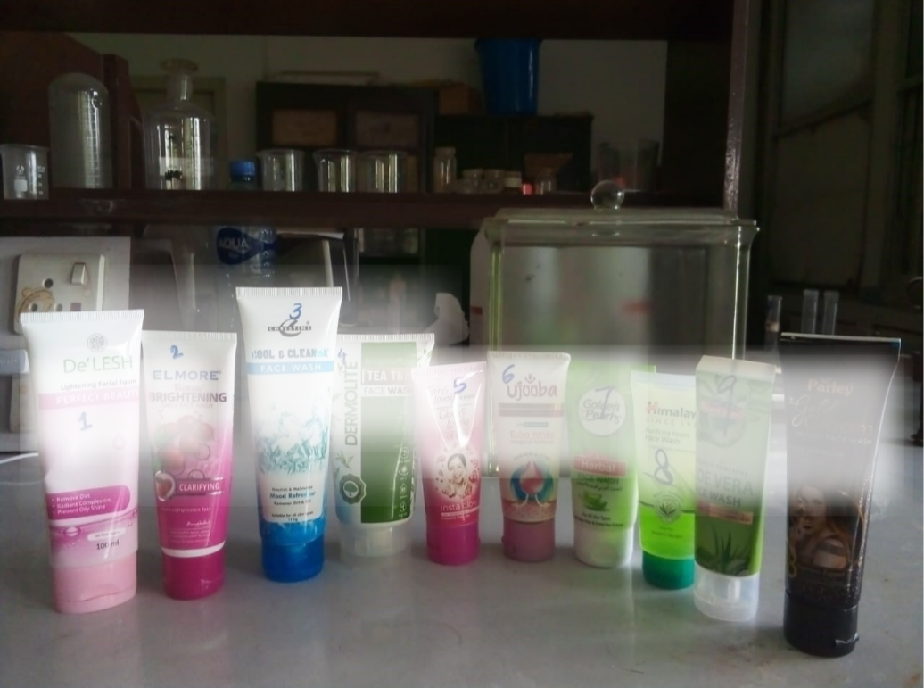
Figure 3.1 Face Wash Samples

Table 3.1 Question used in the questionnaire for the Survey
Sr. | Question
1 | Gender
2 | What is your age group?
3 | What is your highest level of education?
4 | How often do you use Face wash?
5 | How frequently do you use face wash?
6 | Which local brand of face wash do you use most frequently?
7 | What are the main reasons for using face wash?
8 | Are you aware of the ingredients used in face wash?
9 | Have you heard of the following harmful substances in face wash?
10 | Are you aware of any long-term health risks linked to the use of face wash (e.g., skin thinning, skin infection)?
11 | Have you ever experienced side effects from using face wash?
12 | Do you believe heavy metals and steroids are used in face wash due to a lack of regulation in Pakistan?

Determination of Heavy Metal Concentration:

Preparation of Samples:
The standard procedures were used to prepare the samples in order to have heavy metal analysis. Each of the samples was weighed in the evaporating dish to the approximate 5 grams and placed in an electric oven. They dried the samples in the oven at the temperature of 100 ℃ approximately thirty minutes. Thereafter, the plates where the samples had been placed were loaded on a furnace and heated to 525 ℃ temperature in five hours. Ashes in white color, which had no carbon content were obtained.

Digestion and Dilution of Samples:
Each sample was digested in about 5 mL aqua regia or made up of HNO 3 and HCl in a 3:1 ratio on a hot plate at 80-85 o C and the reagent volume displaced to 1 mL or equivalently containing 1 mL of sample included in 5 mL of aqua regia. Subsequently, 3.0 ml of concentrated acid mixture was again added in order to digest it completely and to get the final white-colored residue. This was followed by dissolving the digested samples to 10 mL of distilled water, and filtration using Whatman No. 1 filter paper. Thereafter, the standards were done after which the samples were tested with atomic absorption spectrophotometer.
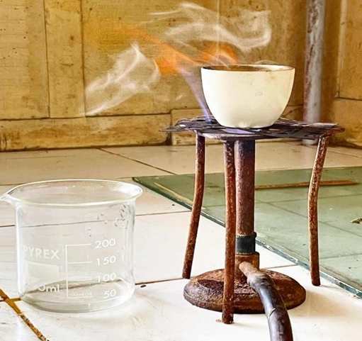
Figure 3.2 Samples during digestion and dilution (a)
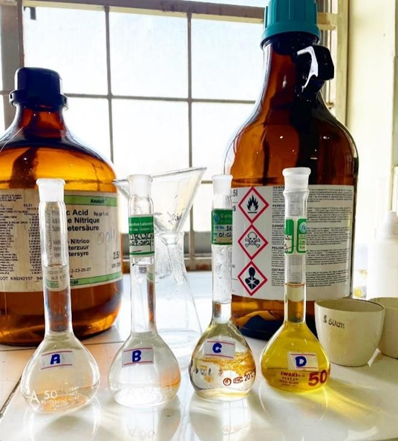
Figure 3.3 Samples during digestion and dilution (b)

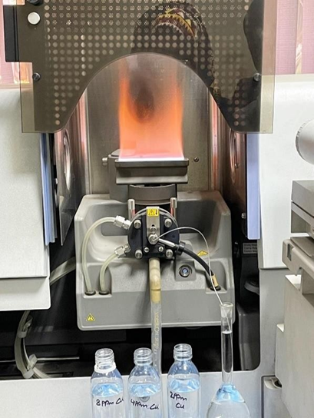
Figure 3.4 Blank solution run to calibrate the instrument

Standards Preparation:
Standard solutions for metals were prepared for the following concentrations: 2 ppm, 4 ppm, and 6 ppm. Cadmium standards of 5 ppm, 10 ppm, and 15 ppm were prepared. For instance, a stock solution of 1000 ppm was prepared to obtain a 100-ppm solution, from which 2, 4, and 6 ppm samples were prepared as follows: 2 mL of the sample was taken from the 100-ppm solution, and 98 mL of distilled water was added. This is done by following the formula:
C₁V₁ = C₂V₂

Analysis of Samples:
First, the blank solution was run to calibrate the instrument. Thirty samples of face wash were labelled. Samples were run after preparing standards and calibrating the instrument for the detection of copper, cadmium, nickel, lead, and chromium. Samples were prepared and analyzed at the Pakistan Council of Scientific and Industrial Research (PCSIR) in Lahore.

Determination of Steroids (Cortisone & Betamethasone):

HPLC Conditions:
- Isocratic HPLC system
- Temperature: 30 ◦C
- Wavelength: 240 nm
- Column: 250 mmL, 4.6 mm ID, C-18, (Octadecyl-silica) ODS, reverse phase
- Flow rate: 1 mL/minute
- Mobile phase: methanol: water mixture (40:60)
- Detector: UV (ultraviolet), with range 190–700 nm
- Extraction: Liquid/liquid extraction
- Pump: Reciprocating pump

Preparation of Standard and its Stock Solution:
1 gram of steroids was taken and dissolved in 100 mL of ethanol to prepare a standard solution. Betamethasone and cortisone were added as internal standards (ISTD). To prevent deterioration and exposure to light, the standard stock solution was stored in amber glass vials.

Mobile Phase Preparation:
The mobile phase was prepared as a mixture (acetonitrile:methanol: water mixture 40:40:20) by adding about 100 mL methanol solution to about 150 mL of DW and then heating after which it was kept to cool at room temperature after about 20 min, then the solution was sonicated in the ultrasonic bath to degas the mobile phase.

Preparation of Face Wash Sample:
A 5g sample of FW was precisely weighed using an analytical balance and diluted with 15 mL of mobile phase. The mixture was homogenized at 60 °C for 30 minutes on a hot plate. Fats and waxes precipitated and were filtered out using filter paper. The filtrate was then diluted to 25 mL with mobile phase in a measuring flask and used as the sample.

UV-High Performance Liquid Chromatography Procedure:
Introduced the mobile phase into the HPLC for 30 minutes to stabilize the baseline. Injected 20 µL of steroid standard solutions and recorded chromatograms at wavelengths of 240 nm and constructed a calibration curve by plotting peak areas against sample concentrations. Filtered the sample through a 0.45 µm filter to remove particulates, and then injected the sample into the HPLC system to record the calibration curve and calculate the concentration of steroids. The percentage of steroids were calculated by using the following equation:
$$\text{\%}\text{age} \text{of} \text{steroid}\text{=}\frac{\text{Area} \text{of} \text{Sample}}{\text{Area} \text{of} \text{Standard}} \text{x}\text{ 100}$$

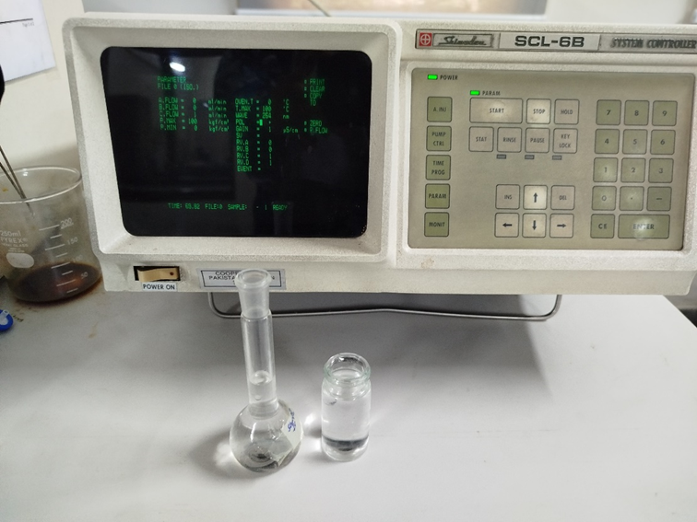
Figure 3.5 Samples detection on HPLC (a)

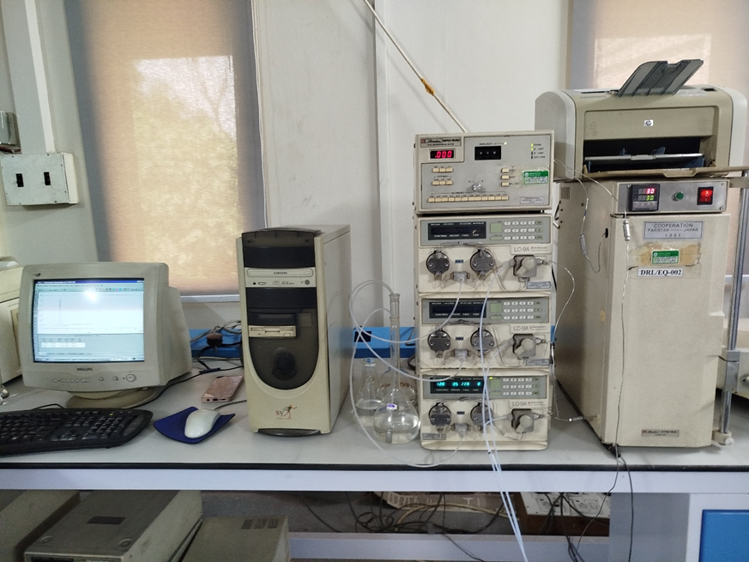
Figure 3.6 Samples detection on HPLC (b)

Health Risk Assessment:
The Chronic Daily Intake (CDI) measures the amount of a substance to which a person is exposed daily over an extended period, primarily through skin absorption. Each variable in the formula represents an important factor in this exposure route. CS indicates the concentration of the contaminant in the samples that come into contact with the skin. SA signifies the part of the body surface exposed to the contaminant, while AF indicates how much of the sample containing the contaminant sticks to the skin. ABS is a key parameter, showing the percentage of the contaminant that penetrates the skin and enters the bloodstream. EF and ED describe the timing of exposure, indicating how often and for how long contact occurs. CF ensures consistency in units across all parameters. Finally, AT and BW divide the consumption during the exposure period and to the body weight of the person, respectively, giving a value of chronic daily intake per kilogram of body weight.

$$CDI= \frac{CS×SA×AF×ABS×EF×ED×CF}{AT×BW}$$
Where:
CS: Metal Concentration in the Sample SA: Exposed Skin Area AF: Adherence Factor
ABS: Dermal Absorption Fraction EF: Exposure Frequency ED: Exposure Duration
CF: Unit Conversion Factor AT: Averaging Time for Non-carcinogens
BW: Body Weight
The long-term exposure potential negative health impacts are evaluated by the use of Hazard Quotient (HQ) formula. The HQ compares the calculated CDI against the Absorbed Reference Dose of Dermal Exposure, or rather the "RfDderm". RfDderm is a major reference toxicology point, which is an estimation of a daily dermal contact with substance that has the ability of not producing harmful effects throughout a lifetime. HQ value above 1 usually means that the estimated exposure is higher than the reference dose and there is a potential risk of an adverse health effect and in such case further study or risk management should be conducted. HQ of 1 and less usually shows that the exposure is less than the level where effects are anticipated. The combination of these formulas offers a methodological way to assess and control risks of dermal exposure to environmental contaminants hence improving the protection of the health of the population.

$$HQ= \frac{CDI}{RfDderm}$$
Where:
CDI: Chronic Daily Intake RfDderm: Absorbed Reference Dose for Dermal Exposure

Table 3.2 Input Parameters for Chronic Daily Intake
Variables in the formula used | Values
Exposed Skin Area (SA) | 5700 cm² (Ali et al., 2024)
Adherence Factor (AF) | 0.07 mg/cm² (Mansouri et al., 2018)
Dermal Absorption Fraction (ABS) | 0.001 (Ali et al., 2024)
Exposure frequency (EF) | 365 days/ year (USEPA et al., 2009)
Exposure duration (ED) | 30 years (Alam et al., 2019)
Unit Conversion Factor (CF) | 10⁻⁶ mg/kg(Ali et al., 2024)
Average Time (AT) | 365days/ year ED (Ali et al., 2024)
Body Weight (BW) | 70 kg (Mansouri et al., 2018)

Table 3.3 Reference dose for dermal exposure associated with Heavy metals
Heavy Metals | RfD (µg/kg-d)
Cd | 10 (USEPA et al., 2009)
Cr | 3 (Mansouri et al., 2018)
Cu | 20 (Mansouri et al., 2018)
Pb | 3 (USEPA et al., 2009)
Ni | 20 (Mansouri et al., 2018)

Analysis
The data of the atomic absorption spectrophotometer and the HPLC were compared. This was done by calculating mean concentrations and standard deviations of all the samples using Microsoft Excel which gave them in the form of Bars. The tool was applied to determine the maximum and minimum levels of the heavy metals and steroids in various samples easily.

Chapter 4

Results
In this chapter, the results of the study including physicochemical characteristics of face wash samples, heavy metals and steroidal content, and the human health risk assessment (CDI and HQ) as well as the findings of the consumer survey. The results were analyzed in each segment regarding to the research objectives and they were compared with the international standards and the existing literature.

Consumer Awareness and Perceptions (Survey Results):
This section incorporates a consumer survey to discuss the critical information of awareness of the population and the use of face wash products, and their perceived health outcomes, which completes the quantitative analytical findings by identifying the human component of exposure and risk perception, and the respective mitigation measures.

Demographic Information:
The population surveyed, shown in Figures 4.1-4.3, consisted mostly of females (71%) and mostly young adults between the ages of 18-24 (46.5%) and 25-34 (43%), with large majority (94%) holding university degree or above. This population characteristic indicates that the group of young educated women is one of the main consumers of face wash, which may affect their awareness rate and habits of exposure.

Figure 4.1 Gender Percentage

Figure 4.2 Age Groups of People Surveyed

Figure 4.3 Education Level of Surveyed People

Usage Patterns:
Figures 4.4-4.6 illustrate the prevalent usage habits. Himalaya, Fair & Lovely, and Parley emerged as the most commonly used brands (15%, 11.5%, and 9.5%, respectively), indicating substantial market presence and widespread consumer exposure. A significant 74% of respondents reported daily face wash use, 10.5% use it weekly, and 15.5% use it occasionally, with 40% applying it once a day and 34% applying it multiple times daily.

Figure 4.4 List of Face Wash Brands Used by People

Figure 4.5 How Often Do You Use Face Wash?

Figure 4.6 How Frequently Do You Use Face Wash?

Awareness of Harmful Substances and Ingredients:
Consumer awareness remains a critical factor in risk mitigation. Figure 4.7 reveals that 55.5% of respondents were unaware of the presence of heavy metals or steroids in face washes, with only 32% aware of both. This lack of specific knowledge is further supported by Figure 4.9, which shows that 43.5% of consumers do not regularly read or understand ingredient lists. Interestingly, 79% of respondents (Figure 4.8) attributed the use of harmful substances to inadequate regulation in Pakistan.

Figure 4.7 Have You Heard of The Following Harmful Substances (Heavy Metals, Steroids) in Face Wash?

Figure 4.8 Do You Believe Heavy Metals and Steroids are used in Face Wash Due to a Lack of Regulation in Pakistan?

Figure 4.9 Are You Aware of The Ingredients Used in Face Wash?

Perceived Effects and Health Risks:
Despite a general lack of awareness (65.5%) of potential long-term health risks associated with face wash use (Figure 4.10), a substantial number of consumers reported experiencing side effects. The most frequent adverse effects included thinning of the skin (18%), skin irritation (itching, burning) (15%), and darkening of the skin (7.5%). 33.5% of respondents reported no effect due to the use of face wash. These reported short-term effects, although not definitively linked to heavy metals in this study, are consistent with symptoms of dermal irritation and allergic reactions that various cosmetic ingredients, including certain heavy metals such as nickel and chromium, can trigger.

Figure 4.10 Are You Aware of Any Long-term Health Risks Linked to the Use of Face Wash (e.g., skin thinning, skin infection)?

Table 4.1 Have You Ever Experienced Any of The Following Side Effects from Using Face Wash?
Sr. No. | Description | Percentage
Effect 1 | Acne, or Pimples | 4%
Effect 2 | Darkening of the Skin | 7.5%
Effect 3 | Redness, or Rashes | 7%
Effect 4 | Thinning of the Skin | 18%
Effect 5 | Skin Irritation (itching, burning) | 15%
Effect 6 | I've never experienced any side effects | 0.5%
Effect 7 | Darkening of the Skin; Thinning of the Skin | 1%
Effect 8 | Redness, or Rashes; Acne or Pimples | 0.5%
Effect 9 | Acne or Pimples; Thinning of the Skin | 1.5%
Effect 10 | Skin Irritation (itching, burning); Thinning of the Skin | 3.5%
Effect 11 | Skin Irritation (itching, burning); Acne, or Pimples | 1.5%
Effect 12 | Skin Irritation (itching, burning); Redness, or Rashes | 1%
Effect 13 | Skin Irritation (itching, burning), Darkening of the Skin | 2%
Effect 14 | Skin Irritation (itching, burning); Redness, or Rashes; Darkening of the Skin; Acne, or Pimples; Thinning of the Skin | 1%
Effect 15 | Skin Irritation (itching, burning); Redness, or Rashes; Acne, or Pimples | 1%
Effect 16 | Skin Irritation (itching, burning); Redness, or Rashes; I've never experienced any side effects | 0.5%
Effect 17 | Skin Irritation (itching, burning); Redness, or Rashes; Darkening of the Skin; Acne, or Pimples | 1%
None | Skin Irritation (itching, burning); Acne, or Pimples; I've never experienced any side effects | 33.5%

Main Reasons for Using Face Wash:
Consumer motivations, as shown in Figure 4.11, were primarily focused on acne reduction (37%), followed by dark spot and pigmentation reduction (34.5%), and skin tone lightening (28.5%). These findings indicate that consumers often prioritize aesthetic benefits, which may inadvertently expose them to risks if products contain undisclosed harmful substances.

Figure 4.11 What are the Main reasons for Using Face Wash?

Table 4.2 Questionnaire Results
Variables | Description | Result Percentage
Gender | Male | 29%
Gender | Female | 71%
Age Group | Under 18 | 1.5%
Age Group | 18-24 | 46.5%
Age Group | 25-34 | 43%
Age Group | Above 35 | 9%
Level of Education | No Formal Education | 0%
Level of Education | Primary School | 0%
Level of Education | High School | 6%
Level of Education | University | 94%
How often do you use FW | Daily | 74%
How often do you use FW | Weekly | 10.5%
How often do you use FW | Occasionally | 15.5%
Frequent use of FW | Multiple times a day | 34%
Frequent use of FW | Once a day | 40%
Frequent use of FW | A few times a week | 13.5%
Frequent use of FW | Once a week | 12.5%
Main reasons for using FW? | Skin tone lightening | 34.5%
Main reasons for using FW? | Dark spots or pigmentation reduction | 28.5%
Main reasons for using FW? | Acne reduction | 37%
Awareness of Ingredients | Yes | 56.5%
Awareness of Ingredients | No | 43.5%
Have you heard of the following harmful substances in FW? | heavy metals | 6.5%
Have you heard of the following harmful substances in FW? | Steroids | 6%
Have you heard of the following harmful substances in FW? | Both | 32%
Have you heard of the following harmful substances in FW? | I don't know about any harmful substances | 55.5%
Are you aware of any long-term health risks linked to the use of FW (e.g., skin thinning, skin infection)? | Yes | 34.5%
 | No | 65.5%
Have you ever experienced side effects from using FW? | Yes | 66.5%
Have you ever experienced side effects from using FW? | No | 33.5%
Do you believe heavy metals and steroids are used in FW due to a lack of regulation in Pakistan? | Yes | 79%
 | No | 21%

Physicochemical Parameters of Face Wash Samples:
The fundamental physicochemical properties of the analyzed face wash samples, namely pH and temperature, are crucial indicators of product quality, stability, and potential dermal compatibility.

pH Levels:
The pH values obtained for the various face wash samples, as illustrated in Figure 4.12, generally fell within the range of 5.9 to 7.7. Notably, no samples were found to have pH values within the optimal range for healthy skin 4.5-5.75 (California Skin Institute, 2023). All pH values were above this healthy range. For instance, Sample 8 recorded the highest pH at 7.7, while Sample 10 showed the lowest at 5.9. Face washes with excessively alkaline pH can disrupt this protective layer, potentially leading to dryness, irritation, and increased susceptibility to bacterial or fungal infections. Conversely, highly acidic formulations might also cause skin sensitivity and redness. The observed deviations in several samples highlight a potential concern regarding dermal compatibility and reinforce the importance of maintaining a pH balance in cosmetic formulations, consistent with dermatological recommendations.

Temperature Levels:
Figure 4.13 presents the temperature measurements recorded for the face wash samples during analysis, which ranged from 22.2 to 26.5°C, with an average temperature of 24.17 °C. These readings reflect the ambient conditions under which the samples were analyzed rather than an intrinsic property of the product itself. Although temperature is not a direct chemical parameter, e.g. pH, it is an essential parameter that impacts on stability and integrity of cosmetic formulations in storage, transportation and usage of cosmetics.

Table 4.3 Results of Temperature and pH
Sr. No. |  | Temperature | pH
FWS 1 | Mean | 22.33333 | 6.33
FWS 1 | Standard Deviation | ±0.471405 | ±0.471405
FWS 2 | Mean | 22.83333 | 6.17
FWS 2 | Standard Deviation | ±0.235702 | ±0.235702
FWS 3 | Mean | 22.16667 | 7.30
FWS 3 | Standard Deviation | ±0.849837 | ±0.216025
FWS 4 | Mean | 23.66667 | 6.30
FWS 4 | Standard Deviation | ±0.471405 | ±0.216025
FWS 5 | Mean | 24.5 | 6.83
FWS 5 | Standard Deviation | ±0.408248 | ±0.235702
FWS 6 | Mean | 24.66667 | 7.22
FWS 6 | Standard Deviation | ±0.471405 | ±0.207579
FWS 7 | Mean | 25.66667 | 7
FWS 7 | Standard Deviation | ±0.471405 | ±0.408248
FWS 8 | Mean | 26.5 | 7.67
FWS 8 | Standard Deviation | ±0.408248 | ±0.235702
FWS 9 | Mean | 24.66667 | 6.43
FWS 9 | Standard Deviation | ±0.235702 | ±0.329983
FWS 10 | Mean | 24.66667 | 5.90
FWS 10 | Standard Deviation | ±0.471405 | ±0.08165
Optimal Range for Healthy Skin |  | 4.5-5.75

Concentrations of Heavy Metals in Face Wash Samples:
In this section, the concentrations of five major heavy metals (Cadmium, Chromium, Nickel, Lead, and Copper) that were found in the samples of locally manufactured face wash addressing the first objective. The fact that heavy metals in cosmetic products are not only present in high concentrations but also in minor amounts is a great cause of concern because they might be toxic and accumulate in the human body (Borowska & BrzOska et al., 2015; Ghaderpoori et al., 2020).

Cadmium (Cd) Concentration:
In Figure 4.12 the concentration of Cd in the samples of face wash analyzed was graphically illustrated. Cadmium was detected in 7 samples in a range of 0 to 1.06 ppm. In particular, FWS-10 had the maximum Cd concentration of 1.06 ppm that exceeded the common tracing impurity levels of the EU and WHO but not exceeding the USFDA. FWS-3 (0.93 ppm), FWS-1 (0.66 ppm), FWS-6 (0.63 ppm) also had the concentration that surpassed EU and WHO limits. On the contrary, the concentration of FWS-9 (0.24 ppm), FWS-2 (0.13 ppm) and FWS-5 (0.03 ppm) were within the EU, WHO and USFDA values. In the remaining three samples the concentration was zero (Slave & Sonwane, 2015) similarly found detectable cadmium levels in face wash samples in India, attributing their presence to poor manufacturing practices and raw material contamination, further supporting the concerns raised by the current findings. Majority of the eye pencil samples in Pakistan also have detectable cadmium levels that vary between 0.07 and 1.93 (Habib et al., 2024).

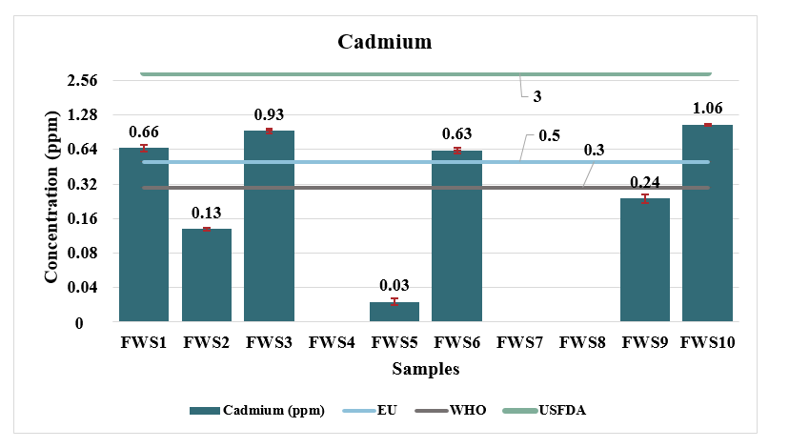
Figure 4.12 Cadmium Concentration in Different Samples of Face Wash

Chromium (Cr) Concentration
The concentrations of Chromium (Cr) in different samples of face wash are depicted in figure 4.13. Chromium was detected in 70 percent of the samples and the measured values were between 0-0.93 ppm. The highest concentration of Cr was measured in FWS 10 with 0.93 ppm. All of the samples were under the EU and USFDA limits. Chromium was also found in FWS-5 (0.72 ppm), FWS-1 (0.47 ppm), FWS-8 (0.33 ppm), FWS-9 (0.18 ppm), FWS-3 (0.05 ppm) and FWS-4 (0.04 ppm). The other three samples were of zero concentration. Compared to the study conducted by (Rasheed et al., 2023), the concentrations of Cr in the cosmetics that are sold in Quetta, Pakistan, were relatively higher and associated with several complications, such as systemic toxicity, allergies, and dermatitis. In their study, (Ehsan et al., 2024) discovered that the concentration of Cr among whitening creams found in the local market of Pakistan was between 0.16 and 0.74, which is also relatable to our research.
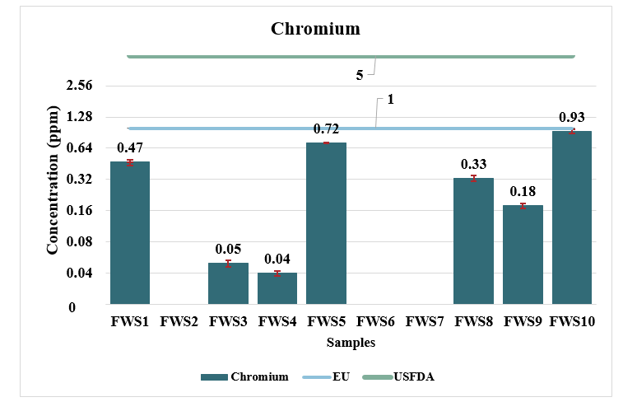Figure 4.13 Chromium Concentration in Different Samples of Face Wash

Nickel (Ni) Concentration
Figure 4.14 indicates the Nickel (Ni) concentrations of the face wash samples. Nickel was found in 6 samples (60 percent), with the minimum and maximum concentration of 0 and 0.68 ppm respectively. The concentration of Ni was the highest in FWS 7 at 0.68 ppm. The samples were found below the EU, WHO and the USFDA limits. Nickel is a widely spread epidemiologically common contact allergen and presence in cosmetic products is a known risk factor of allergic contact dermatitis (Borowska & Brzoska et al., 2015). There was also a detectable concentration in FWS 2 (0.46 ppm), FWS 3 (0.27 ppm), FWS 4 (0.02 ppm), FWS 8 (0.07 ppm) and FWS 10 (0.08 ppm). Four of the samples had no concentrations. In the same way, nickel is present in large quantities in most of the cosmetic products sold in Jordan, which indicate of its widespread use and possible side effects (Ababneh & Al-Momani et al., 2018).

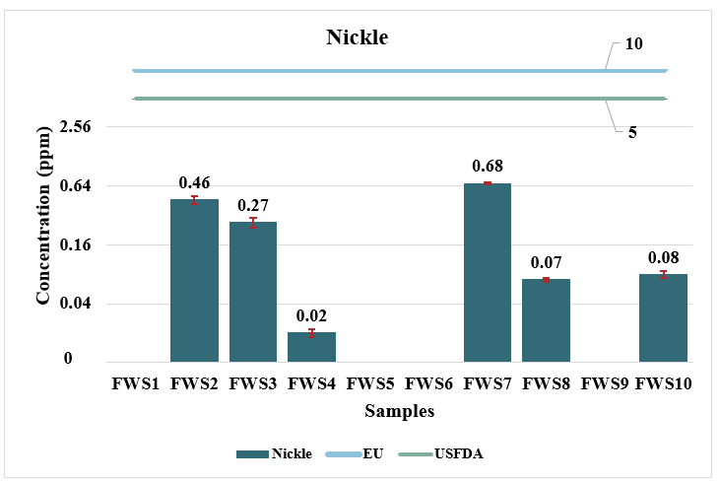
Figure 4.14 Nickel Concentration in Different Samples of Face Wash

Lead Concentration
Figure 4.15 presents the concentrations of Lead (Pb) noticed in the face wash samples. Lead was found in 8 out of 10 samples, with concentrations ranging from 0 to 1.26 ppm. Notably, FWS 3 showed the highest Lead concentration. Most samples exceed the EU and WHO limits but are below the USFDA limits. FWS-1 (0.95 ppm), FWS-2 (0.73 ppm), FWS-4 (0.23 ppm), FWS-6 (0.94 ppm), FWS-7 (1.13 ppm), FWS-8 (0.14 ppm), and FWS-10 (0.64 ppm) also contained lead. The remaining two samples had zero concentrations. Studies by (Dinake et al., 2023) and (Alam et al., 2019) in Botswana and Bangladesh, respectively, consistently reported lead levels in cosmetics exceeding international safety limits, indicating a global challenge in controlling lead contamination. Furthermore, Ullah et al., 2017 found particularly high mean levels of lead in cosmetics sold in Pakistan, reinforcing the findings of the present study. (Quds et al., 2021) An analysis of herbal products available in Pakistan found lead (Pb) in the products, ranging from 0.034 to 1.078, which also supports the findings from our research.

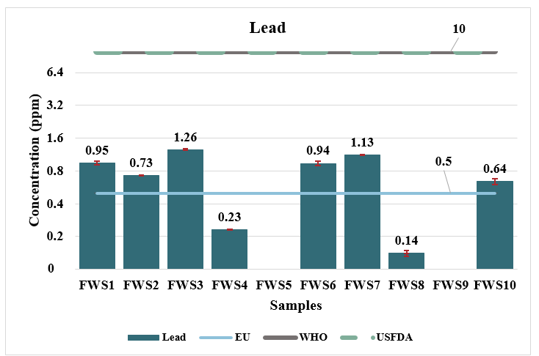
Figure 4.15 Lead Concentration in Different Samples of Face Wash

Copper (Cu) Concentration
The Copper (Cu) concentrations in the face wash samples are displayed in Figure 4.16. Copper was detected in 5 out of 10 samples, with concentrations varying from 0 to 0.66 ppm. FWS 4 showed the highest Cu concentration at 0.66 ppm. There are no standard limits established by the WHO, the USFDA, or the EU for copper in cosmetic products. FWS-1 (0.22 ppm), FWS-6 (0.26 ppm), FWS-8 (0.09 ppm), and FWS-9 (0.05 ppm) also had detectable concentrations. All the samples were below the permissible limit of the EU. The remaining five samples had zero concentrations. (Rasheed et al., 2023) also observed comparatively greater concentrations of copper in cosmetics in Pakistan, highlighting the presence of this metal in cosmetic products. (Ullah et al., 2017) found copper ranging from 0.031 to 6.036 in cosmetic products in Pakistan, which strengthens the result of our research.

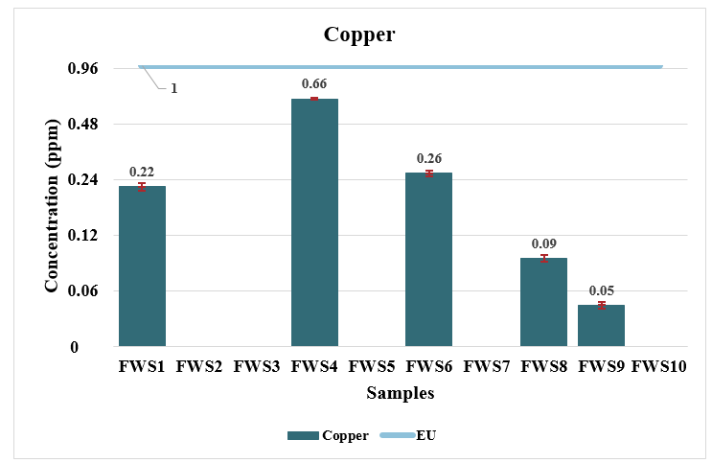
Figure 4.16 Copper Concentration in Different Samples of Face Wash

Comparison of Different Heavy Metal Concentrations
Table 4.4 provides a comprehensive comparative overview of the concentrations of all analyzed heavy metals across the different face wash samples. This aggregated view reveals that lead, chromium, and cadmium were generally detected at higher concentrations compared to copper and nickel across the samples. More particularly, in FWS 1, each of the heavy metals was at an alarming level. A significant problem is also the presence of multiple heavy metals in a single product, the interaction of which can be either synergistic or additive, eventually leading to the greater health risk to the consumers (Borowska & Brzoska et al., 2015; Lim et al., 2018). This comparative analysis also supports the magnitude of the contamination with heavy metals in the face washes and it is consistent with findings of the studies carried out in research. To give an example, (Arshad et al., 2020) highlighted the excess of lead and nickel quantities in lotions and sunblock, as well as products for which the concentrations exceeded the acceptable rates of cancer risk during the lifetime. Along the same lines, (Kader Mohiuddin et al., 2019) gave a detailed explanation of how most of cosmetic products contain toxic heavy metals that include lead, cadmium and chromium and these products do not possess a mechanism to monitor and regulate them in low-income countries. Additional evidence of the tendencies described and the diligence of quality control requirements in cosmetics can also be confirmed by the results of (Morshed, 2017), which also showed high lead and chromium concentrations in face wash products in Bangladesh, especially in the herbal type of these products. Their repetitive identification in various studies and products contributes strongly to the necessity of stricter control and constant surveillance to protect the buyers (Massadeh et al., 2017; Nasirudeen & Amaechi et al., 2015; Ruiz et al., 2019; Saadatzadeh et al., 2019).

Table 4.4 Heavy metal concentration results
Sr. No. |  | Cd(ppm) | Cr(ppm) | Cu(ppm) | Pb(ppm) | Ni(ppm)
EU |  | 0.5 | 1 | 1 | 0.5 | 10
WHO |  | 0.3 | - | - | 10 | -
USFDA |  | 3 | 5 | - | 10 | 5
FWS 1 | Mean | 0.66 | 0.47 | 0.22 | 0.95 | -
FWS 1 | Standard Deviation | ±0.047140 | ±0.032998 | ±0.018856 | ±0.047140 | -
FWS 2 | Mean | 0.13 | - | - | 0.73 | 0.46
FWS 2 | Standard Deviation | ±0.004714 | - | - | ±0.005428 | ±0.047140
FWS 3 | Mean | 0.93 | 0.05 | - | 1.26 | 0.2
FWS 3 | Standard Deviation | ±0.047140 | ±0.004714 | - | ±0.028674 | ±0.032998
FWS 4 | Mean | - | 0.04 | 0.66 | 0.23 | 0.02
FWS 4 | Standard Deviation | - | ±0.028284 | ±0.017140 | ±0.047140 | ±0.004156
FWS 5 | Mean | 0.03 | 0.72 | - | - | -
FWS 5 | Standard Deviation | ±0.002160 | ±0.016330 | - | - | -
FWS 6 | Mean | 0.63 | - | 0.26 | 0.94 | -
FWS 6 | Standard Deviation | ±0.047140 | - | ±0.009188 | ±0.041899 | -
FWS 7 | Mean | - | - | - | 1.13 | 0sss
FWS 7 | Standard Deviation | - | - | - | ±0.015480 | ±0.023570
FWS 8 | Mean | - | 0.33 | 0.09 | 0.14 | 0.07
FWS 8 | Standard Deviation | - | ±0.027140 | ±0.004714 | ±0.008987 | ±0.004714
FWS 9 | Mean | 0.24 | 0.18 | 0.05 | - | -
FWS 9 | Standard Deviation | ±0.041899 | ±0.016330 | ±0.004190 | - | -
FWS 10 | Mean | 1.06 | 0.93 | - | 0.64 | 0.08
FWS 10 | Standard Deviation | ±0.024722 | ±0.047140 | - | ±0.043205 | ±0.006878

Human Health Risk Assessment:
This section directly points at the second research objective: What are the possible health risks of using face washes with these substances? The human health risk assessment was attained by computing the Chronic Daily Intake (CDI) and Hazard Quotient (HQ) of each determined heavy metal, with a quantitative assessment of the possible non-carcinogenic health risk.

Chronic Daily Intake (CDI):
The Chronic Daily Intake (CDI) is an amount of exposure to a substance on a daily basis and over a long run. For this study, CDI values were estimated for several heavy metals found in facewash samples, specifically Cadmium (Cd), Chromium (Cr), Nickel (Ni), Lead (Pb), and Copper (Cu). These estimations are based on measured concentrations within the samples and typical usage patterns.

The calculated CDI values, presented in Table 4.5, represent the estimated daily dermal exposure to these metals. The ranges are as follows:
- Cadmium (Cd): 0 to 7.24×10⁻¹
- Chromium (Cr): 0 to 6.35×10⁻¹
- Nickel (Ni): 0 to 4.64×10⁻¹
- Lead (Pb): 0 to 8.61×10⁻¹
- Copper (Cu): 0 to 4.51×10⁻¹
These CDI values were determined using reasonable assumptions regarding the frequency and amount of facewash application.

Hazard Quotient (HQ)
Hazard Quotient (HQ) is very important indicator of the possible non-carcinogenic health risks which is calculated by dividing the estimated value of exposure (Chronic Daily Intake, CDI) to a reference dose (RfD) substance or chemical compound-specific. An HQ greater than 1 is usually an indication of the scope of negative health impact and an HQ less than 1 is used when there is no possibility of negative health results due to the daily exposure.

The HQ values for Cadmium (Cd), Chromium (Cr), Nickel (Ni), Lead (Pb), and Copper (Cu) are presented in Table 4.5, quantitatively assessing the health risks in line with the second research objective. The calculated HQ ranges for these heavy metals are as follows:
- Cadmium (Cd): 0 to 7.24×10⁻²
- Chromium (Cr): 0 to 2.11×10⁻¹
- Nickel (Ni): 0 to 2.32×10⁻²
- Lead (Pb): 0 to 2.87×10⁻¹
- Copper (Cu): 0 to 2.25×10⁻²
While these calculated HQ values are consistently less than 1, suggesting that the non-carcinogenic risk from individual heavy metals in the analyzed samples is likely acceptable under the assumed exposure scenarios, it is imperative to acknowledge the potential for cumulative effects from exposure to multiple metals and from other environmental sources.

Table 4.5 Chronic Daily Intake (CDI) and Hazard Quotient (HQ)
Sample | CDI |  |  |  |  | HQ Values
Sample | Carcinogenic |  |  | Non-carcinogenic |  | Carcinogenic |  |  | Non-carcinogenic
Sample | Cadmium | Lead | Nickle | Chromium | Copper | Cadmium | Lead | Nickle | Chromium | Copper
FWS 1 | 4.51x10⁻¹ | 6.49x10⁻¹ | 0 | 3.20x10⁻¹ | 1.50x10⁻¹ | 4.51x10⁻² | 2.16x10⁻¹ | 0 | 1.07x10⁻¹ | 7.50x10⁻³
FWS 2 | 8.88x10⁻² | 4.98x10⁻¹ | 3.41x10⁻¹ | 0 | 0 | 8.88x10⁻³ | 2.32x10⁻¹ | 1.57x10⁻² | 0 | 0
FWS 3 | 6.53x10⁻¹ | 8.61x10⁻¹ | 1.84x10⁻¹ | 3.41x10⁻² | 0 | 6.35x10⁻² | 2.87x10⁻¹ | 9.20x10⁻³ | 1.13x10⁻² | 0
FWS 4 | 0 | 1.57x10⁻¹ | 1.36x10⁻² | 2.73x10⁻² | 4.51x10⁻¹ | 0 | 5.23x10⁻² | 6.80x10⁻⁴ | 9.10x10⁻² | 2.25x10⁻²
FWS 5 | 2.05x10⁻² | 0 | 0 | 4.92x10⁻¹ | 0 | 2.05x10⁻³ | 0 | 0 | 1.64x10⁻¹ | 0
FWS 6 | 4.30x10⁻¹ | 6.42x10⁻¹ | 0 | 0 | 1.77x10⁻¹ | 4.30x10⁻² | 2.14x10⁻¹ | 0 | 0 | 8.88x10⁻³
FWS 7 | 0 | 7.72x10⁻¹ | 4.64x10⁻¹ | 0 | 0 | 0 | 2.57x10⁻¹ | 2.32x10⁻² | 0 | 0
FWS 8 | 0 | 9.56x10⁻² | 4.78x10⁻² | 2.25x10⁻¹ | 6.15x10⁻² | 0 | 3.18x10⁻² | 2.39x10⁻³ | 7.50x10⁻² | 3.07x10⁻³
FWS 9 | 1.64x10⁻¹ | 0 | 0 | 1.23x10⁻¹ | 3.41x10⁻² | 1.64x10⁻² | 0 | 0 | 4.10x10⁻² | 1.72x10⁻³
FWS 10 | 7.24x10⁻¹ | 4.37x10⁻¹ | 5.46x10⁻² | 6.35x10⁻¹ | 0 | 7.24x10⁻² | 1.45x10⁻¹ | 2.73x10⁻³ | 2.11x10⁻¹ | 0

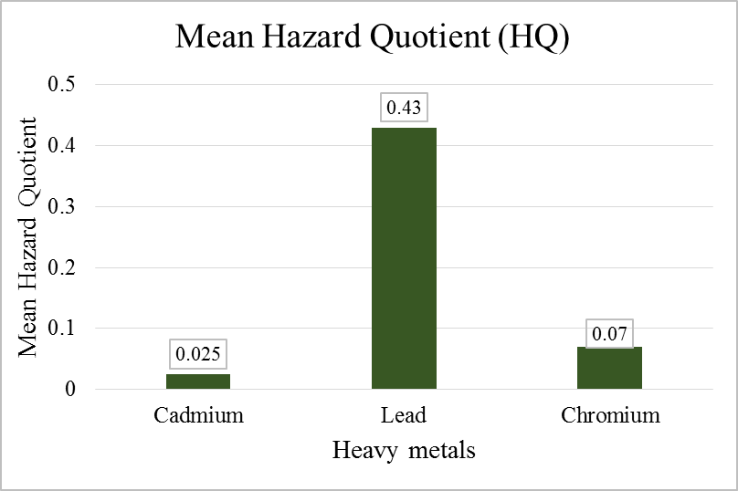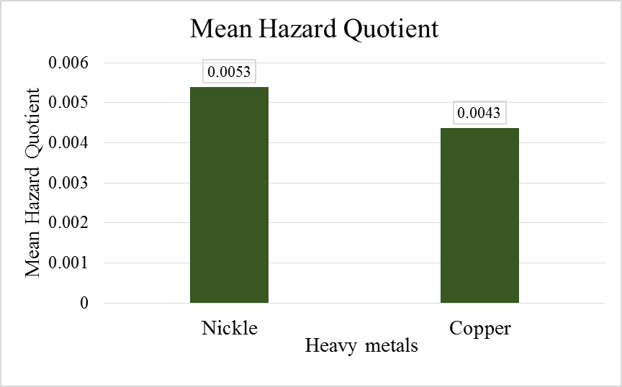
Figure 4.17 Hazard Quotient

Steroids
The analysis of ten facial wash samples for undeclared steroids revealed the presence of both betamethasone and hydrocortisone. As detailed in Table 4.6, 20% (2 out of 10) of the samples contained betamethasone, specifically FWS3 and FWS7, with concentrations ranging from 0.6 to 0.9. Hydrocortisone was detected in 40% (4 out of 10) of the samples (FWS2, FWS5, FWS7, and FWS9), at concentrations between 0.2 and 2.4. Notably, sample FWS7 contained both betamethasone and hydrocortisone.

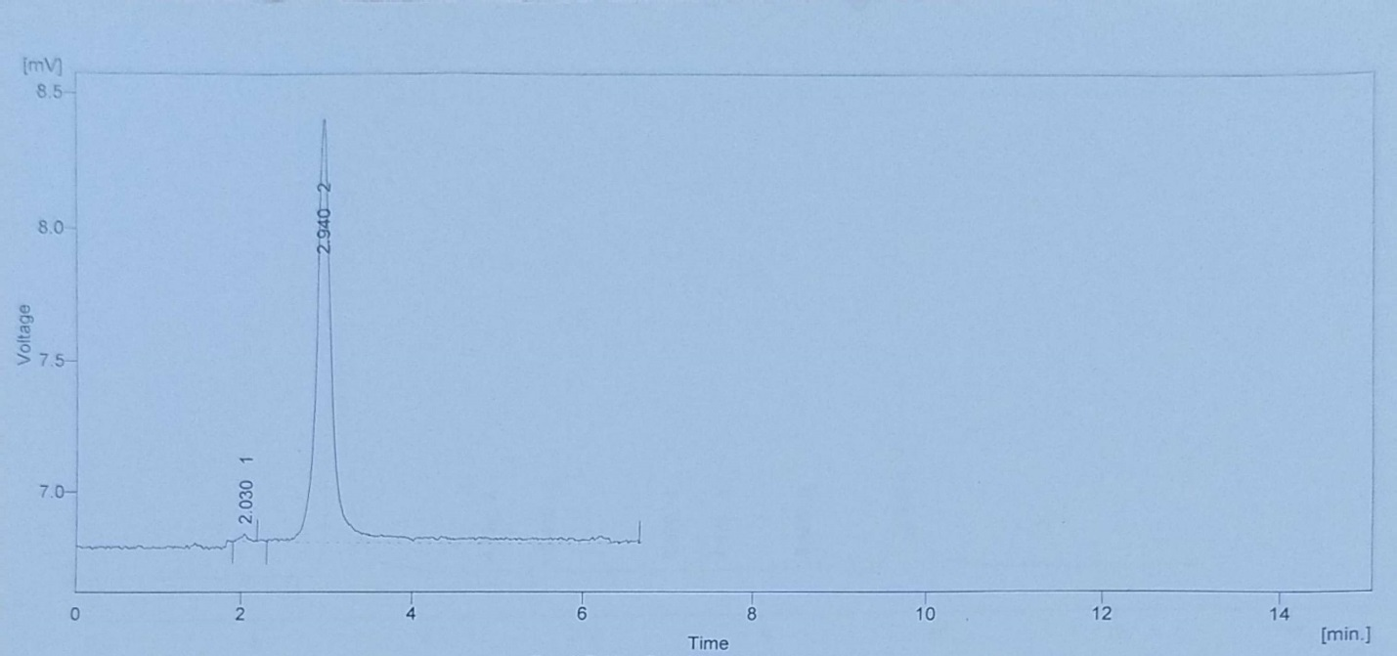
Figure 4.18 Hydrocortisone Standard Chromatograph

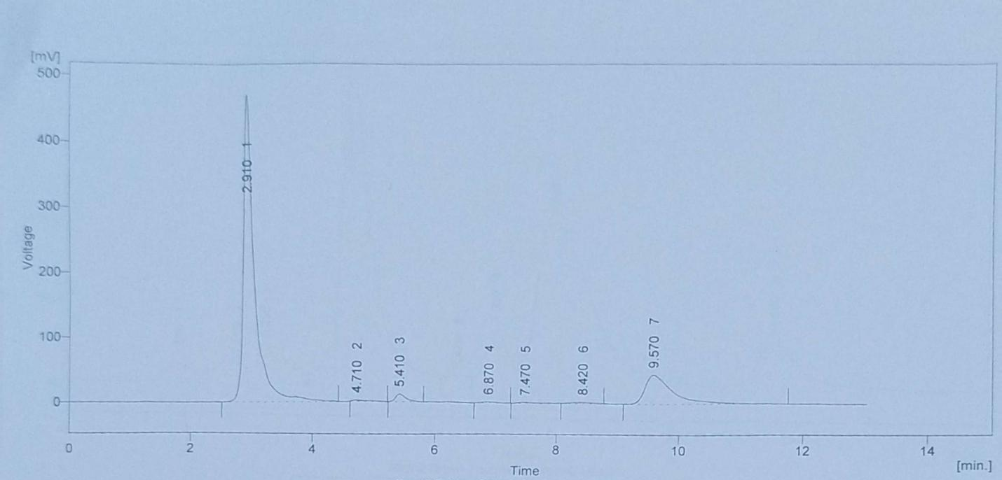
Figure 4.19 Hydrocortisone detected Chromatograph

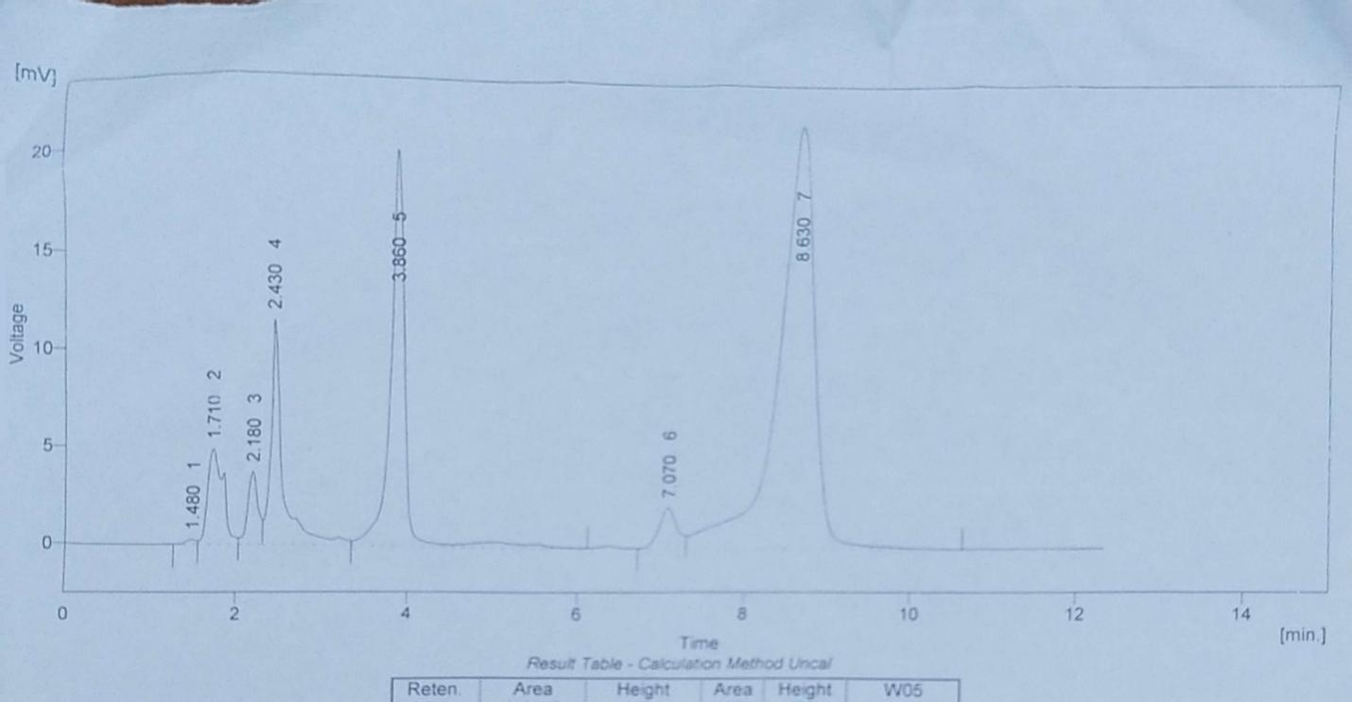
Figure 4.20 Hydrocortisone non-detected Chromatograph

The results correlate with the prior studies revealing the common problem of un-reported corticosteroids in cosmetic products, especially those available as skin-lighteners or anti-inflammatory products (Gimeno et al., 2016; Jaccob et al., 2019). As an example, the different corticosteroids such as betamethasone and hydrocortisone were found in cosmetic products in other areas by (Nam et al., 2012) and (Fiori & Andrisano et al., 2014). These active pharmaceutical ingredients in cosmetic products are of major concern because of their adverse effects and the severity of the effects which include permanent skin atrophy, steroid rosacea, perioral dermatitis, and steroid induced acne (Nam et al., 2012). The identification of several steroids in one sample, which is the case of FWS7, makes the composition of these formulations even more complex and risky.

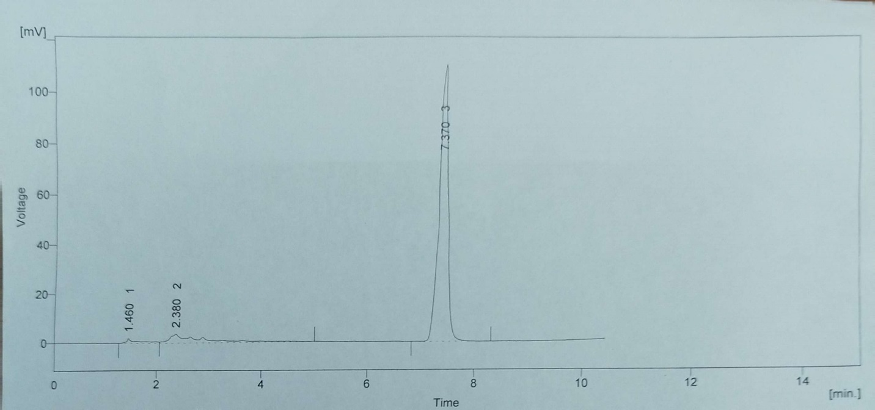
Figure 4.21 Betamethasone standard Chromatograph

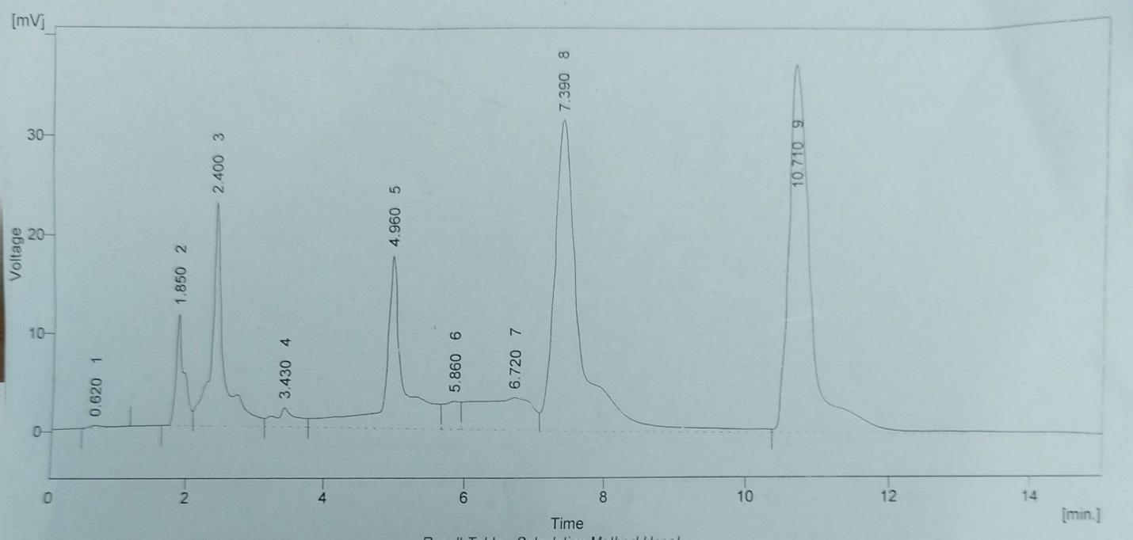
Figure 4.22 Betamethasone detected Chromatograph

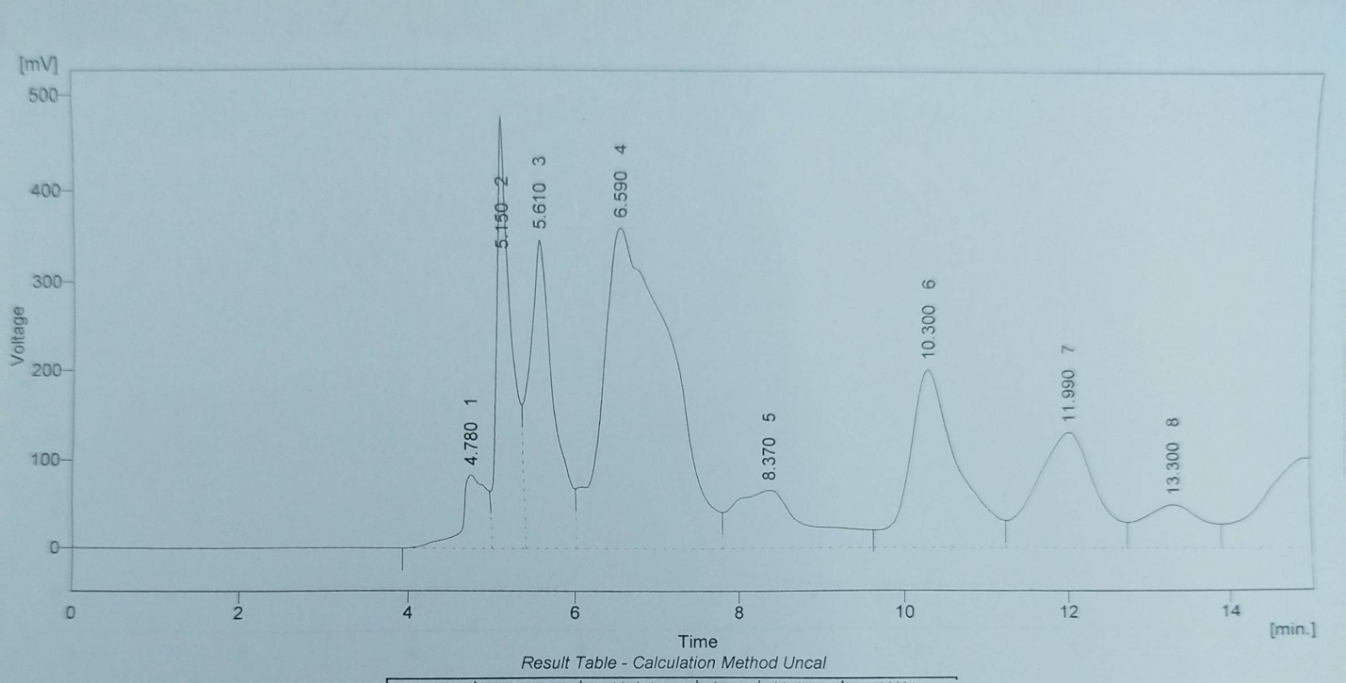
Figure 4.23 Betamethasone Non-detected Chromatograph

Table 4.6 Concentration of Steroids in Facewash Samples
Sr. No. |  | Betamethasone(%) | Hydrocortisone(%)
FWS 1 | Mean | - | -
FWS 1 | Standard Deviation | - | -
FWS 2 | Mean | - | 2.4
FWS 2 | Standard Deviation | - | ±0.09
FWS 3 | Mean | 0.9 | -
FWS 3 | Standard Deviation | ±0.01 | -
FWS 4 | Mean | - | -
FWS 4 | Standard Deviation | - | -
FWS 5 | Mean | - | 0.6
FWS 5 | Standard Deviation | - | ±0.08
FWS 6 | Mean | - | -
FWS 6 | Standard Deviation | - | -
FWS 7 | Mean | 0.6 | 0.2
FWS 7 | Standard Deviation | ±0.02 | ±0.08
FWS 8 | Mean | - | -
FWS 8 | Standard Deviation | - | -
FWS 9 | Mean | - | 0.7
FWS 9 | Standard Deviation | - | ±0.01
FWS 10 | Mean | - | -
FWS 10 | Standard Deviation | - | -

Cosmetics and the Environment
The third research objective of this section is: What is the effect of cosmetic products to the environment? A number of cosmetic products have different chemicals incorporated that include additives, fragrances, preservatives, stabilizers, surfactants, dyes and shine enhancers that are used by people all over the world. Consequently, various ways are usually used to dispose of such chemicals into the environment (Bilal et al., 2020). Despite ongoing efforts to address environmental pollution, the significant impact of cosmetics is often overlooked. The presence of hazardous substances of cosmetic products in water can occur in numerous ways, such as direct discharge of the product in the sewage system, poor disposal of cosmetic items and direct dumping of the cosmetic container in the oceans and rivers especially in highly populated regions (Chen & Li et al., 2022). Such chemical pollutants may exceed the natural carrying capacity of the environment, resulting to extensive damage in the aquatic and human health. To address these issues, certain governments already took such measures as either limiting or prohibiting the use of plastic packaging in cosmetics to reduce their environmental impact (Chen & Li et al., 2022). Moreover, heavy metal mercury, commonly used in illicit cosmetic products, is known to go through methylation reactions when it is released into wastewaters, to generate methylmercury. This very toxic substance is easily bio accumulated in the food chain and it is a serious hazard to aquatic life and thus to human health, especially to pregnant women and unborn babies (Khan et al., 2021). In addition to heavy metals, other cosmetic constituents that end up in the environment, including micro plastics (plastic microbeads), parabens, and phthalates, have the same problem and impact the environment, marine life, endocrine systems of wildlife, and the ecosystem in general (Basha et al., 2020).

Regulatory measures of cosmetics in Pakistan
The study of heavy metal levels, health implications, environmental effects, and consumer knowledge in cosmetics based on the extensive results has shown that a multi-pronged strategy involving the manufacturers, regulating agencies, and consumers is necessary to aid in increasing the safety and health of the people and the environment.

Regulatory bodies in Pakistan
The compliance of regulatory standards regarding heavy metals in cosmetics plays a vital role in safeguarding the health of the population because these chemicals have various harmful effects (Kader Mohiuddin et al., 2019). There should be a regulation and strict enactment of a detailed list of allowable content of heavy metals and other toxic components in cosmetics in line with international best practices and ideally, improved over them, such as the EU (Ababneh & Al-Momani et al., 2018; Borowska & Brzoska et al., 2015). The Pakistan Standards and Quality Control Authority (PSQCA) has been traditionally an important authority in Pakistan to check the safety and quality of cosmetic products. Regarding the standards and regulations concerning cosmetic production, no particular rules, which must be applied by manufacturers, are present at the moment. Nonetheless, the recent formation of the Pakistan General Cosmetics Regulatory Authority (PGCRA) in 2023 demonstrates an increasing awareness of the necessity of a closer regulation of the cosmetics industry in the state (Dawn et al., 2023). It is probably a reaction to the persistent doubts regarding the presence of harmful elements in cosmetics and reflects the attitude to the fact that the existing regulatory framework is not very effective in this case. Nevertheless, the fact that there are still prohibited ingredients in the products available in the market demonstrates that enforcement and monitoring of these ingredients remains a problem.
Pakistan must adopt the most reliable regulatory model that of Cosmetic Europe with some changes to conform to the regulations of the country with immediate effect. This association signifies the European cosmetic sector and has developed new guidelines and principles to improve the process of reporting serious adverse effects of using personal-care cosmetic products to the concerned authorities (Khan et al., 2021).

Chapter 5

Discussion and Recommendation

Discussion and Recommendations
Consumer survey findings in this research indicated that face wash is mostly consumed by young educated females (71 percent female; 46.5 percent aged 18-24; 43 percent aged 25-34; 94 percent have a university degree or higher). Regardless of this high exposure, 55.5 percent of them did not know that heavy metals or steroids were present in FW, and 43.5 percent did not always pay attention to the ingredient lists. A huge proportion of 79 percent saw the reason behind the existence of harmful substances as the absence of proper regulation in Pakistan. Alarmingly, 65.5 percent of them did not know about the long-term health consequences, but 18 percent said they experienced skin thinning, 15 percent said they felt irritation (including itching and burning), and 7.5 percent said their skin had darkened. Findings of the study on face wash samples confirm what is already available in literature about the risk of cosmetic products and their exposure to consumers and regulatory weaknesses. Chronic dermal exposure to contaminants could be demonstrated to occur consistently through the frequent use of face washes, especially by women (Bilal et al., 2020). This highlights the importance of the evaluation of Chronic Daily Intake (CDI) and Hazard Quotient (HQ) to comprehend long-term health effects, which is justified by the research on heavy metal contamination in cosmetics (Alam et al., 2019; Ullah et al., 2017). There is a significant difference between the awareness of consumers and the perceived level of control by regulators, a theme that has been consistent across the literature related to the product safety and the availability of information. Ignorance of the consumer is among the reasons due to the lack of uniformity of the regulations on the subject of heavy metals in cosmetics, as it takes place in Nigeria (Yebpella et al., 2014) and Jordan (Ababneh & Al-Momani et al., 2018).
It is of serious health concern that face wash products contain some of the heavy metals which include cadmium, chromium, nickel, lead, and copper. Cadmium has the possibility to accumulate in the body and it is a carcinogen that causes issues within the kidney and the bones and increases the occurrence of cancer in humans (Borowska & Brzoska et al., 2015). Chromium, especially the hexavalent type (Cr-VI), is very poisonous, carcinogenic, and a strong allergic agent, which can cause allergies of contact dermatitis (Adam-Dima et al., 2024; Borowska & Brzoska et al., 2015; (USEPA et al., 1989). Such allergens as nickel may cause itching, redness, and blistering even in small doses (Borowska & Brzóska et al., 2015; Michalek et al., 2019). Lead is a strong neurotoxicant that has no safe exposure amount; thus, it can harm several organ systems by dermal absorption and hand-to-mouth transfer (Borowska & Brzoska et al., 2015; Munir et al., 2020). Although copper is necessary, its excess introduction causes toxicity (Borowska & Brzoska et al., 2015). This detection of these metals, even in their impurity, proves the necessity of new standards and the education of consumers, particularly because of the risk of contact dermatitis and systemic toxicity (Adam-Dima et al., 2024; Rasheed et al., 2023; Ullah et al., 2017).
The results of face wash products analysis showed the alarming rates of heavy metal contamination and the lack of declaration of corticosteroids inclusion. An example is cadmium that was found in 7 samples and the maximum was 1.06 ppm (FWS-10) which was above the EU and WHO standards. The lead was found in 8 samples with FWS 3 having a concentration of 1.26 ppm, which was also above the EU and WHO standards. Seven samples had a chromium concentration (maximum 0.93 ppm in FWS-10), and 6 samples a nickel concentration (maximum 0.68 ppm in FWS-7). The study calculated Chronic Daily Intake (CDI) and Hazard Quotient (HQ) values using established reference doses (RfDderm) provided by USEPA. HQ values of all the samples were below 1, which means that there was low harmful effect of using face wash. Although the values of Hazard Quotient (HQ) of these metals were less than 1 (e.g. the highest HQ of Pb was 2.87x10-1) and indicated that the non-carcinogenic risk of individual metals under the assumed exposure is acceptable, the co-occurrence of various heavy metals in the samples (e.g. FWS 1 contained alarming concentrations of all tested heavy metals) brings up the issue of cumulative and synergistic toxicity. Moreover, 20 percent of samples (FWS3, FWS7) had betamethasone (0.6-0.9%), and 40 percent (FWS2, FWS5, FWS7, FWS9) had hydrocortisone (0.2-2.4%), and FWS7 had both. These unlabeled steroids, although prohibited in cosmetics, have been linked to extreme dermatological and systemic side effects, which include indefinite deflation of the skin, steroid rosacea, and perioral dermatitis (Gimeno et al., 2016; Nam et al., 2012). The extensive contamination with heavy metals as well as with powerful corticosteroids requires strict quality control of the production and stronger regulatory systems to safeguard the health of the population.
In addition to chemical contaminants, physicochemical characteristics such as pH play a significant role in the safety and the stability of the product (Dhanirama et al., 2012; Salve et al., 2015). Optimal pH may be jeopardized by product deviations and lead to increased dermal sensitivities of ingredients. Likewise, active ingredients will be degraded, viscosity changed, and microbial growth favored by temperature variations during storage, and this will influence the efficacy of the product and its safety (Dhanirama et al., 2012; Salve et al., 2015). Good manufacturing practices are essential in ensuring that the risk of contamination is kept at a minimum during the whole production process (Kader Mohiuddin et al., 2019). Moreover, the manufacturers are encouraged to actively inspect and remodel their products either by removing the ingredients that are more likely to have heavy metal impurities or by minimizing the use of potentially harmful substances, instead, focusing on safer, biodegradable, and sustainably sourced ones (Borowska & Brzoska et al., 2015; Chen & Li et al., 2021). Improved transparency with the help of clear and detailed product labelling, possible impurities and source would also enable consumers to make informed decisions (Saadatzadeh et al., 2019). It is also worth working on being environmentally sustainable in manufacturing and creating an environmentally friendly packaging (Chen & Li et al., 2021). The pressure can also be exerted on the manufacturers by the consumers as they demand an even higher level of transparency and safer formulas to improve the quality of the products. All these findings portray that there is presently a dire need to have a superior regulatory system, excellent labeling and awareness among consumers to minimize the risk on health owing to adulterated cosmetic products. Regulatory authorities such as the Drug Regulatory Authority of Pakistan (DRAP) and the Pakistan Standards and Quality Control Authority (PSQCA) should establish a comprehensive countrywide surveillance mechanism for maintaining the quality of the pharmaceuticals. These regulatory bodies should enforce their laws with regard to strict penalties, including huge fines, recall of products, cancellation of manufacturing license, and prosecution of non-compliance. Ensuring that there is mandatory, accurate, and complete ingredient labeling of all cosmetic products is also important. Products containing substances that may be harmful, even within legal limits, should display clear warning labels specifying all potential side effects. Furthermore, cooperation among government agencies, including health departments, customs, and trade ministries, is essential to prevent the illicit import and sale of toxic cosmetic products.

Chapter 6

Conclusion
This research concluded that some face wash products marketed in Pakistan are contaminated with heavy metals and this study was carried out on the basis of products safety, well-being of the people and the environment. The study measured the concentrations of the five most significant heavy metals i.e. Cadmium, Chromium, Nickel, Lead, and Copper and revealed that these metals are widely present in the products. The levels of Cadmium and Lead were above the international regulatory standards indicating a quality control problem in the local industry. The human health risk assessment showed that there was a consistent pattern of dermal exposure to these metals during the use of face wash every day; nevertheless, the HQ analysis showed that long term exposure does not cause a significant risk of non-carcinogenic health risk. It was also mentioned in the study that the environmental effect of the production and disposal of these products is how they may be contaminated in the raw material or the manufacturing stage or when released to the domestic waste water system. The research also showed that the population has a lack of information about the harmful substances in cosmetics, which is why specific interventions will be required. The recommendations are to have a tighter quality control, make it sustainable, and have transparency on the ingredients.

References:
Ababneh, F. A., & Al-Momani, I. F. (2018). Assessments of toxic heavy metals contamination in cosmetic products. Environmental Forensics, 19(2), 134–142.
Adam-Dima, I., Olteanu, A. A., Nițulescu, G., Cristea, S., Guțu, C. M., & Purdel, C. (2024). NICKEL AND CHROMIUM IN COSMETIC PRODUCTS: FROM LABORATORY TO REGULATION AND POSSIBLE HEALTH RISKS. Farmacia, 72(6), 1273–1282.
Agency for Toxic Substances and Disease Registry. (2004). Toxicological Profile for Copper.
Alam, M. F., Akhter, M., Mazumder, B., Ferdous, A., Hossain, M. D., Dafader, N. C., Ahmed, F. T., Kundu, S. K., Taheri, T., & Atique Ullah, A. K. M. (2019). Assessment of some heavy metals in selected cosmetics commonly used in Bangladesh and human health risk. Journal of Analytical Science and Technology, 10(1).
Alam, S., Begum, M., & Islam, S. S. (2015). Misuse of topical corticosteroids by the patients attending dermatology OPD of Chittagong Medical College Hospital. Journal of Chittagong Medical College Teachers’ Association, 26(1), 12–16.
Ali, R., Ahmida, N. H. S., Ambarak, M., Busaadia, S., El-Zwaey, R. S., Towier, N. H., & Ahmida, M. H. (2024). Advanced Journal of Chemistry-Section B Natural Products and Medical Chemistry Citation: The Health Risk Assessment of Some Toxic Metals in Some Commonly Demand Facial Cosmetics in Benghazi-Libya Markets during 2022. Adv. J. Chem. Sect. B. Nat. Prod. Med. Chem, 6(2), 130–139.
Arshad, H., Mehmood, M. Z., Shah, M. H., & Abbasi, A. M. (2020). Evaluation of heavy metals in cosmetic products and their health risk assessment. Saudi Pharmaceutical Journal, 28(7), 779–790.
Attard, M. A., & Attard, J. (2022). Liver toxicity in chronic lead exposure. Journal of Clinical and Translational Hepatology, 10(3), 475–480.
Basha, M. (2020). Cosmetic ingredients as environmental pollutants. Reviews in Environmental Science and Bio/Technology, 19(3), 441–456.
Bilal, M., Mehmood, S., & Iqbal, H. M. N. (2020). The beast of beauty: Environmental and health concerns of toxic components in cosmetics. In Cosmetics (Vol. 7, Issue 1).
Borowska, S., & Brzóska, M. M. (2015). Metals in cosmetics: Implications for human health. Journal of Applied Toxicology, 35(6), 551–572.
Burger, P., Landreau, A., Azoulay, S., Michel, T., & Fernandez, X. (2016). Skin whitening cosmetics: Feedback and challenges in the development of natural skin lighteners. Cosmetics, 3(4).
Chen, X., & Li, X. (2021). The impact of hazardous substances in cosmetics, and treatment measures. IOP Conference Series: Earth and Environmental Science, 1011(1).
Dauda, B. E. N. (2023). Health risks associated with occupational exposure to hexavalent chromium in Nigeria: A review. Journal of Occupational Health and Environmental Medicine, 2(1), 1–9.
Dawn. (2023). Beauty and Personal Care in Pakistan.
Dhanirama, D., Gronow, J., & Voulvoulis, N. (2012). Cosmetics as a potential source of environmental contamination in the UK. Environmental Technology (United Kingdom), 33(14), 1597–1608.
Di Giovanni, C., Arcoraci, V., Gambardella, L., & Sautebin, L. (2006). Cosmetovigilance survey: are cosmetics considered safe by consumers.
Dinake, P., Motswetla, O., Kereeditse, T. T., & Kelebemang, R. (2023). Assessment of level of heavy metals in cosmetics. Toxicology Research and Application, 7.
Ehsan, A., Sultana, N., Munir, B., Assad, N., Ghaffar, A., & Naeem-ul-Hassan, M. (2024). Assessment of some heavy metals for their potential health implications in the skin whitening creams available in Pakistani cosmetic market. International Journal of Environmental Analytical Chemistry.
Faurschou, A., Menné, T., Johansen, J. D., & Thyssen, J. P. (2011). Metal allergen of the 21st century - A review on exposure, epidemiology and clinical manifestations of palladium allergy. Contact Dermatitis, 64(4), 185–195.
Ference, J. D., & Last, A. R. (2014). Choosing topical corticosteroids. American Family Physician, 89(1), 30–36.
Fiori, J., & Andrisano, V. (2014). LC-MS method for the simultaneous determination of six glucocorticoids in pharmaceutical formulations and counterfeit cosmetic products. Journal of Pharmaceutical and Biomedical Analysis, 91, 185–192.
Ghaderpoori, M., Kamarehie, B., Jafari, A., Alinejad, A. A., Hashempour, Y., Saghi, M. H., Yousefi, M., Oliveri Conti, G., Mohammadi, A. A., Ghaderpoury, A., & Ferrante, M. (2020). Health risk assessment of heavy metals in cosmetic products sold in Iran: the Monte Carlo simulation. Environmental Science and Pollution Research, 27(7), 7588–7595.
Giaccone, M. (2017). Adulteration of cosmetic products with corticosteroids: A review. Journal of Clinical Pharmacy and Therapeutics, 42(6), 661–667.
Gimeno, P., Maggio, A. F., Bancilhon, M., Lassu, N., Gornes, H., Brenier, C., & Lempereur, L. (2016). HPLC-UV method for the identification and screening of hydroquinone, ethers of hydroquinone and corticosteroids possibly used as skin-whitening agents in illicit cosmetic products. Journal of Chromatographic Science, 54(3), 343–352.

Habib, U., Pervaiz, A., Murtaza, A., Hussain, A., Sarwar, H., Ullah, M., ... & Bashir, M. (2024). Assessing the cumulative effects of heavy metal exposure from cosmetic products on local consumers. Journal of Mountain Area Research, 9, 149-167.
International Agency for Research on Cancer. (2012). IARC Monographs on the Evaluation of Carcinogenic Risks to Humans, Vol. 100C: Arsenic, Metals, Fibres and Dusts.
Jaccob, A. A., Yaqoub, A. A., & Rahmani, M. A. (2019). Impact of Abuse of Topical Corticosteroids and Counterfeit Cosmetic Products for the Face: Prospective Demographic Study in Basrah City, Iraq. Current Drug Safety, 15(1), 25–31.
Kader Mohiuddin, A. (2019). Heavy Metals in Cosmetics: The Notorious Daredevils and Burning Health Issues. American Journal of Biomedical Science & Research, 4(5), 332–337.
Karekar, S. V. (2020). Misuse of topical corticosteroids: A growing concern. Indian Journal of Dermatology, Venereology, and Leprology, 86(5), 515–520.
Khan, N. H., Ullah, F., Khan, T. A., Zafar, U., Farhan Ali Khan, M., Mustaqeem, M., ... & Ji, X. Y. (2021). Personal-care cosmetic practices in Pakistan: current perspectives and management. Clinical, Cosmetic and Investigational Dermatology, 9-21.
Lim, S., Kim, H. G., Shin, H. S., Jeong, S. H., & Kim, H. Y. (2018). Quantitative risk assessment of multiple heavy metals in cosmetics. Regulatory Toxicology and Pharmacology, 94, 148–156.
Mansouri, B., Davari, B., & Mahmodi, M. (2018). Health risk assessment of the concentration of trace elements in cosmetic products in Sanandaj, Iran. J Adv. Environ Health Res, 6, 21–26.
Massadeh, A. M., El-khateeb, M. Y., & Ibrahim, S. M. (2017). Evaluation of Cd, Cr, Cu, Ni, and Pb in selected cosmetic products from Jordanian, Sudanese, and Syrian markets. Public Health, 149, 130–137.
Michalek, I. M., Benn, E. K. T., dos Santos, F. L. C., Gordon, S., Wen, C., & Liu, B. (2019). A systematic review of global legal regulations on the permissible level of heavy metals in cosmetics with particular emphasis on skin lightening products. In Environmental Research (Vol. 170, pp. 187–193).
Morshed, A. J. M. (2017). Quantification of Heavy Metals in The Various Branded Face Wash Available in Bangladeshi Markets. International Journal of Scientific & Technology Research, 6.
Munir, A., Hayyat, M. U., Shahzad, L., Sharif, F., Farhan, M., & Ghafoor, G. Z. (2020). Assessment of heavy metals concentrations in commercially available lipsticks in Pakistan. Environmental Forensics, Burger21(3–4), 259–266.
Nam, Y. S., Kwon, I. K., & Lee, K. B. (2011). Monitoring of clobetasol propionate and betamethasone dipropionate as undeclared steroids in cosmetic products manufactured in Korea. Forensic Science International, 210(1–3), 144–148.
Nasirudeen, M. B., & Amaechi, A. U. (2015). Spectrophotometric determination of heavy metals in cosmetics sourced from Kaduna Metropolis, Nigeria. Science world journal, 10(3), 1-5.
Quds, T., Ahmed, M., Shakeel, S., Jalbani, N., Mazhar, F., & Azhar, I. (2021). Determination of the heavy metal contents of frequently used herbal products in Pakistan. Tropical Journal of Pharmaceutical Research, 20(2), 377–382.
Rasheed, H., Iqbal, S., Ullah, H., Akbar, A., Farooqi, A., & Syed, S. (2023). Analysis of heavy metals as toxic elements in cosmetics available at local markets of Quetta, Balochistan, Pakistan. International Journal of Environmental Analytical Chemistry, 103(1), 57–70.
Ruiz, L. R., Ortiz, L., Oliveira, T., Abud, A. M., & Buchala, C. A. (2019). Investigation of the Presence of Heavy Metals and Other Contaminants in Labor Cosmetics and their Health Risks in General. In Health Sci J (Vol. 13, Issue 3).
Saadatzadeh, A., Afzalan, S., Zadehdabagh, R., Tishezan, L., Najafi, N., Seyedtabib, M., & Noori, S. M. A. (2019). Determination of heavy metals (lead, cadmium, arsenic, and mercury) in authorized and unauthorized cosmetics. Cutaneous and Ocular Toxicology, 38(3), 207–211.
Salve, K. S., & Sonwane, N. S. (2015). Detection of heavy metals in cosmetics. World J. Pharm. Res, 4(4), 1368-1372.
Saracoglu, S. (2012). Heavy metals in cosmetic products. Journal of Food and Nutrition Research, 51(2), 118–124.
Tejal, P., Nishan, D., Amisha, J., Umesh, G., Desal, K. T., & Bansal, R. K. (2013). Cosmetics and health: usage, perceptions and awareness.
Ullah, H., Noreen, S., Fozia, Rehman, A., Waseem, A., Zubair, S., Adnan, M., & Ahmad, I. (2017). Comparative study of heavy metals content in cosmetic products of different countries marketed in Khyber Pakhtunkhwa, Pakistan. Arabian Journal of Chemistry, 10(1), 10–18.
U.S. Environmental Protection Agency (US EPA). (1989). Risk Assessment Guidance for Superfund, Volume I: Human Health Evaluation Manual (Part A, Baseline Risk Assessment).
U.S. National Library of Medicine. (2023). Hydrocortisone Topical. MedlinePlus.
Wani AL, Ara A, Usmani JA. Lead toxicity: a review. Interdiscip Toxicol. 2015
Xie, H., Xiao, X., & Li, J. (2017). Topical steroids in Chinese cosmetics. JAMA Dermatology, 153(9), 855–856.
Yebpella, G. G., Magomya, A. M., Lawal, U., Gauje, B., & Oko O. J. (2014). Assessment of Trace Metals in Imported Cosmetics marketed in Nigeria. In Journal of Natural Sciences Research ISSN (Vol. 4, Issue 14).

APPENDIX

Question | Options | Source
Gender | -Male  -Female | Tejal, P., Nishan, D., Amisha, J., Umesh, G., Desai, K. T., & Bansal, R. K. (2013). Cosmetics and health: usage, perceptions and awareness.
What is your age group? | - Under 18  - 18-24  - 25-34  - 35 and more
What is your highest level of education? | - No formal education  - Primary school  - High school  - College/University
How often do you use Face wash? | - Daily  - Weekly  - Occasionally  - Never | Corazza, M., Borghi, A., Lauriola, M. M., & Virgili, A. (2009). Use of topical herbal remedies and cosmetics: a questionnaire‐based investigation in dermatology out‐patients.
How frequently do you use face wash? | -Multiple times a day  -Once a day  -A few times a week  -Once a week | Corazza, M., Borghi, A., Lauriola, M. M., & Virgili, A. (2009). Use of topical herbal remedies and cosmetics: a questionnaire‐based investigation in dermatology out‐patients.
Which local brand of face wash do you use most frequently? | (Please specify) | Naqvi, S. S. S., Akaram, W., Mehmood, Y., Bashir, I., & Saleem, N. (2017). Eye and eyelid infection among females using kajal and mascara.
What are the main reasons for using face wash? | - Skin tone lightening  - Dark spots or pigmentation reduction  - Acne reduction  - Other (Please specify)
Are you aware of the ingredients used in face wash? | - Yes  - No | Exposure method development for risk assessment to cosmetic products using a standard composition by Chevillotte et al., 2014).
Have you heard of the following harmful substances in face wash? | - Heavy metals  - Steroids  - Both  - I don’t know about any harmful substances. | Di Giovanni, C., Arcoraci, V., Gambardella, L., & Sautebin, L. (2006). Cosmetovigilance survey: are cosmetics considered safe by consumers?
Are you aware of any long-term health risks linked to the use of face wash (e.g., skin thinning, skin infection)? | -Yes  -No
Have you ever experienced any of the following side effects from using face wash? | - Skin irritation (itching, burning)  - Redness or rashes  - Darkening of the skin  - Acne or pimples  - Thinning of the skin | Tejal, P., Nishan, D., Amisha, J., Umesh, G., Desai, K. T., & Bansal, R. K. (2013). Cosmetics and health: usage, perceptions and awareness.
Do you believe heavy metals and steroids are used in face wash due to lack of regulation in Pakistan? | - Yes  - No

