Does access to ROSCAs (Informal Savings) reduce vulnerabilities during COVID times? Evidence from Micro-entrepreneurs’ survey of Semi-Urban areas of Punjab

Research Thesis submitted to
Graduate Institute of Development Studies (GIDS)
Lahore School of Economics
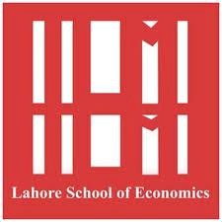
In partial fulfilment of the requirement of the degree of
MPhil in Development Studies

By
Mahin Jehangir Ali

Research Supervisor: Dr Rashid Amjad
Co-Supervisor: Dr Ahmad Nawaz

Abstract
The COVID-19 has exposed vulnerabilities in global economies impacting the marginalised communities the most. The lockdowns during the COVID has disrupted the means of credit interventions leading to increase in vulnerabilities of micro-entrepreneurs. However the role of informal credit interventions in such circumstances became critical. Therefore this thesis investigates the role of Rotating Savings and Credit Associations (ROSCAs), an informal saving mechanism, in mitigating vulnerabilities during the pandemic. This study utilizes primary data collected in June 2021 during peak COVID times, consisting of 508 households situated in Semi-urban areas of Lahore that include Atto Asal, Azad Town, Sue Asal, Khanoharni, Jhulky and Jhulky Sharif Park. Using Food vulnerability and Income vulnerability as dependent variables, the study examines whether access to Informal saving mechanisms (ROSCAs) and formal saving mechanisms reduce vulnerability among participants. The thesis investigates the impact of ROSCAs and Microfinance Institutions on household saving and financial stability during the COVID times. Our findings reveal that informal mechanisms ROSCAs in this case have a more profound impact in reducing vulnerabilities during COVID times compared to formal microfinance borrowers.

Dedication
For my late grandmother.

Acknowledgements
Thankful and grateful to the Almighty for providing me with the opportunity to do this research. I would like to express my appreciation to my supervisor Dr Rashid Amjad, Director of Graduate Institute of Developmental Studies, Lahore School of Economics. Without his support and guidance doing this thesis would not have been possible. Further I would like to thank my Co-Supervisor Dr Ahmad Nawaz for his lasting effort and cooperation. Without his unwavering support this research would not have been possible. Lastly I would like to thank my family and my dear friend Mariam who helped me by lending her expertise in empirical analysis. I would also like to thank my two year daughter Meherbano for being patient during the time I was occupied with this thesis.

Table of Contents
Dedication 3
Table of Contents 5
List of Tables 7
List of Figures 8
CHAPTER 1 10
1. Introduction 11
1.1. Research Objective 14
1.2. Research Question 14
1.3. Research Hypothesis 14
1.4. Significance of the Study 15
CHAPTER 2 16
2. Literature Review 17
2.1 Research Gap 21
CHAPTER 3 23
3. Methodology 24
3.1Research Design 24
3.2. Data and its Sources 24
3.3. Method 29
CHAPTER 4 30
4. The Analysis and its Discussion 31
4.1 Descriptive Analysis 31
4.1.2 Correlations 32
4.1.3 Income Vulnerability and Food Vulnerability Correlations 33
4.1.5 Income Vulnerability among the Cohorts 34
4.1.6 Food Vulnerability among the Cohorts 36
4.2. Empirical Analysis 38
4.2.1 ROSCA Participation and Income Vulnerability 39
4.2.2 ROSCA participation and Food Vulnerability 39
4.2.3 Microfinance participation and Income Vulnerability 40
4.2.5 ROSCA/MFI participation and Income Vulnerability 41
4.2.6 ROSCA/MFI participation and FOOD Vulnerability 42
4.2.7 ROSCA Participants vs. Microfinance vs. ROSCA/MFI participants 43
Chapter 5 45
5. Conclusion 46
5.1 Research Implications of the study 46
5.2 Limitations of the study 47
References 48
Questionnaire 55
Appendix 57

List of Tables

Table 3.3: Variable Description………......................................................................................................26
Table 4.1: Summary Statistics …………………………………………………………………………....31
Table 4.1.1: Correlations………………………………………………………………………………….32
Table 4.2.1 Regression Analysis ……………………………… ……………………………………….. 38

List of Figures

Figure 3.1: Sample distribution of households……………………………………………. 25
Figure 3.2: Households bifurcated by Occupation………………………………………...... 25
Figure 3.3: Hypothesized framework……………………………………………………… 28
Figure 4.1.5: Savings before and during COVID (Bifurcated by ROSCA vs MFI vs ROSCA&MFI vs None) …………………………………………………………………………………….. 35
Figure 4.1.7: Food vulnerabilities (Bifurcated by ROSCA, MFI, ROSCA&MFI vs NONE)...36

Acronyms
ROSCA – Rotating and saving credit association
MFI – Microfinance Institution
IMF – International Monetary Fund
BRAC- Bangladesh Rural Advancement Committee
CARE –Cooperative for Assistance and Relief everywhere
VSLA- Village Savings and Loan Associations
UN – United Nations
ASA –Association for Social Development

CHAPTER 1

INTRODUCTION

1. Introduction
The COVID-19 pandemic had such a profound impact on the global economy that it was declared a public health emergency (Coibion et al.,2020). The pandemic called for drastic changes in day to day interactions due to the lockdown and curfews imposed by the national governments resulting in loss of millions of jobs (Sangwan et al.,2020). According to the World Bank (2020), 7 million people were forced into unemployment and poverty during this time. At the same time, many national Governments had to provide financial assistance to help mitigate the negative consequences of high unemployment levels (Boramy & Grabowskly; 2020).
Needless to say the formal interventions on the part of the money-starved governments around the world to absorb the negative shocks of COVID were not enough to provide a cushion to the affected households. Therefore, the informal form of interventions may provide a substitute but their efficacy is still not very clear due to the lack of empirical evidence. Among many of those informal saving mechanisms is Rotating and Saving Credit Associations (ROSCAs), which is a form of community-saving groups. This mechanism remained instrumental in providing financial support to millions of households during this calamity.
ROSCAs are informal savings mechanisms formed through social networks and provide interest-free loans to those who participate. Each participant contributes a fixed sum to a collective fund and receives a full sum at least once (Armendariz & Morduch, 2005). These groups consist of people from the same neighborhood (Rutherford, 1997), with the cycle lasting a year. The funds help cover expenses such as school fees or household items (Gurgerty, 2007). ROSCAs play an important role in meeting life cycle needs. These are appropriate for dealing with idiosyncratic events rather than saving for old age. Aggarwal et al. (2018) suggest that the benefit of joining ROSCAs isn’t constrained to the purchase of durable goods but also to develop a source of excessive earnings. Individuals also join ROSCA to save and invest (Gugerty, 2007).

Theoretical perspectives on ROSCAs highlight their function in consumption smoothing and management of risk. Besley, Coate, and Loury (1993) describe ROSCA as a self-enforcing contract where the cyclical distribution of funds incentivizes members to honour their contributions. Other than facilitating saving, the structure reduces the risk of default. Bouman (1995) mentions how ROSCAs in agrarian economies where income is mostly seasonal enable households to smooth income over the year and make necessary purchases, including food, thereby reducing food insecurities. Nici Nelson, a social anthropologist for 22 years observed a ROSCA in Nairobi, Kenya from 1971 to 1993. She mentions how the number of people in the group initially in 1971 was 20, all women who had houses in the Mathare valley. The group met once a week and contributed K.sh 12 each week from which a total of K.sh 240 was given to a participant of the group. This total was more than the monthly minimum wage in Kenya which at that time was 150. This cycle took 5 months to complete (Nelson 1996, p.54).
The concept of ROSCAs first emerged in the subcontinent in the early 1900s and was popularly known as Kamettis. To date, they are one of the most popular means of saving mainly among women (Ardener and Burman, 1995, Czura and Klonner, 2018). The accounts of ROSCAs are simple as no storage of funds is needed because the money goes from one pocket to another. This process comes in 3 different variants with the first being where members decide who gets the pot. The second is random selection and the third is bidding for a given pot. ROSCAs operate on 3 very important assumptions. The first is that participants of ROSCA wish to buy an indivisible durable good; the second is that these members are impatient to do so. The third assumption is that participants keep turning up and pooling in the pot until every participant has had the chance (Armendariz and Murdoch, 2005). Saving programs such as this are a good alternative for those residing in rural areas as they provide a financial safety net. Participants can use these savings to smooth consumption, deal with illnesses, pay school fees, and even start or expand a small business.
Therefore the role of ROSCAs as an informal credit-saving mechanism during testing times like the pandemic is critical. These savings acted as an emergency fund for those who had lost their livelihood and helped them cope with financial stress. Savings mobilization is important for individual and societal welfare. At the individual level, they help households’ smooth consumption and aid in investing in human and business capital. At the macroeconomic level, savings are an important predictor of future economic growth. For low-income groups and the poor, savings are difficult because of resource scarcity (Laureti and Szafarz, 2014).

Expenses in emergencies and security issues are an additional threat to poor people's savings. However, according to Collins (2009) poor households save actively. Household surveys have been conducted that show that the poor do have some surplus that they use for non-essential expenditure (Banerjee and Duflo, 2007). Access to savings has multiple benefits, for starters it encourages female empowerment (Ashraf et al., 2010; Guerin, 2006) and female business investment (Dupas and Robinson, 2013a). Savings help people cope with health emergencies (Dupas and Robinson, 2012b). According to Robinson (2001) access to savings is even mor e important than access to credit.
The World Bank estimates that 100 million people in Pakistan lack access to formal financial services and instead rely on informal channels. A report from Financial Inclusion Insight (2013) shows that 36% of Pakistanis save money, with only 4% saving through formal institutions while 33% use ROSCA or Rotating Savings and Credit Associations. A research by Oraan states that 41% of Pakistanis save through committees whereas Karandaaz estimates the figure to be 34%. Pakistan Institute of Development Economics suggests that the informal economy accounts for 30% of the total economy, this translates into an estimated 4 Trillion rupees in annual committee savings at the base price (Dawn, 2022).
In addition, the pandemic has also posed a serious threat to global food security by disrupting the food supply chains which resulted in steep decline in incomes of millions of households around the world (Scudellari, 2020). The pandemic particularly hit hard for the populations living below and close to the poverty line because the loss of income had severely affected their food security through loss in nutritional level (FAO and CELAC, 2020). Vulnerable people were not able to fulfil basic requirements, less income led to lesser demand for nutrient-rich foods.
Travkina, Froy and Pyne (2013) talk about how participation in ROSCAs also mitigates food insecurity and socioeconomic inequality. The COVID-19 aggravated the food insecurity situation and poverty leading to health consequences globally (Singh et al, 2021).
According to FAO (2017) food security can be described as a situation when people have physical, economic and social access to safe, nutritious and sufficient food that meets their dietary needs for a healthier lifestyle. ROSCAs enhance food security by allowing members to use their resources and purchase food in bulk thereby reducing per unit costs and ensuring a steady supply of staples. The cyclical nature of ROSCAs provide financial resilience and help households maintain levels of food consumptions during times of income stability (Besley et al., 1993). In agrarian economies income is seasonal, ROSCAs smooth income over the year and enables households to make food purchases and mitigate food insecurity (Bouman, 1995).
Therefore, this research aims to examine the role of ROSCA in Pakistan across all income groups in reducing food and income vulnerabilities. ROSCAs are present in the rural and semi-urban areas of Pakistan. However, it is informal and undocumented therefore the dynamics of ROSCA participation are largely ignored. This study adopts a quantitative approach to look at the impact of ROSCAs in reducing vulnerabilities in semi-urban settings. The sample of this study includes 508 micro-entrepreneurs who have access to various credit schemes including formal microfinance and informal ROSCAs.
Further, the paper also investigates the role of Microfinance Institutions and ROSCAs combined in dealing with uncertainties as the sample includes participants who are part of both these schemes.

1.1. Research Objective
The present study has the following research objectives:
- To empirically investigate the role of ROSCAs (informal savings) in reducing vulnerabilities of households during COVID times
- To examine the role of ROSCAs in reducing vulnerabilities and compare it with formal microfinance
- To provide suggestions based on the findings on how informal mechanisms help in building community resilience in testing times.

1.2. Research Question
Keeping in view the above-stated research objectives, the following research question is framed:
Does access to informal savings (ROSCAS) help reduce household vulnerabilities during the pandemic COVID-19 controlling for household characteristics compared to formal microfinance?

1.3. Research Hypothesis
The following alternative hypothesis is formulated to assess the impact of participation in ROSCA and Microfinance on Income and Food vulnerabilities:
- H₀₁: ROSCA beneficiaries have significantly lower income vulnerabilities compared to Microfinance borrowers.
- H₀₂: ROSCA beneficiaries have significantly lower food vulnerabilities compared to Microfinance borrowers.

1.4. Significance of the Study
This study aims to provide valuable insights into the challenges and dynamics faced by communities in semi-urban areas. The findings of this study can contribute to a better understanding of how an informal mechanism of ROSCAs works as a coping strategy during a crisis in the context of Pakistan. Additionally, this research aims to address a gap in literature particularly in the context to Pakistan. To this extent, it will contribute significantly to the existing body of knowledge on informal financial schemes and their role in mitigating vulnerabilities compared to the formal interventions of Microfinance. Furthermore, this study will elucidate the benefits of ROSCAS and its ability to mitigate vulnerabilities thereby empowering communities. In all this study will highlight the important role of social networks in building resilience among communities in mitigating the adverse consequences of any crisis.
The thesis is organized as follows: The literature review is presented in Chapter 2 followed by Methodology in Chapter 3. Chapter 4 discusses the analysis and finally, Chapter 5 provides the conclusion.

CHAPTER 2

LITERATURE

REVIEW

2. Literature Review
This chapter provides a literature review by highlighting the importance of savings in reducing vulnerabilities for marginalized households. It has been organized thematically, starting with a literature review of Microfinance, the importance of saving, and the role of ROSCAs in dealing with calamities. Further, it presents studies related to COVID-19 and various forms of credit interventions in use during COVID-19.
Microfinance has played a pivotal role in providing financial services to low-income individuals who have been excluded from formal institutions for years. Microfinance institutions aim to alleviate poverty by providing loans, financial services, and insurance allowing individuals to set up a small-scale business, invest in an already operating business, smooth consumption, and manage risks (Aghion & Murdoch, 2005; Robinson, 2001). Murdoch (1999) reports access to microcredit has a spillover effect as it further provides employment to family and community members and helps individuals retain profit. Studies conducted in the early 90s by Pitt and Khandker (1996) second this finding with their study conducted in Bangladesh. They learned that for every 100 takas lent to a woman, the annual household expenditure increased by 18 takas. This proved to be of great success for 5% of the clientele of this program as they managed to lift out of poverty (Khandker, 1998).
Women make up 74% of microfinance clientele worldwide. The use of microfinance schemes empowers women economically as it provides them with working capital through which they generate income (Tandon, 2016). A report by the UN (2011) states that Microfinance institutions empower women economically, and improve overall labour productivity thereby increasing wages. Income changes and opportunities for self-employment are beneficial to the community (Ertu & Tilahun, 2022). Yunus (1999) states that through microfinance can gender equality be promoted along with better working conditions for women. Women are at a disadvantage when it comes to applying for credit services. Banks focus on providing loans to men and those with an established business thereby neglecting women. By targeting the major section of the economy, microfinance institutions can contribute publically. Women have a higher repayment rate which is a benefit for the institution. Microfinance institutions claim that with access to credit, women can escape poverty. (Yeboah et al., 2015). Morduch and Haley (2002) highlight how microfinance has been an effective tool for poverty reduction. In Bangladesh four of the big Microfinance institutions which are the Grameen Bank, BRAC, ASA, and Proshika helped 13.7 million families by loaning 7548 million dollars (Zaman, 2004).
However, the negative side of this mechanism has received less attention. Despite being a popular mechanism in developing countries, microfinance faces criticism for not reaching the core poor (Weiss & Montgomery, 2005). Shaw (2004) finds that microcredit did not have a significant impact on poverty reduction. A study conducted by Bateman (2007; 2010) in Bosnia revealed that clients of Microfinance Institutions reported a high failure rate, in fact, clients went into deeper poverty than they were before taking the loan. Therefore, Microfinance in reality is a poverty trap that damages local economic and social development (Bateman, 2010: 5). Other than this Microfinance is criticised because of its commercialization and the high interest rates (Karnani, 2007; Bateman 2010). Biswas (2010) talks about suicides by microcredit clients in Andhra Pardesh, India due to shame encountered from not being able to pay back the loan (The Economist, 2006b). Montgomery (1996) criticizes the debt collection strategies Microfinance institutions use and the fake claims about women's empowerment (Rahman, 1999; 2001).
A common assumption regarding low-income households is that they aren’t motivated to save and this is because of their limited incomes. Empirical evidence states that low-income households have lower-than-average savings rates. (Bhalla, 1980; Bunting, 1997; Diamond & Hausman, 1984; Mayer, 1966). Theories of savings mostly focus on the middle and upper classes. Willingness to save and ability to save are important determinants of saving (Katona (1951; 1975).
Households save for several reasons, some do it to facilitate lumpy expenditures in the short and long run. This behaviour of saving can be divided into two categories, low-frequency savings and high-frequency savings. Low-frequency saving models are common in middle and high-income countries. People borrow when young, save in middle age, and spend when older. The model derives a flat consumption pattern without any ups and downs (Morduch, J.& Armendariz). However, the model focuses on the behavior of nuclear families making it insignificant for low-income countries where multi-generational families exist. In a survey collected by the World Bank on 4734 households in Pakistan, Kochar (1996) found that income patterns of intergenerational households were steady as compared to nuclear households. Instead of borrowing and saving to smoothen consumption, the households simply rebundle. If consumption patterns are smooth, the need for savings is eliminated. High frequency saving on the other hand applies to low-income countries. The purpose of these savings could be to fund short-term investments or smooth consumption from month to month.
The COVID-19 was labelled a global pandemic in 2020 as a result of which lockdown was observed worldwide (Chakraborty & Maity, 2020). Social distancing and lockdown restrictions led to people losing their jobs and declines in income. People were forced to borrow or rely on their savings for survival. According to Mckinsey (2020), households reduced their expenditure by one-fourth and savings declined by 36%. Due to panic, people started to stock up on essentials such as medical goods and household products. The pandemic had a significant effect on rural households as it impacted their financial planning (Haleem et al.,2020). As compared to urban areas, rural areas already have low-income earning opportunities and the pandemic made things worse. People’s consumption behaviors during the pandemic tend to be disorderly and chaotic. Individuals cope with threats by purchasing specific products such as necessities.
Low-income communities rely on informal financial strategies that increase their resilience. They do so by cooperating. ROSCAs are one of these strategies and are an agreement between groups of individuals to cooperatively save a pot of savings by paying a monthly or weekly installment. ROSCAs vary depending on the number of participants, the contribution frequency, monthly or weekly contribution, and the process of pot allocation. ROSCAs are an optimal saving strategy, especially for those who lack access to formal saving institutions (Anderson & Baland, 2002), but lack policy attention (Tiers, 2014). During the financial crisis in Indonesia in 1998, ROSCAs aided in the economic reconstruction (Acquah & Dahal, 2018). They were also useful during the Tsunami in India in 2004 (Czura & Klonner, 2018).
To deal with future uncertainties, people in a pandemic save more (Jin et al., 2020; Sharma et al., 2020). During the COVID-19, household savings increased significantly. Lockdown measures and social distancing led to a reduction in consumption. This reduction allowed households to save more of their disposable income than usual (European Central Bank,2020). According to the IMF (2021), the intervention of the government and enhanced unemployment benefits provided households with additional financial resources. Heightened economic uncertainty led to precautionary saving behavior. Households were inclined to save in anticipation of future financial difficulties (San Francisco Fed, 2023).
Another factor was the heightened economic uncertainty, which drove precautionary saving behaviour. Households were more inclined to save in anticipation of potential future financial difficulties, reflecting a desire to build a financial buffer against the economic fallout of the pandemic (San Francisco Fed, 2023). A survey in China showed that more than half of the country’s households increased their savings and reduced their spending due to the pandemic; compared to the same period last year (when there was no pandemic) (Survey and Research Center for China Household Finance, 2020). In a study conducted on savings groups in Africa, it was seen that savings groups contributed to mitigating the negative economic consequences of COVID-19 (Anderson et al., Forthcoming, 2021). In Nigeria, households with a female member were less likely to experience food insecurity.
Another study conducted in Uganda showed that those part of the savings group suffered fewer income shocks and were less likely to see a reduction in food consumption (Kansime et al., 2021). Women part of the Village Savings and Loan Association (VSLA) were able to carry on their activities post-COVID in Nigeria (Siwach et al.,2021). Those with no financial banking were unable to continue with their activities. Most of the savings groups, especially with women participants, were able to continue their activities because of mobiles. During the lockdown, women continued to meet with safety measures (Allen, 2020; CARE, 2020a; CARE, 2020c; Green et al.,2020). Savings groups have been beneficial for women as they have attained leadership positions, especially during COVID-19 (Agene & Onyishi, 2020; Laouan, 2020).
According to the Global Multidimensional Poverty Index (2021), ROSCA is common in countries with high poverty index. Asia and Africa are two countries from where most studies have been collected. Savings groups have enabled participants to pursue regular activities during lockdown relaxation. Data collected by CARE shows that 83% of groups in Malawi and 70% in Jigawa, Yobe, and Bauchi which are states in Nigeria continued to save during the lockdown (CARE, 2020b; CARE, 2020c; CARE, 2020d). With savings, not only can households build up better assets to use as collateral but also better smooth seasonal consumption needs, finance major shocks, and self-finance investments (Robinson, 2001).
Participants of ROSCAs in South Africa revealed how they didn’t have to experience hunger or food insecurity after being part of a savings group (Bophela, M.J., & Khumala, N.2019). Savings groups are women’s biggest source of resilience. Women part of saving groups were half as likely to report impacts on areas such as livelihood, food, and health compared to those who weren’t (CARE, 2022), Anderson and Baland (2002) talk about how ROSCAs are a way of forceful saving. Anderson and Treich (2002) argue that ROSCA communities follow a framework of social obligations where the richer people are obliged to help their poor relatives. By being part of a ROSCA they avoid such obligations.
The success and sustainability of ROSCAs is dependent on social collateral (Handan and Kirtin ;1999). In case a member defaults, he or she may not be accepted as a member of any other. The exclusion is considered a serious deprivation (Brink and Chavas, 1997; Biggart, 2001). Since members are part of a close knit community, social pressure and peer monitoring reduces the likelihood of defaults. Community based oversight is a powerful mechanism ensuring that participants meet their obligations (Calomiris & Rajaraman, 1998). Biggart (2001) notes how divorced and separated people face difficulty in obtaining a ROSCA membership due to cultural and social norms. These individuals are viewed as irresponsible and not being able to keep up with promises.

2.1 Research Gap
Keeping in view the above literature review the empirical evidence of socio-economic implications of formal credit interventions such as microfinance institutions are very well documented. However, there is a dearth of literature that examines informal credit interventions such as ROSCAs in adverse circumstances such as the pandemic. Further, the literature related to credit interventions mainly focuses on the urban areas. However poverty is a fast-growing phenomenon in urban settings as well. Therefore resilience strategies through informal saving mechanisms such as ROSCAs in the communities residing in semi-urban areas is an interesting avenue of research. Particularly in the context of Pakistan, there is limited research addressing the role of ROSCAS in mitigating vulnerabilities during COVID-19. Therefore, this study aims to fill in the void by taking the focus on formal interventions such as Microfinance in reducing vulnerabilities towards the informal saving strategies of ROSCAs. It would be highly imperative to see the findings of this study which can be used for informed policy making.
The independent variables used in this study are categorical variables bifurcated into 4 categories. The first is the households’ part in ROSCA, the second is the households’ part of Microfinance, and the third is the households’ part of both ROSCA and Microfinance schemes. The last category is households not part of any schemes.
The dependent variables are Income vulnerability (calculated by deducting Income from expenses before and during COVID) and Food vulnerabilities (standardized food security questions). Besides these, the control variables are household size (categorical variable where 1= Own house, 2= Rented) Value of household Assets (in rupees), Occupation which is a categorical variable (1=Laborer, 2=Salaried, 3=Non-farm Business/traders) House ownership (rented=1, Own house =2) and Total Household income.

CHAPTER 3

METHODOLOGY

3. Methodology
This section highlights the methodology employed in this study. It includes the research design, data and its sources and the data analysis technique.

Research Design
Following the philosophy of positivism, this quantitative cross-sectional study examines the relationship between the ROSCA participants and those part of the Microfinance scheme on income and food vulnerabilities in semi-urban areas near Lahore during COVID-19. Employing a deductive approach, inferences are derived from observations to assess the viability of established hypotheses (Bryman, 2016).

3.2. Data and its Sources
The survey was conducted in the summer of 2021 during COVID-19 and employs cross-sectional data. It was done at the household level and consists of 5 towns located on the outskirts of Lahore. The households in these semi-urban towns are primarily employed as small-scale micro-entrepreneurs, laborers (skilled), and Salaried class. Around 100 of the respondents have been interviewed from each town. The respondents were selected randomly.
This quantitative study comprises 508 households residing in semi-urban towns of Lahore (Atto Asal, Azad Town, Sue Asal, Khanoharni, Julky Sharif Park) Punjab. Self-administered Survey was conducted by a team of enumerators and based on the respondents’ answers, questionnaires were filled in. All participants have access to various credit schemes that include Microfinance, Informal ROSCAS, and transfer grants. The survey has been conducted by the University of Westminster. The focal persons for the project is Isaam Malki (Reader at Westminster University) and Asad Ghalib (Senior lecturer at Liverpool University).
The figure 3.1 below shows the sample distribution of 508 households. 39.17% of the sample labelled as “None” are those not part of any formal or informal scheme. 31.5% are participants of Microfinance schemes whereas 17.3% are ROSCA participants. Only 12% of these respondents are part of both ROSCA and Microfinance schemes.

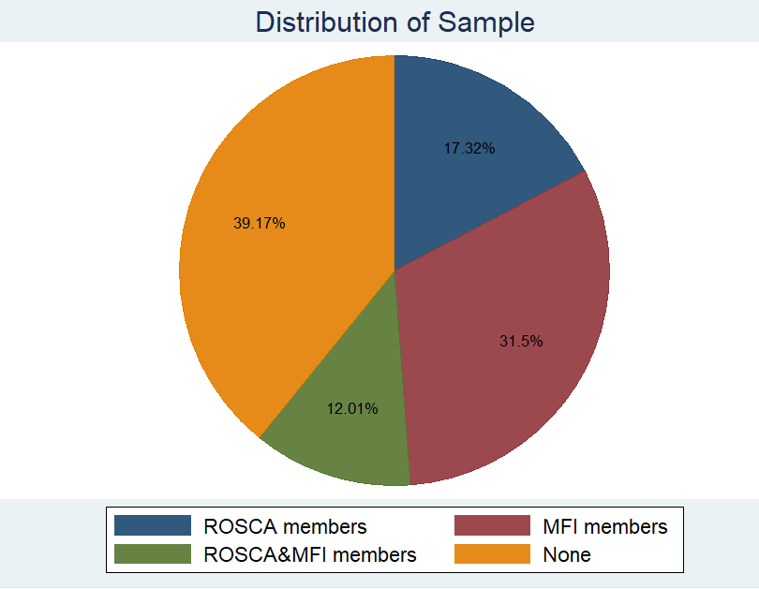
Figure 3.1: Sample Distribution of Households
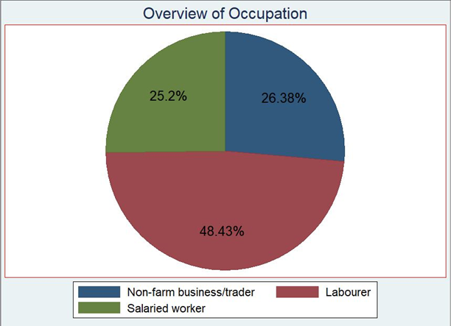
Figure 3.2: Households bifurcated by Occupation
Figure 3.2 explains the bifurcation of the households by occupation. One-fourth of the sample respondents are salaried workers while 26.38% are Non-farm business/traders. 48.43% of the respondents are skilled laborers and are the majority.
Table 3.3 below explains the variables used in this study in detail. The dependent variable in this study is Food and Income vulnerability whereas the independent variable is divided into four cohorts – households’ part of ROSCA, households’ part of Microfinance schemes, households’ part of both Microfinance and ROSCA, and lastly those not part of any scheme. Other than this controlling variables used in this study are total household income, asset value, house ownership, and household size.

Table 3.3: Variable Description
Variable | Variable Name | Variable Measurement | Variable Definition
Dependent Variable, Y
Income Vulnerability | IV1, IV2 | IV1(Income–Expenses before COVID),  IV2(Income–Expenses during COVID) | 1. Total household income  2. Total monthly expenditure  3.Total expenditure before COVID and the lockdown (in rupees)
Food Vulnerability Index | FD1,FD2,FD3,FD4,FD5,FD6,FD7,FD8 | Standardized food security questions | FD1: During the last seven days how many days did you have mutton, chicken or beef?  FD2: During the last seven days how many days did you cook vegetables and lentils?  FD3: How many weeks of wheat/flour stock do you have?  FD4: How many weeks of rice stock do you have?  FD5: Food purchased did not last and you did not have money to get more  FD6: You could not afford to eat a balanced meal  FD7: Did you or other households ever cut the size of the meal or skip meals because there wasn’t enough money for food?  FD8: Did you ever eat less than you wanted because there wasn’t enough money for food?
Independent Variable (X)
Participation in formal/informal schemes | ROSCA = 1 | Categorical Variable where:  ROSCA=1  MFI=2  ROSCA&MFI=3  NONE=4 | Is the person participating in any committee scheme?
Participation in Microfinance schemes | MFI=2 | Categorical Variable where:  ROSCA=1  MFI=2  ROSCA&MFI=3  NONE=4 | Is the person part of the microfinance scheme?
Participation in ROSCA and Microfinance Schemes | ROSCA&MFI | Categorical Variable where:  ROSCA=1  MFI=2  ROSCA&MFI=3  NONE=4 | Is the person part of both ROSCA and Microfinance Schemes
Participation in none of the informal/formal schemes | NONE | Categorical Variable where:  ROSCA=1  MFI=2  ROSCA&MFI=3  NONE=4 | Is the person part of any informal/formal scheme?
Controlling Variables
Occupation | Occupation | Type of Occupation:  Laborer, Salaried Worker and Non-farm business/trader
Household Size | HHS | Total Adults + Total Children | Total number of members in the household
Value of Assets | Asset Value | In rupees | Total value of Assets
Household Income | Income | In rupees | Total Household Income

Figure 3.3 below highlights the hypothesized framework where the main independent variable “Participation” is a categorical variable bifurcated in 4 categories. The first category pertains to those households’ who are a member of ROSCAs. The second category is microfinance beneficiaries, third category relates to those households’ part of both ROSCA and Microfinance schemes. Finally the last category also the reference category are those not part of any scheme.
Whereas, the dependent variables are Income vulnerability (difference between income and expenditures) and Food vulnerabilities (standardized food security questions). Besides these the control variables are household ownership (categorical variable where 1= Own house, 2= Rented); Value of household Assets (in rupees), Occupation which is categorical variable (1=labourer, 2=Salaried, 3=Non-farm business/trading) Household size and Total Household income.

Independent Variables Dependent Variable
Categorical Variable “Participation”
ROSCA=1(part of a ROSCA)
MFI=2 (received MFI loan)
ROSCA&MFI=3 (part of ROSCA and received MFI loan)
NONE=4 (Not part of ROSCA & did not receive MFI support)

Income Vulnerability
Income -expenditure gap (assessed both before COVID and during COVID)

Control-factors
(Demographic and socio-economic factors)

- Occupation
- Household size (Adults and Children)
- Value of Assets
- House Ownership

Food Vulnerabilities
(8 Standardized food security questions)
Refer to table 3.3

Figure 3.3. Hypothesized Framework

3.3. Method
This study first provides a descriptive analysis which includes summary statistics, pair wise correlations of all the variables used in the study. Further the T test of mean differences among the four cohorts of participation of households bifurcated by their income and food vulnerabilities is provided. Following the descriptive analysis for empirical analysis this study employs simple OLS regression keeping in view the nature of the survey data. Statistical significance of the relationship between ROSCA participation with food and income vulnerability is assessed. This model was controlled for other demographic-related variables such as occupation, household ownership, and value of assets, household income, and household size. Data analysis was done using the STATA 14.0 version employing the regression technique to estimate coefficients and access robustness.
The functional form of the equations is discussed below.
Equation 1: Participation in formal/informal schemes
Y_{ij} = 𝛼 + 𝜃 (Participation) _{ij} + 𝛽₁ (Occupation)_{ij} + 𝛽₂ (Assets) _{ij} + 𝛽₃ (HHs) _{ij} + 𝛽₄ (HouseOwn) _{ij} + 𝜖
Where:
Y_{ij} = Food and Income Vulnerability (Dependent Variable) is estimated separately.
Participation is a categorical variable taking on values mentioned below:
1= ROSCA
2= MFI
3= ROSCA&MFI
4= NONE (those not part of any scheme)
HHs are Household Size (number of individuals in a household)
Occupation is a categorical variable where:
1=Laborer,
2 =Salaried
3=Non-Farm Business/traders (reference category)
Assets are the Total Value of Household Assets in rupees
House Ownership is a categorical variable where:
1 = Rented
2 = Own house (reference category)

CHAPTER 4

ANALYSIS AND DISCUSSION

4. The Analysis and its Discussion
This chapter is divided into two sections Descriptive analysis and Empirical analysis. The first section relates to descriptive analysis which discusses the Summary statistics, correlations, and Mean averages of variables used. The second section provides the results of the regression analysis performed for households’ part of ROSCAs, households’ part of Microfinance schemes, and those part of both ROSCA and Microfinance.

4.1 Descriptive Analysis
Table 4.1: Summary Statistics
Variable | Unit | Observations | Mean | Standard Dev | Min | Max
Savings before COVID | In Rupees | 508 | 6628.878 | 6345.152 | -5000 | 40000
Savings during COVID | In Rupees | 508 | 2905.02 | 5723.146 | -20,000 | 30000
FD 1 | Days | 508 | 0.257 | 0.516 | 0 | 3
FD 2 | Days | 508 | 6.655 | 0.915 | 0 | 7
FD 3 | Weeks | 508 | 4.576 | 12.89 | 0 | 53
FD 4 | Weeks | 508 | 1.950 | 7.93 | 0 | 52
FD 5 | Scale (1-3) | 508 | 1.614 | 0.603 | 1 | 3
FD 6 | Scale (1-3) | 508 | 1.616 | 0.637 | 1 | 3
FD 7 | Scale (1-2) | 508 | 1.840 | 0.366 | 1 | 2
FD 8 | Scale (1-2) | 508 | 1.137 | 0.345 | 1 | 2
Household Size | In Numbers | 508 | 6.00 | 2.228 | 0 | 22
Asset Value | In Rupees | 508 | 27169.59 | 35565.02 | 0 | 300000
Total Household Income | In Rupees | 508 | 17934.55 | 7761.215 | 0 | 60000

Table 4.1 gives an overview of the summary statistics of variables used in this study. It summarizes various statistics related to savings before and during the pandemic, components of food vulnerabilities and demographic variables during COVID-19. Clearly the savings during the pandemic times have significantly declined from their pre-COVID levels falling from 6628.7 rupees to 2905 rupees. There is an increase in dissaving which is evident from the stats provided in the table. There was a deduction in maximum savings during COVID indicating that those with higher incomes experienced a reduction. Both periods depict high variability in savings (Standard Deviation of 6345.15 and 5,723.15) indicating a wide disparity in how households experienced debts and savings.
For FD1 (Access to meat calculated in days) the mean is only 0.25 days whereas it is 6.65 for FD2 (Access to lentils). Mean average for household size during COVID was 6 members per household. Further, mean averages for Assets is 27169 and total household income is 17934 during COVID. Food security indicators show limited access to essential food items and disparities in food availability and affordability. The data underscores considerable variability in incomes, household size and asset values reflecting disparities in economic resilience and financial stability during the pandemic.

4.1.2 Correlations

 | IV1 | IV2 | FD1 | FD2 | FD3 | FD4 | FD5 | FD6 | FD7 | FD8 | HH  Size | AV | HHold  Income
IV1 | 1.0000
IV2 | 0.515* | 1.0000
FD1 | 0.242* | 0.199* | 1.0000
FD2 | -0.115* | -0.112* | -0.496* | 1.0000
FD3 | 0.226* | 0.193* | 0.142* | -0.083 | 1.0000
FD4 | 0.198* | 0.172* | 0.127* | -0.025 | 0.656* | 1.0000
FD5 | -0.028 | 0.059 | 0.136* | -0.134* | 0.193* | 0.136* | 1.0000
FD6 | 0.009 | 0.001 | 0.127* | 0.127* | 0.120* | 0.059 | 0.352* | 1.000
FD7 | -0.127* | 0.091* | -0.074 | -0.074 | -0.020 | -0.050 | 0.078 | 0.016 | 1.0000
FD8 | 0.003 | 0.035 | 0.121* | 0.121* | 0.149* | 0.126* | 0.426* | 0.411* | 0.080 | 1.0000
HHS | 0.095* | 0.021 | 0.050 | 0.0084 | -0.027 | 0.009 | 0.001 | 0.029 | -0.208* | 0.003 | 1.0000
AV | 0.434* | 0.286* | 0.300* | -0.089* | 0.329* | 0.278* | 0.153* | 0.411* | 0.032 | 0.199* | 0.063 | 1.0000
HH Income | 0.544* | 0.767* | 0.309* | -0.166* | 0.208* | 0.192* | 0.121* | 0.114* | 0.017 | 0.014* | 0.247* | 0.423* | 1.0000

IV1 = Income before COVID
IV2 = Income during COVID
FD1-FD8 (standardized food security questions)
HHS = Household size
AV = Asset Value
HH Income = Household Income

Table 4.1.1: Correlations
Table 4.1.1 discusses the pair-wise correlation analysis showing the relationships between various variables that include dependent variables income and food vulnerabilities along with controlling factors.

4.1.3 Income Vulnerability and Food Vulnerability Correlations
IV2 or Savings during COVID have a positive coefficient and are significant at the 5% level indicating a moderate relationship between income before and after COVID. A strong positive correlation exists between income before and during COVID portraying consistency in financial status over time. Higher income before the pandemic is positively correlated with better access to meat as evident from the table (r = 0.242*), stock of wheat/flour, and stock of rice. However, it is negatively correlated with access to lentils/vegetables suggesting that higher income enhances food security. Similarly, higher income during the pandemic is also positively correlated with access to meat, stock of wheat/flour, and stock of rice and has a negative correlation with accessing lentils and vegetables.
FD1 or access to meat is positive before and during the pandemic and is significant. This shows that higher income allows access to high-protein diets. For FD2 (access to lentils/vegetables), the coefficient is negative but significant. Individuals with higher incomes are less likely to have lentils and vegetables as they prefer meat and chicken. The strong negative correlation between access to meat and access to lentils tells that improved access to rich protein sources reduces difficulty in accessing the other. FD3 (stock of wheat/flour) and FD4 (stock of rice), the coefficients are positive and significant both before and during the pandemic. FD5 (food insufficiency) and FD6 are positively correlated and reverse coded thereby indicating a positive coefficient as a positive outcome. This means that high-income levels are associated with better stock of these essential staples. FD7 (Did you or other households ever cut the size of the meal or skip meals because there wasn’t enough money for food?), the coefficient is positive during the COVID times and significant. This means that individuals did not cut down on their meal size during COVID.
Household size was positive and significant before COVID but during COVID value was positive but insignificant. Households saw a reduction in number of children during the pandemic. Asset value is positive and significant in all equations except for FD2 (access to lentils/vegetables). As income increases so does value of assets. These correlations emphasize on the interdependence of income and food security variables highlighting the role of stable income in ensuring consistent and diverse food access

4.1.5 Income Vulnerability among the Cohorts
Figure 4.1.5 below presents a comparative analysis of savings behaviour across different savings groups: ROSCA, MFI, ROSCA & MFI and None. The data is segmented in two periods: Savings before COVID and savings during COVID depicted by blue and red bars. For the first group that includes participation in ROSCA savings before COVID are 8738.3 but reduced to 5147.72 during COVID. This means that there is a 41.1% decline in income during the pandemic. For the second group which is participation in Microfinance schemes, the savings reduced from 7006.25 to 2592.19. This means that savings decreased by 63% for this group. Similarly for the last two groups savings also decreased. For participants’ part of both ROSCA and MFI, the savings decreased from 8459.02 to 3368.84 indicating a deduction of 60.2%.
Overall there is a downward trend in savings across all groups during the COVID-19 pandemic. This means that the pandemic had a widespread economic impact resulting in reduced savings irrespective of the type of saving mechanism used. However the most affected group of the lot is participants’ part of the Microfinance schemes. The MFI group experienced the highest percentage decline in savings indicating that those reliant on microfinance faced more severe economic challenges and had less financial resilience during the pandemic. Although all groups faced significant declines, the least affected group is ROSCAs as it has the lowest percentage decrease. This implies that informal saving mechanisms such as ROSCAs act as a financial buffer against economic disruptions in challenging times such as COVID-19. Those part of both ROSCAs and Microfinance schemes saw a decline in income by 60.2% which suggests that a combination of formal and informal mechanisms did not offer better protection against the economic impacts of the COVID-19.
Further from the T-Tests conducted on this data for comparing means of the groups and to determine the significance between them. The first observation compares averages of two groups which includes members of ROSCA and members of Microfinance. Members of ROSCA consist of 88 participants and the other group has 160 members. Mean incomes of these groups are analysed to determine presence of significant differences. For savings before COVID, the T value is 0.2581 and P value is 0.7967 which indicates that there is no statistical significance in the two groups’ pre-COVID (refer to appendix A1.1). However during COVID, the T value for the mean differences is 3.20 and the P value is 0.0015 (refer to appendix A1.2). Based on these results we can say that the observed differences in the mean incomes are statistically significant. T Test results for participants of ROSCA and participants of ROSCA and Microfinance schemes for savings during COVID are 1.70 whereas the P value is 0.898 (refer to appendix A1.3). This tells that the results are not statistically significant at the 5% level.

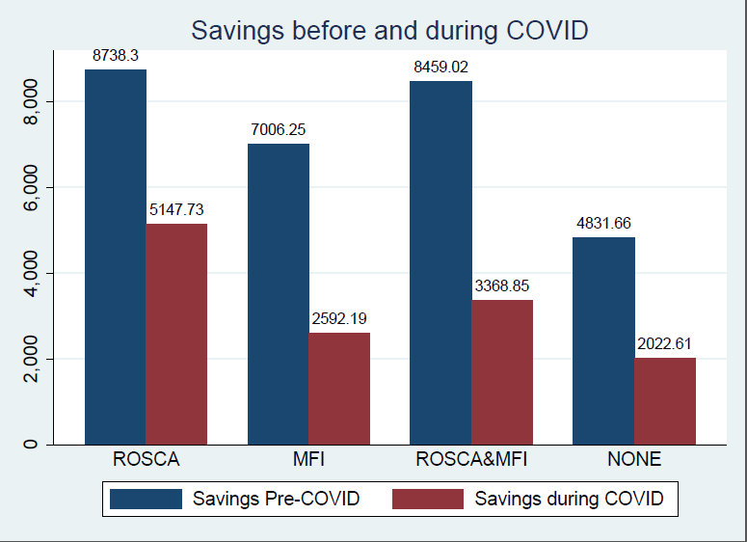
Figure 4.1.5: Savings before and during COVID (Bifurcated by ROSCA, MFI, ROSCA&MFI and NONE)
For groups 2 and 3 which are Microfinance participants and those part of both ROSCA and Microfinance schemes, the savings during COVID are 2592.19 and 3368.85 as depicted in the figure above. The mean difference is -776.6, indicating that Microfinance participants have lower incomes than those in both schemes. T-test results for these observations are -0.9476 with a P value of 0.344 (refer to appendix A1.5) Based on these results we can conclude that there is no statistical difference in the mean difference of these two categories. T-test results for the cohorts including ROSCA and MFI participants and those not part of any scheme is 1.75 for the T value and the P value is 0.083 (refer to appendix A1.4). This means that the result is not statistically significant at the 0.05 level but is significant at the 0.10 level.

4.1.6 Food Vulnerability among the Cohorts

Figure 4.1.6 explains averages of Food vulnerabilities of all the groups’ part of the data set. It illustrates the number of days of access to various food items across the groups: ROSCA, MFI, ROSCA and MFI and NONE. The categories of food items include access to meat, access to lentils/vegetables, wheat/flour and rice. For the first group in the set which includes participants of ROSCA, the number of days for meat consumption is 0.39 whereas days for lentils and vegetables is 6.63. For stock of wheat and flour the mean average is 71.54 days whereas for rice it is 41.84 days. For participants of Microfinance schemes, the mean average for access to meat is 0.206 days whereas for vegetable access it is 6.68 days. For stock of wheat and flour the mean average is 20.5 days and for rice it is 4.33 days.
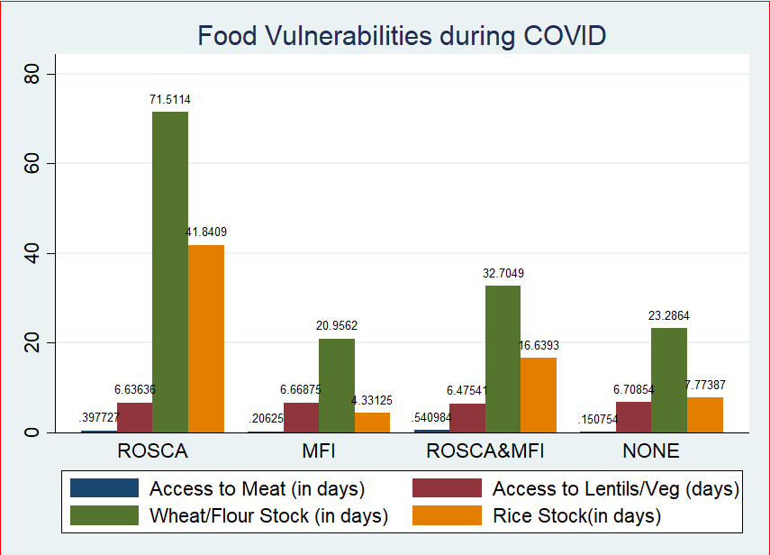
Figure 4.1.6: Food Vulnerabilities (calculated in days)
Those parts of ROSCA and Microfinance schemes could access meat for 0.54 days. The mean average for access to lentils is 6.47 days and it is 32.7 days for stock of wheat/flour. The mean average for the stock of rice is 16.6 days. Lastly, we have the group labelled None which includes respondents not part of any scheme. For the None category mean average for access to meat is 0.15 days, and access to vegetables is 6.70 days. The stock of wheat/flour average is 23.2 days and rice stock is 7.7 days.
From the above figure, it is evident that participants of ROSCA have the best food security in terms of wheat/flour and rice stock. Participants of Microfinance schemes have the lowest food security for rice stock and meat access. Participants of both Microfinance and ROSCA schemes have moderate stocks of wheat and rice. The last category which is None has limited access to meat and rice but better access to wheat/flour in comparison to Microfinance participants.
Further based on T test results for group 1 which is participants of ROSCA alone and group 2 participants part of Microfinance schemes, the results are statistically significant for FD1 which is access to meat. The T test indicate that there is statistically significant difference in mean between the 2 groups. ROSCA only participants have higher mean access in comparison to Microfinance participants. The difference of 0.19 is significant at the 0.05 level with a P value of 0.0042 (refer to appendix A2.1). For FD3 (Stock of Wheat/Flour) the T value for this observation is 3.91 and T value is 0.0001 (refer to appendix A2.2). The result indicates that there is statistically significant difference in means for Group 1 and Group 2. The mean difference of 7.222 is statistically significant at the 0.05 level and has a T stat of 3.91. For the observation, FD4 (Stock of Rice), the T-Test value is 4.59 and the P value is 0.000 (refer to appendix A2.4). The mean for ROSCA participants is 5.977 significantly higher than the mean for Microfinance participants. The P value is zero indicating that the observed difference is statistically significant.
A T-Test was conducted for Groups 2 (participants of Microfinance) and Group 3 participants of ROSCA and Microfinance for the observation FD1 (Access to meat). The mean of Group 2 is 0.20625 which is lower than that of Group 3. The difference of -0.3347 is statistically significant with a T-test of -4.4251 with a P value of 0 (refer to appendix A2.7). Thus, based on these results we conclude that there is a statistically significant difference in means of Group 2 and Group 3. For FD3 (Stock of wheat/flour), the observed difference in means is -1.6783. The T-Test value is -0.98 and the P value is 0.32 (A2.8). This means that there is no statistically significant difference between them. For FD4 (Stock of rice), the mean difference for both categories is -1.7582.
T-test results for FD1 (Access to meat) for categories 1 (participation in ROSCA) and 3 (participation in both ROSCA and Microfinance schemes) is -1.3903 and the P value is 0.1665 (refer to appendix A2.4). Similarly, for FD2 (access to lentils/vegetables), the T-test result is 1.572 and the P value is 0.1183 (refer to appendix A2.11). There is no statistically significant difference in the means of the variable FD2 for both these categories. For FD3 (stock of wheat/flour), the mean of ROSCA-only participants is higher than the mean of ROSCA and Microfinance participants combined at the 5% significant level. The T value is 2.04 and the P value is 0.09 indicating that there is a statistically significant difference in the means of this variable between these categories ( refer to appendix A2.5). The variable FD4 has a T-test value of 1.70 and a P value of 0.09 (refer to appendix A2.6). The p-value is greater than the significance level which is 0.05 therefore concluding that the difference is not significant.

4.2. Empirical Analysis
This section provides the regression results and their discussion in light of the literature. Table 4.2.1 below highlights the empirical findings pertaining to 10 regression equations. The first two equations (1 and 2) relates to income vulnerability as dependent variable before and during the COVID respectively whereas equations 3 to 10 present results of food vulnerabilities as dependent variable.
 | (1) | (2) | (3) | (4) | (5) | (6) | (7) | (8) | (9) | (10)
VAR | IV1 | IV2 | FD1 | FD2 | FD3 | FD4 | FD5 | FD6 | FD7 | FD8
Participation
1. ROSCA | 1.647** | 1.594** | 0.135* | 0.002 | 3.374* | 3.156** | 0.00261 | 0.0211 | -0.0368 | -0.0634
T value | 2.07 | 2.26 | 1.74 | 0.03 | 1.74 | 2.29 | 0.03 | 0.25 | -0.75 | -1.49
2.MFI | 1.425** | -0.052.64 | 0.015 | -0.016 | -1.534 | -0.979** | -0.122* | -0.157** | -0.00697 | -0.0814**
T value | 2.32 | -0.09 | 0.31 | -0.15 | -1.31 | -2.10 | -1.94 | -2.42 | -0.19 | -2.34
3.ROS/MFI | 1.662** | -0.2253 | 0.294*** | -0.173 | -1.617 | -0.130 | 0.0940 | 0.113 | 0.0366 | -0.0463
T value | 2.44 | -0.03 | 3.59 | -1.63 | -0.94 | -0.10 | 1.10 | 1.13 | 0.67 | -0.99
HHSize | 0.1592 | -0.0141 | 0.00520 | 0.008 | -0.319 | -0.0274 | -0.00378 | 0.00545 | -0.036*** | -0.00154
T value | 1.49 | -0.11 | 0.51 | 0.52 | -1.56 | -0.20 | -0.32 | 0.45 | -4.18 | -0.22
Salaried | -2.779*** | -2.412*** | -0.0514 | 0.145 | -4.771*** | -2.551*** | 0.0579 | 0.107 | 0.087** | 0.104***
T value | -3.39 | -1.77 | 0.59 | 1.13 | -2.90 | -2.54 | -1.54 | 1.33 | 0.71 | -0.45
Labourer | -2.390*** | -1.247* | 0.0406 | 0.130 | -5.093*** | -2.786** | -0.104 | 0.0932 | 0.0333 | -0.0155
T value | -4.15 | -4.33 | -0.90 | 1.22 | -2.89 | -2.63 | 0.89 | 1.55 | 2.00 | 3.03
Asset Value | 0.00064*** | 0.00034*** | 3.52e-06*** | -1.74e-06* | 9.94e-05*** | 4.83e-05** | 2.66e-06*** | 3.00e-06*** | 7.16e-07* | 2.41e-06***
T value | 7.73 | 3.39 | 4.36 | -1.69 | 4.31 | 2.23 | 3.47 | 3.64 | 1.75 | 5.38
House(Rented) | -0.5112 | -1.296** | -0.0243 | 0.0262 | -2.90*** | -0.0772 | -0.0558 | -0.0106 | -0.0718** | -0.0394
T value | -0.98 | -2.32 | -0.53 | 0.32 | -3.17 | -0.11 | -0.97 | -0.17 | -1.99 | -1.19
Constant | 5.102*** | 3.673*** | 0.0897 | 6.56*** | 8.361*** | 2.541* | 1.606*** | 1.462*** | 2.013*** | 1.089***
Prob > F | 0.0000 | 0.0000 | 0.0000 | 0.1709 | 0.1704 | 0.0154 | 0.0004 | 0.0005 | 0.0014 | 0.0000
Obv | 508 | 508 | 508 | 508 | 508 | 508 | 508 | 508 | 508 | 508
R-squared | 0.248 | 0.141 | 0.135 | 0.017 | 0.170 | 0.132 | 0.050 | 0.052 | 0.065 | 0.080
Robust standard errors in parentheses
*** p<0.01, ** p<0.05, * p<0
Reference Category
For Participation, reference category is those not part of any schemes
For Occupation, reference category is Non-farm business / traders
For House ownership, reference category is Own house

Below is a detailed analysis for each category and their effect on the dependent variables.

4.2.1 ROSCA Participation and Income Vulnerability
Table 4.2.1 depicts regression results for ROSCA participants. The coefficient is positive for both Income Vulnerability before and during COVID in equations (1) and (2) respectively. Equation 1 relates to income vulnerability before COVID with the coefficient being 1.647**. For equation 2 which is income vulnerability during COVID, the coefficient is 1.594**.
There is a decrease in savings from 1.647 to 1.594 units but it is a slight reduction still highlighting a robust positive effect of ROSCA participation on saving behaviour. Previous literature states that ROSCA participation has a positive impact on financial resilience as it allows easier access to saving mechanisms (Adams & Von Pishke 1992). Based on regression results, the value for income before and during COVID was statistically significant. This is best explained by careful spending and reduced transport costs due to the imposition of the lockdown. Literature suggests that ROSCAs are an effective savings tool that aids communities with limited access to formal institutions. Anderson and Baland (2002) found that ROSCAs help individuals commit to saving by reducing the temptation to spend on items that aren’t essential. Bouman (1995) mentions how ROSCAs besides financial benefits also support social cohesion and mutual support among members. The social pressure also increases commitment to regular savings.

4.2.2 ROSCA Participation and Food Vulnerability
For Food Vulnerability the results showed mixed significance. The Coefficients vary across the model for the variables tested. For the first Food vulnerability variable which is FD1 equation (3) as depicted in table 4.2.1 (During the last seven days how many days did you have mutton, chicken, or beef), the coefficient is positive. This indicates that people part of ROSCA had access to this food group. Participation in ROSCA improves household food security by providing financial stability and ensuring better budgeting and expenditures on food items including meat. Anderson and Baland (2002) mention in their study how ROSCAs help in better allocation of resources thereby leading to improved access to higher quality food.
For FD2 (Access to vegetables/Lentils) the co-efficient is positive but it is insignificant. Naturally, if ROSCA participants are having meat, they are less likely to have lentils and vegetables. For FD3 which is the fifth equation in the table (How many weeks of wheat/flour stock do you have), the results are statistically significant. As a ROSCA participant you have the capacity to stock up on basics such as wheat and flour. The coefficient for this variable is 3.374 meaning you are likely to have 3 weeks more stock than non-participants. Participants of ROSCAs have access to lump sums that are useful to purchase and stockpile essential food items thereby enhancing food security. Gertler, Martinez and Codina (2012) talk about how informal saving groups help manage resources in a better way and ensure availability of food supplies during uncertain times.
A higher level of stock held by ROSCA members indicates better financial resilience. Savings discipline enforced by participating in this saving scheme explains this. This means that ROSCAs facilitate saving accumulation and providing financial buffers. The results are similar for FD4 equation (6) (How many weeks of rice stock do you have), it is statistically significant. The graph highlights the impact of ROSCAs on food security among low-income groups along with financial behaviour. It shows how ROSCAs have a more diversified and resilient stock-holding pattern. While both Non-ROSCAs and ROSCAs have a considerable number of participants with no stock, ROSCAs show a more diversified and resilient stock-holding pattern. This underscores the role of informal savings mechanisms in enhancing economic stability and preparedness, especially during challenging times like the COVID-19 pandemic

Results for assets are robust in all regressions, as income rises so does the build-up of assets. This means that higher assets correlate with better financial and food security options. Labourers and Salaried workers both have lower resilience to income and food vulnerability as compared to Non-farm businesses/traders with the impact being higher on labourers. Coefficients for FD3 (access to Wheat/Flour) and FD4 (access to Rice) for laborers was negative which means they have lower stock of these staples compared to non-farm businesses/traders. The same applies to the salaried class who could not stock up on these staples. However, results for the Salaried class fared better for FD8 (Did you ever eat less due to less funds) which means respondents did not have to cut down on meals. For house ownership, the coefficient is negative for Income vulnerability suggesting that renting a house negatively impacts income resilience. This is evident from FD 3 (access to wheat) which means respondents with rented houses have lower access to wheat and flour.

4.2.3 Microfinance participation and Income Vulnerability
The second independent variable in the regression model is participation in Microfinance. For the first regression equation that is Income Vulnerability 1 or savings before COVID, the coefficient is positive and it is statistically significant. The significant positive coefficient of 1.425 suggest that participation in Microfinance is associated with higher savings before the pandemic. Dupas and Robinson (2013) mention how microfinance schemes promote financial discipline and increase savings among participants. Savings are encouraged as a prerequisite for obtaining loans. During COVID the coefficient was very low at -52.64 although insignificant. The pandemic caused widespread economic disruptions thereby reducing incomes and resulting in increased expenses. Even with the availability of microfinance, participants are drawn down on their savings to cope with economic shocks. Kansiime et al. (2021) report on how the pandemic significantly affected savings and consumption patterns.
4.2.4 Microfinance Participation and Food Vulnerability
Results for food-related variables tested for participation in Microfinance schemes have a mixed response. For the third equation in the model which is FD1, the coefficient is positive but insignificant. Though small and statistically insignificant, the result suggests that it has a minimum impact in access to meat. For FD2 (access to lentils/vegetables), the coefficient is negative but insignificant. This means that respondents did not have access to lentils and vegetables though not significantly. For FD3 (stock of wheat/flour), the coefficient is again negative and insignificant. This means that participants in microfinance were not able to stock up on staples such as wheat and flour. According to Pitt and Khandker (1998), the primary use of microfinance loans is for productive investments rather than immediate consumption needs. For FD4 (stock of rice), the coefficient is negative but statistically significant. Respondents’ part of this scheme were not able to stock up on rice. Banerjee et al (2015) suggest that microfinance participants instead of immediate consumption prioritize business and income-generating activities. FD5 (Food purchased did not last and you did not have money to get more), the coefficient is negative but significant. The findings suggest that microfinance participants did not have a lasting food supply and funds during this time of crisis. FD6 (you couldn’t afford to eat a balanced meal) and FD8 (Did you ever eat less than you wanted because there wasn’t enough money to buy food), the coefficient is negative and statistically significant. This means that microfinance participants were less resilient to food vulnerabilities during the pandemic and had to cut down on food consumption.

4.2.5 ROSCA/MFI participation and Income Vulnerability

Table 4.2.3 reveals the regression results for ROSCA & MFI participation. Equation 1 shows the results for Income before COVID as statistically significant. However, during COVID, the impact was negative. Those part of ROSCA/MFI witnessed a decline in income during the pandemic. The findings suggest that households experienced income vulnerability during the pandemic compared to the period before it. Increased vulnerability in this case can be attributed to job losses, decrease in business activities and reduction in income levels. The pandemic added to income inequality and increased poverty levels worldwide thereby contributing to income vulnerability (Sumner, Hoy, and Ortiz Juarez, 2021). According to the World Bank (2020), the pandemic had a significant impact on low-income households reliant on informal employment
Participation in Microfinance Institutions (MFI’s) and ROSCAS play an important role in the economic lives of individuals especially those earning low incomes. However, these mechanisms come with challenges of their own. While MFI provides credit to low-income individuals, the loan has to be paid back. During economic downturns repaying these loans can be greatly impacted. This results in financial stress and adds to income vulnerability. Microfinance does have a positive effect on business investment however it does not alleviate poverty, and the burden of repayment adds to financial vulnerability (Banerjee, Duflo, Glennerster, and Kinnan 2015). The scheme does provide essential credit but also adds to creating potential debt traps if borrowers aren’t able to pay back. As for ROSCAS, they are an effective informal means of forceful saving and aid in providing short-term liquidity. However, participants’ part of both these schemes are likely to face income shocks.
The negative coefficient observed for the variable Income Vulnerability during COVID-19 aligns with the literature in terms of the economic impacts of the pandemic. Participation in ROSCAs and MFIs may increase financial burden during times of economic disruption. This emphasizes the need for resilient financial mechanisms to support vulnerable populations to withstand economic shocks.

4.2.6 ROSCA/MFI participation and FOOD Vulnerability

Analysis of Food vulnerability in relation to ROSCA participation and Microfinance Institutions reveal a varying degree of significance across the different food security indicators used. Results for equation 3 which is FD1 (Access to meat) is statistically significant which means households part of these schemes did have access to Meat, chicken and beef. The coefficient for equation 4 which is FD2 (Access to lentils) is negative and insignificant. This means that participants had less access to vegetables and lentils.
FD3 (wheat/four stock) and FD4 have a negative coefficient which means respondents part of both ROSCA and Microfinance schemes could not stock up on staples. All these findings suggest that being part of these schemes affects certain aspects of food security.
The significant association between participation in ROSCA/MFI and the number of days of meat consumption ensures that these financial mechanisms influence the ability to afford protein-rich foods such as mutton, chicken and beef. According to Banerjee et al (2015) microfinance improves household spending patterns including those on food. This theory also aligns with findings from Karlan and Zinman (2010) who state that microfinance borrowers are more likely to invest in improved diet quality. According to Deaton (1997), Microfinance enhances food security by providing financial means to purchase diverse range of foods. ROSCAS too facilitate members by allowing them to opt for healthier food options (Bouman, 1995).
For FD3 (Wheat, flour stock) and FD 4 (Rice stock), there is lack of significant association which indicates that ROSCA&MFIS do not necessarily impact quantity of food stocks. These findings suggest that staple stocks are less sensitive to these short-term financial interventions. Murdoch (1999) in his study suggests that microfinance does help with fulfilling immediate consumption needs but its impact on long-term food reserves is less noticeable. Results for FD 5 (Food purchased did not last), FD6 (Inability to afford balanced meals) and FD7 (Reduction in meal size) is insignificant. Coleman (1999) supports these findings by suggesting that while microfinance helps with immediate cash flow, it does not eliminate food insecurity issues. According to World Bank (2020) financial programs have to be complemented by food assistance to mitigate food insecurity.
Overall the analysis shows that participation in ROSCAS&MFIS significantly impact dimensions of food vulnerability. This is evident in terms of variety of food consumption (meat, vegetables and balanced meals) along with experiences of food insecurity (FD5, FD6 and FD7). However, when it comes to staple food stocks and reduction in food intakes the influence is limited. The findings align with existing literature that suggests that microfinance and ROSCAS improve immediate financial liquidity along with quality of food. The impact on broader and chronic food security issues is less pronounced.

ROSCA Participants vs. Microfinance vs. ROSCA/MFI participants
Based on the results discussed above it is evident that individuals participating solely in ROSCAs experience stable income during COVID times. In contrast those part of Microfinance and ROSCA and MFI both saw a decrease in their savings significantly. A coefficient of 1.594** for ROSCA participants shows that even during COVID these participants had high savings compared to other groups. This informal mechanism is designed to encourage regular savings. Anderson and Baland (2002) mention how ROSCA members commit to saving by creating a regular savings schedule which is beneficial during times of uncertainty.
For ROSCAMFI, the coefficient decreased from 1.662** to -0.0225 indicating lower savings for these participants. While ROSCAS do not impose any formal conditions, MFI requires formal conditions that have to be fulfilled. Bateman, M. (2010) argues how Microfinance leads to over-indebtedness among those who use it pressurizing individuals to take out new loans to repay old ones. The drop in income during COVID-19 for ROSCA/MFI participants is explained by the financial pressures of repaying MFI loans and the economic hardships induced by COVID-19. Armendariz and Morduch (2010) suggest that debt obligations are inherent in Microfinance and can strain household finances, especially in economic downturns. Banerjee (2015) also supports this finding by stating how microfinance does facilitate business investments but doesn’t necessarily increase household saving and in fact diverts fund away from personal savings to meet loan repayments. The same applies to microfinance participants who faced reduction in incomes during the pandemic.
ROSCA participants in comparison to ROSCA/MFI participants reported access to protein-based diets. The predictable nature of ROSCA pay-outs allows members to plan and purchase food items periodically (Anderson and Baland, 2002). Other than this ROSCA members managed to maintain their stock of staples which include wheat and rice (FD3 and FD4). This stability can be attributed to predictable lump sum pay-outs that enable bulk purchases. Overall ROSCA structure facilitated better financial planning and availability of emergency cash. Social aspects of ROSCA foster a supportive community that provides informal financial support during the crisis (Besley et al.,1993).

Chapter 5

Conclusion

5. Conclusion
The objective of this thesis is to investigate the role of ROSCAs in reducing income and food vulnerabilities during the COVID times. To this extent, a survey of 508 households located in semi-urban towns of Lahore, and Punjab was conducted. The households include members’ part of informal ROSCAs and formal microfinance institutions. We have employed a simple OLS regression technique and the empirical results in general suggest that beneficiaries of ROSCAs tend to have lower food and income vulnerabilities during COVID times. Because they generate higher levels of savings which enabled them to withstand idiosyncratic shocks in their consumption patterns during the COVID times in a better way. These ROSCA member households were able to stock up on staple crops such as Wheat and Rice in a sustainable way. However, interestingly households who are Microfinance borrowers became more vulnerable during COVID times because their income had decreased. From the food security perspective, these Microfinance participants were also not able to stock up on essentials such as wheat and rice. Therefore, it may suggest that ROSCA participants were able to withstand idiosyncratic shocks and able to smooth consumption levels relative to microfinance borrowers. On the other hand, households who are members of both ROSCA and Microfinance schemes witnessed increased vulnerabilities. We may relate this result to the fact that microfinance is a conditional credit program that requires borrowers to repay the loan along with the interest amount. During the COVID because of the frequent lockdowns economic activity was at a minimum and therefore microfinance borrowers found it hard to repay loans. In addition, we have found that household assets lead to reduced vulnerabilities.

5.1 Research Implications of the study

The main findings of this research warrant that ROSCA should be incorporated as a saving scheme and supported as an essential community-based financial mechanism at the local level. Besides helping manage financial needs and smooth consumption, these groups foster a sense of community and mutual support. Communities can also be given financial literacy training to inform them about the benefits of ROSCAs and how they can maximize benefits of their savings and investment through this scheme. Further to enhance efficiency and security of ROSCAs the use of digital tools can be encouraged as employed by initiatives such as Oraan. Through mobile banking can it be easier to collect and monitor payments thereby reducing risk of fraud and mismanagement. For Academic purposes further research may be conducted to monitor the effectiveness of ROSCAs and areas can be identified for improvement. By focusing on these initiatives communities can capitalize on the strengths and positives of ROSCAs which may enhance their resilience in economic disruptions. This saving mechanism can help communities build stronger, self-reliant communities capable of withstanding shocks and helping maintain stable food supplies. Microfinance institutions need to make savings and deposits a compulsory part of their system.
Further in the context of Pakistan ROSCA has to be studied from a gender perspective because women demonstrate superior management skills when it comes to household resource allocation. This is reflected in their contributions towards managing the household and directing resources to ensure food and income security for their children. Focusing on women’s roles and experiences may discover valuable insights into how ROSCAs can be optimized to better support and empower women in Pakistan. Sustained research on ROSCAs can provide insights for policymakers, microfinance institutions, and community leaders to leverage these community-based mechanisms effectively.

5.2 Limitations of the study
This study has a few research limitations. The usual biases during survey data collection are present. The first is social desirability bias as it is a close-knit community and respondents may understate or overstate their plight and miseries. Self-reported information can compromise the validity of the findings. Further, the research is geographically constrained to 5 small towns in semi-urban areas of Lahore. This geographical limitation affects the generalizability of results as the broader population is compromised. The study also has omitted variable bias as important variables such as gender is missing.

References
- Adams, D. W., & Canavesi, M. L. (1992). Rotating savings and credit associations in Bolivia. In D. W. Adams, & D. A. Fitchett (Eds.), Informal finance in low-income countries (pp. 313-324). Oxford: Westview Press.
- Adams, Dale W & Von Pischke, J. D., 1992. "Microenterprise credit programs: Deja vu," World Development, Elsevier, vol. 20(10), pages 1463-1470, October.
- Aggarwal S, Francis E, Robinson J (2018) Grain today, gain tomorrow: evidence from a storage experiment with savings clubs in Kenya. J Dev Econ 134:1–15
- Ambec, S. and Treich, N. (2007). ROSCAs as financial agreements to cope with self-control problems. Journal of Development Economics, 82(1):120–137.
- Ambec, S., & Treich, N. (2007). ROSCAs as financial agreements to cope with self-control problems. Journal of Development Economics, 82(1), 120-137
- Anderson CL, de Hoop T, De Milliano M, et al.: Savings groups and individual resilience after COVID-19: Evidence from Longitudinal data from Nigeria. Forthcoming.
- Anderson, S. and Baland, J.-M. (2002). The economics of ROSCAs and intrahousehold resource allocation. The Quarterly Journal of Economics, 117(3):963–995.
- Anderson, S., Baland, J.-M., and Moene, K. O. (2009). Enforcement in informal saving groups. Journal of Development Economics, 90(1):14–23
- Anderson, Siwan, and Jean-Marie Baland. 2002. “The economics of ROSCAs and intrahousehold allocation.” Quarterly Journal of Economics, 117(3): 983-995
- Ardener, S. (1995). A comparative study of rotating credit associations. In S. Ardener, &
- Ardener, S., “The comparative study of Rotating Credit Associations,” Journal of the Royal Anthropological Institute, Vol. 94, No. 2 (1964), pp. 201-229.
- Armendáriz, B., & Morduch, J. (2005). The economics of microfinance (2nd ed.). London: MIT Press.
- Ashraf, N., “Spousal Control and Intra-Household Decision Making: An Experimental Study in the Philippines,” American Economic Review, 99, 1245–77, 2009
- Baland, J.-M., Guirkinger, C., and Hartwig, R. (2019). Now or later? the allocation of the pot and the insurance motive in fixed ROSCAs. Journal of Development Economics, 140:1–11.
- Banerjee, A. and E. Duflo, “The Economic Lives of the Poor,” Journal of Economic Perspectives, 21, 141–67, 2007.
- Banerjee, Abhijit, Esther Duflo, Rachel Glennerster, and Cynthia Kinnan. 2015. "The Miracle of Microfinance? Evidence from a Randomized Evaluation." American Economic Journal: Applied Economics, 7 (1): 22-53.
- Bateman, M. (2007). De-industrialization and social disintegration in Bosnia. In T. Dichter, & M. Harper (Eds.), What’s wrong with microfinance (pp. 207-224). Warwickshire: Intermediate Technology Publications.
- Bateman, M. (2010). Why doesn't microfinance work?: The destructive rise of local neoliberalism. London: Zed Books.
- Besley, T., Coate, S., and Loury, G. (1993). The economics of rotating savings and credit associations. The American Economic Review, pages 792–810.
- Besley, T., Coate, S., and Loury, G. (1993). The economics of rotating savings and credit associations. The American Economic Review, pages 792–810. Besley, T. and Levenson, A. (1996). The role of informal finance in household capital accumulation: Evidence from taiwan. Economic Journal, 106(434):38 – 59.
- Bhalla, S. S. (1980). The measurement of permanent income and its application to savings behavior. Journal of Political Economy, 88(4), 722-44.
- Biggart, N. W. (2001). Banking on each other: The situational logic of rotating savings and credit associations. Advances in Qualitative Organization Research, 3, 129-153.
- Biggart, N. W. (2001). Banking on each other: The situational logic of rotating savings and credit associations. Advances in Qualitative Organization Research, 3, 129-153.
- Biswas, S. (2010). India's micro-finance suicide epidemic, available at http://www.bbc.co.uk/news/world-south-asia-11997571 retrieved on 15 December, 2011.
- Bophela, M.J.; Khumalo, N. The role of stokvels in South Africa: A case of economic transformation of a municipality. Probl. Perspect. Manag. 2019, 17, 26–37
- Boramy, P. P., & Grabowsky, V. The Covid-19 Pandemic and Cambodian Government Political Adaptation: Successes and Challenges.
- Bortei-Doku, E., & Aryeetey, E. (1995). Mobilizing cash for business: Women in rotating susu clubs in Ghana. In S. Ardener, & S. Burman (Eds.), Money-go-rounds: The importance of rotating savings and credit associations for women (pp.77-94).Oxford: Berg.
- Bouman, F. J. A. (1995). Rotating and accumulating savings and credit associations: A development perspective. World Development, 23(3), 371–384
- Brink, R. v. d., & Chavas, J. (1997). The microeconomics of an indigenous African institution: The rotating savings and credit association. Economic Development and Cultural Change, 45(4), 745-772.
- Bryman, A. (2016). Social Research Methods (5th ed.). London: Oxford University Press.
- Bunting, David. (1997, July). Distribution and the iron law of consumption. Paper presented at the Society for the Advancement of Socio-Economics 9th International Conference on SocioEconomics, Montreal, Canada.
- Calomiris, C. W. and Rajaraman, I. (1998). The role of ROSCAs: lumpy durables or event insurance? Journal of development economics, 56(1):207–216
- Calomiris, C. W., & Rajaraman, I. (1998). The role of ROSCAs: Lumpy indivisibles or event insurance. Journal of Development Economics, 56(1), 207-216.
- CARE: CARE rapid gender analysis north east Nigeria – Borno. 2020a
- CARE: Learning brief: VSLA and CARE adaptations to COVID-19 and past crises. 2020e.
- CARE: Malawi VSLA Survey for COVID-19 September 2020. 2020c. CARE: Coping with COVID-19: The experience of savings groups in Nigeria. 2020d.
- CARE: Uganda COVID-19 rapid gender analysis. 2020b.
- Chakraborty, I., Maity, P. (2020). COVID-19 outbreak: Migration, effects on society, global environment and prevention. The Science of the Total Environment, 728, 1–7.
- Coibion, O., Gorodnichenko, Y., & Weber, M. (2020). The cost of the COVID-19 crisis: Lockdowns, macroeconomic expectations, and consumer spending (No. w27141). National Bureau of Economic Research. https://doi.org/10.3386/w27141
- Collins, D., J. Morduch, S. Rutherford, and O. Ruthven, Portfolios of the Poor: How the World’s Poor Live on $2 a Day, Princeton University Press, available at: http://press.princeton.edu/titles/ 8884.html, 2009.
- Coleman, B., 1999. “The Impact of Group Lending in Northeast Thailand.” Journal of Development Economics 60:105-42
- Cozarenco, A., Hudon, M., & Szafarz, A. (2016). What type of microfinance institutions supply savings products?. Economics Letters, 140, 57-59.
- Czura, K. and Klonner, S. (2018). Financial market responses to a natural disaster: Evidence from local credit networks and the Indian Ocean Tsunami.
- De Aghion, B. A., Armendáriz, B., & Morduch, J. (2007). The economics of Microfinance
- Dupas, P. and J. Robinson, “Savings Constraints and Microenterprise Development: Evidence from a Field Experiment in Kenya,” American Economic Journal: Applied Economics, 5, 163–92, 2013a.
- Erstu, K., & Tilahun, G. (2022). Exploring factors that determine the innovation of micro and small enterprises: The role of entrepreneurial attitude towards innovation in Woldia, Ethiopia. Journal of Innovation and Entrepreneurship, 11(1), 1–16.
- European Central Bank. (2022). The impact of the COVID-19 pandemic on household saving.
- FAO & CELAC. 2020. Food security under the COVID-19 pandemic.
- FAO. 2017. The State of Food security and Nutrition in the world 2017
- Federal Reserve Bank of San Francisco. (2023, November 8). Data revisions and pandemic-era excess savings. SF Fed Blog.
- Finclusion.org, "Financial Inclusions Insights - FII - Driving Financial Inclusion," InterMedia, 2013..
- Geetha, S. N., Vimala, K. (2014). Perception of household individual investors towards selected financial investment avenues (with reference to investors in Chennai city). Procedia Economics and Finance, 11, 360–374.
- Guérin, I. (2006). Women and money: lessons from Senegal. Development and Change, 37(3), 549–570.
- Gugerty, M. (2007). You can ‘t save alone: Commitment in rotating savings and credit associations in Kenya. Economic Development and Cultural Change, 55(2), 251-282
- Haleem, A., Javaid, M., Vaishya, R. (2020). Effects of COVID-19 pandemic in daily life. Current Medicine Research and Practice, 10, 78– 79.
- Handa, S., & Kirton, C. (1999). The economics of rotating savings and credit associations: Evidence from the Jamaican ‗Partner'. Journal of Development Economics, 60(1), 173-194.
- Hashmat, F., Nawaz, A., Bradley, T., & Ghalib, A. (2021). The Case of Pakistan: The Impact of COVID-19 on the Perceived Well-Being of Displaced Households. The International Journal of Social Quality, 11(1-2), 204-230.
- Hausman, J. (1979). Individual discount rates and the purchase and utilization of energy-using durables. Bell Journal of Economics, 10, 33-54.
- Iqbal H, (2022, December 11). The fault in our committees. Dawn. Retrieved from https://www.dawn.com/news/1725956
- International Monetary Fund. (2021, November 9). The unequal COVID saving and wealth surge. IMF Blog. Retrieved from https://www.imf.org/en/Blogs/Articles/2021/11/09/the-unequal-covid-saving-and-wealth-surge
- Jin, Xiaotong, et al. “Save for Safe: Effect of COVID-19 Pandemic on Consumers’ Saving and Spending Behavior in China.” Frontiers in Psychology, vol. 12, 1 Apr. 2021,
- Karlan, Dean, Beniamino Savonitto, Bram Thuysbaert and Christopher Udry. Ongoing. "The Impact of Village Savings and Loan Groups on Financial Inclusion and Household Welfare."
- Kansiime MK, Tambo JA, Mugambi I, et al.: COVID-19 implications on household income and food security in Kenya and Uganda: Findings from a rapid assessment. World Dev. 2021
- Karnani, A. (2007). Undermining the chances of sustainable development in India with microfinance. In M. Bateman (Ed.), Confronting microfinance: Undermining sustainable development (pp. 83-96). Sterling, VA: kumarian Press
- Katona, G. (1951). Psychological analysis of economic behavior. New York: McGraw-Hill.
- Katona, G. (1975). Psychological economics. Elsevier.
- Klonner, S. (2003). Rotating savings and credit associations when participants are risk averse. International Economic Review, 44(3), 979-1005.
- Klonner, S. (2008). Private information and altruism in bidding ROSCAs. The Economic Journal, 118(528):775–800.
- Kochar, Anjini, smoothing consumption by smoothing income: hours-of-work responses to idiosyncratic agricultural shocks in rural India’ manuscript, Stanford University (1996).
- Koşelerli, A. (2020). Household financial decision making amidst the COVID-19 pandemic.
- Laureti, C. and A. Szafarz (2014). Having it Both Ways: A Theory of the Banking Firm with TimeConsistent and Time-Inconsistent Depositors, CEB Working Paper 14/011, Université Libre de Bruxelles.
- Levenson, Alec R. and Besley, Timothy (I995). 'The anatomy of an informal financial market: rosca participation in Taiwan.' Typescript
- Mayer, T. (1966). The propensity to consume permanent income. American Economic Review, 56(5), 1158-77.
- Mckinsey (2020). Survey: Indian consumer sentiment during the coronavirus crisis. Mckinsey.
- Montgomery, R. (1996). Disciplining or protecting the poor: Avoiding the social cost of peer pressure in microcredit schemes. Journal of International Development, 8 (2), 289-305.
- Morduch, J. 1999. "The Microfinance Promise," Journal of Economic Literature, American Economic Association, vol. 37(4), pages 1569-1614, December.
- Mosley, P. (2001). Microfinance and poverty in Bolivia. The Journal of Development Studies, 37(4), 101-132.
- N. Ashraf, D. Karlan, W. Yin Female empowerment: impact of a commitment savings product in the Philippines World Dev., 38 (3) (2010), pp. 333-344
- Niculescu-Aron, I., Mihăescu, C. (2012). Determinants of household savings in EU: What policies for increasing savings? Procedia - Social and Behavioral Sciences, 58, 483–492.
- Nelson, N. (1996). The Kiambu group: A successful women’s ROSCA in Mathare Valley, Nairobi (1971 to 1990). In S. Ardener & S. Burman (Eds.), Money-go-rounds: The importance of rotating savings and credit associations for women (pp. 56). Berg Publishers.
- Pitt, M.M. and Khandker, S.R. (1998) “The impact of group‐based credit programs on poor households in Bangladesh: Does the gender of participants matter?,” Journal of Political Economy, 106(5), pp. 958–996. Available at: https://doi.org/10.1086/250037.
- Rahman, A. (1999). Micro-credit initiatives for equitable and sustainable development: Who pays. World Development, 27 (1), 67-82.
- Rahman, A. (2001). Women and microcredit in rural Bangladesh: An anthropological study of Grameen bank lending. Boulder, CO: Westview Press.
- Robinson, Marguerite. 2001. The Microfinance Revolution: Sustainable Banking for the Poor. Washington, DC: The World Bank
- Rutherford, Stuart. 1997. “Informal financial services in Dhaka’s slums.” In Geoffrey Wood and Iffath Sharif, eds., Who needs Credit? Poverty and Finance in Bangladesh. Dhaka: University Press Ltd.
- S. Burman (Eds.), Money-go-rounds: The importance of rotating savings and credit associations for women (pp. 289-318). Oxford: Berg.
- Sangwan, S., Nayak, N. C., Sangwan, V., & Pradhan, A. K. (2021). Covid‐19 pandemic: Challenges and ways forward for the Indian microfinance institutions. Journal of Public Affairs, 21(4), e2567.
- Scudellari, Megan. (2020). How the pandemic might play out in 2021 and beyond. Nature. 584. 22-25. 10.1038/d41586-020-02278-5.
- Sharma P, Kar K, Menon V, Kaliamoorthy C, Mukherjee S, Mohamed AA, et al. Panic Buying: Is It a Normal Social Construct? Anatol J Family Med 2020;3(3):270–271.
- Shaw, J. (2004). Microenterprise occupation and poverty reduction in microfinance programs: Evidence from Sri Lanka. World Development, 32 (7), 1247-1264
- Singh, D. R., Sunuwar, D. R., Shah, S. K., Sah, L. K., Karki, K., & Sah, R. K. (2021). Food insecurity during COVID-19 pandemic: A genuine concern for people from disadvantaged community and low-income families in Province 2 of Nepal. PLoS ONE, 16(7), e0254954. Siwach G, de Hoop T, Ige M, et al.: Women’s group and member resilience after COVID-19: Evidence from Nigeria. 2021.
- Sumner, Andy & Hoy, Chris & Ortiz-Juarez, Eduardo. (2020). Estimates of the impact of COVID-19 on global poverty. 10.35188/UNU-WIDER/2020/800-9.
- Tandon, T. (2016). Women empowerment: Perspectives and views. The International Journal of Indian Psychology, 3(3), 3–8.
- The Economist (2006b). Microcredit in India: Microsharks: Rapid expansion of Indian microcredit leads to a turf war with the government (August), available at http://www.economist.com/node/7803631 retrieved on 15 December, 2011.
- Travkina, E., Froy, F., & Pyne, L. (2013). Local strategies for youth employment: Learning from practice. OECD. United Nations. (2011). Empowerment of women throughout the life cycle as a transformative strategy for poverty eradication
- Weiss, J., & Montgomery, H. (2005). Great expectations: Microfinance and poverty reduction in Asia and Latin America. Oxford Development Studies, 33(3-4), 391- 416.
- Yeboah, Thomas, Arhin, Albert, Kumi, Emmanuel and Owusu, Lucy (2015) ‘Empowering and Shaping Gender Relations? Contesting the Microfinance-Gender Empowerment Discourse’, Development in Practice, 25 (6): 895-908.
- Yunus, M. (1999) Banker to the poor: Micro-lending and the Battle Against World Poverty. New York: PublicAffairs.
- Zaman, H. (2004). The scaling-up of microfinance in Bangladesh: Determinants, impacts and lessons. World Bank Policy Research Working Paper, No. 3398. Washington DC: World Bank.
- Zhang, D. (2016). Understanding China from a Household’s Perspective: Studies Based on the China Household Finance Survey (CHFS). Emerging Markets Finance and Trade, 52(8), 1725–1727

Questionnaire

- Occupation: (1) Agriculture (2) Non-farm business/trader (3) Student (4) Labourer (5) Salaried worker (6) Unemployed, Retired or unable to work (7) Household work
- How long in occupation? Less than 2 years (2) 2-5 years (3) 10 years (4) 11 years and above
- Total adults in the household
- Total children in the household
- MFI client? (1) Yes (2) No
- Total amount borrowed: (Actual)
- Total number of years in MFI Programme (round off to nearest year):
- Total monthly instalment: (Actual)
- Original reason for taking out loan (record in open text description)
- .Eventual use of loan amount: (1) As applied for (2) To pay off existing debt to moneylenders (3) To pay off debts to friends/family (4) Marriage (5) Household expenditure (6) Home improvement (7) Sickness/health
- Participation in any Committee scheme (1) Yes (2) No
- .Amount of monthly contribution to the Committee scheme (Actual)
- Total value of Committee scheme on encashment (Actual)
- How many members of the household have completed five years of schooling?
- Are there any school-aged children who are not attending school (collect data up to class 8 only)
- Has any child died in the household?
- Is there any malnourished child in the household?
- Does the house have electricity? (1) Yes (2) No
- 20.Type of Roof: (1) Metal beams and bricks (T.R Grader) (2) Concrete (3) Wood and bricks
- Exterior walls: (1) Bricks (2) Mud
- Type of floor: (1) Bricked (2) Cemented (3) Mud
- Source of water supply: (1) No supply (2) Piped water (3) Well water (4) Borehole (5) Hand pump (6) Hand pump with motor
- Type of toilet: (1) No toilet/outside (2) Flush toilet (WC) (3) Pit latrine
- Cooking fuel: (1) Gas (2) Kerosene (3) Charcoal (4) Firewood (5) Animal dung/’Pathee’
- Value of Livestock (Cows, goats, chicken, donkeys)
- Value of household assets: (Motorcycle, Bicycle, TV, Fridge, Washing machine Mobile phone)
- During the last seven days, how many days did you have mutton, chicken or beef?
- During the last seven days, how many days did you cook vegetables, lentils, etc.
- How often do you purchase wheat / flour? (1) Daily (2) Twice a Week (3) Weekly (4) Every two weeks (5) Monthly (6) Every 6 months (7) Annually (8) Do Not Purchase (9) Received as Labour (10) Own Production
- How many weeks of wheat/flour do you have?
- How many weeks of rice do you have?
- Important note for interviewer: The time period for the following six questions is 12 months
- Food purchased didn’t last, and you didn’t have money to get more (1) Often (2) Sometimes (3) Never
- You couldn’t afford to eat balanced meals (1) Often (2) Sometimes (3) Never
- Did you or other adults in your household ever cut the size of your meals or skip meals because there wasn't enough money for food? (1) Yes (2) No
- If yes, how often did this happen (1) almost every month (2) sometimes (3) only 1 or 2 months?
- Did you ever eat less than you wanted because there wasn't enough money for food? (1) Yes (2) No
- You were hungry but didn't eat because there wasn't enough money for food? (1) Yes (2) No
- Total household income
- Total monthly household expenditure
- Total expenditure on clothes and shoes (per annum)
- Total income before Coronavirus and the lockdown (in rupees)
- Total expenditure before Coronavirus and the lockdown (in rupees)
- Value of donations, cash, food parcels received from any NGOs, Government, charities, family, etc.
- How long did these last? (record in days)

Appendix
Appendix A: STATA T-test Results of Mean Difference
A.1: T-Test mean difference of group 1 (ROSCA) and group 2 (MFI) bifurcated by Income Vulnerabilities (before and during COVID)
A.1.1 T- Test mean of ROSCA and MFI bifurcated by Income Vulnerability before COVID
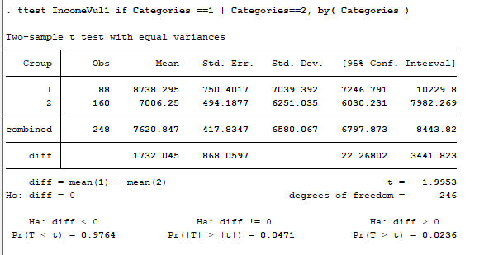
A.1.2 T- Test mean of ROSCA and MFI bifurcated by Income Vulnerability during COVID
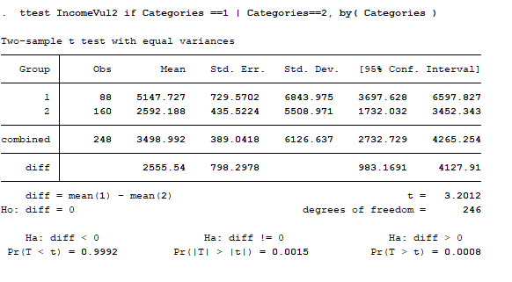
A.1.3 T- Test mean of ROSCA and ROSCA/MFI bifurcated by Income Vulnerability during COVID
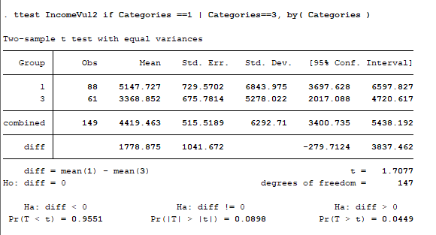

A.1.4 T- Test mean of ROSCA/MFI and NONE category bifurcated by Income Vulnerability during CO
A.1.5 T- Test mean of MFI and ROSCA/MFI category bifurcated by Income Vulnerability during COVID
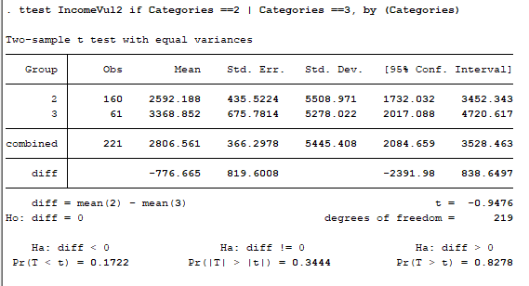

A.2: T-Test mean difference of group 1 (ROSCA) and group 2 (MFI) bifurcated Food Vulnerabilities
A.2.1 T- Test mean of ROSCA and MFI bifurcated by FD1 (Access to Meat)
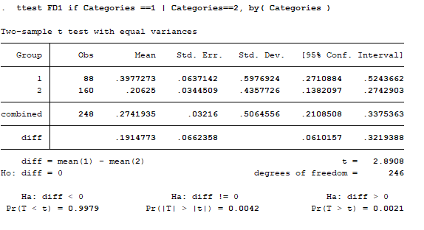
A.2.2 T- Test mean of ROSCA and MFI bifurcated by FD3 (Stock of Wheat/Flour)
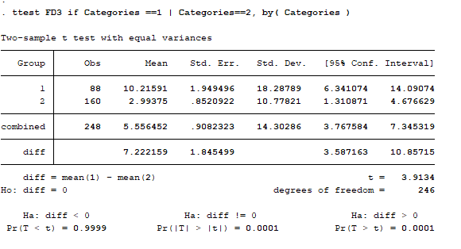
A.2.3 T- Test mean of ROSCA and MFI bifurcated by FD4 (Stock of Rice)
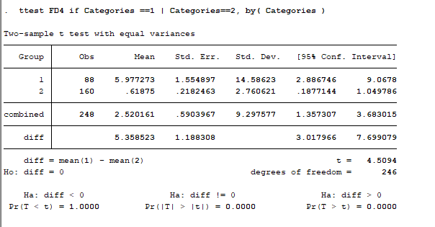
A.2.4 T- Test mean of ROSCA and ROSCAMFI bifurcated by FD1 (Access to Meat)
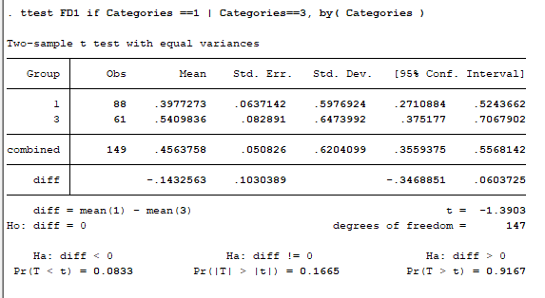
A.2.5 T- Test mean of ROSCA and ROSCAMFI bifurcated by FD3 (Stock of Wheat/Flour)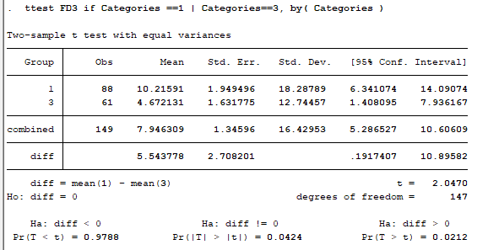

A.2.6 T- Test mean of ROSCA and ROSCAMFI bifurcated by FD4 (Stock of Rice)
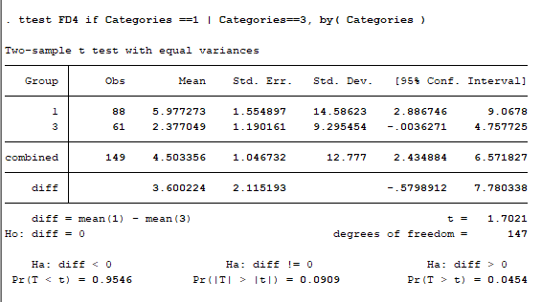
A.2.7 T- Test mean of MFI and ROSCAMFI bifurcated by FD1 (Access to Meat)
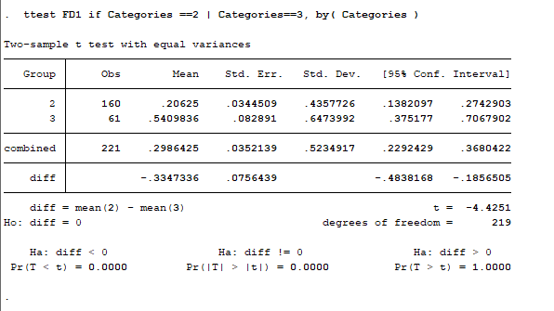
A.2.8 T- Test mean of MFI and ROSCAMFI bifurcated by FD3 (Stock of Wheat)
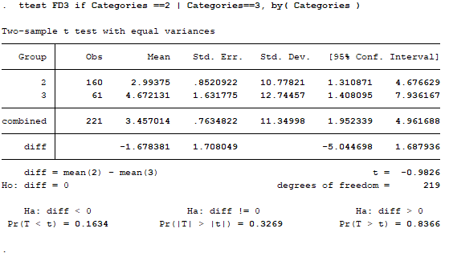
A.2.9 T- Test mean of MFI and ROSCAMFI bifurcated by FD3 (Stock of Wheat)
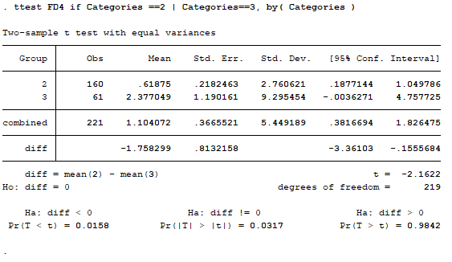
A.2.10 T- Test mean of MFI and ROSCAMFI bifurcated by FD4 (Stock of Rice)
A.2.11 T- Test mean of MFI and ROSCAMFI bifurcated by FD2 (Stock of Wheat/Flour)
